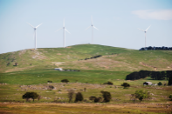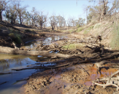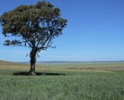

Hi All.

Typed “Easter and Soil” into Google, the first three articles are the more interesting finds.

Have a great Easter

Brian

Bacteria found in soil near Easter Island statues could offer treatment for Alzheimer's
- In tests on mice, the drug reverses decline caused by ageing
- Scientists believe it could be used as treatment for Alzheimer's disease
- The drug includes bacteria found in soil near the Easter Island statues
- It is already used to treat transplant patients
- It could also be used to treat depression
By Rob Waugh
A natural drug discovered in the soil of Easter Island could improve the memory of older people - and even treat Alzheimer's, researchers say.
In tests in mice, the drug halted the decline in brain function as they got older, and offered hope that it could also treat depression.
The drug - rapamycin - is a bacterial by-product discovered in the shadows of the island's famous statues.
It is named after Rapa Nui, the Polynesian name for Easter Island, which sits isolated in the Pacific ocean - 2000 miles from anywhere.
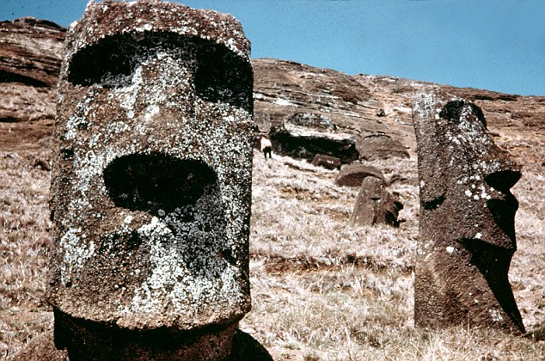
Easter Island heads: It is named after Rapa Nui, the Polynesian name for Easter Island, which sits isolated in the Pacific ocean - 2000 miles from anywhere
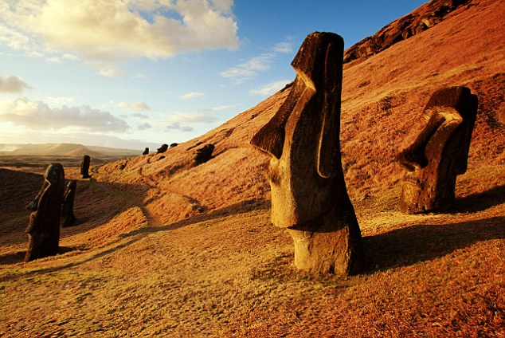
Read more: http://www.dailymail.co.uk/sciencetech/article-2168152/Mysterious-bacteria-soil-near-Easter-Island-statues-offer-cure-Alzheimers.html#ixzz4e5kefXsK

Don’t send foil to the soil this Easter
Easter is a great time to remember that all that Easter egg foil can actually be recycled, Minister for Transport and Municipal Services Meegan Fitzharris said today.
“Easter is a time when we get together with family and friends and maybe get stuck into an Easter egg or two. Often those Easter eggs are wrapped in foil, cardboard and plastic,” Minister Fitzharris said.
“The good news is foil, cardboard and plastic, if it’s firm and flexible, can all be recycled. So make sure you pop them straight into that yellow bin.
“Canberrans are known for being great recyclers, but our market research shows there is a lot of confusion about what can and can’t go in the recycling bin. http://www.cmd.act.gov.au/open_government/inform/act_government_media_releases/meegan-fitzharris-mla-media-releases/2016/dont-send-foil-to-the-soil-this-easter

Easter and erosion: Could soil erosion have been a contributing factor?

“The metaphor is so obvious. Easter Island isolated in the Pacific Ocean — once the island got into trouble, there was no way they could get free. There was no other people from whom they could get help. In the same way that we on Planet Earth, if we ruin our own world, we won't be able to get help.”

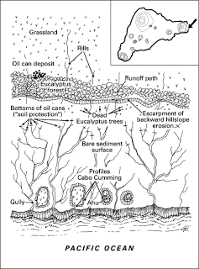
Figure 1. Complex of land use and soil erosion in the most eastern part of peninsula near Cabo Cumming
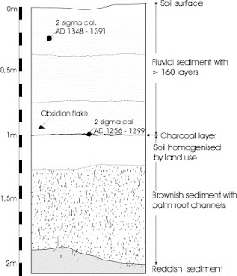
His
\
http://theeasterislandmystery.blogspot.com.au/2011/12/easter-and-erosion-could-soil-erosion.html

Watching the planet breathe—studying Earth's carbon cycle from space

12 April 2017 by Berrien Moore Iii And Sean Crowell, The Conversation
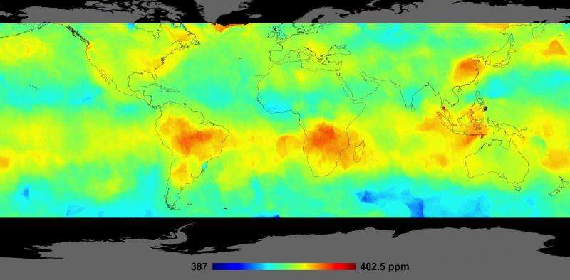
Average carbon dioxide concentrations, Oct. 1 - Nov. 11, 2014, measured by the Orbiting Carbon Observatory-2 satellite. Credit: NASA
Carbon is a building block of life on our planet. It is stored in reservoirs on Earth – in rocks, plants and soil – in the oceans, and in the atmosphere. And it cycles constantly between these reservoirs.
Read more at: https://phys.org/news/2017-04-planet-breathestudying-earth-carbon-space.html#jCp

Grow your soil water

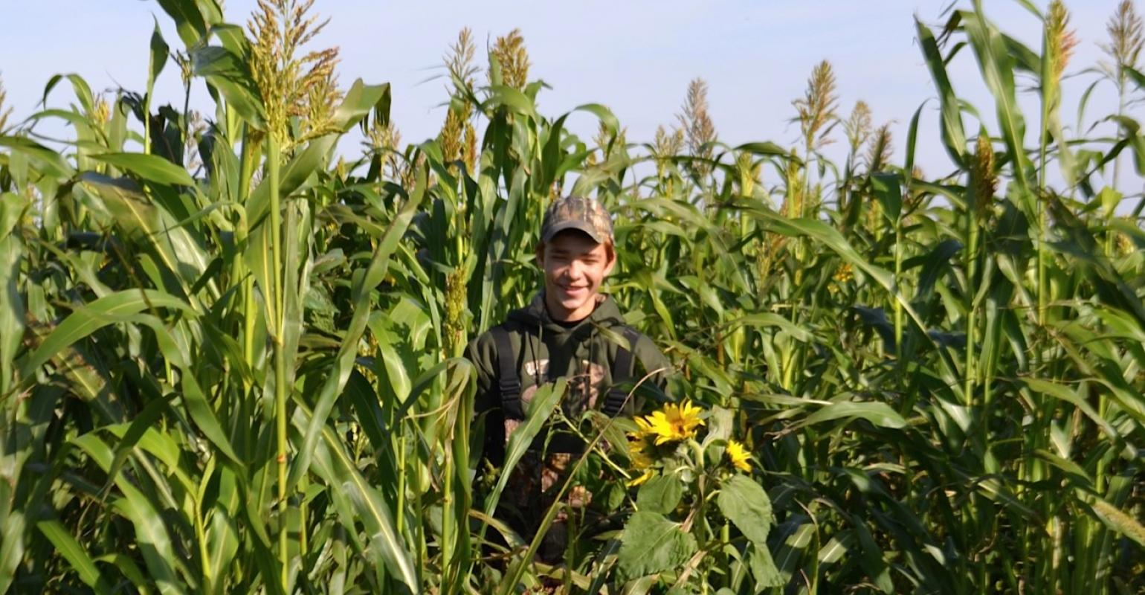
Dan DeSutter believes that any time the sun shines and a crop isn't growing is a wasted opportunity to build soil. In late October his son Dalton stood in a 12-way cover crop mix that was planted after wheat was harvested and in preparation for a 2017 corn crop.
Weatherproof your soils against drought by improving organic matter and cover crop roots.
While even a single year of cover crops can provide a benefit, no-till consultant Dan Towery emphasizes that real water storage benefits come with a sustained combination of no-till and cover crops over time. He breaks them into multiple factors: http://www.cornandsoybeandigest.com/cover-crops/grow-your-soil-water

New England's glacial upland soils provide major groundwater storage reservoir

11 April 2017 by Janet Lathrop
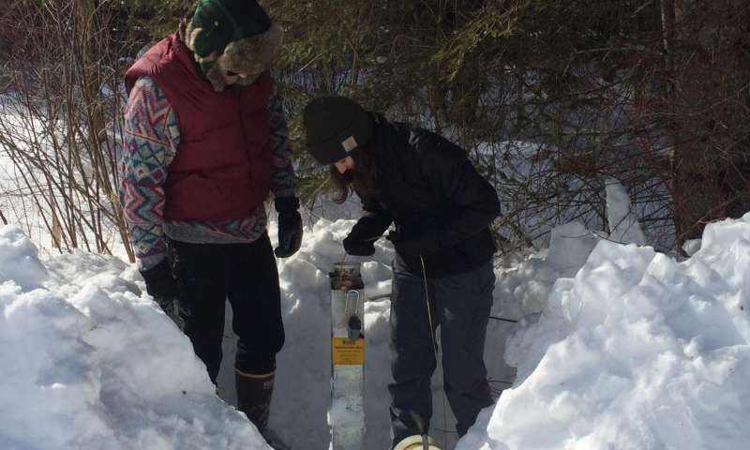
At left, Seth Oliver with Leah Santangelo, right, both hydrogeology UMass Amherst graduates, taking water level measurements at a till site in Blandford, Mass., for a recent study of natural groundwater storage reservoirs in New England by …more
A recent study of natural groundwater storage reservoirs in New England by hydrologist David Boutt at the University of Massachusetts Amherst found that upland aquifer systems dominated by thin deposits of surface till - a jumbled, unsorted material deposited by glaciers - make up about 70 percent of the active and dynamic storage for the region.
Read more at: https://phys.org/news/2017-04-england-glacial-upland-soils-major.html#jCp


http://www.earthday.org/
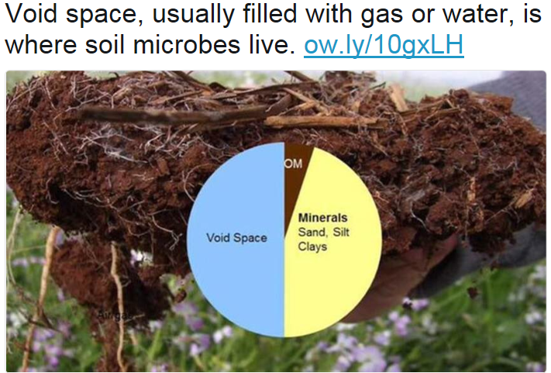
https://twitter.com/USDA_NRCS/status/849260771334799360/photo/1

Banking on Soil Health for Long-Term Profits

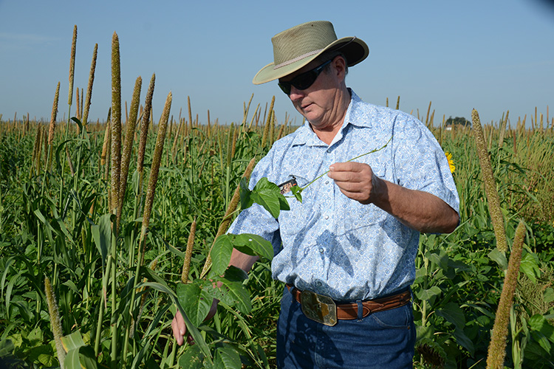
Tommy Henderson inspects a cowpea vine that has grown up next to a millet plant. This vertical growth increases biomass and future organic material for the soil.
By Dee Ann Littlefield, NRCS Marketing Director/Public Affairs Specialist
Tommy Henderson says the wheat market is going to turn around. In fact he is banking on it. Not with his banker, but with his soil.
- See more at: https://www.no-tillfarmer.com/articles/6163-banking-on-soil-health-for-long-term-profits#sthash.G9J9CgDc.dpuf

Groundwater overuse has permanently reduced San Joaquin Valley's water storage ability

12 April 2017 by Ker Than
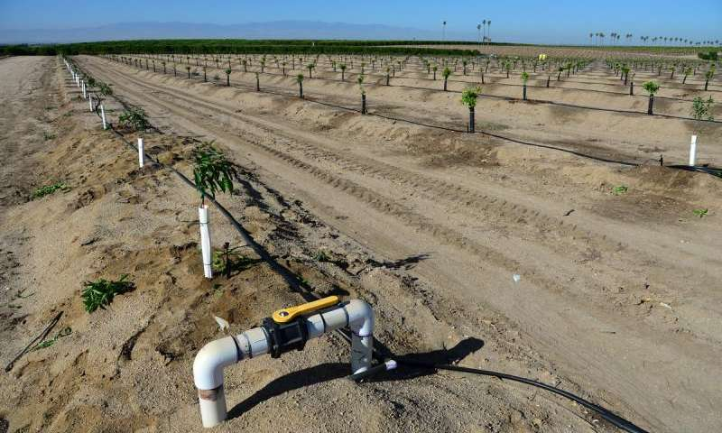
Newly planted almond trees, like these on a San Joaquin Valley farm, and other crops in California depend on groundwater. Credit: Shutterstock
Decades of over-pumping groundwater have irreversibly altered clay layers in parts of California's Central Valley, causing the ground to sink and permanently reducing its capacity to store water, a new satellite remote sensing study shows.
Read more at: https://phys.org/news/2017-04-groundwater-overuse-permanently-san-joaquin.html#jCp

Ancient Earth leaves a fading signature

Rare-earth isotopes are providing clues to the nature of the Earth's first crust. Richard A Lovett reports.
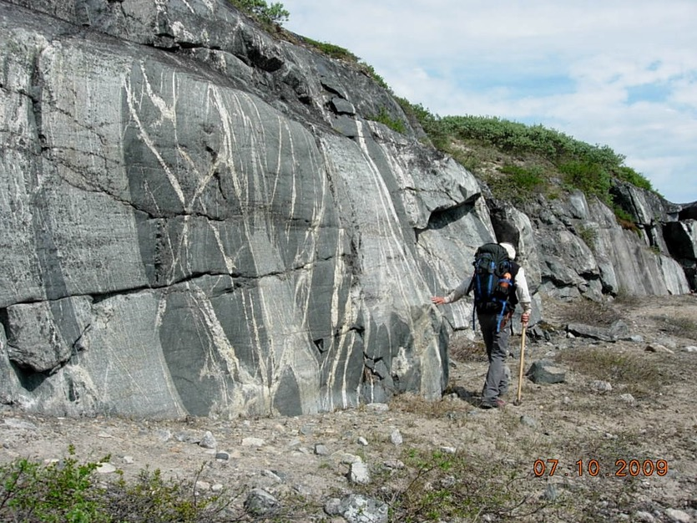
Granite such as this along the eastern shores of the Hudson Bay reveal remnants of the Earth's crust.
Rick Carlson
Scientists studying ancient rocks in northeastern Canada have found them to be composed of remnants of even older rocks, dating back to within a few hundred million years of the formation of the Earth.
These remnants suggest that tectonic processes in the planet’s first 1.5 billion years may have been very different to what we know today. The find is important in part because on most of the planet’s surface, geological processes have long ago erased visible traces of the Earth’s primitive crust. https://cosmosmagazine.com/geoscience/ancient-earth-leaves-a-fading-signature?utm_source=Today+in+Cosmos+Magazine&utm_campaign=55e1116e29-RSS_EMAIL&utm_medium=email&utm_term=0_5f4ec2b124-55e1116e29-179982353

The cooling effect of agricultural irrigation

12 April 2017

Farm in the arabian desert. Credit: Nullplus / iStock
Previously, scientists have suggested that agricultural irrigation affects mean climate in several regions of the world. New evidence now shows that this cooling influence is even more pronounced when it comes to climate extremes. https://phys.org/news/2017-04-cooling-effect-agricultural-irrigation.html

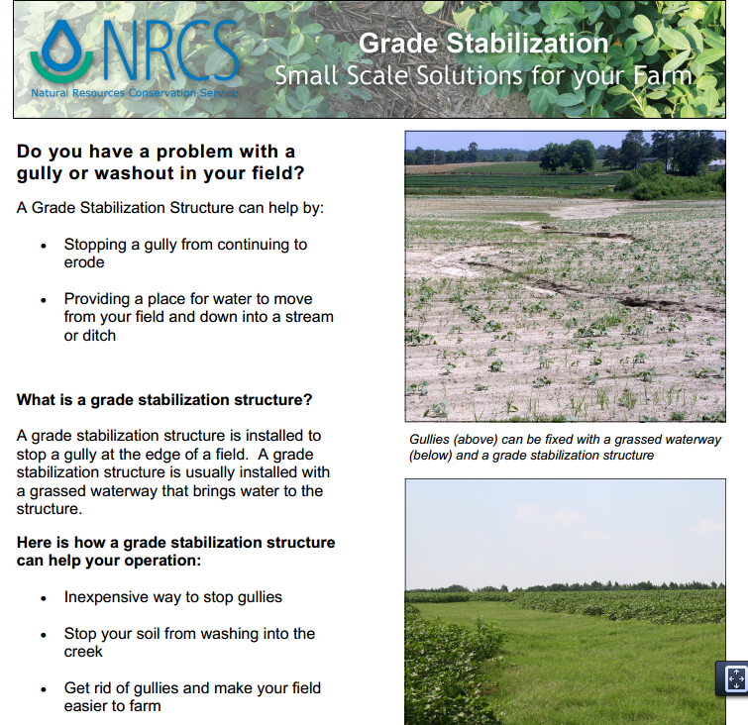
go.usa.gov/czhA9

Ants thrived in a cooling climate by taming fungus

Ants’ agricultural revolution 30 million years ago may hold lessons for humans. Tim Wallace reports.

Leafcutter ants carrying leaves to feed to their fungus.
Tim Flach / Getty

By the time humans began the transition from hunting and gathering to agriculture about 10,000 years ago, colossal and sophisticated agricultural operations had been prospering under their feet for tens of millions of years.
Now a team of scientists from the Smithsonian Institution’s National Museum of Natural History have identified when and where the planet’s first farmers – ants – made a revolutionary leap in their own agricultural evolution, developing farming practices rivalling modern human agriculture by domesticating fungal crops to the point where the fungi’s survival and evolution became dependent on their formic farmers. https://cosmosmagazine.com/biology/ants-agricultural-revolution-in-a-changing-climate-may-hold-lesson-for-humans?utm_source=Today+in+Cosmos+Magazine&utm_campaign=ff19bc8ed2-RSS_EMAIL&utm_medium=email&utm_term=0_5f4ec2b124-ff19bc8ed2-179982353

Volcanic arcs form by deep melting of rock mixtures

7 April 2017
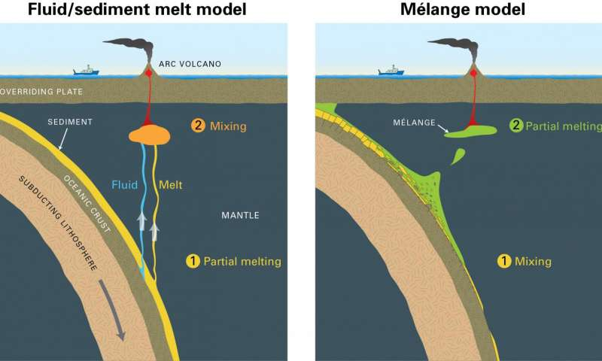
The two main events -- mixing and melting -- are reversed in the mélange model, which is an important distinction because scientists use measurements of isotope and trace elements to determine compositions of arc lavas. Credit: Jack Cook, Woods Hole Oceanographic Institution
Beneath the ocean, massive tectonic plates collide and grind against one another, which drives one below the other. This powerful collision, called subduction, is responsible for forming volcanic arcs that are home to some of Earth's most dramatic geological events, such as explosive volcanic eruptions and mega earthquakes.
Read more at: https://phys.org/news/2017-04-volcanic-arcs-deep-mixtures.html#jCp

Englobe Corp. hails the Quebec Ministry of Environment's improvement initiative on Soils Protection and Land Decontamination
LAVAL, QC, April 10, 2017 /CNW Telbec/ - Englobe Corp. welcomes yesterday's announcement about the release of the new version of the Soils Protection and Land Decontamination Policy and its 2017-2021 Action plan, made by Quebec Environment Minister, Mr. David Heurtel. The revised Policy confirms the Ministry's strong commitment to prioritize the use and development of Green Technologies in the contaminated soil management and treatment fields, in order to rectify wrongs of the past.
http://www.newswire.ca/news-releases/englobe-corp-hails-the-quebec-ministry-of-environments-improvement-initiative-on-soils-protection-and-land-decontamination-619043184.html

Soil Health for Non-Operator Land Owners
Top of Form
Bottom of Form
This webinar will focus on educating non-operator land owners on the benefits improving soil health have to increase the value of their land, and that it takes a solid working relationship between the landowner and farmer (often requiring changes in leasing structures) to obtain changes in soil health.
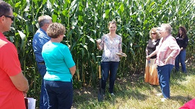
The American Farmland Trust views soil as being essential to supporting human life and increasing soil carbon as the primary productive component of topsoil. To do this farmers/ranchers must adopt soil health management systems that include conservation practices and activities that follow the soil health principles NRCS is advocating: minimize disturbance, maximize diversity, keep living roots growing and maintain residue cover. To do this will require a commitment from non-operator owners, who own nearly 40% of America’s agricultural lands (2012 USDA Ag Census). Non-operator landowners need to have an […]
http://www.conservationwebinars.net/webinars/soil-health-for-non-operator-land-owners

Hey Canada: It's time to soil your undies in the name of soil conservation
BEAUSEJOUR, MB, 10 April 2017 /CNW/ - Who doesn't like playing in the dirt? The Soil Conservation Council of Canada (SCCC) sure does and is encouraging the Canadian public to do so as well in honour of National Soil Conservation Week coming up April 16. Launching the entertaining Soil Your Undies campaign, the SCCC wants everyone who cares about soil health to bury a pair of cotton undergarments to witness firsthand the amazing activity that happens right under our feet. In Ontario, the Soil Your Undies project was initiated by the Innovative Farmers Association of Ontario. Now SCCC, in partnership with Stanfield's, is giving this project a national perspective. http://finance.yahoo.com/news/hey-canada-time-soil-undies-192800996.html
Validation Analysis of SMAP Products Using Ground-Based Measurements
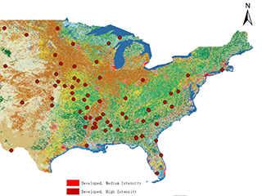
25 January 2017
Validation Analysis of SMAP Products Using Ground-Based Measurements
Results reveal that SMAP soil moisture retrievals are generally better than AMSR2 soil moisture data. http://www.mdpi.com/2072-4292/9/2/104

A Smartphone App Provides New Way to Access Soil Survey Information
Posted by David Sanden, NRCS California in Conservation
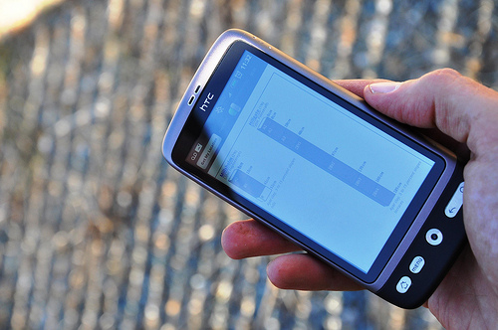NRCS Soil Scientist Dr. Dylan Beaudette developed the SoilWeb application for mobile devices while he was a graduate student at UC Davis. The app provides soil survey information in a mobile form and is particularly useful for those working in the field.
A new smartphone application, or “app,” is available as a free download for both iPhone and Android users to access soil survey information. The app, SoilWeb, combines online soil survey information with the GPS capabilities of smartphones.
The SoilWeb app is a portable version of the UC Davis California Soil Resource Lab’s Web-based interface to digital soil survey data from USDA’s Natural Resources Conservation Service (NRCS). Because the app provides soil survey information in a mobile form, it is particularly useful for those working in the field.
https://www.usda.gov/media/blog/2012/02/3/smartphone-app-provides-new-way-access-soil-survey-information

Reef damage could cost Australia a million tourists: study

12 April 2017
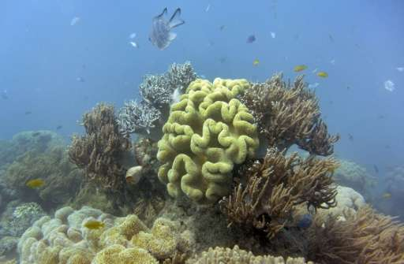
Damage to Australia's Great Barrier Reef could lead to a drop in tourism and the loss of 10,000 jobs
Mass coral bleaching on Australia's Great Barrier Reef could cost the region more than a million tourists a year and up to Aus$1.0 billion (US$760 million) in lost revenue, a study warned Wednesday.
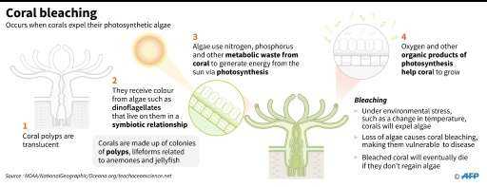
Coral bleaching
It is also under pressure from farming run-off, development and the crown-of-thorns starfish.
In another setback, scientist Andrew Brooks of Griffith University on Wednesday said aerial assessments showed flood plumes from two rivers swelled by the cyclone were now pushing sediment and nitrogen pollution into reef waters.
"We know sediment can harm coral and sea grass by restricting light," he said.
"Now we're learning that sediment from this area also carries large loads of harmful nitrogen because it sticks to the sediment sourced from these same soils."
Read more at: https://phys.org/news/2017-04-reef-australia-million-tourists.html#jCp

Lab-on-a-glove: Swipe right on nerve agents
By Ali Green & Jesse Hawley 3rd April 2017
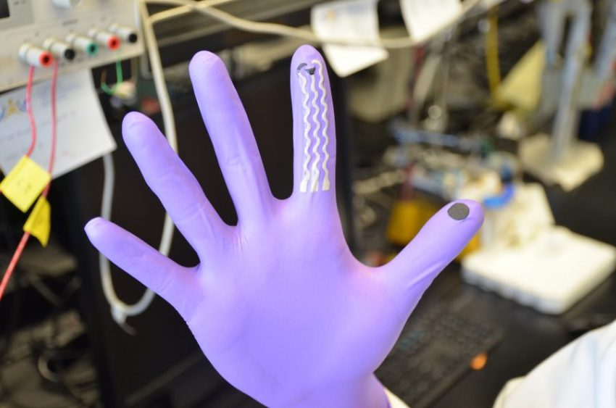
The ‘lab-on-a-glove’ developed by us and the University of California, San Diego can detect OP compounds, a group of toxic chemicals found in some pesticides. Image: University of California, San Diego.
Remember that classic Brothers Grimm tale where a vain and embittered queen makes various attempts at murdering her beautiful young step daughter, Snow White? The queen hires a mercenary to slaughter Snow White, and after that fails, attempts to strangle the girl with her own hands. Finally, the insidious queen laces an apple and gives it to Snow White to eat. https://blog.csiro.au/swipe-right-on-nerve-agents/?utm_source=Snapshot-April-2017&utm_medium=newsletter&utm_campaign=Snapshot

Study Tracks ‘Memory’ of Soil Moisture
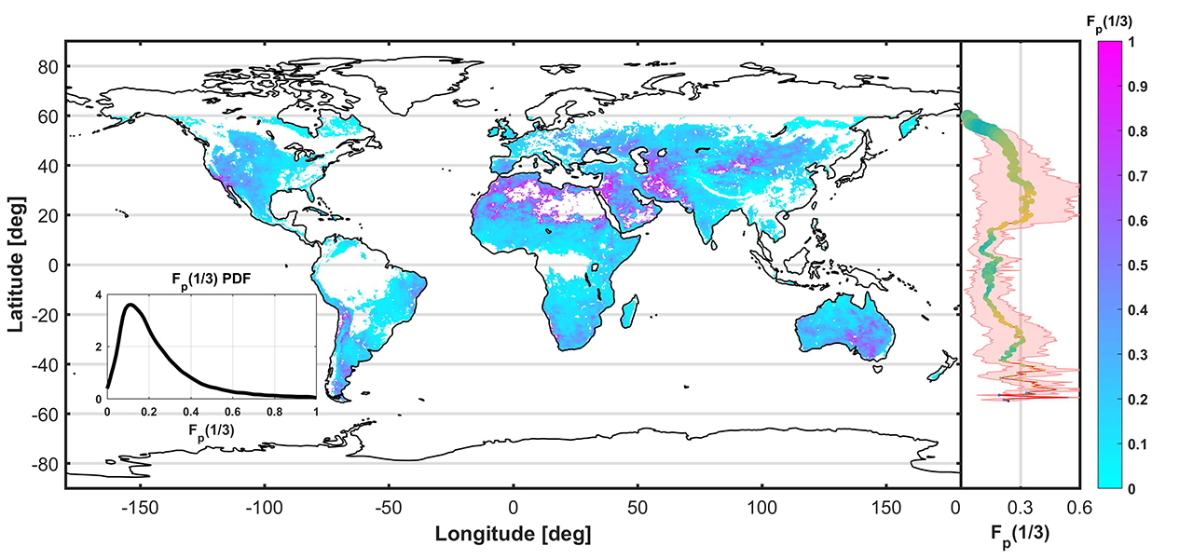
Global map and associated averages, by zone, of a new measure of how long it takes for soil moisture from rainfall to dissipate (estimated soil moisture water cycle fraction), produced from one year of data from NASA’s Soil Moisture Active Passive mission.
Credits: MIT/NASA/JPL-Caltech
NASA SMAP Data Provide Insights for Weather, Agriculture, Climate
A new study of the first year of observational data from NASA’s Soil Moisture Active Passive (SMAP) mission is providing significant surprises that will help in modeling Earth’s climate, forecasting our weather and monitoring agricultural crop growth. https://smap.jpl.nasa.gov/news/1261/study-tracks-memory-of-soil-moisture/

New night lights maps open up possible real-time applications

12 April 2017 by Michael Carlowicz
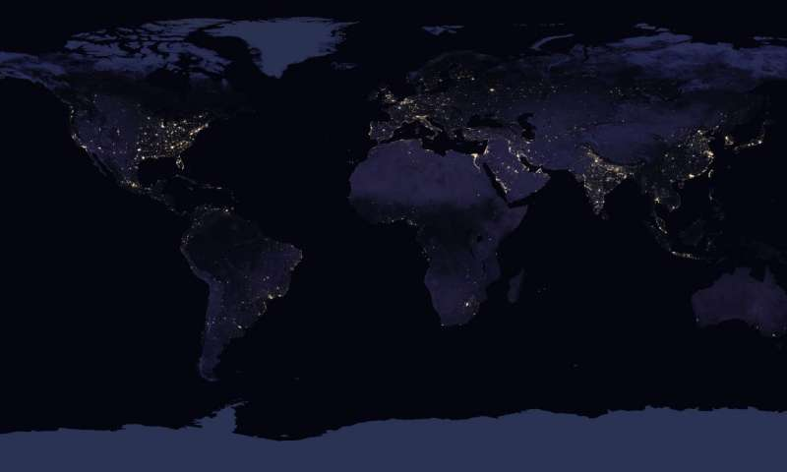
This flat-map composite image depicts Earth's night lights in 2016. Credit: NASA Earth Observatory images by Joshua Stevens, using Suomi NPP VIIRS data from Miguel Román, NASA's Goddard Space Flight Center
NASA scientists are releasing new global maps of Earth at night, providing the clearest yet composite view of the patterns of human settlement across our planet.
Read more at: https://phys.org/news/2017-04-night-real-time-applications.html#jCp

A new kind of sand dune on Mars

In 2015 the Curiosity rover discovered a kind of wind-rippled sand dune never seen before on Mars or here on Earth.


Namib Dune, Gale Crater, Mars.
NASA/JPL-Caltech/MSSS
This view of the surface of a sand dune on Mars shows two different sizes of ripples created by wind. Sand dunes, like the small ripples seen here, are familiar sights on Earth. The bigger ripples are around 3 meters apart and have not been seen before, on Earth or on Mars. The larger ripples have distinctive sinuous crest lines.
https://cosmosmagazine.com/space/a-new-kind-of-sand-dune-on-mars?utm_source=Today+in+Cosmos+Magazine&utm_campaign=a962e7c300-RSS_EMAIL&utm_medium=email&utm_term=0_5f4ec2b124-a962e7c300-179982353

Scientists uncover isotopic fingerprint of N2O emissions from Arctic tundra

7 April 2017
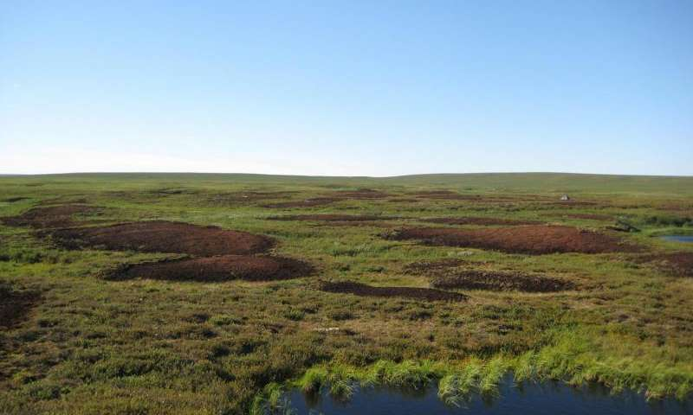
“Bare peat surfaces in the discontinuous permafrost zone of the sub-Arctic East European tundra. New research explores the source of unexpectedly high nitrous oxide emissions from such bare peat soils in Arctic tundra.". Credit: University …more
A new study from the University of Eastern Finland presents, for the first time, the isotopic fingerprint of nitrous oxide produced by Arctic soils. The finding opens new avenues for predicting future trends in atmospheric nitrous oxide as well as in identifying climate change mitigation actions in the Arctic, a region that is particularly sensitive to climate change.
Read more at: https://phys.org/news/2017-04-scientists-uncover-isotopic-fingerprint-n2o.html#jCp

Fitbit for sheep – it’s not what ewe think
By Darius Koreis 17th March 2017

Activity trackers could allow farmers to breed high performance sheep … but probably not for racing. Image: Fraser Reid (Flickr, CC BY 2.0).
Erase that image of headband wearing, treadmill running sheep from your mind (sorry). But in the same way that wearable devices such as Fitbits log your activity and health, activity trackers could soon be a vital tool for Australian farmers to monitor the health and behaviour of their sheep. https://blog.csiro.au/fitbit-sheep-not-ewe-think/?utm_source=Snapshot-April-2017&utm_medium=newsletter&utm_campaign=Snapshot

A spring thaw comes to Arctic permafrost

Lush greenery and azure lakes cover northern Norway as the Arctic warms.

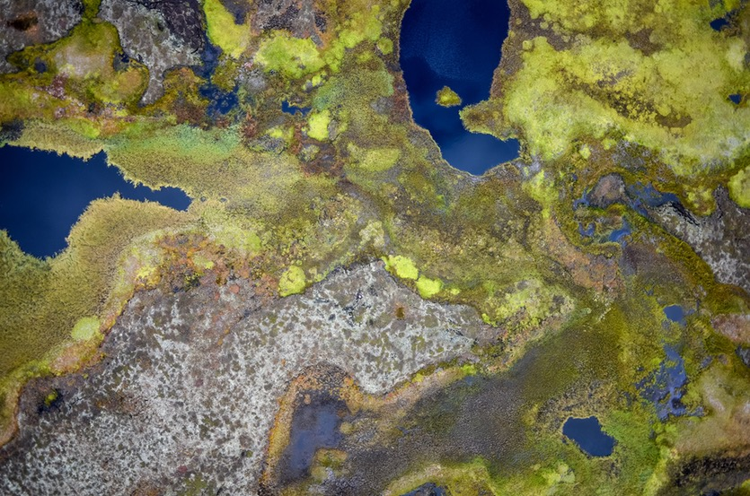
An aerial drone photo shows thawing permafrost peat plateaus in Northern Norway.
Sebastian Westermann
Common throughout the Arctic and Antarctic – and in some high-altitude regions such as the Tibetan plateau – permafrost is frozen soil that has been at a temperature below freezing all year round for at least two years.
It is estimated that the frozen organic matter trapped in these icy soils contains more carbon than the total amount now in the atmosphere. https://cosmosmagazine.com/climate/a-spring-thaw-comes-to-arctic-permafrost?utm_source=Today+in+Cosmos+Magazine&utm_campaign=f5d02a72ab-RSS_EMAIL&utm_medium=email&utm_term=0_5f4ec2b124-f5d02a72ab-179982353

The Life Cycle of a Flood Revealed
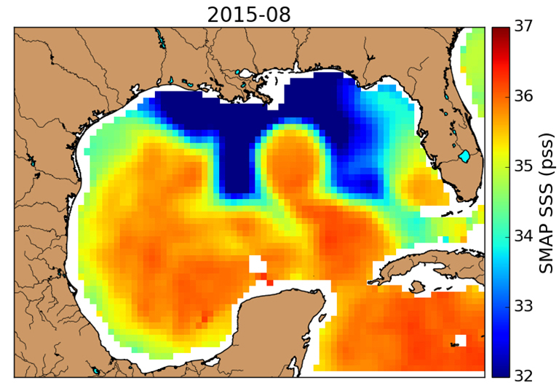
SMAP observed an unusual horseshoe-shaped plume of freshwater (dark blue) in the Gulf of Mexico after Texas flooding in May 2015. Louisiana is above the center of the plume, with Florida on the right and the Texas coastline at upper left. Credit: NASA/JPL-Caltech
A NASA analysis of a 2015 Texas flood is the first to document the full life cycle and impacts of a flood on both land and ocean. Using data from NASA's Soil Moisture Active Passive (SMAP) satellite and other satellite instruments, the study traced the event's chronology -- starting with rains that fell weeks before the flood and ending with an unusually shaped plume of freshwater that lingered in the Gulf of Mexico months later, with a potential for significant impacts on the gulf's marine life. https://smap.jpl.nasa.gov/news/1259/the-life-cycle-of-a-flood-revealed/

Using tropical microbes to improve the environment

12 April 2017
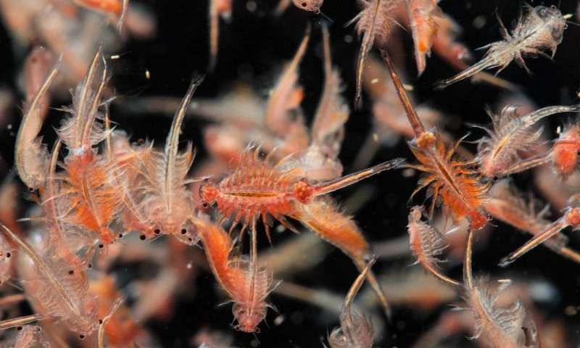
Researchers found that bioencapsulated brine shrimp larvae (pictured) provide a level of disease protection to a commonly eaten fish in Asia, called climbing perch. Credit: Napat Polchoke / 123rf
Researchers in Malaysia are harnessing properties in tropical microbes to address a variety of environmental, agricultural and aquacultural issues
The team also found that formulations made with strains of Streptomyces bacteria commonly found in soil had antibacterial and antifungal properties that could be used to protect banana crops from the fungal-borne Panama wilt disease. Plants can also be protected from wilt disease by extracting organisms—called endophytes—that live in plants to 'pre-colonize' other target plants.
Read more at: https://phys.org/news/2017-04-tropical-microbes-environment.html#jCp

Bionic leaf breakthrough could revolutionise fertiliser production, but environmental questions remain

A new nitrogen-fixing device may offer farmers independence from industrial fertiliser giants, but nitrogen-based fertiliser itself could present a larger problem for the world. Tim Wallace reports.

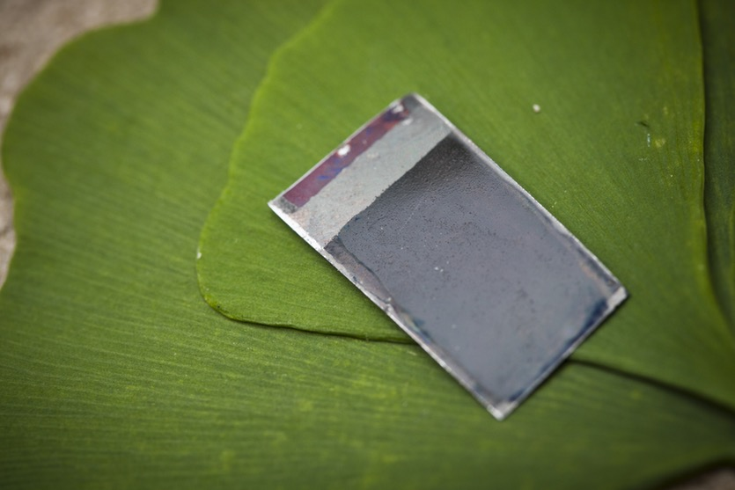
The ‘bionic leaf’ makes use of the ‘artificial leaf’ (shown above) that Nocera developed in 2011.
Dominick Reuter/MIT
Harvard chemistry professor Daniel Nocera has already wowed the scientific world with breakthroughs in artificial photosynthesis – including the “artificial leaf”, a metallic wafer that produces hydrogen and oxygen from sunlight and water, and the “bionic leaf”, which uses a bio-engineered bacterium that consumes hydrogen and carbon-dioxide to produce liquid fuels.
This week he revealed another potential game changer in human replication and super-charging of natural chemistry: a different kind of “bionic leaf” that uses another bio-engineered bacteria to make fertiliser in the very ground where crops are grown. https://cosmosmagazine.com/technology/bionic-leaf-breakthrough-could-revolutionise-fertiliser-production-but-environmental-questions-remain?utm_source=Today+in+Cosmos+Magazine&utm_campaign=8eb3067402-RSS_EMAIL&utm_medium=email&utm_term=0_5f4ec2b124-8eb3067402-179982353

Why we shouldn’t harm the desert’s ‘skin’
Posted by Daniel Stolte-Arizona 2nd April 2017

Scientists have discovered that the desert’s biocrust plays a previously unknown role in regulating the arid climate.
This “living skin of the desert” goes by different names. You may have seen signs in parks and protected areas advising you not to step on “cryptobiotic soil,” or read about “biocrusts.” Each refers to the same thing: a community of mosses, lichens, and sometimes cyanobacteria in various proportions that is critical to human and ecosystem health and climate in the Southwest and other dryland areas. http://www.futurity.org/biocrust-desert-skin-1391692-2/

(Sicilian farmers look) Back to the future
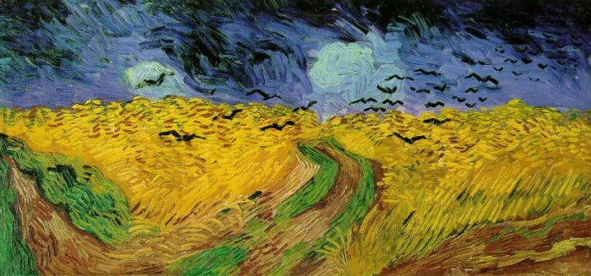Wheatfield with Crows, by Van Gogh. Van Gogh Museum, Amsterdam.
Sicilian farmers are returning to cultivate ancient seed. This is to recover the ancient wisdom that feed the island and Italy since ancient times. Giuseppe Li Rosi is a local farmer and one of the strongest supporters of the return to traditional agriculture. He has converted a property of 100 hectares to traditional farming and proudly guards three local seed varieties (“Timilia”, “Maiorca” and “Strazzavisazz”), keeping at least 10 hectares for each one […] https://gsoil.wordpress.com/

Webinar: Best Practices for Nutrient Management


20 April 2017

15:00 CET
*** CLICK HERE TO REGISTER ***
A brand new handbook detailing the best ways to effectively manage nutrients on farms has been released, in an effort to help farmers achieve the triple win of boosting productivity, achieving resilience and reducing greenhouse gas emissions. Join the International Fertilizer Association (IFA) and experts online for an interactive webinar on the findings of the Nutrient Management Handbook and the latest on soil health guidance.
Speakers:
- Patrick Heffer, Director of Agriculture, IFA (International Fertilizer Association)
- Adrian Johnston, Former Vice President, Africa & Asia, IPNI (International Plant Nutrition Institute)
Farmer representatives:
- Max Schulman, Finish Farmer of cereals and oilseeds, and Representative of the Cereals Working party of CopaCogeca, Europe
- Alan Madison, Madison Farm on Soybeans and Corn, Illinois, USA
Join the expert panel to discuss critical questions such as:
- Which nutrients are essential for plant growth?
- Are organic, or mineral fertilizers more effective?
- What are the challenges of nutrient management, and how can they be tackled?
- How to implement best management practices ?
- How can I use fertilizer in a way that will make my farm “climate-smart”?
Read more and download the Nutrient Management Handbook >>
https://farmingfirst.org/2017/04/what-does-it-take-to-achieve-the-triple-wins-productivity-sustainability-and-resilience/

The soil and the age of the vines were the keys to success, according to Edouard Moueix, whose family owns many Pomerol and Saint-Emilion estates. Vineyards with clay and limestone, which hold water, suffered no stress during the drought. Those planted on gravel and sand often did.
https://www.bloomberg.com/news/articles/2017-04-12/after-a-blockbuster-year-for-bordeaux-the-top-18-wines-to-buy

State Oil Companies Stay in Oil Sands as Conoco, Shell Exit
by
Robert Tuttle
‎1‎ ‎April‎ ‎2017‎ ‎8‎:‎19‎ ‎AM
- Cnooc becomes fourth-biggest foreign producer in oil sands
- Position grows after rules passed to hinder state-owned firms
Four years ago, Canada’s government tried to keep state-owned companies out of Alberta’s oil sands. Now, they may be around for a while.
ConocoPhillips, Marathon Oil Corp. and Royal Dutch Shell Plc decided this month to sell most of their oil sands to Cenovus Energy Inc. and Canadian Natural Resources Ltd. That leaves firms such as China’s Cnooc Ltd. among the last foreigners holding major stakes in the bitumen-soaked soil of northern Alberta.
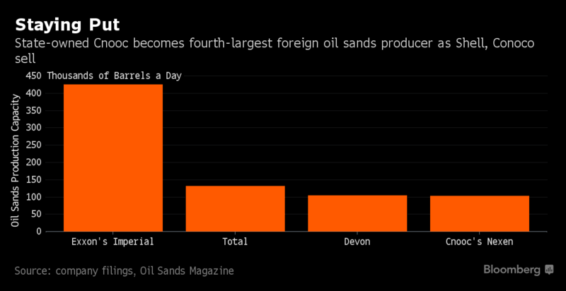
https://www.bloomberg.com/news/articles/2017-03-31/state-oil-companies-stay-put-in-oil-sands-as-conoco-shell-exit

Why the Earth’s magnetic poles could be about to swap places – and how it would affect us

Our planet’s history includes at least several hundred global magnetic reversals, where north and south magnetic poles swap places. So when’s the next one happening and how will it affect life on Earth?

The Earth’s magnetic field surrounds our planet like an invisible force field – protecting life from harmful solar radiation by deflecting charged particles away. Far from being constant, this field is continuously changing. Indeed, our planet’s history includes at least several hundred global magnetic reversals, where north and south magnetic poles swap places. So when’s the next one happening and how will it affect life on Earth?
https://cosmosmagazine.com/geoscience/why-the-earth-s-magnetic-poles-could-be-about-to-swap-places-and-how-it-would-affect-us

Prescribed fires consume Kansas landscape

12 April 2017
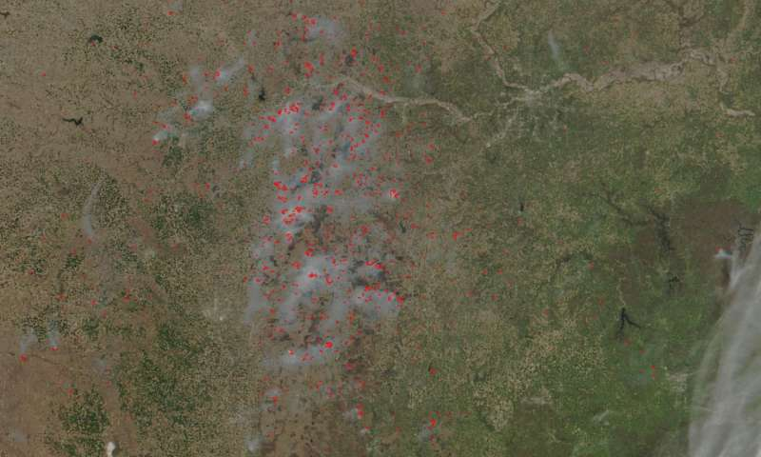
Credit: NASA image courtesy Jeff Schmaltz LANCE/EOSDIS MODIS Rapid Response Team, GSFC. Caption by Lynn Jenner
Most if not all the fires in this image taken by Suomi NPP satellite's VIIRS (Visible Infrared Imaging Radiometer Suite) instrument on April 11, 2017 are controlled fires set by farmers to manage land.
Read more at: https://phys.org/news/2017-04-consume-kansas-landscape.html#jCp

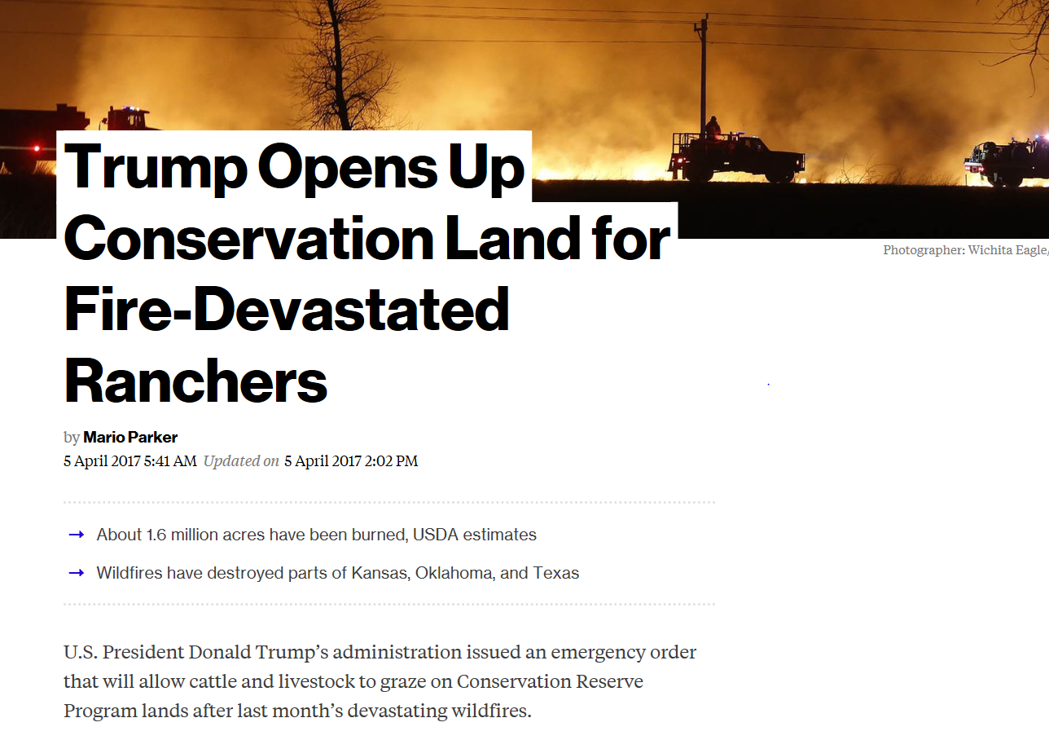
https://www.bloomberg.com/news/articles/2017-04-04/trump-opens-up-conservation-land-for-fire-devastated-ranchers

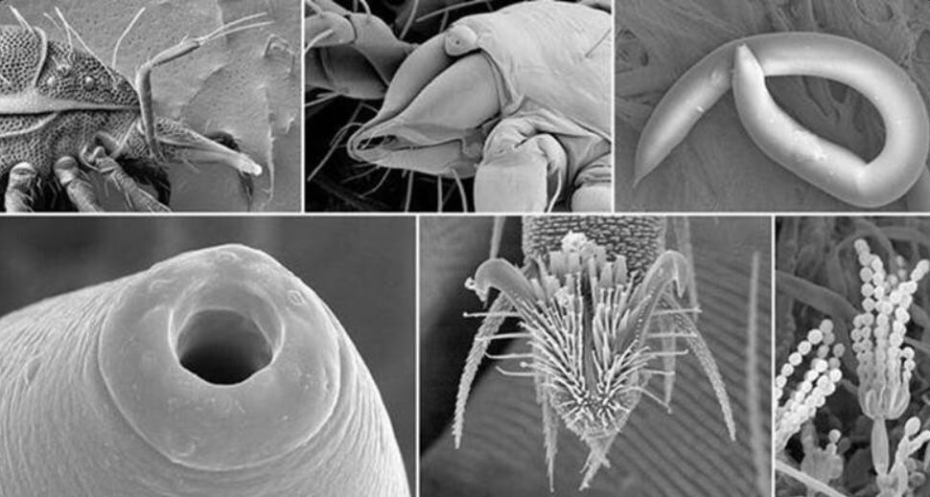

90% of soil function is attributable to soil microbes USDA NRCS 3rd April 2017

