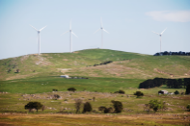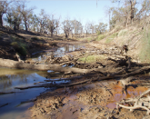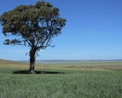

Hi All,

Please see the article on the app to print 3-D terrain models of any place on Earth. COP members who have used the app said it is easy to use.Here’s a quick model one CoP member did for the Wolgan Valley (90m DEM)

Very interesting - <http://www.news.iastate.edu/news/2017/03/13/touchterrain>

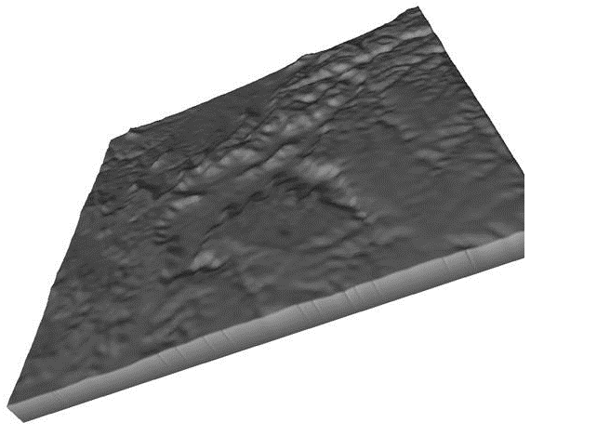

Cheers

Brian

# **Iowa State geologists develop app to print 3-D terrain models of any place on Earth**

[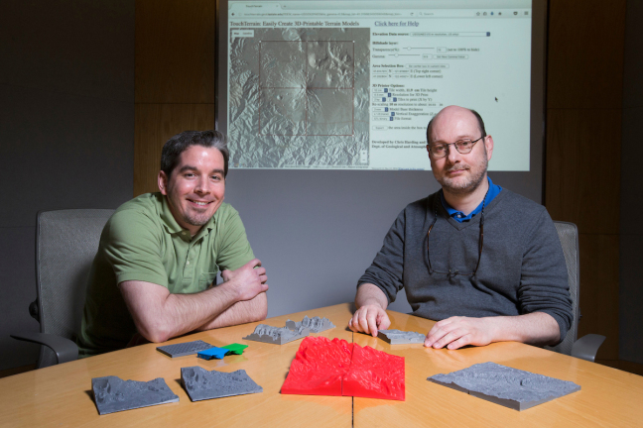](http://www.news.iastate.edu/media/2017/03/V85B.jpg)

Alex Renner, left, and Chris Harding, two of the developers of TouchTerrain, with the web application that makes it quick and easy to print 3-D terrain models. [Larger photo.](http://www.news.iastate.edu/media/2017/03/V85B.jpg) Photos by Christopher Gannon.

AMES, Iowa – Today’s geology lesson is all about anticlines.

Students can read all they want about geological folds, axial planes, hinge lines, antiformal synclines and synformal anticlines. But it can still be a challenge to visualize just what geologists are talking about <http://www.news.iastate.edu/news/2017/03/13/touchterrain>

# **Artificial soils could be key in rehabilitation of Latrobe Valley coal mines**

##### 27 March 2017

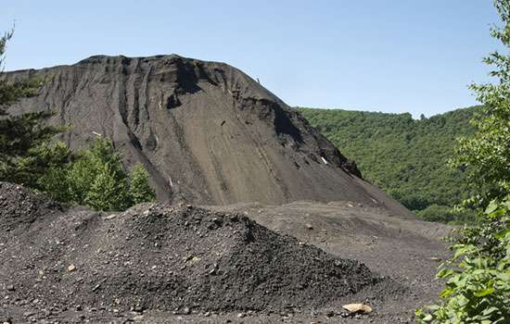

Credit: Monash University

With Hazelwood Power Station commencing its staged shutdown, creating artificial soils from waste materials could provide an environmentally friendly option for rehabilitating the adjoining mine, according to a leading mining researcher from Monash University. <https://phys.org/news/2017-03-artificial-soils-key-latrobe-valley.html>

# **Legends of the lost reservoirs**

##### 20 March 2017 by Melanie Schefft

[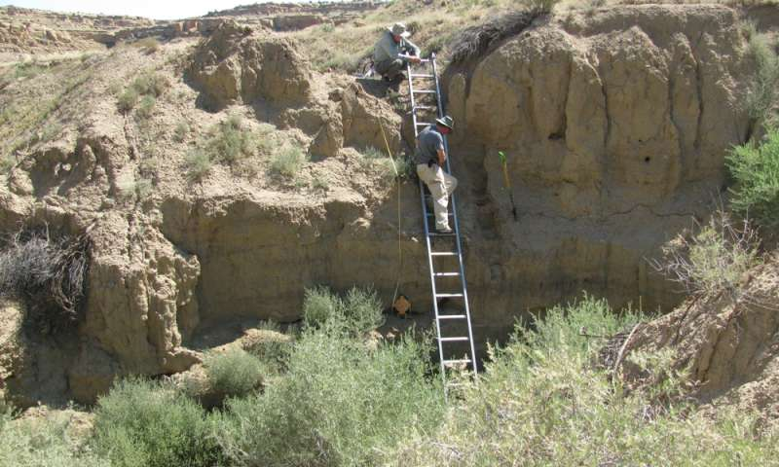](https://3c1703fe8d.site.internapcdn.net/newman/gfx/news/hires/2017/1-legendsofthe.jpg)

UC Professor Nick Dunning (on ladder) records alluvial stratigraphy in a Chaco Canyon arroyo while UC Professor Vern Scarborough looks on. Credit: University of Cincinnati

Tucked away in a laboratory in University of Cincinnati's Braunstein Hall are tubes of rock and dirt that quietly tell a story—a story that looks back on ancient society's early water conservation. UC researchers hope the story will aid in the future preservation of our planet's most precious resource.

Read more at: <https://phys.org/news/2017-03-legends-lost-reservoirs.html#jCp>

# **Frozen soils might be major emitter**

## **A University of Manitoba study has discovered  the previously overlooked emissions**

AddThis Sharing Buttons

Share to FacebookShare to TwitterShare to EmailShare to PinterestShare to More

[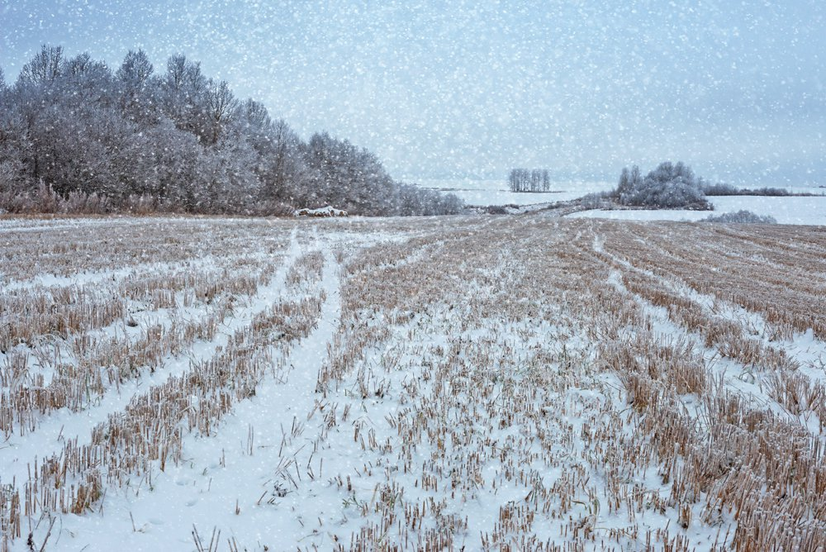](https://static.agcanada.com/wp-content/uploads/sites/5/2017/03/first-snowfall-on-harvested.jpg)

Frozen cropland may be a larger source of nitrous oxide emissions than previously understood. *Photo: Thinkstock*

A new study suggests global greenhouse emission calculations have overlooked an important aspect of the agricultural sector.

Emissions, especially of the key gas nitrous oxide, may in fact be about 17 to 28 per cent greater for cultivated soils frozen in winter than currently thought.

<https://www.manitobacooperator.ca/news-opinion/news/frozen-soils-might-be-major-emitter/>

# **Cattle associated antibiotics disturb soil ecosystems**

##### 28 March 2017

[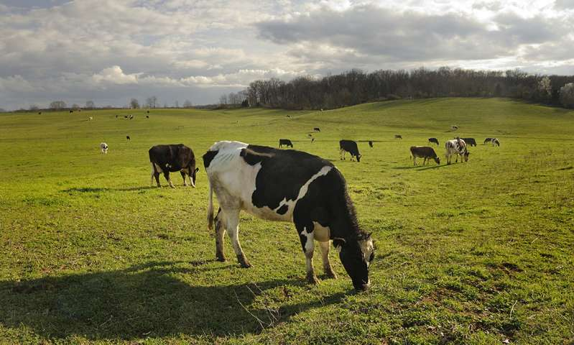](https://3c1703fe8d.site.internapcdn.net/newman/gfx/news/hires/2017/cattleassoci.jpg)

Cows graze on pastures near Virginia Tech in Blacksburg, Virginia. Credit: Virginia Tech

Manure from cattle administered antibiotics drastically changes the bacterial and fungal make-up of surrounding soil, leading to ecosystem dysfunction, according to a Virginia Tech research team.

Read more at: <https://phys.org/news/2017-03-cattle-antibiotics-disturb-soil-ecosystems.html#jCp>

# **Soil Organic Carbon: the hidden potential**

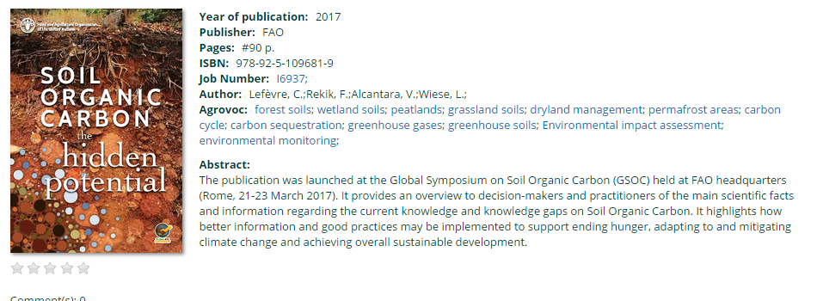

# **Researchers discover tree trunks act as methane source in upland** **forests**

##### 30 March 2017 by Adam Thomas

[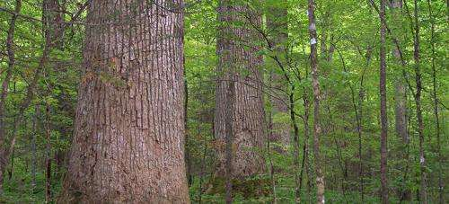](https://3c1703fe8d.site.internapcdn.net/newman/gfx/news/hires/2014/trees.jpg)

Credit: Notneb82, Wikimedia Commons

A new study from the University of Delaware is one of the first in the world to show that tree trunks in upland forests actually emit methane rather than store it, representing a new, previously unaccounted source of this powerful greenhouse gas.

Read more at: <https://phys.org/news/2017-03-tree-trunks-methane-source-upland.html#jCp>

# **Radiocarbon study provides insight into soil carbon dynamics and effects of agriculture**

##### 29 March 2017

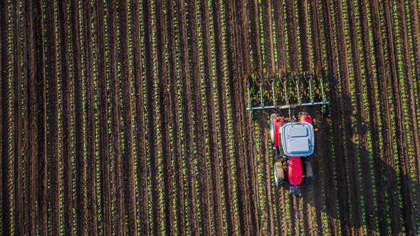

ANSTO has contributed to research that indicated agriculture affects the organic carbon storage in subsoil up to one metre and challenged the concept that subsoil is a stable repository of organic carbon.

Read more at: <https://phys.org/news/2017-03-radiocarbon-insight-soil-carbon-dynamics.html#jCp>

## **How to Use Crop Rotation for Healthier Soils and Higher Productivity**

A vital part to thinking long-term with organic gardening is to learn about and utilize crop rotation to maintain healthy soils and extend productivity. In truth, crop rotation is nothing new on the gardening scene. Rather, many gardeners are a new to the scene and perhaps haven’t quite caught on. And, that’s okay, as we’ll all start somewhere. In the simplest of terms, crop rotation can be summed up as not planting the same species (actually, family) of crops in the same space for consecutive years.

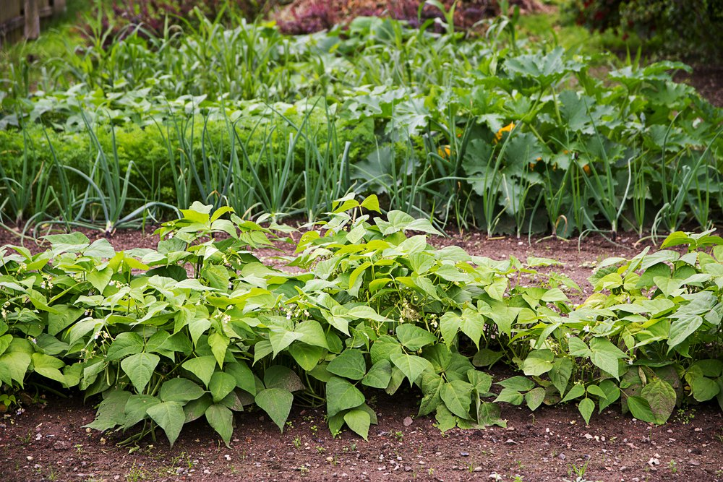[Maren Winter](https://www.shutterstock.com/g/Maren+Winter)/Shutterstock

<http://www.onegreenplanet.org/lifestyle/how-to-use-crop-rotation/>

# **No ill effects from grazing cattle on crop residues: Nebraska study**

##### 29 March 2017

[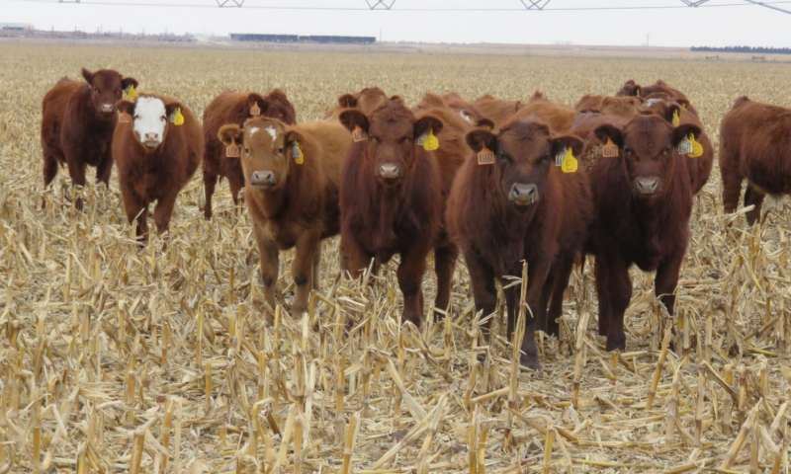](https://3c1703fe8d.site.internapcdn.net/newman/gfx/news/hires/2017/steeringtowa.jpg)

Researchers found that grazing corn residues could actually improve certain soil properties and is preferable to baling. Credit: Mary Drewnoski

It makes sense that a 1,200 pound Angus cow would place quite a lot of pressure on the ground on which it walks. But a new study shows that even these heavy beasts can't do much to compact common soils—if they're grazed responsibly.

Read more at: <https://phys.org/news/2017-03-ill-effects-grazing-cattle-crop.html#jCp.0>

# **Conserving blink-and-you’ll-miss-it biodiversity**

Using biodiversity data collected from 160 ecosystem-monitoring plots along an 870 km long section of TERN’s South West Australian Transitional Transect (SWATT), new research has revealed the conservation and management implications of rapid changes in species composition between Western Australia’s sandplain ecosystems.

Researchers from [Western Australia’s Department of Parks and Wildlife](https://www.dpaw.wa.gov.au/), the [University of Western Australia](http://www.uwa.edu.au/) and the [CSIRO](https://www.csiro.au/) have found that the vegetation of southern WA’s sandplains is not only very diverse but also highly variable between locations.

In their paper just [published in the journal PLOS One](http://journals.plos.org/plosone/article?id=10.1371/journal.pone.0172977) […]

|  |  |
| --- | --- |
| http://www.tern.org.au/rs/7/sites/998/user_uploads/Image/Newsletter/2017%2003March/SWATT_IMG_9133_480.JPG | [http://www.tern.org.au/rs/7/sites/998/user_uploads/Image/Newsletter/2017%2003March/SWATT_Map_PLoS_480.jpg](http://www.tern.org.au/rs/7/sites/998/user_uploads/Image/Newsletter/2017%2003March/SWATT_Map_PLoS.PNG.jpg) |
| New research using TERN's South West Australian Transitional Transect research infrastructure (right) has revealed the conservation and management implications of highly variable biodiversity across Western Australia’s sandplain ecosystems | |

<http://www.tern.org.au/Newsletter-2017-Mar-SWATT-Species-Turnover-pg31939.html>

# **Understanding predictability and randomness by digging in the dirt**

##### 28 March 2017

When tilling soil, the blade of the tillage tool cuts through the dirt, loosening it up in preparation for seeding. The dirt granules are pushed aside in a way that certainly looks random—but might not be.

Now, from studying soil tilling, researchers have found a way to distinguish whether such a process is truly random, or only appears so and is actually predictable and deterministic—which can lead to a deeper understanding and the ability to precisely control the process.

This mathematical method, the researchers say, could be useful in a range of applications beyond soil, from drying and sorting grains to seismology. They describe the analysis this week in the journal *Chaos*.

Read more at: <https://phys.org/news/2017-03-randomness-dirt.html#jCp>

**Raindrops make soil bacteria take off and fly through air**

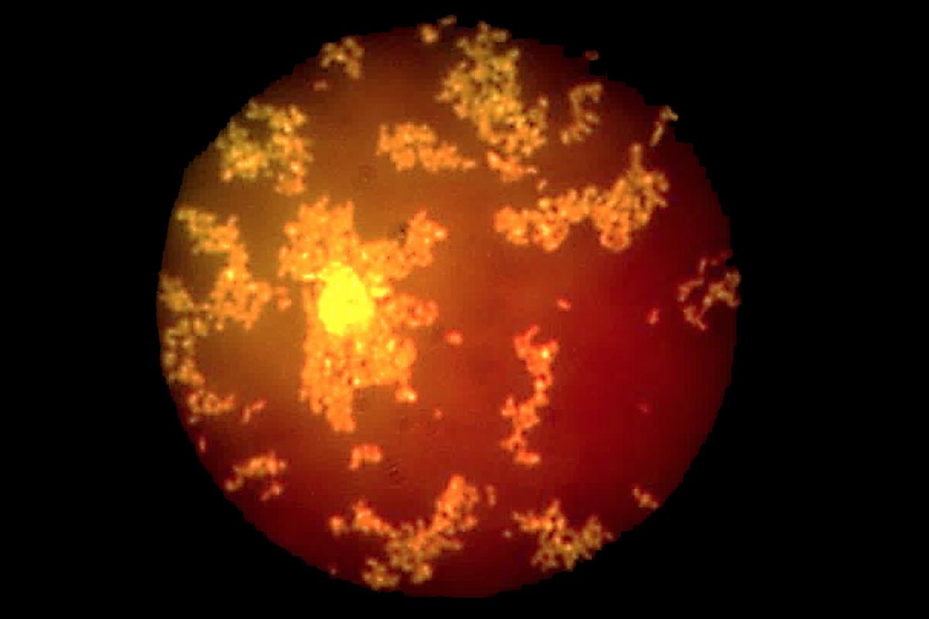

Ready for lift-off

Joung et al. Nature Communications

By **Sam Wong**

When water falls to the ground, bacteria take to the skies. High-speed camera footage has revealed how raindrops can disperse microbes from the soil into the air in tiny water droplets, possibly allowing them to travel long distances.

Bacteria and other microorganisms are [abundant in the atmosphere](https://www.newscientist.com/article/dn7217-detritus-of-life-abounds-in-the-atmosphere/), affecting the weather and  helping to spread diseases. We knew at least two ways they could get there: wind can lift them into the air from dry soil, and bursting bubbles can expel them from the ocean.

Splashing raindrops is now a third. <https://www.newscientist.com/article/2123762-raindrops-make-soil-bacteria-take-off-and-fly-through-air/>

## **Scientists use HPC to unearth new species in tropical rainforest soils**

*23 March 2017*

An international team of scientists, including researchers from [TU Kaiserslautern](https://www.uni-kl.de/en/home/), Heidelberg Institute for Theoretical Studies (HITS) and the [Karlsruhe Institute of Technology (KIT](http://www.kit.edu/english/index.php)) have unearthed new species of eukaryotic organisms in tropical rainforest soils using german supercomputer [SuperMUC](https://www.lrz.de/services/compute/supermuc/).

The researchers examined the presence and diversity of protist organisms in rainforest soils by analysing their DNA using SuperMUC which is housed at the Leibniz Rechenzentrum (LRZ) in Garching, Germany part of the [Gauss Centre for Supercomputin](http://www.gauss-centre.eu/gauss-centre/EN/Home/home_node.html)g. The research findings have recently published in a [paper](http://www.nature.com/articles/s41559-017-0091) entitled: ‘Parasites dominate hyperdiverse soil protist communities in Neotropical rainforests’ in the journal ‘[Nature Ecology and Evolution](http://www.nature.com/natecolevol/)’. <https://www.scientific-computing.com/news/scientists-use-hpc-unearth-new-species-tropical-rainforest-soils>

# **Dust helps regulate Sierra Nevada ecosystems, study finds**

##### 28 March 2017

[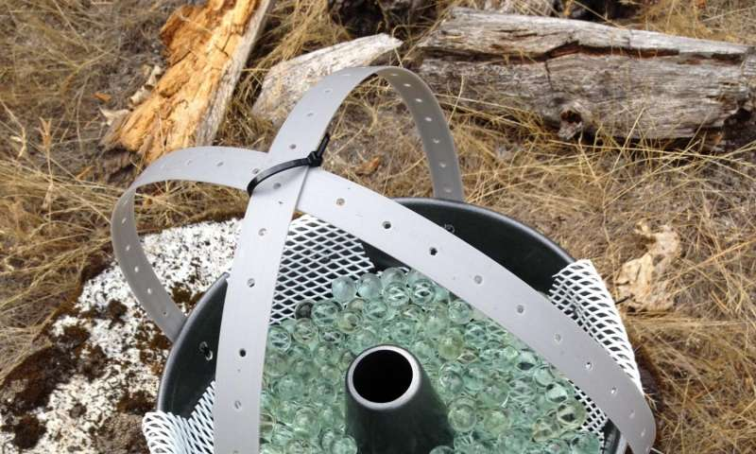](https://3c1703fe8d.site.internapcdn.net/newman/gfx/news/hires/2017/studydusthel.jpg)

Bundt cake pans filled with marbles are hoisted atop poles and left to collect dust in the Sierra Nevada so researchers can analyze the dust for microbes and vegetation-sustaining nutrients. Credit: Professor Stephen Hart

"Collecting dust" isn't usually considered a good thing

But [dust](https://phys.org/tags/dust/) from as near as the Central Valley and as far away as the Gobi Desert in Asia provides more nutrients—especially critical phosphorus—than previously thought to sustain the vegetation in the Sierra Nevada, a team of scientists has   
  
Read more at: <https://phys.org/news/2017-03-sierra-nevada-ecosystems.html#jCp>

**The Sahara Desert used to be green and lush. Then humans showed up.**

Jeremy Deaton

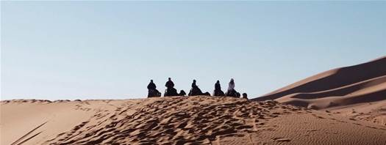

Today, the Sahara Desert is defined by undulating sand dunes, unforgiving sun, and oppressive heat. But just 10,000 years ago, it was lush and verdant. So, what spurred the shift from woodland to wasteland?

A [new study](http://journal.frontiersin.org/article/10.3389/feart.2017.00004/full?dom=pscau&src=syn) suggests humans played a big role. Author [David Wright](https://davidkwright.com/?dom=pscau&src=syn), an environmental archeologist at Seoul National University, says that as humans spread west from the Nile river 8,000 years ago, they brought with them sheep, cows, and goats that gobbled up, mowed down, and trampled over native vegetation. This transformed the landscape and altered the local climate.

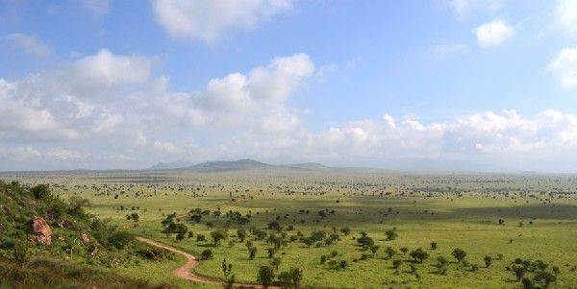

[Chris Cooper](https://commons.wikimedia.org/wiki/File:Savanna_towards_the_north-east_from_Lion_Rock_in_the_LUMO_Community_Wildlife_Sanctuary,_Kenya_2.jpg?dom=pscau&src=syn)

Today the Sahara is the largest hot desert in the world. Ten thousand years ago, it looked more like the African savanna, seen here. <http://www.popsci.com.au/science/nature/the-sahara-desert-used-to-be-green-and-lush-then-humans-showed160up,455666>

# **More than hundred years of flooding and erosion in one event**

##### 27 March 2017

[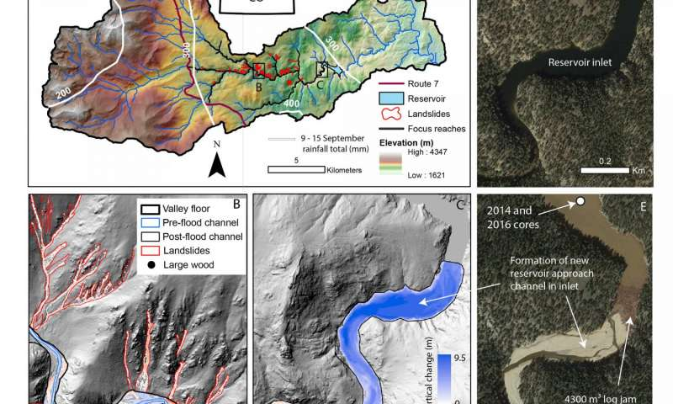](https://3c1703fe8d.site.internapcdn.net/newman/gfx/news/hires/2017/morethan100y.jpg)

Flood impacts in the North St. Vrain Creek catchment, northern Colorado, USA. Credit: Images in D and E are from Google Earth

Sara Rathburn of Colorado State University and colleagues have developed an integrated sediment, wood, and organic carbon budget for North St. Vrain Creek in the semi-arid Colorado Front Range following an extreme flooding event in September of 2013. Erosion of more than 500,000 cubic meters, or up to ~115-years-worth of weathering products, occurred through landsliding and channel erosion during this event.

Read more at: <https://phys.org/news/2017-03-years-erosion-event.html#jCp>

# **Basic microbiology research study unexpectedly uncovers practical findings for growers**

##### 27 March 2017

[](https://3c1703fe8d.site.internapcdn.net/newman/gfx/news/hires/2017/basicmicrobi.jpg)

*Phytobiomes*. Credit: The American Phytopathological Soceity

Cover cropping, or the practice of growing unharvested crops to protect and enrich the soil during off-season periods, is a promising approach to reducing some of the negative environmental impacts of production agriculture.

Read more at: <https://phys.org/news/2017-03-basic-microbiology-unexpectedly-uncovers-growers.html#jCp>

# **Take an integrated approach to salinity management**

[[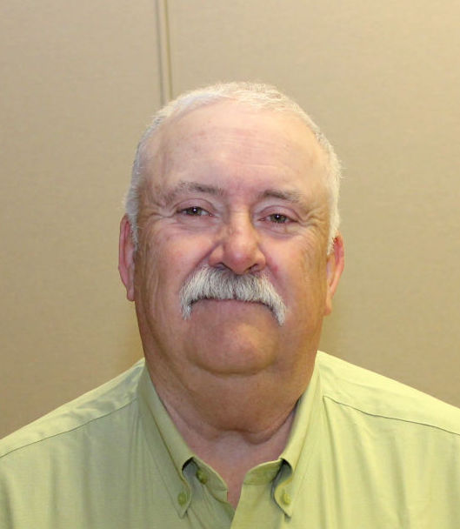](http://www.hpj.com/content/tncms/live/#1)](http://www.hpj.com/content/tncms/live/" \l "1)

Don Miller

prev

next

Bottom of Form

Wherever alfalfa fields are irrigated or sub-irrigated, the potential for salinity exists. “Anytime water comes out of the ground it picks up salts,” said Don Miller, director of product development for Alforex Seeds. Miller presented information on salinity at all three stops of the 2017 Alfalfa U tour in Grand Island, Nebraska; Dodge City, Kansas; and Twin Falls, Idaho.

Saline, or marginal soils, refers to dissolved salts, variations in pH or sodium levels that affect the drainage of that soil. Saline soils have high levels of dissolved salts above 4 electrical conductivity, known as EC, alkaline soils have a pH above 8.5, and alkali soils have sodium levels above 15 percent. <http://www.hpj.com/rich/take-an-integrated-approach-to-salinity-management/article_ad27a72c-470a-54cd-98fa-0f3fff82a422.html>

# **NASA examines the rainfall left behind from ex-Tropical Cyclone Debbie**

##### 30 March 2017

[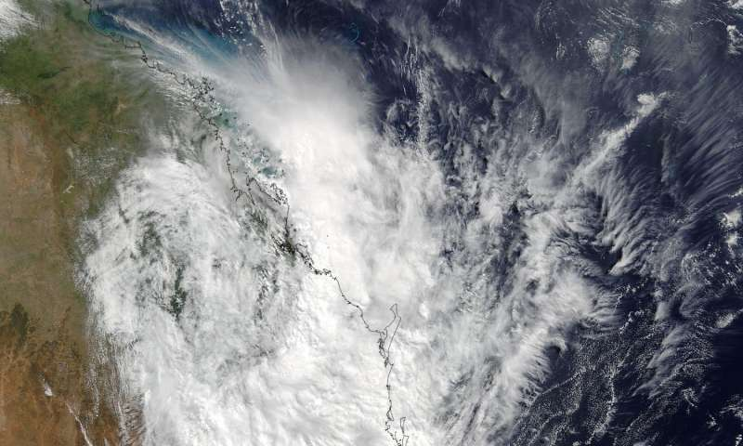](https://3c1703fe8d.site.internapcdn.net/newman/gfx/news/hires/2017/7-nasaexamines.jpg)

The MODIS instrument aboard NASA's Terra satellite captured this visible image of the remnants of Tropical Cyclone Debbie over eastern Australia on March 30 at 0000 UTC (Mar. 29 at 8 p.m. EST). Credit: NASA Goddard MODIS Rapid Response Team

Tropical Cyclone Debbie generated a lot of rainfall before and after it made landfall in Queensland, Australia, and NASA analyzed how much rain fell from a vantage point of space. NASA's Terra satellite provided a look at the remnants early on March 30 is it lingered near Australia's Gold Coast.

Read more at: <https://phys.org/news/2017-03-nasa-rainfall-left-ex-tropical-cyclone.html#jCp>

# Mice were in the house way before the dawn of farming

## Mice were hanging out with humans thousands of years earlier than the advent of agriculture. **Andrew Masterson** reports.

[Share](https://cosmosmagazine.com/archaeology/mice-were-in-the-house-way-before-the-dawn-of-farming?utm_source=Today+in+Cosmos+Magazine&utm_campaign=1abe0d7daf-RSS_EMAIL&utm_medium=email&utm_term=0_5f4ec2b124-1abe0d7daf-179982353#facebook-share)

[Tweet](https://cosmosmagazine.com/archaeology/mice-were-in-the-house-way-before-the-dawn-of-farming?utm_source=Today+in+Cosmos+Magazine&utm_campaign=1abe0d7daf-RSS_EMAIL&utm_medium=email&utm_term=0_5f4ec2b124-1abe0d7daf-179982353#twitter-tweet)



The house mouse: raiding human food supplies for at least 15,000 years.

Getty Images

**Mice are nothing if not early adopters**, new research shows. A study led by archaeologist Thomas Cucchi of the University of Haifa in Israel has discovered that mice were hanging around human settlements as long as 3000 years before the advent of agriculture.

<https://cosmosmagazine.com/archaeology/mice-were-in-the-house-way-before-the-dawn-of-farming?utm_source=Today+in+Cosmos+Magazine&utm_campaign=1abe0d7daf-RSS_EMAIL&utm_medium=email&utm_term=0_5f4ec2b124-1abe0d7daf-179982353>

# **Massive, computer-analyzed geological database reveals chemistry of ancient ocean**

##### 30 March 2017 by David Tenenbaum

[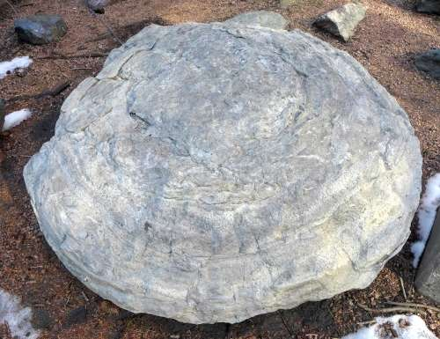](https://3c1703fe8d.site.internapcdn.net/newman/gfx/news/hires/2017/1-massivecompu.jpg)

A stromatolite from Northern Wisconsin in the courtyard of Weeks Hall on the UW–Madison campus. Credit: David Tenenbaum

A study that used a new digital library and machine reading system to suck the factual marrow from millions of geologic publications dating back decades has unraveled a longstanding mystery of ancient life: Why did easy-to-see and once-common structures called stromatolites essentially cease forming over the long arc of earth history?

Read more at: <https://phys.org/news/2017-03-massive-computer-analyzed-geological-database-reveals.html#jCp>

# **A seismic mapping milestone**

##### 28 March 2017

[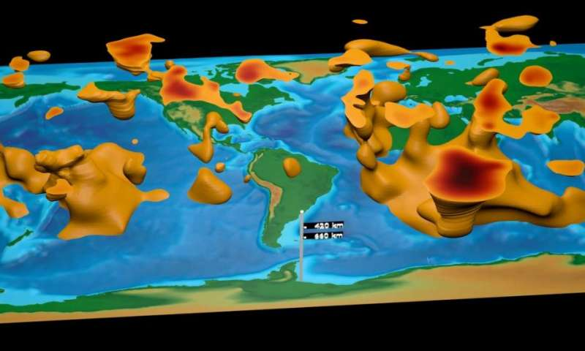](https://3c1703fe8d.site.internapcdn.net/newman/gfx/news/hires/2017/aseismicmapp.jpg)

This visualization is the first global tomographic model constructed based on adjoint tomography, an iterative full-waveform inversion technique. The model is a result of data from 253 earthquakes and 15 conjugate gradient iterations with transverse isotropy confined to the upper mantle. Credit: David Pugmire, ORNL

Because of Earth's layered composition, scientists have often compared the basic arrangement of its interior to that of an onion. There's the familiar thin crust of continents and ocean floors; the thick mantle of hot, semisolid rock; the molten metal outer core; and the solid iron inner core. <https://phys.org/news/2017-03-seismic-milestone.html>

# **Kaikoura quake may prompt rethink of earthquake hazard models internationally**

##### 24 March 2017

[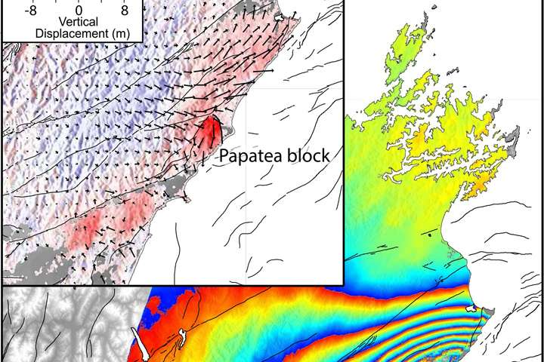](https://3c1703fe8d.site.internapcdn.net/newman/gfx/news/2017/kaikouraquak.jpg)

Credit: GNS Science

Last November's magnitude 7.8 Kaikoura earthquake was so complex and unusual that it is likely to lead to changes in the way scientists think about earthquake hazards in plate boundary zones worldwide, a new study says.

Read more at: <https://phys.org/news/2017-03-kaikoura-quake-prompt-rethink-earthquake.html#jCp>

# **Researcher weighs in on fairy circles of Namibia**

##### 28 March 2017

[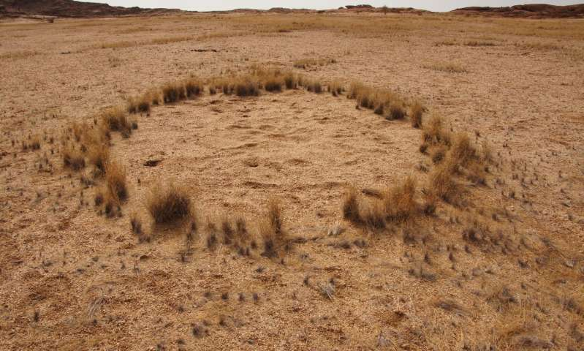](https://3c1703fe8d.site.internapcdn.net/newman/gfx/news/hires/2017/iupuiresearc.jpg)

A fairy ring in Namibia. Credit: School of Science

A study conducted by researchers at Indiana University-Purdue University Indianapolis adds new insights into one of nature's great mysteries: the fairy circles of Namibia.

Numbering in the millions, the so-called fairy circles are in the eastern, interior margin of the coastal Namib Desert, stretching from southern Angola to northern South Africa. They range in size from about 12 feet to about 114 feet, consisting of bare patches of soil surrounded by rings of grass. The origins of the circles have long been debated by researchers.

There is more than solving a mystery at stake. Analysis on the formation, structure and growth of vegetation patterns and their interactions with Earth's water cycle can improve our understanding of important processes underlying the dynamics of water-limited ecosystems, said IUPUI researcher Lixin Wang.

Read more at: <https://phys.org/news/2017-03-fairy-circles-namibia.html#jCp>

 **"We speak a lot of the importance of sustainable food systems for healthy lives. Well, it starts with soils."** **José Graziano da Silva, FAO Director-General**