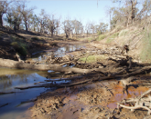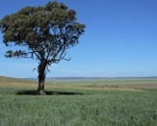

**Can greenhouse gas emissions from organic soils be decreased?**

Published: 27 April 2017

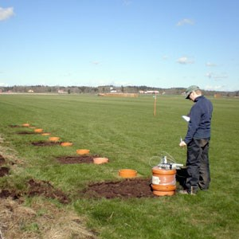

Lisbet Norberg measures carbon dioxide emissions from drained peatland cultivated with grass. Photo: Kerstin Berglund.

Lisbet Norberg has assessed greenhouse gas emissions from drained peatlands and carbon-rich soil in a new doctoral thesis. She found great variations in emissions between and within sites and over time. The results are important to consider in management plans for peat soils.

In the mid-19th century peatlands were drained for agricultural purposes. Today, climate change is a major concern and <http://www.slu.se/en/ew-news/2017/4/can-greenhouse-gas-emissions-from-organic-soils-be-decreased/>

**Northern Territory Government announces $10 million to map soils and water for development**

**[ABC Rural](http://www.abc.net.au/news/rural/" \o "ABC Rural)**

By [Lydia Burton](http://www.abc.net.au/news/rural/burton-lydia/5366136)

Posted 11 April 2017 at 2:05 pm

[[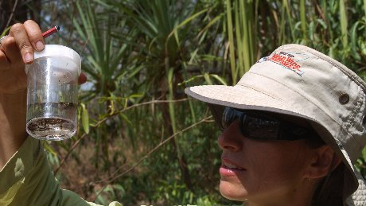](http://www.abc.net.au/news/rural/2017-04-11/northern-territory-soil-water-study-funding-agriculture-land/8433884#lightbox-content-lightbox-6)](http://www.abc.net.au/news/rural/2017-04-11/northern-territory-soil-water-study-funding-agriculture-land/8433884" \l "lightbox-content-lightbox-6" \o "Open lightbox)

[The NT Government has announced soil and water studies in prospective areas for development.](http://www.abc.net.au/news/rural/2017-04-11/northern-territory-soil-water-study-funding-agriculture-land/8433884" \l "lightbox-content-lightbox-6" \o "Open lightbox)

(Supplied: Jenni Metcalfe)

The Northern Territory Government has announced almost $10 million ahead of this year's budget for scientific works to identify key areas for agricultural and regional development.

The five-year project, Mapping the Future, will support soil, water, vegetation and biodiversity surveys of potentially productive lands.

It follows a similar $15 million study in northern Australia, funded by the Federal Government, [currently being undertaken by the CSIRO](http://www.abc.net.au/news/2016-12-18/scientists-dig-up-the-dirt-on-northern-australia/8124142) into areas around the Finniss, Adelaide, Mary and Wildman river basins in the Top End. <http://www.abc.net.au/news/rural/2017-04-11/northern-territory-soil-water-study-funding-agriculture-land/8433884>

# Shunned by microbes, organic carbon can resist breakdown in underground environments

##### 1 May 2017

[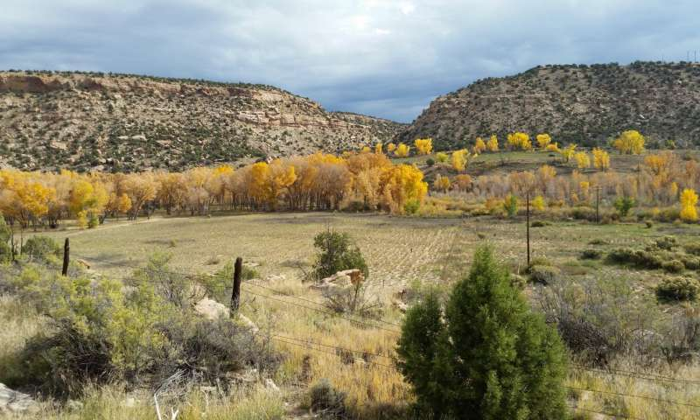](https://3c1703fe8d.site.internapcdn.net/newman/gfx/news/hires/2017/shunnedbymic.jpg)

A new study uncovered a previously unknown mechanism that explains why microbes sometimes fail to break down buried plant and animal matter. Above, the field site in the floodplains in the upper Colorado River Basin where soil samples were taken. Credit:John Bargar

The soils and sediments beneath our feet can contain an astonishing amount of carbon—more than in all of the world's plants and the atmosphere combined—and represents a significant potential source of the greenhouse gas carbon dioxide.

Read more at: <https://phys.org/news/2017-05-shunned-microbes-carbon-resist-breakdown.html#jCp>

# A new interpretation of petrogenesis of Earth's early continental crust

##### 1 May 2017

[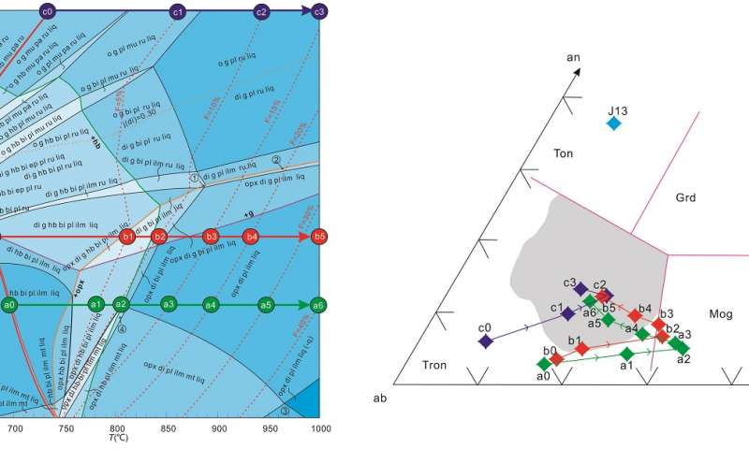](https://3c1703fe8d.site.internapcdn.net/newman/gfx/news/hires/2017/anewinterpre.jpg)

The left figure shows the P-T pseudosection calculated for the representative tonalitic sample (J13). The melt compositions simulated for three isobaric melting processes under high, medium and low pressure conditions are presented in the …more

The Earth's continental crust was mainly formed in the Archean period, ~2.5 to 4.0 billion years ago, and is chiefly composed of tonalite, trondhjemite and granodiorite (TTG rocks). These three kinds of rock preserve pivotal information of the formation and evolution of early continental crust. Study on the petrogenesis of TTG rocks can elucidate the tectonic regimes of the early Earth. A recent study using a quantitative phase modeling approach to document the partial melting process of tonalitic gneiss presents an innovative viewpoint of petrogenesis of Archean trondhjemite in the Eastern Hebei, China.

Read more at: <https://phys.org/news/2017-05-petrogenesis-earth-early-continental-crust.html#jCp>

**Scientists Make Sturdy Bricks From Mars-Like Soils**

**Their findings may be a step forward in the mission to build structures on the Red Planet**

By [Brigit Katz](http://www.smithsonianmag.com/author/brigit-katz/)

smithsonian.com   
1 May 2017 6:00AM

One of the many hurdles standing in the way of a manned mission to Mars is the question of how to build structures on the Red Planet. Transporting all of the materials necessary for space construction would be absurdly expensive, so scientists have proposed a number of alternatives that rely on Martian resources, such as setting up a nuclear-powered kiln, or turning organic compounds on Mars into binding polymers. But a team of scientists at the University of California, San Diego may have (literally) hit upon a much simpler solution: take some Martian soil and squeeze.

In a new study published in the journal [*Scientific Reports*](https://www.nature.com/articles/s41598-017-01157-w)*,* researchers say that they were able to create solid bricks by smacking Mars-like soils with a high-pressure hammer, Loren Grush writes for [*The Verge*](http://www.theverge.com/2017/4/27/15436154/mars-soil-simulant-study-building-human-missions)*.* “Mars-1a,” as the soil simulant is called, is derived from rocks that have the same chemical makeup as Martian soils, along with grains of a similar shape and size. <http://www.smithsonianmag.com/smart-news/scientists-make-sturdy-bricks-mars-soils-180963077/>

# Rock samples indicate water is key ingredient for crust formation

##### 1 May 2017

[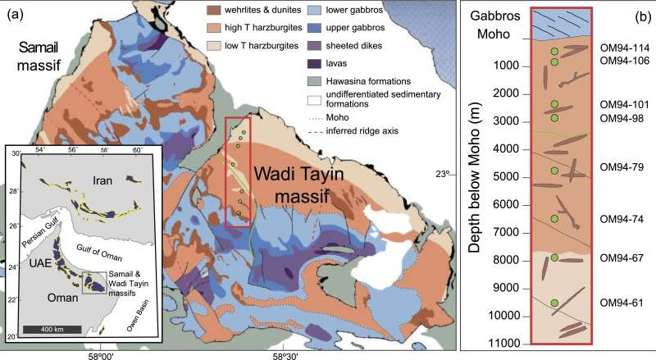](https://3c1703fe8d.site.internapcdn.net/newman/gfx/news/hires/2017/rocksamplesi.jpg)

A geologic map of the Wadi Tayin massif, Samail ophiolite. Credit: Modified from Hanghøj et al. (2010), and Nicolas et al. (2001).

By examining the cooling rate of rocks that formed more than 10 miles beneath the Earth's surface, scientists led by The University of Texas at Austin Jackson School of Geosciences have found that water probably penetrates deep into the crust and upper mantle at mid-ocean spreading zones, the places where new crust is made. The finding adds evidence to one side of a long-standing debate on how magma from the Earth's mantle cools to form the lower layers of crust.

# Read more at: <https://phys.org/news/2017-05-samples-key-ingredient-crust-formation.html#jCp>

# Dry soils and residual herbicides

Herbicide effectiveness can be significantly reduced when a soil-applied herbicide is sprayed on a dry soil surface with no precipitation or mechanical incorporation for several days following application.

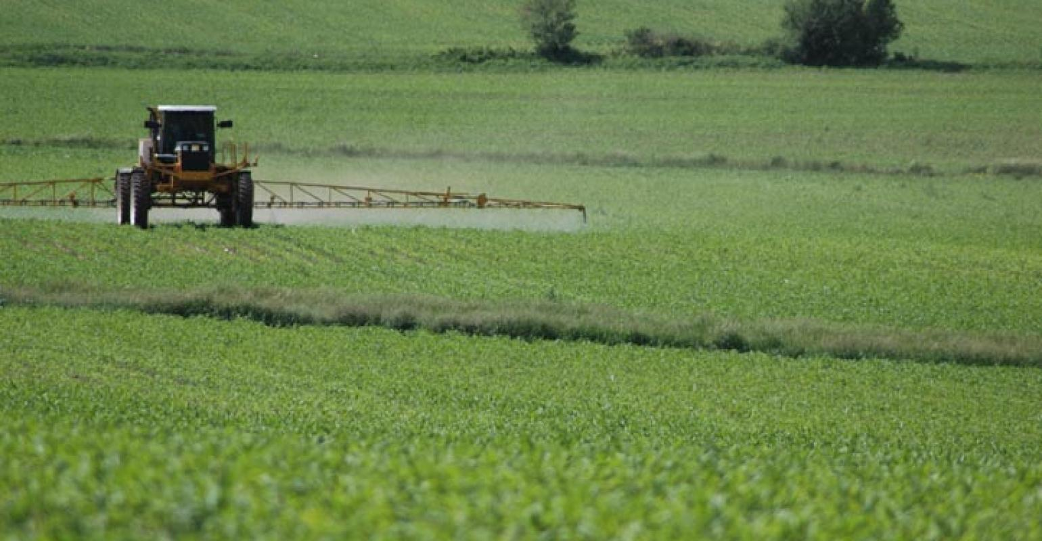

[Crop Protection](http://www.cornandsoybeandigest.com/crop-protection)>[**Herbicide**](http://www.cornandsoybeandigest.com/crop-protection/herbicide)

Decades ago it was very common for the majority of corn and soybean acres in Illinois to be treated with one or more soil-residual herbicides before crop/weed emergence. During the 1980s, commercialization of broad-spectrum, postemergence herbicides began the shift away from widespread use of soil-residual herbicides; products such as Basagran, Classic, Accent and Pursuit contributed to the early adoption of postemergence weed control programs. <http://www.cornandsoybeandigest.com/herbicide/dry-soils-and-residual-herbicides>

**Terroir And The Science of Taste**

06 April 2017

*Terroir*. A word synonymous with wine and one we have become more familiar with in recent years through discussions on cheese, chocolate, coffee and tea to name a few. Simply put, terroir can be described as the complete natural environment in which a product is grown. The categories that make up terroir are numerous (latitude, altitude, biodiversity, local ecosystem, water etc.) and for us as tea merchants many hours are spent in gardens around the world observing, questioning, learning and tasting how the environment the tea has grown in and the decisions made during cultivation impact the final flavour in our cup. Last year having returned from our travels, we found ourselves continually returning to one particular topic - soil.

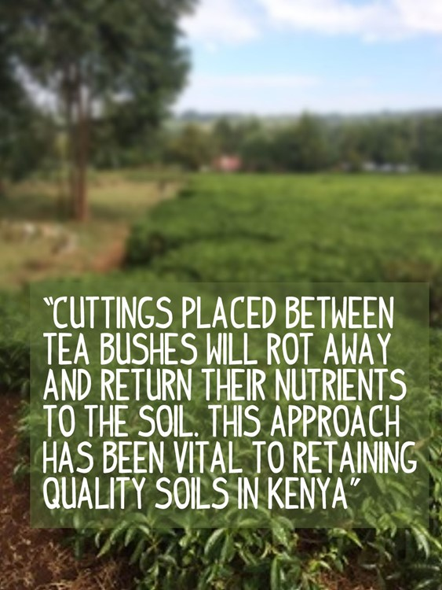

<https://www.soilassociation.org/blogs/2017/april/terroir-and-the-science-of-taste/?count=31>

# No bones? No problem: DNA left in cave soils can reveal ancient human occupants

By [**Lizzie Wade**](http://www.sciencemag.org/author/lizzie-wade) 27 Apr. 2017, 2:00 PM



Matthias Meyer, shown working in a clean room, helped find a way to fish out human DNA from ancient soils.

Max Planck Institute for Evolutionary Anthropology

Fifty thousand years ago, a Neandertal relieved himself in a cave in present-day Belgium, depositing, among other things, a sample of his DNA. The urine clung to minerals in the soil and the feces eventually decomposed. But traces of the DNA remained, embedded in the cave floor, where earth falling from the cave’s ceiling and blowing in from outside eventually entombed it. Now, researchers have shown they can find and identify such genetic traces of both Neandertals and Denisovans, another type of  archaic human, enabling them to test for the presence of ancient humans even in sites where no bones have been found. <http://www.sciencemag.org/news/2017/04/no-bones-no-problem-dna-left-cave-soils-can-reveal-ancient-human-occupants>

# High-clay soils may be hidden carbon sink

Deep soils may play prominent role in mitigating climate change and compensating for some of agriculture's greenhouse gas emissions.

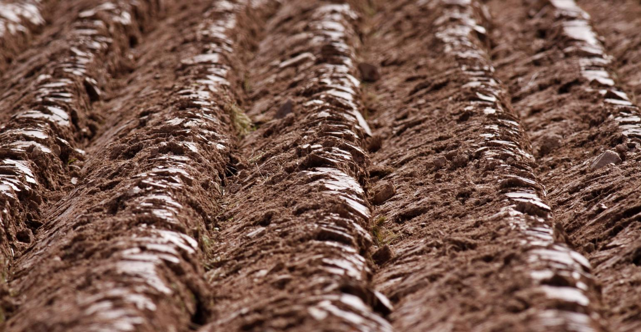

Research on grasslands in Ireland, supervised by professor Gary Lanigan with Teagasc — the Irish Agriculture & Food Development Authority — and professors Rachel Creamer and Rogier Schulte with Wageningen University & Research has revealed that soils with high clay content in deeper layers lock away carbon for much longer and at a much greater depth than previously known.

Publishing their results in Nature Scientific Reports, the authors demonstrated how t

<http://www.feedstuffs.com/news/high-clay-soils-may-be-hidden-carbon-sink>

**Grass control warning in moist soils**

24 Apr 2017, 4:52 p.m.

GRAINGROWERS are being urged to be mindful that early sowing under wet, warm conditions can reduce the length of efficacy of pre-emergent herbicides.

GRAINGROWERS are being urged to be mindful that early sowing under wet, warm conditions can reduce the length of efficacy of pre-emergent herbicides.

The warning comes on the back of a trial conducted by the WA No-Tillage Farmers Association (WANTFA) and funded by the Grains Research and Development Corporation (GRDC), investigating the breakdown of pre-emergent herbicides over time.

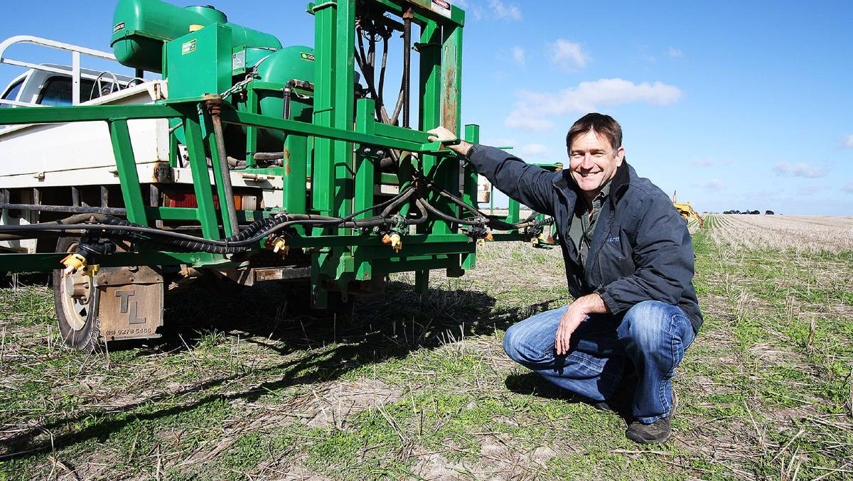

WANTFA executive director David Minkey says the message from the trial was not to rely on pre-emergent herbicides to provide adequate control.

The trial results were presented at a GRDC Crop Updates.

WANTFA executive director David Minkey said they suspected certain chemicals decayed faster under particular conditions, but the trial results exceeded his expectations. <http://www.avonadvocate.com.au/story/4618222/grass-control-warning-in-warm-moist-soils/>

Top of Form



# Top 5 Under 40

[](https://www.unsw.edu.au/)



**Are you a young scientist with a flair and passion for communicating your research?**

UNSW and ABC RN have teamed up again for **Top 5 Under 40**, an exciting initiative to discover Australia's next generation of science communicators and give them a voice.

Applications are now open for outstanding early-career researchers under 40 who are working in Australian universities and research organisations across science, technology, engineering, mathematics and medical research.

Following this call out, the 10 most promising science communicators will be shortlisted for interview by a panel of judges. The winners will be announced on RN Breakfast in June.

In July, the Top 5 will undertake a two-week media residency in Sydney at RN, the ABC's national ideas network, supported by UNSW, one of Australia's leading universities.

**2017 Key dates and FAQs  
  
Applications open**: Friday 10 March  
**Applications close**: Friday 21 April (midnight)  
**Judging panel for 10 shortlisted applicants**: Tuesday 30 May  
**Top 5 winners announced**: Thursday 8 June  
**Media residency at ABC RN in Sydney**: Monday 3 July - Friday 14 July

<https://www.unsw.edu.au/top5under40>

# Australian volcanic eruption may have lived on in Aboriginal stories

##### 28 April 2017

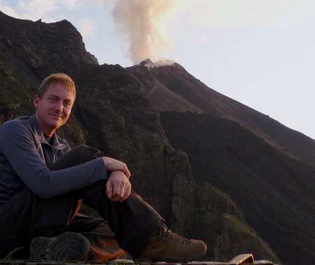

Dr Benjamin Cohen. Credit: University of Glasgow

New research shows that a volcano in northeastern Australia last erupted around 7000 years ago – and stories passed down by the Gugu Badhun Aboriginal people suggest they were there to see it happen.

Read more at: <https://phys.org/news/2017-04-australian-volcanic-eruption-aboriginal-stories.html#jCp>

**Why Does Soil Smell So Good in Spring?**

20 April 2017

**Who doesn't love the fresh "earth" smell after the rain? Most of us appreciate that perfume, but do you know what's behind the pleasant smell?**

Get in your garden after a spring rain, dig up some of its soil and give it a big sniff. Can you smell an “earthy” distinctive and refreshing aroma? If you can, that’s good. It means that your soil is fertile and hosts an abundance of microorganisms.



<https://www.soilassociation.org/blogs/2017/april/soilsmell/?count=13>

# Earthworms Work Wonders for Soils

Posted by Sandra Avant, Public Affairs Specialist, Agricultural Research Service in [Research and Science](https://www.usda.gov/media/blog/category/research-and-science)

21 April 2017

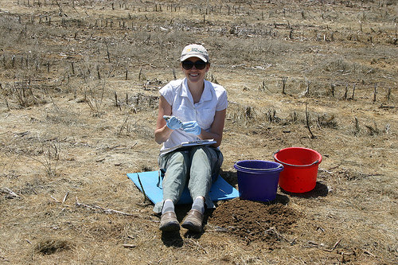

Soil scientist Amanda Ashworth doing field research. Earthworms are an important part of maintaining healthy soil.

Think earthworms are only good for fish bait? Think again! Earthworms play a valuable role in soil health and viability in forests, prairies, gardens and even on farmland.

Earth Day is a good time to recognize earthworms as environmental helpers. They feed primarily on organic material in soils, eating fresh and decaying material from plant roots, including crops like corn and soybeans. As they feed, they move and mix their waste with the soil in a moist, microbe-rich environment. Earthworm tunnels bring in oxygen, drain water and create space for plant roots. Their natural feeding habits mean that small amounts of soil pass through their bodies and, surprisingly, when they excrete it, it is in better condition—what goes in comes out much better! <https://www.usda.gov/media/blog/2017/04/21/earthworms-work-wonders-soils>

# Five Signs You Might Be the Perfect 'Soil Mate'

Posted by Ron Nichols, NRCS in [Conservation](https://www.usda.gov/media/blog/category/conservation)

There’s a whole new generation of “soil mates” working to unlock the secrets in the soil.

The [hope in healthy soil](https://www.nrcs.usda.gov/wps/portal/nrcs/detail/national/soils/health/?cid=nrcseprd755006) is taking root across America.

Farmers, ranchers, researchers, conservationists, non-profit organizations, foodies and others are all working to help regenerate our working lands by improving the health of function of our nation’s soil. So inspired by what they’re learning about the hope in healthy soil, there’s a whole new generation of “soil mates” working to [unlock the secrets in the soil](https://www.nrcs.usda.gov/wps/portal/nrcs/main/national/soils/health/).

Here are five signs you might be one of them:

1. When you drive by a freshly plowed field, you feel sad knowing that the habitat for trillions upon trillions of [soil microbes](https://www.nrcs.usda.gov/wps/portal/nrcs/detail/national/soils/health/?cid=stelprdb1143204) is being disrupted—and […]<https://www.usda.gov/media/blog/2017/02/13/five-signs-you-might-be-perfect-soil-mate>

# Martian landscape created by two distinct asteroid epochs

## NASA-backed study shows a 400 million year gap in impact activity. Tim Wallace reports.

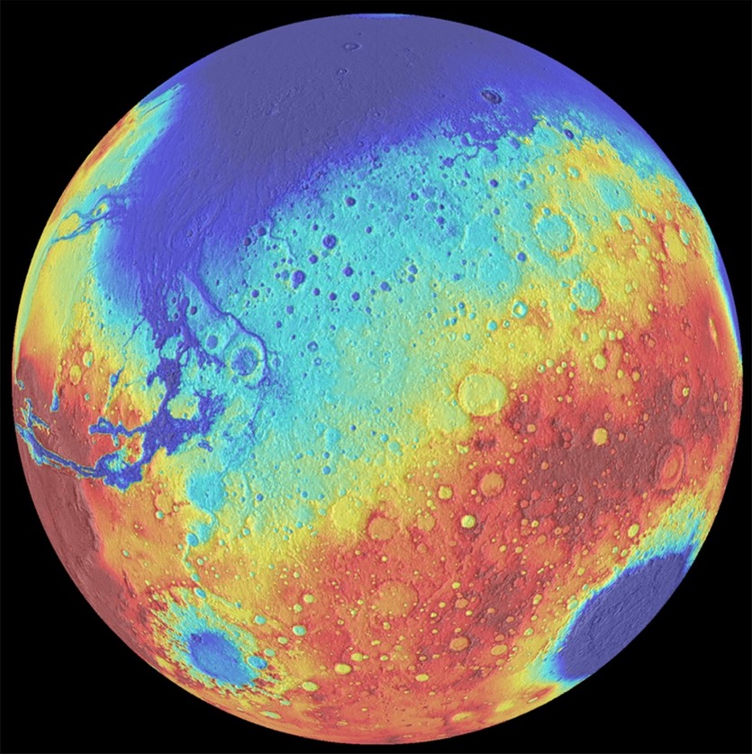

Major impacts on the Martian surface include the ancient giant Borealis basin (top of globe), Hellas (bottom right), and Argyre (bottom left).There appears to have been a 400-million-year lull in impacts between the formation of Borealis and the younger basins.

University of Arizona/LPL/Southwest Research Institute

**It’s magnitude, and infrequency that counts in explaining how asteroid impacts shaped Mars**, with new research dramatically revising down the number of giant asteroids that crashed into the Red Planet to just one-tenth of some previous estimates.

<https://cosmosmagazine.com/space/martian-landscape-created-by-two-distinct-asteroid-epochs?utm_source=Today+in+Cosmos+Magazine&utm_campaign=00b8fb139b-RSS_EMAIL&utm_medium=email&utm_term=0_5f4ec2b124-00b8fb139b-179982353>

# “Healthy Soils Are Full of Life” School Poster Contest Winners Are Announced

CULDESAC, ID - The Nez Perce County Soil and Water Conservation District has chosen this year’s top 10 poster contest winners. The District received over 500 submissions from area 5th and 6th graders that illustrated the theme, “Healthy Soils Are Full of Life.”

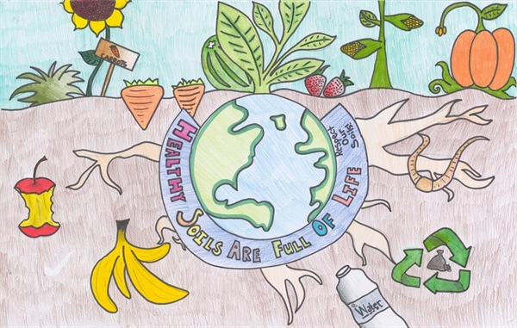

[Mia Carlson](https://lcvalley.dailyfly.com/Home/PID/1352/authorid/101/AuthorName/Mia-Carlson) / Wednesday, 26 April 2017

Schools from Clarkston, Asotin, Lewiston, and Culdesac participated, with 1st place going to Jocelyn Lemanski of Camelot Elementary.

From NPC Soil and Water Conservation District: <https://lcvalley.dailyfly.com/Home/ArtMID/1352/ArticleID/46617/%E2%80%9CHealthy-Soils-Are-Full-of-Life%E2%80%9D-School-Poster-Contest-Winners-Are-Announced>

# New England's glacial upland soils provide major groundwater storage reservoir

##### 11 April 2017 by Janet Lathrop

[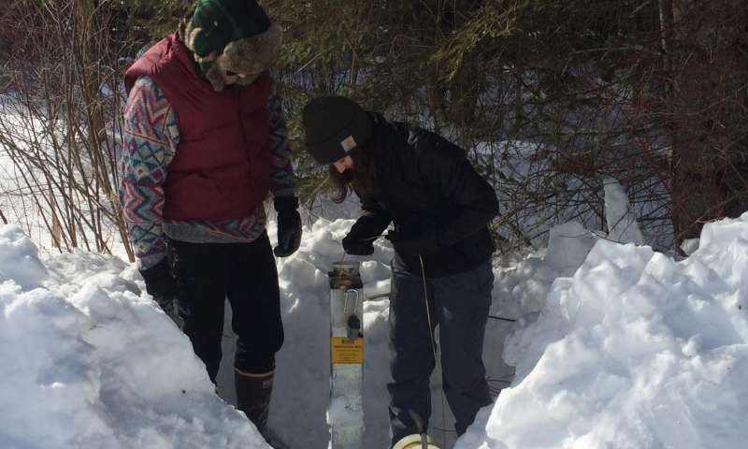](https://3c1703fe8d.site.internapcdn.net/newman/gfx/news/hires/2017/newenglandsg.jpg)

At left, Seth Oliver with Leah Santangelo, right, both hydrogeology UMass Amherst graduates, taking water level measurements at a till site in Blandford, Mass., for a recent study of natural groundwater storage reservoirs in New England by …more

A recent study of natural groundwater storage reservoirs in New England by hydrologist David Boutt at the University of Massachusetts Amherst found that upland aquifer systems dominated by thin deposits of surface till - a jumbled, unsorted material deposited by glaciers - make up about 70 percent of the active and dynamic storage for the region.

Read more at: <https://phys.org/news/2017-04-england-glacial-upland-soils-major.html#jCp>

# East Africa: Volcanic Soils Causing Elephantiasis in Kamwenge, New Study Suggest

By Zurah Nakabugo

Podoconiosis elephantiasis outbreak has been confirmed in Kamwenge district and other parts of western Uganda after a new study by the ministry of Health and World Health Organisation (WHO).

Since 2015, ministry of health received reports on cases of people suffering from podoconiosis elephantiasis, characterised by severe swelling in the limbs, yet Kamwenge was not affected or at risk of the disease. <http://allafrica.com/stories/201704190693.html>

# Fire recovery tips target fragile soils

#### **Stories from Headlines Network**

Recovering from wildfire relies on many of the same resource management principles and strategies applicable to any producer forced to contend with fragile, depleted or drought-damaged soils.

By Candace Krebs / Contributing Writer

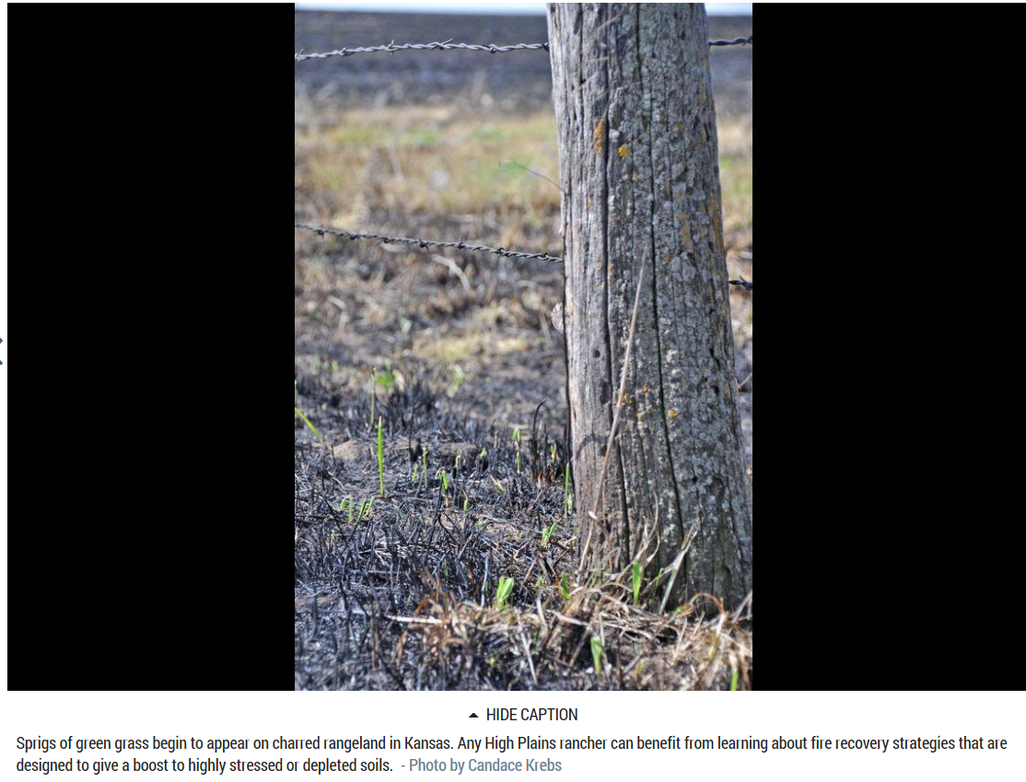

Recovering from wildfire relies on many of the same resource management principles and strategies applicable to any producer forced to contend with fragile, depleted or drought-damaged soils.

<http://www.lajuntatribunedemocrat.com/news/20170421/fire-recovery-tips-target-fragile-soils>

# New light on how tsunamis form

## Latest research shows earlier experiments on how earthquakes sparked tsunamis were flawed.

[Tweet](https://cosmosmagazine.com/geoscience/new-light-on-how-tsunamis-form?utm_source=Today+in+Cosmos+Magazine&utm_campaign=00b8fb139b-RSS_EMAIL&utm_medium=email&utm_term=0_5f4ec2b124-00b8fb139b-179982353#twitter-tweet)

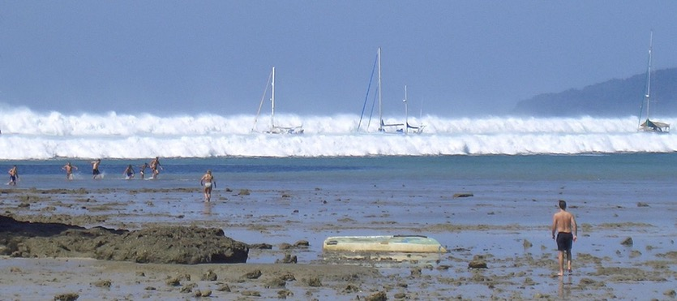

Tsunami waves arrive at Hat Rai Lay Beach, near Krabi in southern Thailand, on 26 December 2004.

AFP/Getty Images

**What causes a tsunami? We thought we knew.** The energy from a massive uplift of the seafloor caused by subduction – where one tectonic plate slides under another – during an earthquake transmits the force to the water above. Right? Well maybe not.

That understanding that the upwards movement of the seafloor was the cause of tsunamis was the result of 1970s wave tank experiments. The theory was reinforced when Japanese scientists later simulated horizontal seafloor displacements in a wave tank and found negligible energy transfers. <https://cosmosmagazine.com/geoscience/new-light-on-how-tsunamis-form?utm_source=Today+in+Cosmos+Magazine&utm_campaign=00b8fb139b-RSS_EMAIL&utm_medium=email&utm_term=0_5f4ec2b124-00b8fb139b-179982353>

# Producers waiting for soils to warm

Bottom of Form

For the week ending April 9, temperatures warmed later in the week and averaged 4 degrees above normal, according to USDA’s National Agricultural Statistics Service, Northern Plains Regional Field Office, Nebraska. Rainfall was limited in most areas except for portions of north central, northeast, and extreme southeast Nebraska where totals of an inch or more were recorded. Fieldwork was limited to spring tillage and fertilizer application, as producers waited for soils to warm. There were 4.8 days suitable for fieldwork. Topsoil moisture supplies rated 5 percent very short, 21 short, 70 adequate, and 4 surplus. Subsoil moisture supplies rated 8 percent very short, 25 short, 65 adequate, and 2 surplus. <http://www.hpj.com/crops/producers-waiting-for-soils-to-warm/article_6ddf0c2a-f3d4-534f-a303-af8f5985aaa9.html>



<https://unacademy.com/lesson/soils-of-india/0V7XBPU5>

# Keep Earth's soils healthy to feed world's growing population: NGO|

By

**RREUTERS**

22 | April 2017



A picture of smiling face made of rice plants is seen at a paddy field in Xianju county, Zhejiang province, August 27, 2015. Photo: courtesy REUTERS

**ROME: Feeding a growing global population will become almost impossible if the world doesn't take better care of its rapidly deteriorating soils, a humanitarian agency warned on Earth Day.**

More than a third of arable land is already degraded because of soil erosion - the loss of the topsoil by wind, rain or use of machinery - as well as contamination of soil and city sprawl, according to Catholic Relief Services (CRS).

"If we don't start to address the issue of soil erosion I don't see how we can address the food security needs," Lori Pearson, an agricultural adviser at CRS told the Thomson Reuters Foundation. <https://www.geo.tv/latest/139100-Keep-Earths-soils-healthy-to-feed-worlds-growing-population-NGO>

**Is Your Urban Soil Polluted?**

20 April 2017

**Urban gardening gives people access to fresh fruits and vegetables. But the soil in cities may be contaminated, having a negative impact on our health. How can you protect your soil from air pollution?**

If we want to eat better, we need to [feed ourselves better](https://www.soilassociation.org/better-food/). And [growing our own organic](https://www.soilassociation.org/farmers-growers/supporting-you/future-growers/why-become-a-future-grower/) [food](https://www.soilassociation.org/better-food/transforming-the-way-we-farm/future-growers/) could be a partial solution to that. But if you live in a city [growing food in the asphalt jungle](https://www.soilassociation.org/blogs/2017/february/alice-holden-growing-for-the-future/) can be tricky, because urban soil can be contaminated with chemicals from years of intense industrial activity. And if the soil is contaminated, home-grown vegetables and fruits may become polluted too.

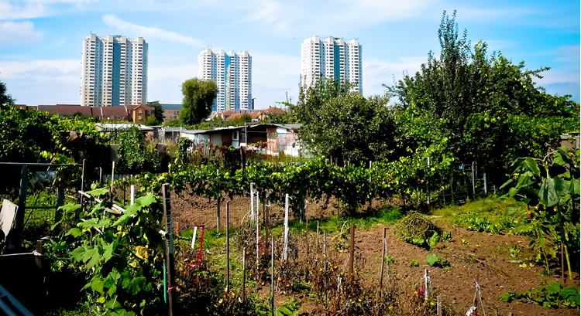

All soils contain a variety of chemicals which are naturally present, such as metals, phosphates, nitrates, lipids, proteins, etc. But when the amounts of these components exceed natural levels (what is naturally present in the soil), pollution is generated. <https://www.soilassociation.org/blogs/2017/april/soilpollution/?count=13>

# Corn with a cover of grass

The phrase “a double-edged sword” describes something that is beneficial in some ways but problematic in others. One example is removing maize stover (the husks, stems and leaves of corn plants) from fields. Maize stover is used to make cellulosic ethanol, a renewable biofuel. And renewable biofuels are beneficial to the environment. However, removing the stover can harm the environment because it can cause the soil to erode and lose nutrients.



A perennial grass cover planted alongside maize is part of research to find the best way to protect fields from erosion. Photo credit Cynthia Bartel.

Taking up this double-edged sword is Cynthia Bartel, a doctoral candidate at Iowa State University. She’s finding a way to lessen the harm and increase the benefits of removing maize stover.

“While water and wind erosion are substantial problems for maize stover removal, soil quality preservation is an even greater constraint,” she explained. Bartel needed to find a way to remove the stover but preserve the soil quality. So, she turned to previous research for ideas and found that cover or companion crops can improve soil quality. Bartel liked the idea of using cover crops, but was curious about a different type of cover crop. <https://www.soils.org/discover-soils/story/corn-cover-grass>

# Some farm equipment too heavy for soil

##### **By** [Karen Hopper Usher](http://greatlakesecho.org/author/karen-hopper-usher/) **| April 20, 2017**

[Like](http://www.facebook.com/sharer/sharer.php?u=http://greatlakesecho.org/2017/04/20/some-farm-equipment-too-heavy-for-soil/)[Tweet](https://twitter.com/intent/tweet?text=Some%20farm%20equipment%20too%20heavy%20for%20soil&url=http://greatlakesecho.org/2017/04/20/some-farm-equipment-too-heavy-for-soil/&via=) Email[Print](http://greatlakesecho.org/2017/04/20/some-farm-equipment-too-heavy-for-soil/) [More](http://greatlakesecho.org/2017/04/20/some-farm-equipment-too-heavy-for-soil/)

* [More on Agriculture](http://greatlakesecho.org/tag/agriculture/)
* [Subscribe to Agriculture](http://greatlakesecho.org/tag/agriculture/feed/)

**3**

**SHARES**



By Karen Hopper Usher

Heavy farm machinery is squishing the life out of soil, the president of the International Union of Soil Scientists said recently.



Rainer Horn, a soil expert, spoke at the Fate of the Earth symposium at Michigan State University in April 2017. Image: Christian Albrechts University zu Kiel.

“Pay attention. We need our soils forever,” Rainer Horn told participants at an environmental symposium at Michigan State University.

Soils are a non-renewable resource and are vital to food production, air quality and water quality, he said.

And not all soils are created equal, Horn said at the “Fate of the Earth” symposium. He gave a talk titled “The Effects of Land Use Management Systems on Coupled Hydraulic Mechanical Soil Processes Defining the Climate-Food-Energy-Water Nexus.” <http://greatlakesecho.org/2017/04/20/some-farm-equipment-too-heavy-for-soil/>

**How Humble Moss Healed the Wounds of Thousands in World War I**

**The same extraordinary properties that make this plant an “ecosystem engineer” also helped save human lives**

The First World War had just begun, and already the wounds were rotting on the battlefield. In the last months of 1914, doctors like Sir. W. Watson Cheyne of the Royal College of Surgeons of England noted with horror the “[great prevalence of sepsis](http://www.utpjournals.press/doi/pdf/10.3138/cbmh.6.1.27),” the potentially life-threatening response triggered by a bad infection. And by December 1915, a British report warned that the thousands of wounded men were threatening to exhaust the material for bandages.

Read more: <http://www.smithsonianmag.com/science-nature/how-humble-moss-helped-heal-wounds-thousands-WWI-180963081/#7Xtzy5VpGsMzpdZM.99>

**Lava bursts from Hawaii’s Kilauea Iki crater**

## Lava gives insights into Earth’s ancient conditions.

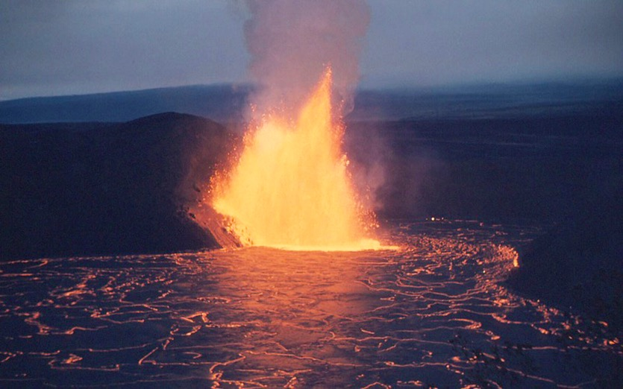

Hawaii’s Kilauea Iki crater, 1959.

USGS / J.P. Eaton

A powerful surge of lava erupting from Hawaii’s Kilauea Iki crater uncovered rock samples that could date back to Earth’s birth.

Analysis of two rock samples from volcanic eruptions in Hawaii and Samoa by geologists from the University of Maryland have revealed unexpected geochemical anomalies indicative of conditions existing 4.5 billion years ago, just after the planet formed. These unusual signatures can be understood in terms of the ratios of key isotopes of the elements tungsten and helium.

The study [published in *Science*](http://science.sciencemag.org/content/356/6333/66) observed unusually low levels of tungsten-182 and surprisingly high levels of helium-3, conditions suggestive of material from Earth’s core. Researchers don’t know how these primitive compositions survived for so long yet believe this discovery will open the doors to exciting future research. <https://cosmosmagazine.com/geoscience/lava-bursts-from-hawaii-s-kilauea-iki-crater?utm_source=Today+in+Cosmos+Magazine&utm_campaign=b62e64d15d-RSS_EMAIL&utm_medium=email&utm_term=0_5f4ec2b124-b62e64d15d-179982353>

# Flushed Away...Probing For Antibiotic Presence in Our Food Supply

Posted by Dennis O'Brien, Public Affairs Specialist, Agricultural Research Service in [Research and Science](https://www.usda.gov/media/blog/category/research-and-science)

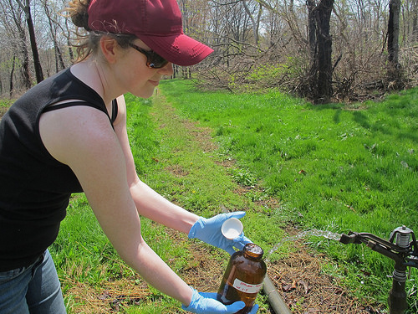Penn State University doctoral candidate Alison Franklin collects samples of treated wastewater used to spray-irrigate crops at a research site. Photo by Katie Colaneri.

It’s a question with major public-health implications: Could antibiotics and other widely used medications get into our food supply when they are flushed into our sewers?

To try to answer that question, researchers from USDA and Penn State University (PSU) assessed whether some commonly used pharmaceuticals could get into a wheat crop irrigated with recycled wastewater.

<https://www.usda.gov/media/blog/2017/02/17/flushed-awayprobing-antibiotic-presence-our-food-supply>

**How Low Can Life Go? New Study Suggests Six Miles Down**

**Evidence of life from below a mud volcano hints at life beneath the crust**

501 4 0 1 0 1 577

There’s plenty of life on Earth's surface and deep in the oceans—so many species that researchers think they have [barely scratched the surface](https://www.theguardian.com/environment/2011/aug/23/species-earth-estimate-scientists) naming all the plants and animals that make up the biosphere. Now, new research suggests there could be much more. As [Chelsea Whyte reports for New Scientist](https://www.newscientist.com/article/2127488-life-could-exist-up-to-10-kilometres-beneath-the-sea-floor/) new evidence hints at a “deep biosphere” locked miles below Earth’s surface.

The study, published in [*The Proceedings of the National Academies of Science*](http://www.pnas.org/content/early/2017/04/04/1612147114)*,*documents the results of a deep-sea drilling expedition at the South Chamorro mud volcano. This massive underwater mountain sits near Challenger Deep in the Mariana Trench, the deepest spot in the world’s ocean, and is fueled by the tectonic activity that grinds below as the Pacific plate slips beneath the Philippine Sea plate.

Read more: <http://www.smithsonianmag.com/smart-news/life-could-exist-six-miles-below-earths-surface-180962861/#XWREHVsA3DCoXfKF.99>

# Scientists Extract DNA From Ancient Humans Out of Cave Dirt

**The new technique promises to transform the study of the hominid family tree**

Finding bones from early humans and their ancestors is difficult and rare—often requiring scientists to sort through the sediment floor of caves in far-flung locations. But modern advances in technology could completely transform the field. As [Gina Kolta reports for *The New York Times*](https://www.nytimes.com/2017/04/27/science/ancient-human-dna-cave-dirt.html?rref=collection%2Fsectioncollection%2Fscience&action=click&contentCollection=science&region=rank&module=package&version=highlights&contentPlacement=1&pgtype=sectionfront&_r=0), a new study documents a method to extract and sequence fragments of hominid DNA from samples of cave dirt.

The study, published this week in the journal [*Science*](http://science.sciencemag.org/content/early/2017/04/26/science.aam9695)*,* could completely change the type of evidence available to study our ancestral past. Researchers from the Max Planck Institute for Evolutionary Anthropology in Leipzig, Germany, collected 85 sediment samples from seven archeological sites in Belgium, Croatia, France, Russia and Spain, covering a span of time from 550,000 to 14,000 years ago.

Read more: <http://www.smithsonianmag.com/smart-news/new-technique-pulls-ancient-human-dna-out-cave-soil-180963084/#Jk757B5hAGXQUYdO.99>

**How high will global sea levels rise?**

## Predicting the rate of Antarctica’s ice melt is tricky business as the rise in global sea levels depends on the state of the ice cap. New research suggests it may be worse than we thought, writes James Mitchell Crow.



In the low-lying Netherlands, floating houses such as these in Ijberg, a suburb of Amsterdam, are ready for higher sea levels. Whether housing in other places should be built this way depends largely on what happens with Antarctica.

Ashley Cooper / Getty Images

Estimates of global sea level rise by 2100 have fluctuated wildly in recent decades – from more than two metres to as little as 31 centimetres.

The rubbery figures have been a source of ammunition for climate change sceptics and consternation for policy makers – undermining their ability to plan ahead. Most of the blame can be levelled at Antarctica. Its 30 million km3 ice sheet holds 90 per cent of the world’s fresh water. If it all melted, sea levels would rise 60 metres. By contrast, a melt of the Greenland ice sheet, the world’s second largest, would contribute six metres. <https://cosmosmagazine.com/climate/how-high-will-global-sea-levels-rise?utm_source=Today+in+Cosmos+Magazine&utm_campaign=049bac9476-RSS_EMAIL&utm_medium=email&utm_term=0_5f4ec2b124-049bac9476-179982353>

# Tropical forests may be hiding mass extinctions

## Species loss from disturbed tropical habitats will be much higher than previously thought, a new study says. Andrew Masterson reports

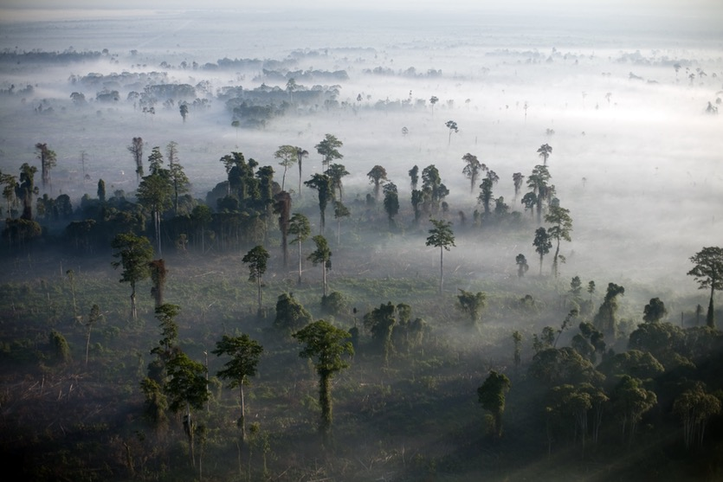

Fires burn off logged virgin rainforest, home to threatened orangutans and other rare species of wildlife in Tripa, Aceh province, Indonesia. Scientists warn deforestation could lead to 'hundreds of thousands' more extinctions in the near future.

Robert Nickelsberg / getty images

A mass extinction of tropical species ranging from bats to butterflies may have already happened without anyone noticing, suggests research from Australia’s Macquarie University.

In a paper published in the journal [Proceedings of the National Academy of Sciences](http://www.pnas.org/content/early/2017/04/25/1611855114), biologist John Alroy has used local-scale ecological data obtained across the world’s tropical zones to predict global-scale extinction rates across 11 key ecological groups. <https://cosmosmagazine.com/biology/tropical-forests-may-be-hiding-mass-extinctions?utm_source=Today+in+Cosmos+Magazine&utm_campaign=09557a5b6b-RSS_EMAIL&utm_medium=email&utm_term=0_5f4ec2b124-09557a5b6b-179982353>

# Researchers find evidence of traffic pollution in remote Himalaya

##### 2 May 2017 by Michael Miller

[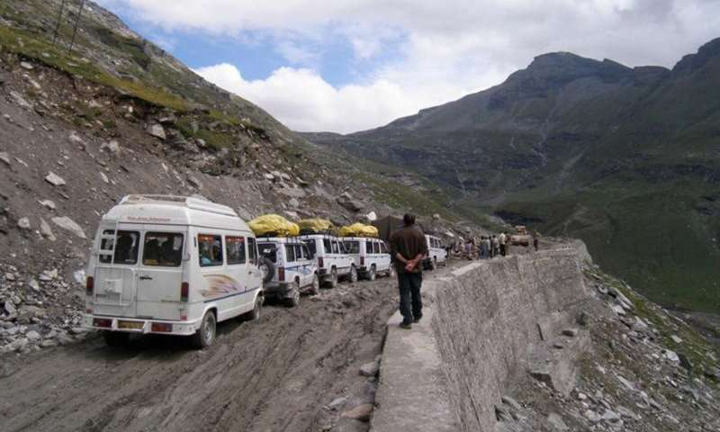](https://3c1703fe8d.site.internapcdn.net/newman/gfx/news/hires/2017/41-researchersf.jpg)

UC researchers found pollution from traffic along the Manali-Leh Highway in India's Himalaya Mountains. Credit: Brooke Crowley

Smog from cars and trucks is an expected health hazard in big cities, but researchers from the University of Cincinnati found pollution from truck exhaust on one of the most remote mountain roads in the world.

# Read more at: <https://phys.org/news/2017-05-evidence-traffic-pollution-remote-himalaya.html#jCp>

# A close-up portrait of Jupiter

## The Hubble Space Telescope zooms in on the largest planet in the solar system.

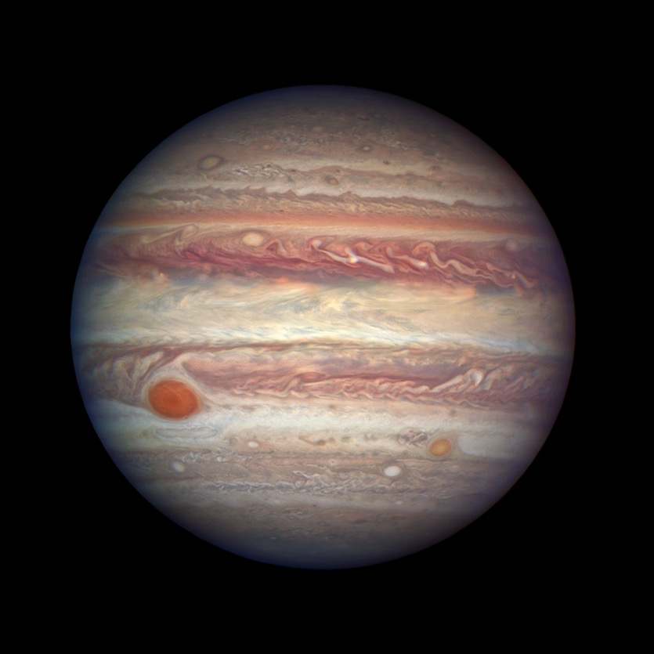

Jupiter snapped by the Hubble Space Telescope.

NSA/ESA/A. Simon

On 3 April the Hubble Space Telescope turned its Wide Field Camera 3 toward Jupiter.

The gas giant is currently at “opposition”, which means the Earth is now sitting on a straight line between it and the sun. This is the time of year when we are closest to Jupiter, and the planet is brightest in the night sky. <https://cosmosmagazine.com/space/a-close-up-portrait-of-jupiter?utm_source=Today+in+Cosmos+Magazine&utm_campaign=f647bf80a9-RSS_EMAIL&utm_medium=email&utm_term=0_5f4ec2b124-f647bf80a9-179982353>

# Antarctic ice rift spreads: New branch revealed in latest data from ice shelf

##### 2 May 2017

[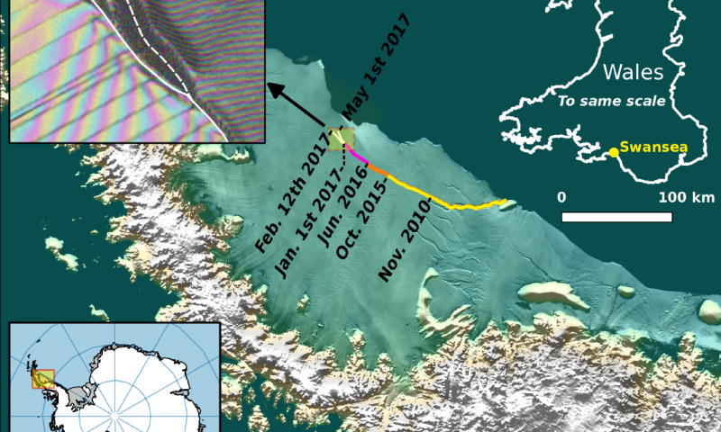](https://3c1703fe8d.site.internapcdn.net/newman/gfx/news/hires/2017/antarcticice.png)

Labels highlight significant jumps. Tip positions are derived from Landsat (USGS) and Sentinel-1 InSAR (ESA) data. Background image blends BEDMAP2 Elevation (BAS) with MODIS MOA2009 Image mosaic (NSIDC). Other data from SCAR ADD and OSM. …more

The rift in the Larsen C ice shelf in Antarctica now has a second branch, which is moving in the direction of the ice front, Swansea University researchers revealed after studying the latest satellite data.

Read more at: <https://phys.org/news/2017-05-antarctic-ice-rift-revealed-latest.html#jCp>

**How Glowing Soil Can Help Find Land Mines**

**Using genetically engineered bacteria and lasers, Israeli scientists have devised a unique way to detect buried explosives**

when there is much talk of a [“Mother of All Bombs”](https://en.wikipedia.org/wiki/GBU-43/B_Massive_Ordnance_Air_Blast) and the possibility of [a conflict involving nuclear weapons,](https://www.theguardian.com/world/2017/apr/15/north-korea-nuclear-test-miltary-parade-kim-il-sung) a land mine can seem an artifact of conflicts past, a weapon that has little to do with mass destruction.

And yet, the prosaic device continues to induce its own form of terror around the world, sometimes long after wars have ended. In 2015, the number of people killed or maimed by land mines and other explosive remnants of war rose to 6,461, an increase of 75 percent, according to the [2016 Landmine Monitor.](http://the-monitor.org/en-gb/reports/2016/landmine-monitor-2016/major-findings.aspx) The big jump was largely related to conflicts in Afghanistan, Syria, Libya, Ukraine and Yemen.

Almost 80 percent of the victims were civilians, and nearly 40 percent were children.

Read more: <http://www.smithsonianmag.com/innovation/how-glowing-soil-can-help-find-land-mines-180962918/#eloSfGYQuKuc65ql.99>

|  |
| --- |
| **Poor forestry regulations will not protect soils or rivers**  **Monday, 24 April 2017, 12:14 pm** **Press Release:** [**Green Party**](http://info.scoop.co.nz/Green_Party) |

24 April 2017

Poor forestry regulations will not protect our soils or rivers

Weak forestry regulations proposed by the National Government will do little to prevent forests being planted on steep, erosion-prone country, or avoid forestry debris harming streams, the Green Party said today.

The comments come on the back of [news](http://www.radionz.co.nz/programmes/water-fools/story/201841276/water-fools-river-damage-from-forestry-in-northland) that Northland’s Mangakahia River has been clogged with forestry debris from plantation forests in the catchment.

“With heavy rain from more intense storm events as a result of climate change, care and thought around plantation forests is important to protect our rivers, soils and the ecosystems that depend on them,” said Green Party forestry spokesperson Eugenie Sage. <http://www.scoop.co.nz/stories/PA1704/S00289/poor-forestry-regulations-will-not-protect-soils-or-rivers.htm>

# What creates Earth's magnetic field?

## The Earth's core works like a giant bicycle dynamo in reverse. Vishnu Varma reports.

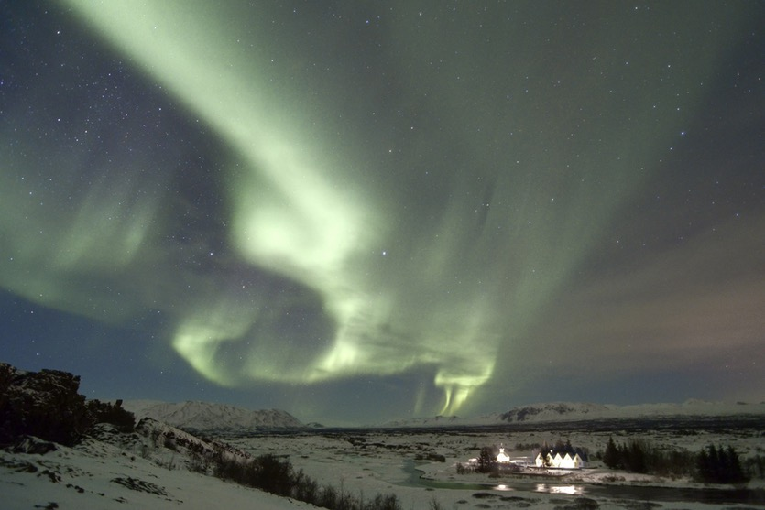

Northern Lights By Full Moon: the Aurora Borealis in Thingvellir National Park (UNESCO World Heritage Site), Iceland.

Barcroft/Contributor/Getty

**Travelling to see the Northern or Southern lights** has made its way into almost everyone’s bucket list. But unknown to most, these beautiful displays of light are [caused by dangerous cosmic rays that have been deflected by our Earth’s magnetic field](http://geoscience/what-causes-an-aurora-over-the-poles).

Magnetic fields around planets behave in the same way as a bar magnet. But at high temperatures, metals lose their magnetic properties. So it’s clear that Earth’s hot iron core isn’t what creates the magnetic field around our planet.

Recommended

# [Why the Earth’s magnetic poles could be about to swap places – and how it would affect us](https://cosmosmagazine.com/geoscience/why-the-earth-s-magnetic-poles-could-be-about-to-swap-places-and-how-it-would-affect-us)

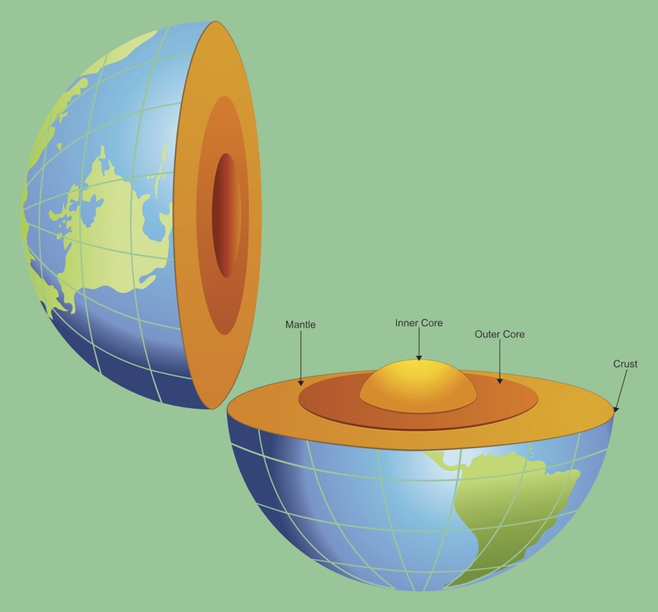

Labelled cross section of the earth interior view.

Diane Labombarbe

Instead, Earth’s magnetic field is caused by a dynamo effect.

The effect works in the same way as a dynamo light on a bicycle. Magnets in the dynamo start spinning when the bicycle is pedalled, creating an electric current. The electricity is then used to turn on the light.

This process also works in reverse. If you have a rotating electric current, it will create a magnetic field. <https://cosmosmagazine.com/geoscience/what-creates-earth-s-magnetic-field?utm_source=Today+in+Cosmos+Magazine&utm_campaign=00b8fb139b-RSS_EMAIL&utm_medium=email&utm_term=0_5f4ec2b124-00b8fb139b-179982353>

