

Focus should shift from food security to soil preservation
China Daily | Updated: 2017-08-30 07:57
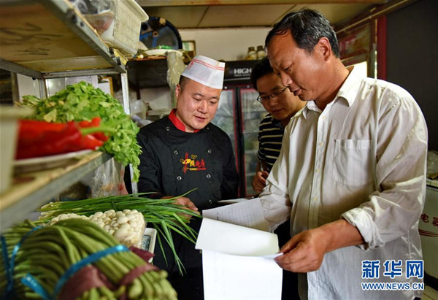
A coordinator checks a purchase record book in a restaurant of Weixian country to ensure food safety on May 10. [Photo by Yang Shiyao/ Xinhua]
CHINA'S FOOD PRODUCTION has been increasing since the abolition of the agricultural tax－introduced more than a thousand years ago- in 2004. But food imports, too, have increased steadily and significantly in recent years. Southern Metropolis Daily commented on Monday:
After hitting an all-time-high of 621 million metric tons in 2015, China's food production seems to be overshadowed by the simultaneously increasing food imports, which have not just imposed extra financial burden on the country but also somewhat blunted the competitiveness of Chinese agricultural products in global markets. http://www.chinadaily.com.cn/opinion/2017-08/30/content_31305154.htm

Mapping the Topographic Fingerprints of Humanity Across Earth
If increasingly globalized societies are to make better land management decisions, the geosciences must globally evaluate how humans are reshaping Earth's surface
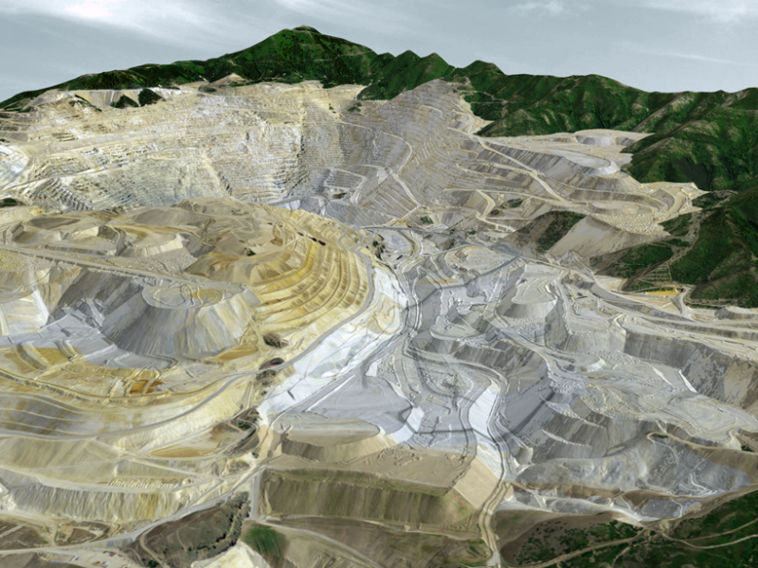Fig. 1. Three-dimensional view of Bingham Canyon Mine, Utah, a human-made topographic signature, based on a free, open-access high-resolution data set. Credit: Data from Utah AGRC
By Paolo Tarolli, Giulia Sofia, and Erle Ellis 16 March 2017
Since geologic time began, Earth’s surface has been evolving through natural processes of tectonic uplift, volcanism, erosion, and the movement of sediment. Now a new force of global change is altering Earth’s surface and morphology in unprecedented ways: humanity.
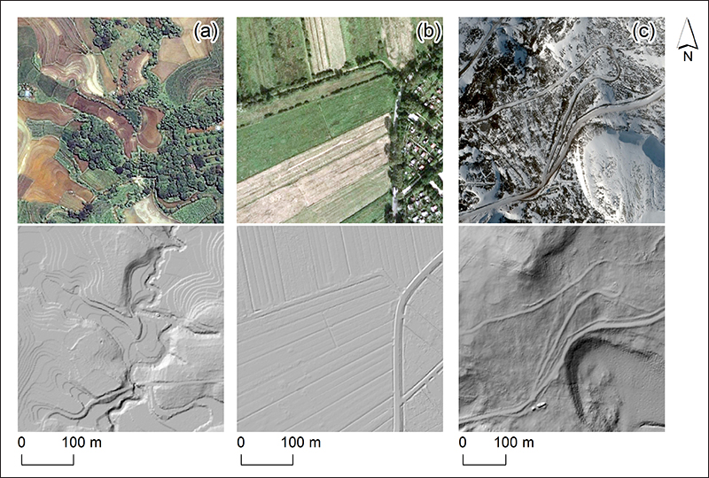Fig. 2. High-resolution geodata reveal the topographic fingerprints of humanity: (a) terraces in the Philippines, (b) agricultural practices in Germany, and (c) roads in Antarctica. The bottom images are lidar images of the same landscapes. Credit: Data from University of the Philippines TCAGP/Freie und Hansestadt Hamburg/Noh and Howat [2015]. Top row: © Google, DigitalGlobe
https://eos.org/opinions/mapping-the-topographic-fingerprints-of-humanity-across-earth

Price of electricity is rising, not sure about temperatures
By Jennifer Marohasy - posted Friday, 14 July 2017
Because the masses believe that global atmospheric temperatures are rising unnaturally – the Hazelwood coal-fired power station was decommissioned, and the price of electricity is surging across Australia.
The evidence, however, for a rise in global temperatures is actually not that compelling – unless you believe the output from computer models. Rather, since at least November 2009 there has been evidence piling up and up, and up some more, that key temperature records are being remodelled to prop-up the notion that global temperatures are rising – and to agree with the output from the computer models.

Jennifer Marohasy is a senior fellow with the Institute for Public Affairs.

http://www.onlineopinion.com.au/view.asp?article=19156

Three Reasons Why Earth Scientists Should Edit Wikipedia
Are you looking to communicate science more broadly? Start by editing articles on the Internet's most popular general reference work.
iStock.com/Zmeel Photography
By Evan B. Goldstein
If you are a researcher who is looking to communicate science more broadly, an easy step involves Wikipedia.
Wikipedia is a frequent first stop for researchers, students, and the public. The world’s largest free encyclopedia, Wikipedia is also one of the largest websites in terms of traffic.
If you edit a page to include results from your research, your audience will likely expand by at least an order of magnitude. Here’s the important thing: Page views of Wikipedia are immense compared with views of primary literature articles. As a result, if you edit a page to include results from your research, your audience will likely expand by at least an order of magnitude. https://eos.org/opinions/three-reasons-why-earth-scientists-should-edit-wikipedia

Global Significance of the Changing Freshwater Carbon Cycle
Freshwater ecosystems constitute a small fraction of our planet but play a disproportionately large and critical role in the global carbon cycle.
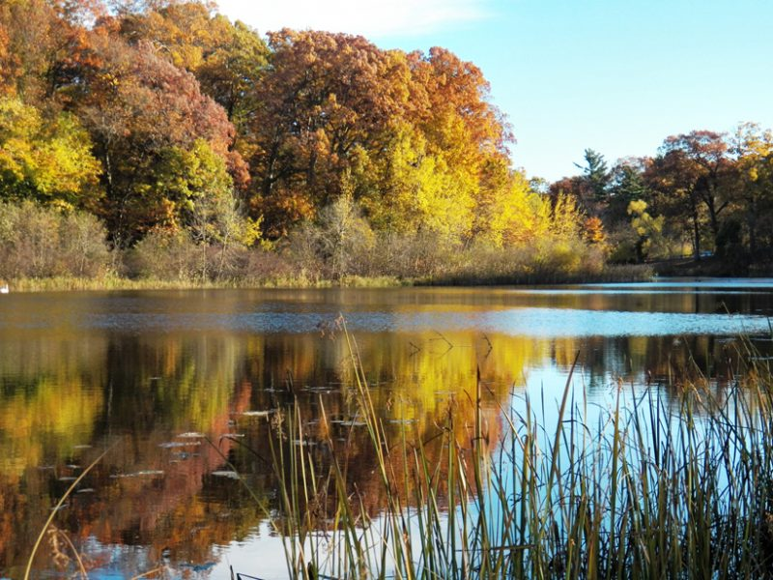Small inland freshwater bodies play a large role in the global carbon cycle. Here Ruddiman Lagoon, a small freshwater lake, joins Muskegon Lake, a freshwater estuary in Michigan that drains the extensive Muskegon River watershed into Lake Michigan. This North American Great Lake feeds the Saint Lawrence River, which drains into the Atlantic Ocean. Credit: Janet H. Vail
By Bopaiah A. Biddanda
As human activities continue to pump carbon into the atmosphere, the backbone of our understanding of the resulting warming is our knowledge of where that carbon is going: into the atmosphere, into the land, and into bodies of water. When it comes to accounting for the carbon absorbed and emitted by water, the role of inland freshwater may appear quite small compared to the vastness of Earth’s oceans. After all, inland lakes, rivers, streams, reservoirs, wetlands, and estuaries cover less than 4% of Earth’s surface [Downing, 2010; Verpoorter et al., 2014]. https://eos.org/opinions/global-significance-of-the-changing-freshwater-carbon-cycle

Murray-Darling Basin Plan: 'Grenade' Matthews report reveals ICAC probing alleged water corruption
Analysis
Four Corners
By Linton Besser
Updated Fri at 1:18pmFri 15 Sep 2017, 1:18pm
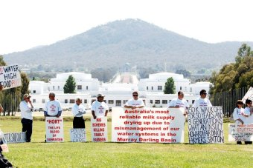Photo: Farmers are calling for the NSW Government to be held accountable for what has been done with the water. (AAP: Paul Miller)
Louth grazier Stuart Le Lievre does not mince his words: "There is nothing right about it, none at all."
The wool-grower has been angry for years about the way the NSW Government decided to share the water in the fragile Barwon-Darling river system.
Linton Besser is a reporter for the ABC's Four Corners program. He previously worked for Fairfax and won a Walkley for investigative journalism in 2010 http://www.abc.net.au/news/2017-09-11/murray-darling-basin-plan-grenade-report-icac-four-corners/8893456

Three Steps to Successful Collaboration with Data Scientists
A step-by-step cartoon guide to efficient, effective collaboration between Earth scientists and data scientists.
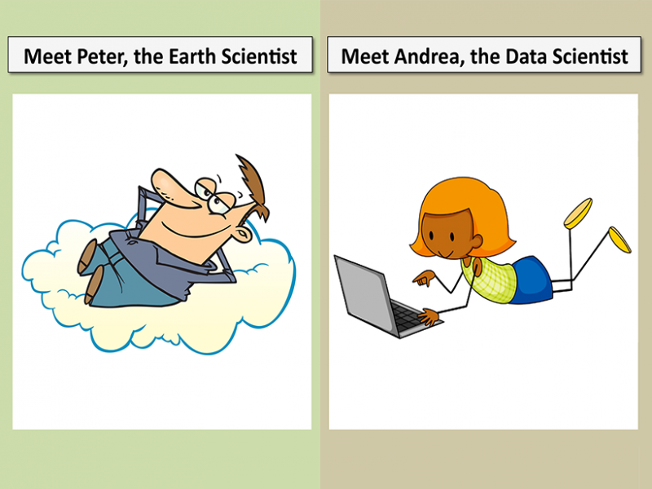Peter, the Earth scientist, and Andrea, the data scientist, worked together to make important decisions regarding their research problem, approach, and experiments, as well as to validate and interpret the results of their study. Cartoon figures are from Clipart Of LLC.
By Imme Ebert-Uphoff and Yi Deng 30 August 2017
The vast and rapidly increasing supply of new data in the Earth sciences creates many opportunities to gain scientific insights and to answer important questions. Data analysis has always been an integral component of research and education in the Earth sciences, but mainstream Earth scientists may not yet be fully aware of many recently developed methods in computer science, statistics, and math. https://eos.org/opinions/three-steps-to-successful-collaboration-with-data-scientists
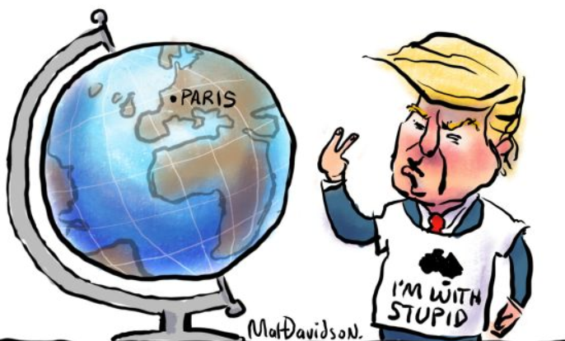
http://www.smh.com.au/photogallery/federal-politics/cartoons/illustrations-by-matthew-davidson-20090928-g8gc.html
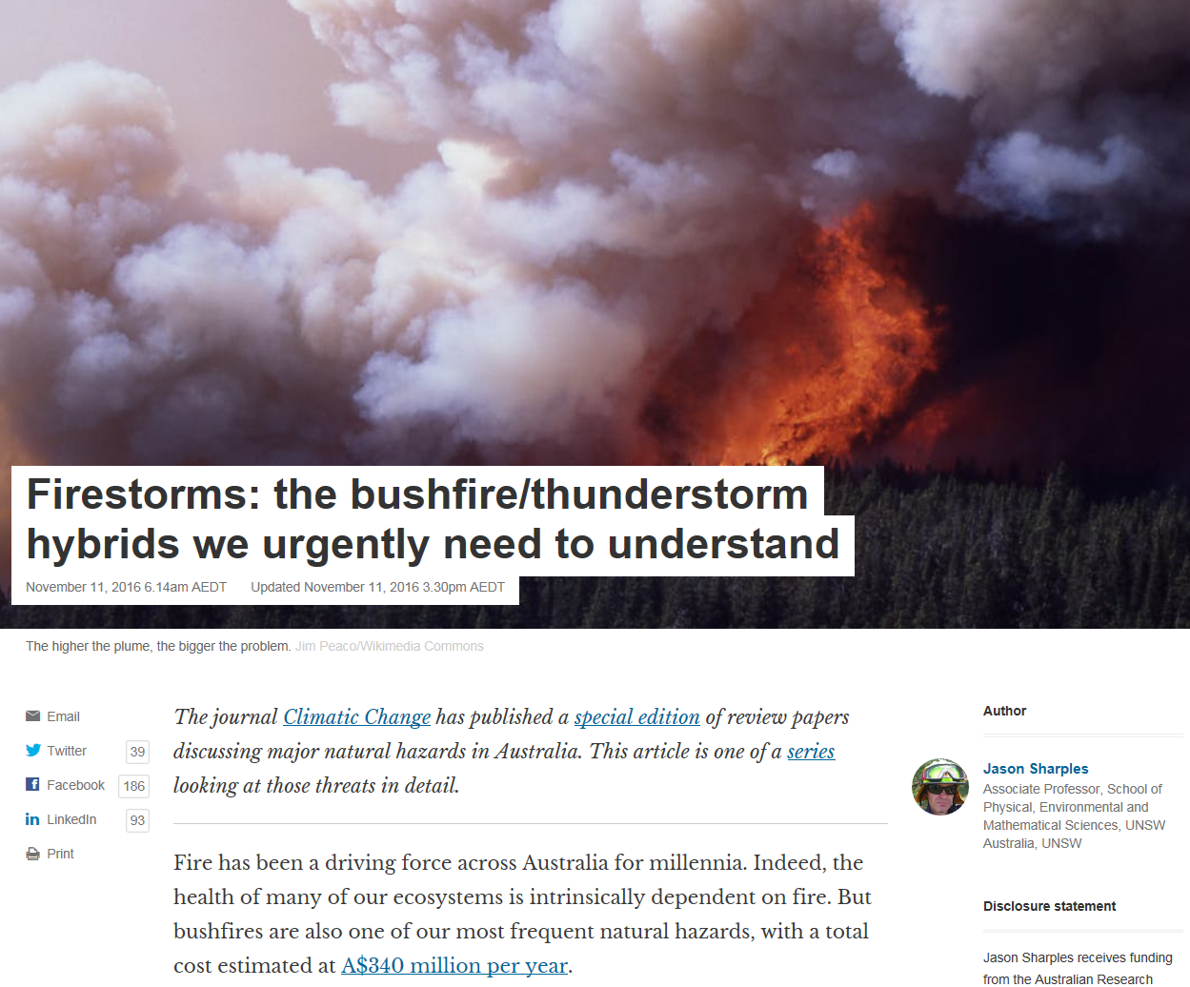
https://theconversation.com/firestorms-the-bushfire-thunderstorm-hybrids-we-urgently-need-to-understand-68426
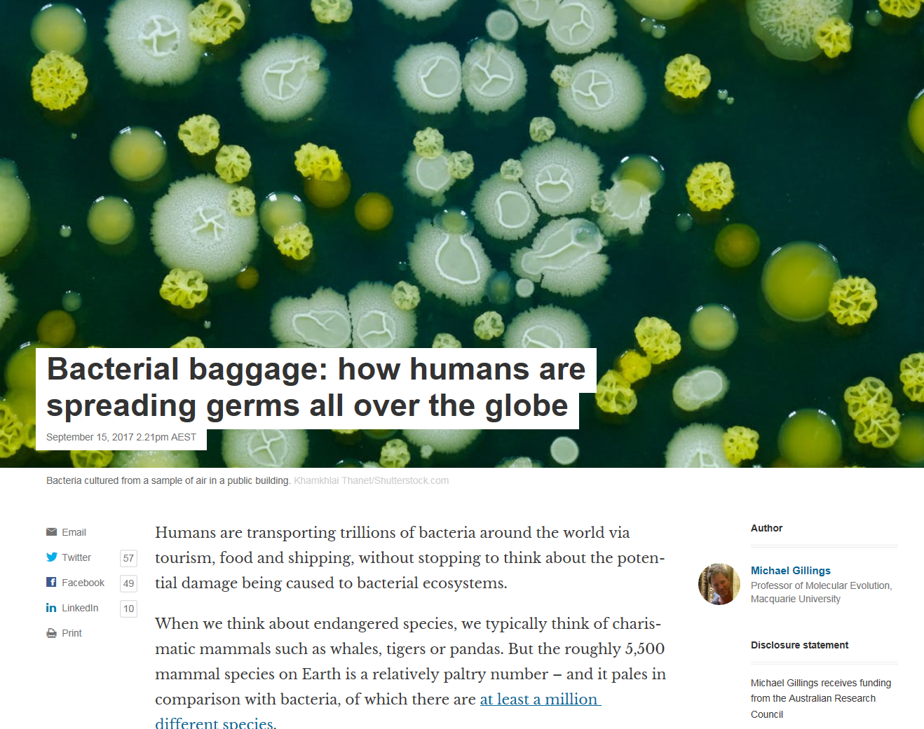
https://theconversation.com/bacterial-baggage-how-humans-are-spreading-germs-all-over-the-globe-84073

How regulators could kill off Australia's water recycling industry

A world-leading system in Sydney’s Central Park precinct helps residents reuse up to 97% of their water. But a pricing change threatens future schemes
Monday 18 September 2017 04.00 AEST Last modified on Monday 18 September 2017 06.12 AEST
In the basement of a Sydney housing development is the world’s largest water recycling plant in a residential building.
Normal apartments put more than 90% of the water they consume back into the sewer. But thanks to the recycling plant, units in Central Park, built on the site of the old Carlton brewery close to the CBD, return just 3% https://www.theguardian.com/environment/2017/sep/18/how-regulators-could-kill-off-australias-water-recycling-industry

Acquiring a Taste for Advocacy
A scientist rethinks his distrust of political engagement.
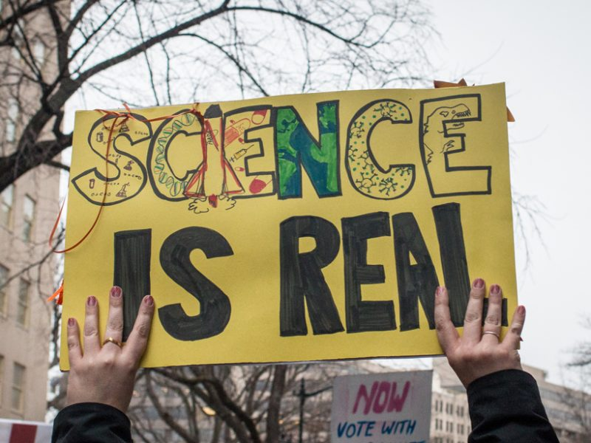A sign held at the 21 January 2017 Women’s March in Washington, D. C. Credit: Liz Lemon
By Robert Pincus
On the Sunday before last year’s American Geophysical Union (AGU) Fall Meeting—about a month after the U.S. elections—I found myself in a windowless room, deep in the basement of the San Francisco Marriot Marquis. It was 8:00 a.m., and I was shaking off jet lag to attend a science communications workshop hosted by AGU’s Sharing Science program. https://eos.org/opinions/acquiring-a-taste-for-advocacy
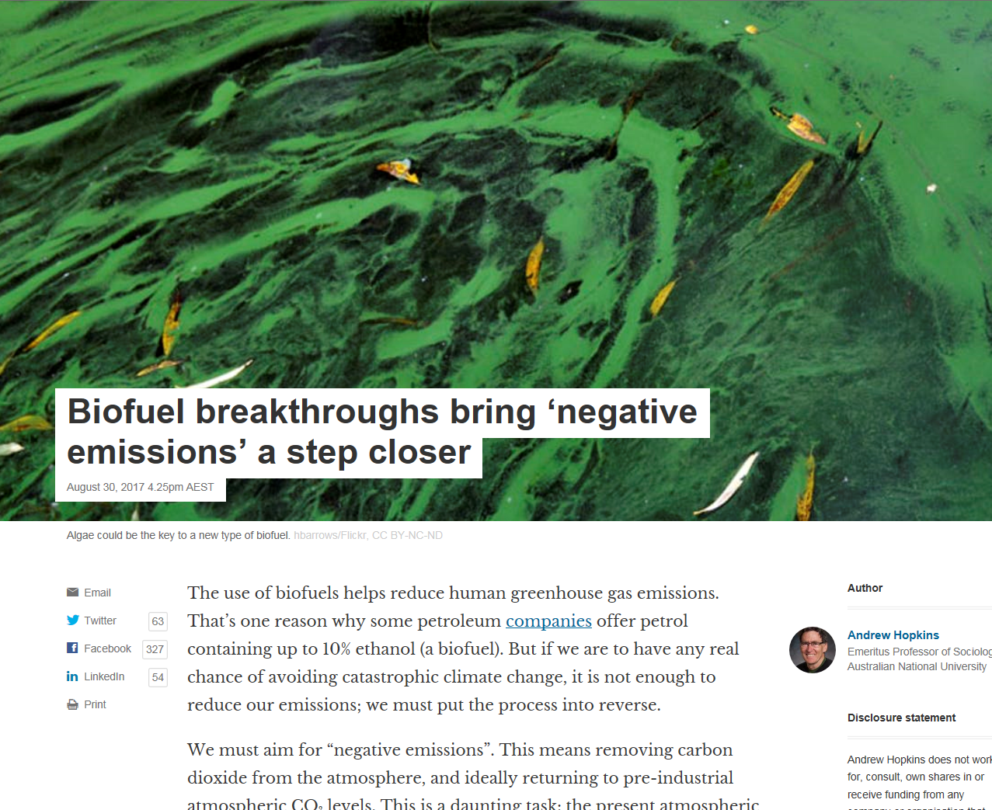
https://theconversation.com/biofuel-breakthroughs-bring-negative-emissions-a-step-closer-82513
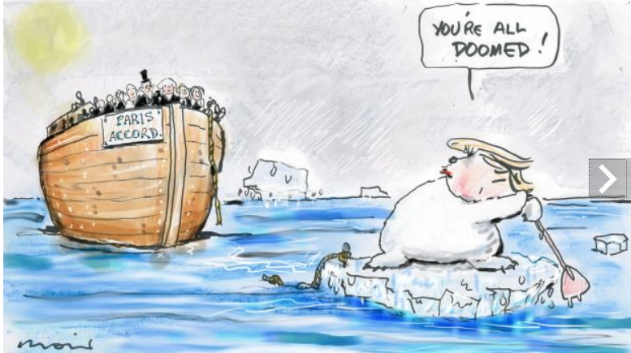
http://www.smh.com.au/photogallery/federal-politics/cartoons/alan-moir-20150921-gjrcxr.html

Gas, not coal, the key to fixing Australia's electricity mess
Analysis
By business editor Ian Verrender
Updated 11 Sep 2017, 8:44amMon 11 Sep 2017, 8:44am
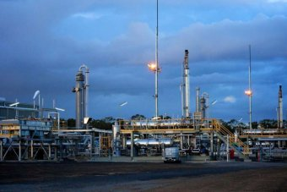Photo: One of the main causes of the power price spike is the soaring price of gas. (Origin Energy)
AGL boss Andy Vesey made a fundamental miscalculation last week.
The straight-talking American vainly attempted to use logic, honesty and rational economic thought to explain why he is shifting the company out of coal-fired power generation and towards renewables.
That has put him at odds with sections of the Federal Government, some in the mining industry and a rump of frothing shock jocks.
Ian Verrender is the ABC's business editor. http://www.abc.net.au/news/ian-verrender/5261264

The idea that climate scientists are in it for the cash has deep ideological roots
Graham Readfearn
Author and academic Nancy MacLean says cynicism about the motives of public servants, including government-backed climate scientists, can be traced to a group of neoliberals and their ‘toxic’ ideas
Friday 15 September 2017 18.43 AEST Last modified on Saturday 16 September 2017 13.18 AEST
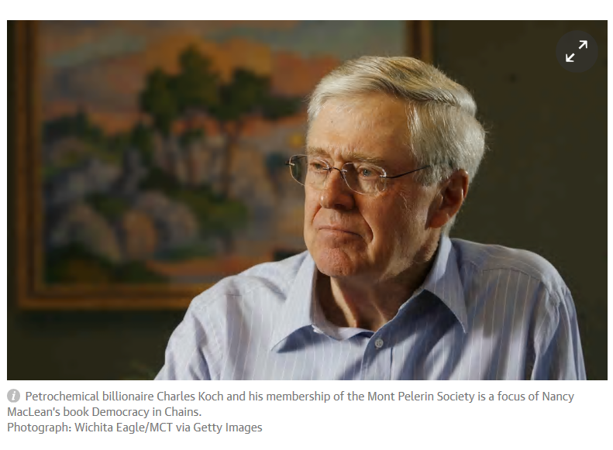You’ll have heard that line of argument about cancer scientists, right?
The one where they’re just in it for the government grant money and that they don’t really want to find a cure, because if they did they’d be out of a job?
No, of course you haven’t. That’s because it’s ridiculous and a bit, well, vomit-inducing.
To make such an argument, you would need to be deeply cynical about people’s motives for consistently putting their own pay packets above the welfare of millions of people. https://www.theguardian.com/environment/planet-oz/2017/sep/15/the-idea-that-climate-scientists-are-in-it-for-the-cash-has-deep-ideological-roots
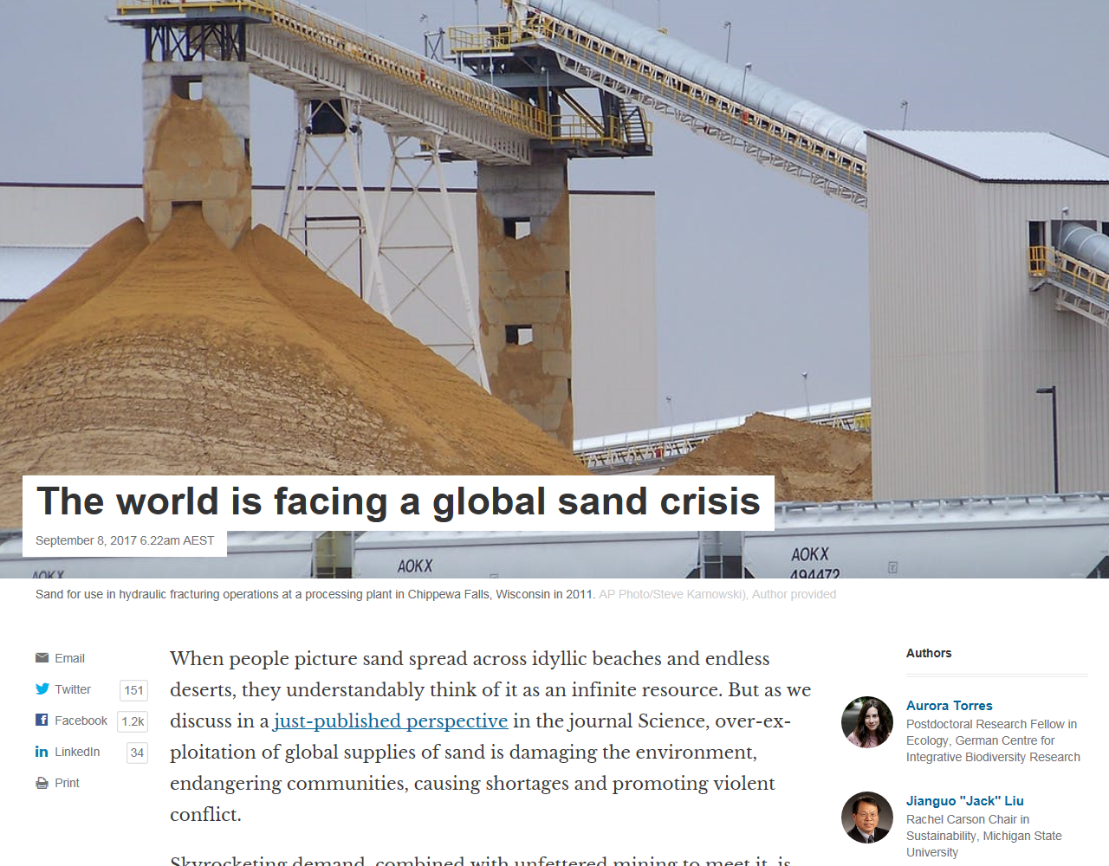
https://theconversation.com/the-world-is-facing-a-global-sand-crisis-83557

Coal battles to escape the inevitable
When is a water catchment not a water catchment? The answer, to judge by this week's news, is: when it sits on a coal mine. That conclusion can be drawn from this week's report of the environmental study into the effect of long-wall coal mining near the Cordeaux dam catchment area south-west of Sydney. The story is both shocking and expected at the same time. The reaction from the state government – silence – is equally so, and it raises the question: if our community is willing to compromise the security of its own water supply to keep a coal mine operating, is there any cost too high, any price we will not pay, to keep this dangerous, damaging industry clinging to life?
The report found new cracks, caused by mining activity in the catchment, now extend from the coal seam to the surface. Simply put, the newly porous earth is swallowing Sydney's water. The value of the community's investment in the Cordeaux Dam, and perhaps also the nearby Avon Dam, has been compromised and
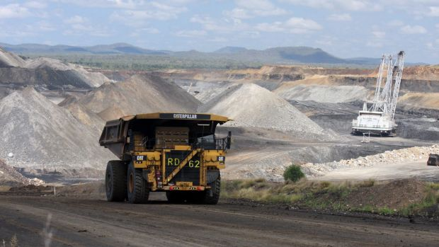
Coal mining is a legacy industry. Photo: Supplied
http://www.smh.com.au/comment/smh-editorial/coal-battles-to-escape-the-inevitable-20170915-gyif5y.html
Trump promised to hire the best people. He keeps hiring the worst. Nasa is next
Dana Nuccitelli
Trump’s Nasa nominee Jim Bridenstine is a climate denier who wants to end the agency’s climate research
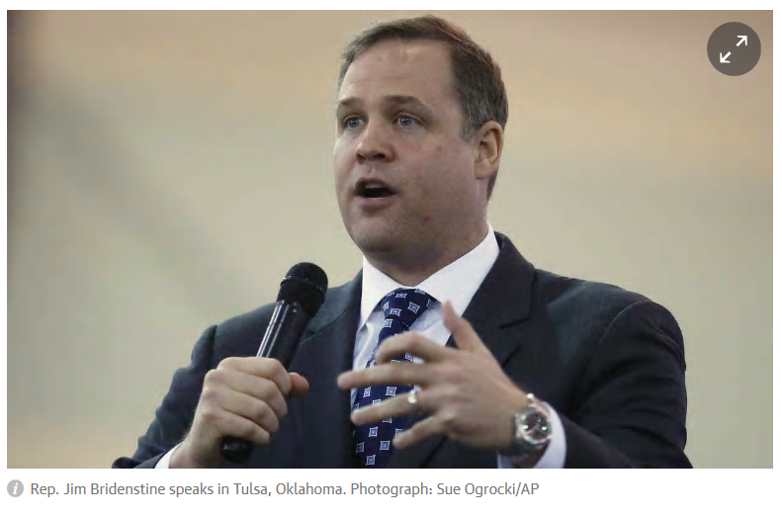
According to 2016 election exit polls, only 38% of voters considered Donald Trump qualified to be president. 17% of those who thought him unqualified voted for Trump anyway, perhaps because he promised that as a wealthy businessman, he would be able to hire the best people to advise him. That was a claim his daughter Ivanka explicitly made in her speech at the Republican National Convention: https://www.theguardian.com/environment/climate-consensus-97-per-cent/2017/sep/12/trump-promised-to-hire-the-best-people-he-keeps-hiring-the-worst-nasa-is-next

Death of the CET
By Graeme McLeay - posted Tuesday, 19 September 2017
Coalition talk of dumping Finkel's Clean Energy Target leaves Australia's climate policy in tatters.
Turnbull is sounding less like a leader and more like Tony Abbott's ventriloquist doll.
The Paris Agreement to which Australia is a signatory is based on the idea of a carbon budget, the maximum amount of carbon the world can burn before 2050 if it is to avoid climate chaos. By 2011 the world had already consumed a third of that budget and emissions have continued to rise. Australia's target of a 26-28% reduction in emissions by 2030, which has been described as a "three inch putt", is part of that agreement but the trajectory we are now on suggests we will fail even that weak target, as emissions continue to rise. It is no small thing to break an international agreement.
Graeme McLeay is an Adelaide anaesthetist, a grandfather and a member of Doctors for the Environment Australia.
http://www.onlineopinion.com.au/view.asp?article=19298

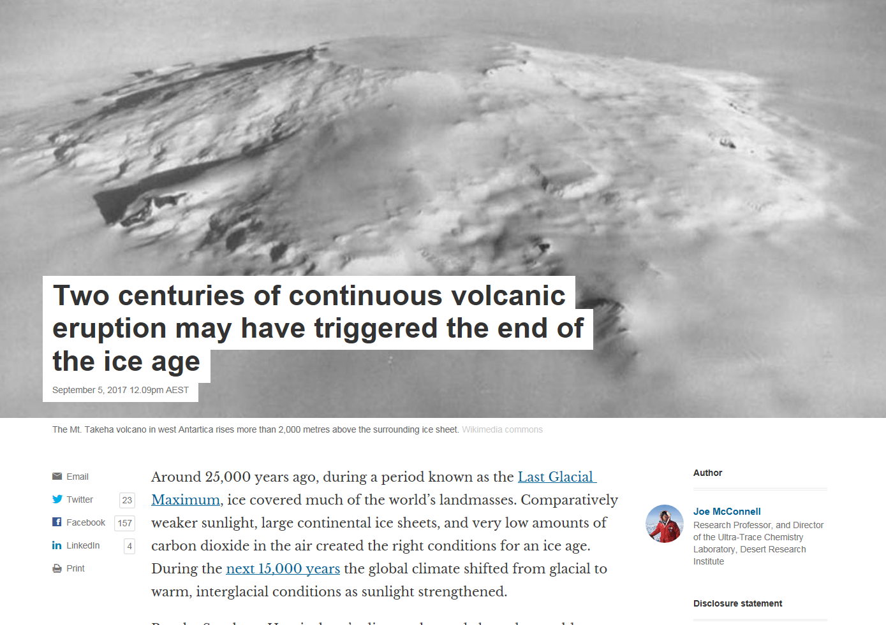
https://theconversation.com/two-centuries-of-continuous-volcanic-eruption-may-have-triggered-the-end-of-the-ice-age-83420

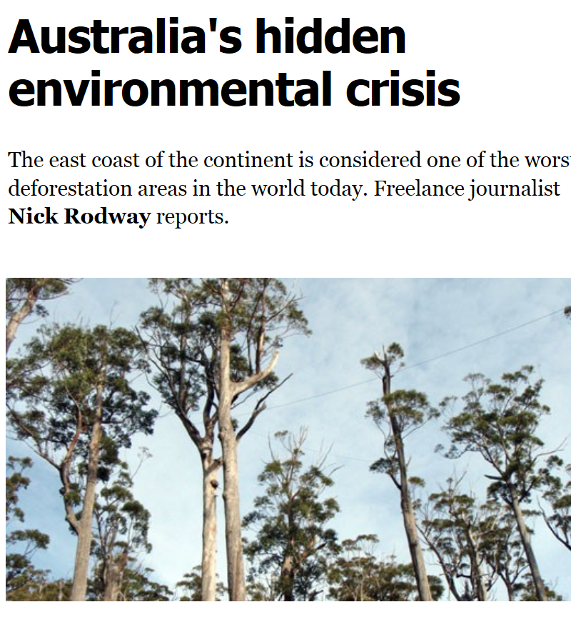Tuesday 12 September 2017 20.00 AEST Last modified on Wednesday 13 September 2017 00.51 AEST
The forests of the Amazon basin are often referred to as the lungs of the Earth, nurturing life through rich, tropical biodiversity. Although often overlooked, it’s equally fitting to consider the jungles of the Asia-Pacific as the Earth’s heart. After all, they contain 20% of the world’s plant and animal species, and by some measurements make up six of the world’s 25 biodiversity hotspots. Australia adds to the variety, with its wealth of native vegetation. Each one of these areas is unique and plays an integral part in the world’s interrelated ecological systems. https://www.crikey.com.au/2017/09/04/australias-hidden-environmental-crisis/

The trials of the Murray-Darling Basin Plan
By David Leyonhjelm - posted Thursday, 17 August 2017
The Millennium Drought, the longest and most severe drought for a hundred years, prompted some people to panic about climate change and conclude that drought was the new normal, that water would always be scarce, and that the environment was facing catastrophe.
More sensible people knew, and others found out, that droughts always end. That occurred in 2010/11 with widespread flooding. Wetlands recovered, birds bred enthusiastically, frogs and fish proliferated and the cycle of life resumed as it has for thousands of years. Dorothea Mackellar's description of Australia as a land of droughts and flooding rains was never better demonstrated.
David Leyonhjelm is the Liberal Democrat Senator for NSW.
http://www.onlineopinion.com.au/view.asp?article=19227

We can no longer tolerate climate change denial
The United States Weather Service, normally not an agency prone to colourful language, issued an extraordinary statement on Sunday regarding hurricane Harvey, saying, "This event is unprecedented and all impacts are unknown beyond anything experienced". It is now predicted the storm could eventually drop over 150 centimetres of rain in some areas, more than any other in the region's history.
Far from over, it is already clear that Harvey's impact is catastrophic. Six people are confirmed dead and that number is expected to increase. Cost estimates range up to $US100 billion.
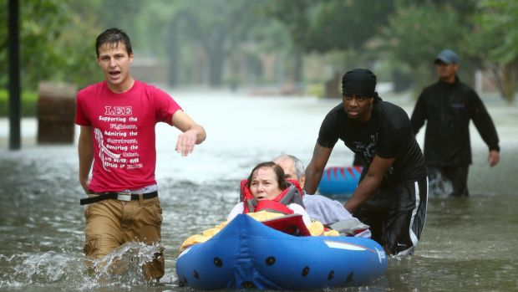America's efforts to combat climate change have been battered by President Donald Trump. Photo: AP
http://www.smh.com.au/comment/smh-editorial/we-can-no-longer-tolerate-climate-change-denial-20170829-gy6he6.html
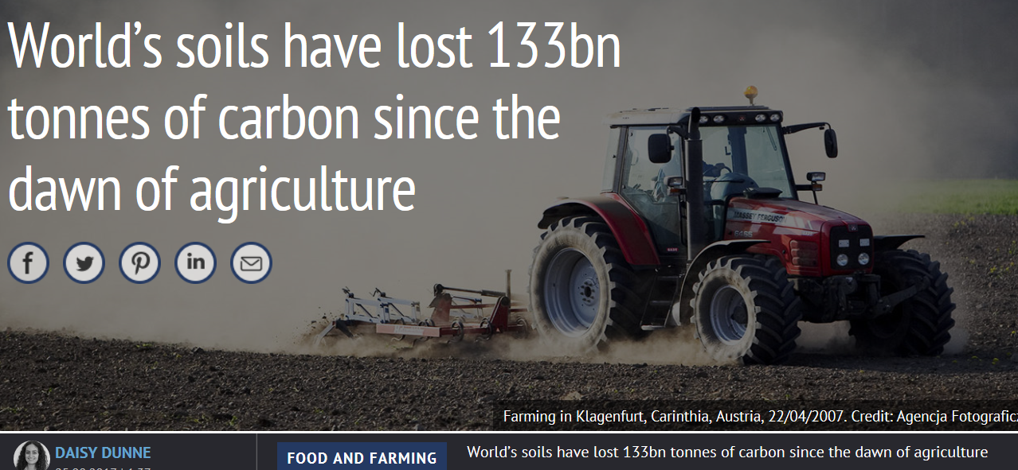
The world’s soils have lost a total of 133bn tonnes of carbon since humans first started farming the land around 12,000 years ago, new research suggests. And the rate of carbon loss has increased dramatically since the start of the industrial revolution.
The study, which maps where soil carbon has been lost and gained since 10,000BC, shows that crop production and cattle grazing have contributed almost equally to global losses.
Understanding how agriculture has altered soil carbon stocks is critical to finding ways to restore lost carbon to the ground, another scientist tells Carbon Brief, which could help to buffer the CO2 accumulating in the atmosphere. https://www.carbonbrief.org/worlds-soils-have-lost-133bn-tonnes-of-carbon-since-the-dawn-of-agriculture

Tanzania's ghost safari: how western aid contributed to the decline of a wildlife haven
Lions, elephants and hippos have vanished from Kilombero valley after UK- and US-funded projects helped turn a once-thriving habitat into farmland, teak, and sugar plantations
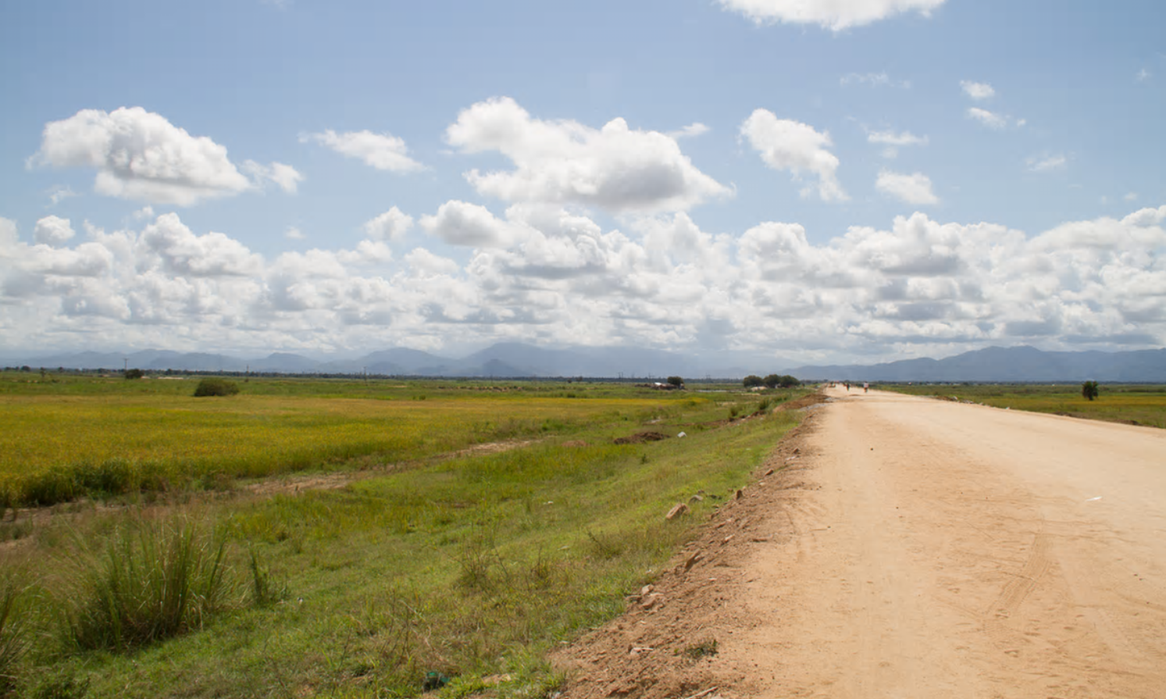Sunday 13 August 2017 16.00 AEST Last modified on Friday 15 September 2017 02.33 AEST
The long road from Dar es Salaam brings you through sparsely wooded hills and fields to the narrow northern neck of the Kilombero valley. There’s a bend in the road, then the land opens out, suddenly, in front of you.
Along the west side lie the steep-faced Udzungwa mountains, one of the last pristine rainforests in Tanzania. The Kilombero river runs through the red soils of the valley, flooding in November or December and subsiding by June. Down the longer eastern flank rise the Mahenge mountains, and beyond them, invisible, unfurls the vast territory of the Selous game reserve, one of the largest remaining chunks of African wilderness. https://www.theguardian.com/environment/2017/aug/13/tanzanias-ghost-safari-how-western-aid-contributed-to-the-decline-of-a-wildlife-haven

PNG kept genetic diversity after agriculture, unlike Europe

While the development of farming has often been linked to greater genetic homogeneity, in Papua New Guinea it had the opposite effect, writes Andrew Masterson.
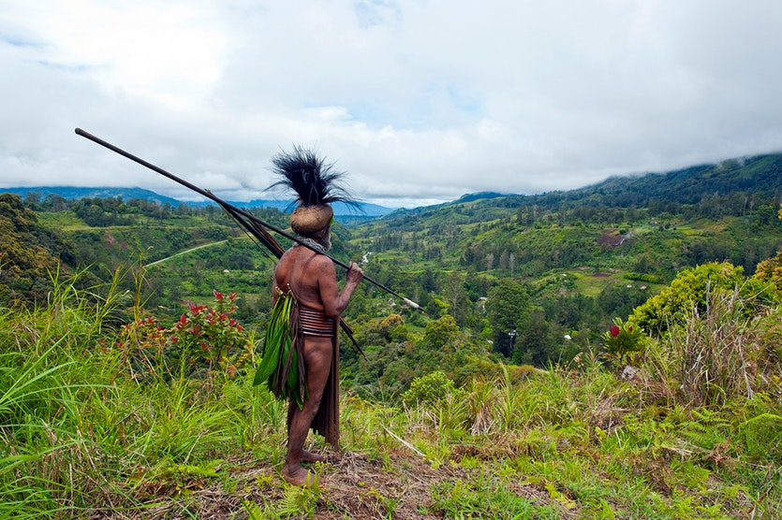
The people of the Papua New Guinea highlands are some of the most genetically isolated in the world.
Danita Delimont / Getty
When agriculture emerged in Europe more than 10,000 years ago, communities began to intermingle more and genetic diversity across the continent decreased.
At roughly the same time, agriculture also developed in Papua New Guinea, but the effect on the genetic composition of the human population was very different. https://cosmosmagazine.com/archaeology/png-kept-genetic-diversity-after-agriculture-unlike-europe

'Clean coal' is a lie straight out of the Orwellian playbook
Despite the dire warning of climate scientists, underpinned by the current spate of extreme weather events around the world, the government appears to be bent on promoting coal-fired power generation, writes Earth and Paleo-climate scientist Andrew Glikson.
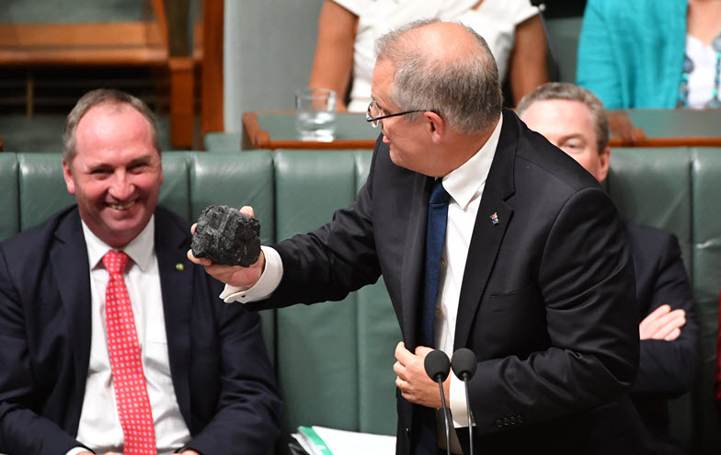
“Clean coal” constitutes a process whereby power-generating efficiency is increased by about 30% and CO2 emission https://www.crikey.com.au/2017/09/18/turnbull-government-backs-clean-coal-even-though-its-useless-rubbish/

Air pollution: a silent killer we must urgently act on
By George Crisp and Graeme McLeay - posted Wednesday, 19 July 2017
Media reports last week that the government planned to introduce strict new fuel and vehicle efficiency standards starting in 2022, characterised as a "carbon tax on cars", brought an emphatic denial from Minister for the Environment and Energy Josh Frydenberg.
The proposed changes being considered by the Ministerial Forum on Vehicle Emissions would have two aims; firstly to improve fuel efficiency which would help keep Australia's high per capita greenhouse gas emissions down and secondly would reduce the harmful and growing air pollution in our cities
George Crisp is a Perth GP. He is a member of Doctors for the Environment.
http://www.onlineopinion.com.au/view.asp?article=19166

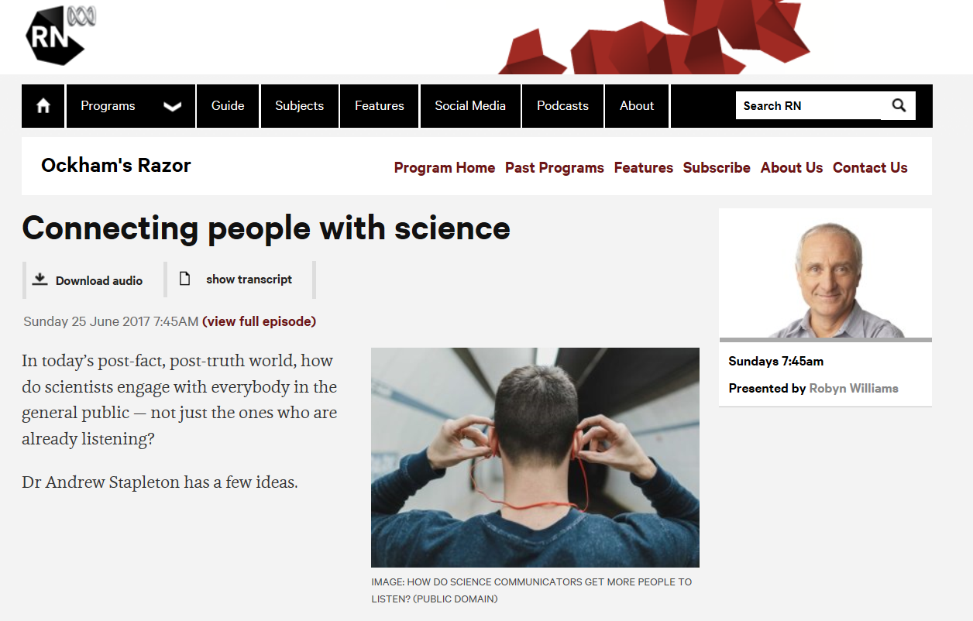
http://www.abc.net.au/radionational/programs/ockhamsrazor/connecting-people-with-science/8645644
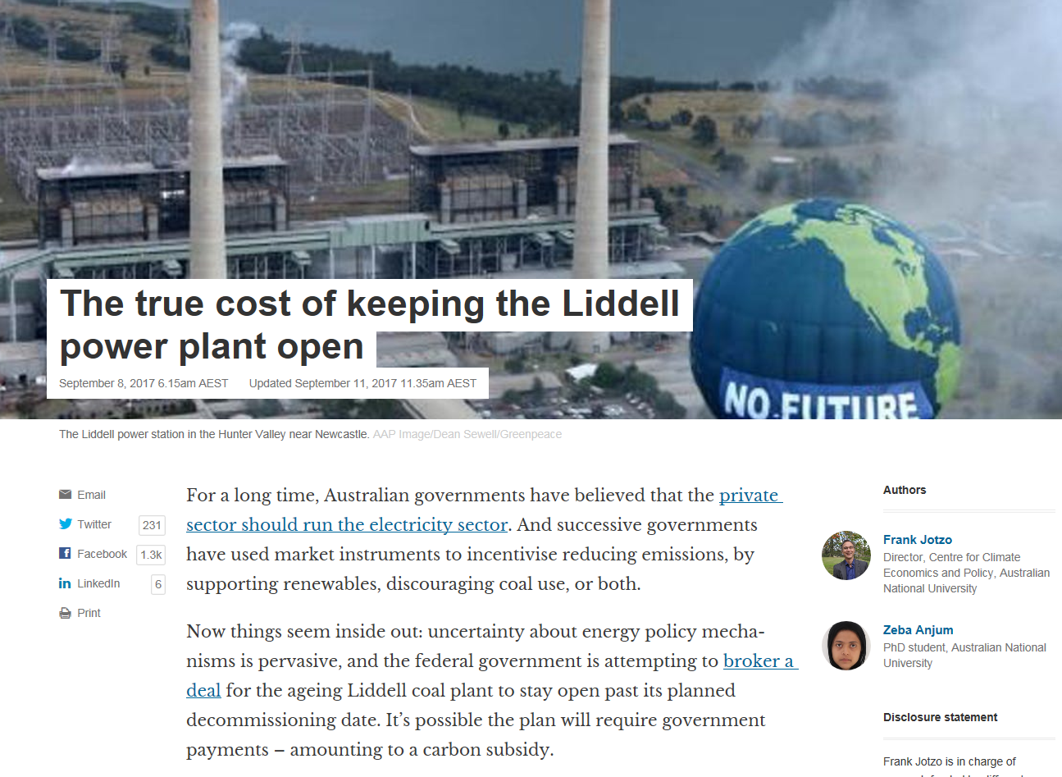
https://theconversation.com/the-true-cost-of-keeping-the-liddell-power-plant-open-83634

http://www.smh.com.au/photogallery/federal-politics/cartoons/alan-moir-20150921-gjrcxr.html

We need to make democracy work in the fight to save the planet
AC Grayling
For centuries, humans have championed the democratic political system. But can it facilitate the radical change needed to stop the potentially annihilating effects of climate change?

Demonstrators take to the streets of New York City after Donald Trump announced that he intended to withdraw the US from the Paris climate agreement, June 2017. Photograph: Michael N/Pacific/BarcroftImages
Climate change

We need to make democracy work in the fight to save the planet
AC Grayling
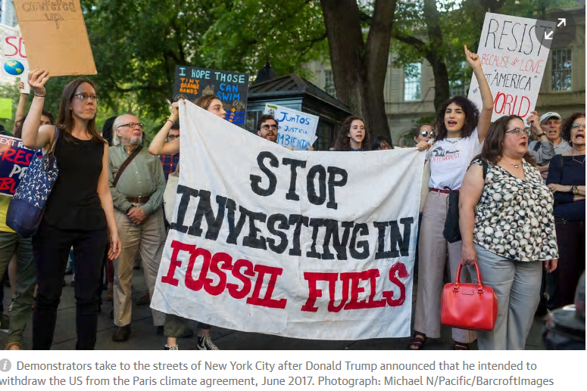
For centuries, humans have championed the democratic political system. But can it facilitate the radical change needed to stop the potentially annihilating effects of climate change?
Monday 18 September 2017 20.16 AEST Last modified on Monday 18 September 2017 20.17 AEST
Although individual action to protect the environment – consuming less, recycling more, reducing one’s carbon footprint – might be a contribution if enough people did it, the battle to minimise human-induced climate change has to be a worldwide endeavour among cooperating states. The outcome of the 2015 UN Climate Change Conference was one of the most optimistic and encouraging steps hitherto achieved in that battle – that is, until Donald Trump said he intended to withdraw the US, the biggest climate polluter in history, from the agreement. The Paris agreement and President Trump’s decision illustrate the two ends of the spectrum of effort and concern. Our planet cannot be protected from a warming atmosphere – with melting ice caps, rising sea levels, droughts, floods, famines and migrations of desperate populations – without vigorous joint effort by the world’s states. https://www.theguardian.com/environment/2017/sep/18/we-need-to-make-democracy-work-in-the-fight-to-save-the-planet

Defining Snow Drought and Why It Matters
Swings from snow drought to extreme winter rainfall make managing reservoirs, like the Oroville Dam, incredibly difficult. But what exactly is "snow drought"?
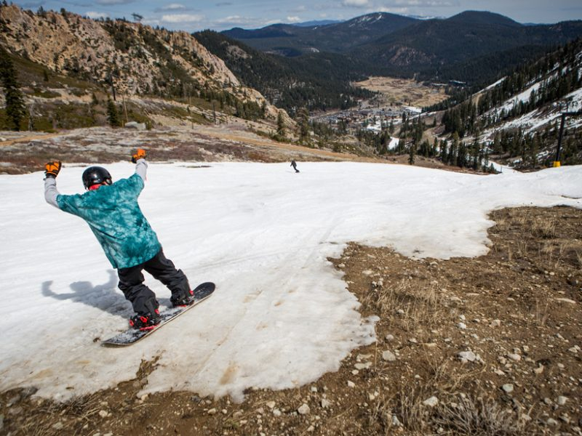A snowboarder threads his way through patches of dirt at Squaw Valley Ski Resort on 21 March 2015 in Olympic Valley, Calif. Credit: Max Whittaker/Getty Images
By Adrian A. Harpold, Michael Dettinger, and Seshadri Rajagopal 28 February 2017
On 12 February, water resource managers at the Oroville Dam issued an evacuation warning that forced some 180,000 Californians to relocate to higher ground. The story of how conditions got to this point involves several factors, but two clearly stand out: the need to prevent water shortages during a record drought, followed by one of the wettest October–February periods in California history. https://eos.org/opinions/defining-snow-drought-and-why-it-matters

http://www.smh.com.au/photogallery/federal-politics/cartoons/david-pope-20120214-1t3j0

Nuclear must be part of the low-carbon mix
Agneta Rising of the World Nuclear Association and Dr Alexander Bannara reply to criticisms of the industry
Tuesday 19 September 2017 03.48 AEST Last modified on Tuesday 19 September 2017 07.00 AEST
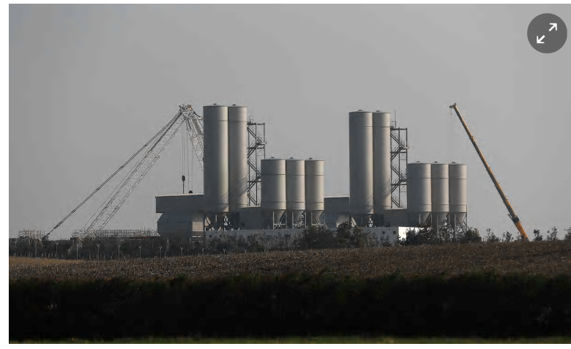
The Hinkley Point C nuclear power station site near near Bridgwater, Somerset. Photograph: Stefan Wermuth/Reuters
Re David Lowry’s criticisms of nuclear energy (Letters, 17 September), it is true that nuclear plants stop generating temporarily for maintenance and repair, but the same is true for most other forms of electricity generation. However, on average these outages represent a much smaller quantity of lost generation compared to the day-to-day intermittency of wind or solar. Nuclear plants spend a high proportion of the time generating at their maximum capacity. https://www.theguardian.com/environment/2017/sep/18/nuclear-must-be-part-of-the-low-carbon-mix
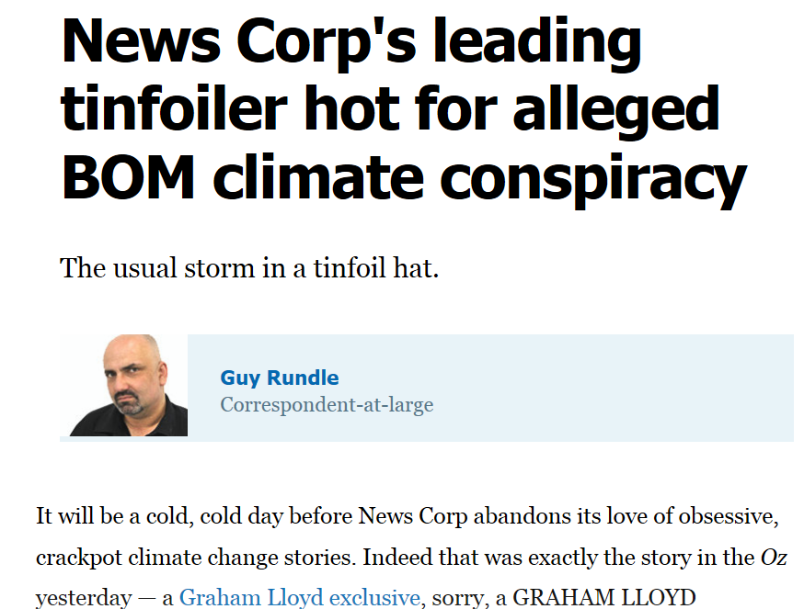
https://www.crikey.com.au/2017/08/02/news-corps-leading-tinfoiler-hot-for-alleged-bom-climate-conspiracy/
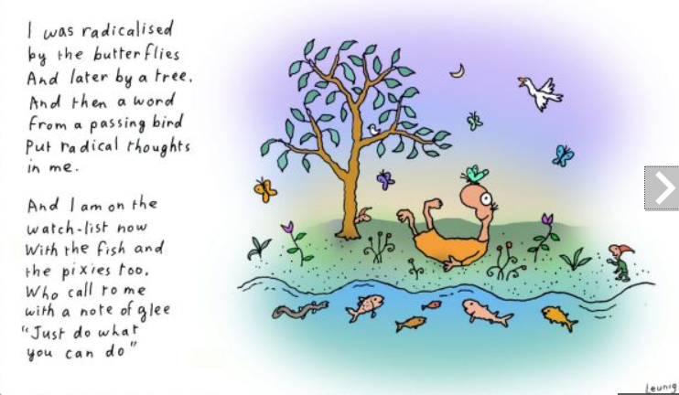
http://www.smh.com.au/photogallery/federal-politics/cartoons/cartoons-by-michael-leunig-20090711-dgl6

“Do You Expect Me to Just Give Away My Data?”
The Editor-in-Chief of JGR: Oceans explains why the new AGU data policy is important for the rigor and long-term security of scientific research.
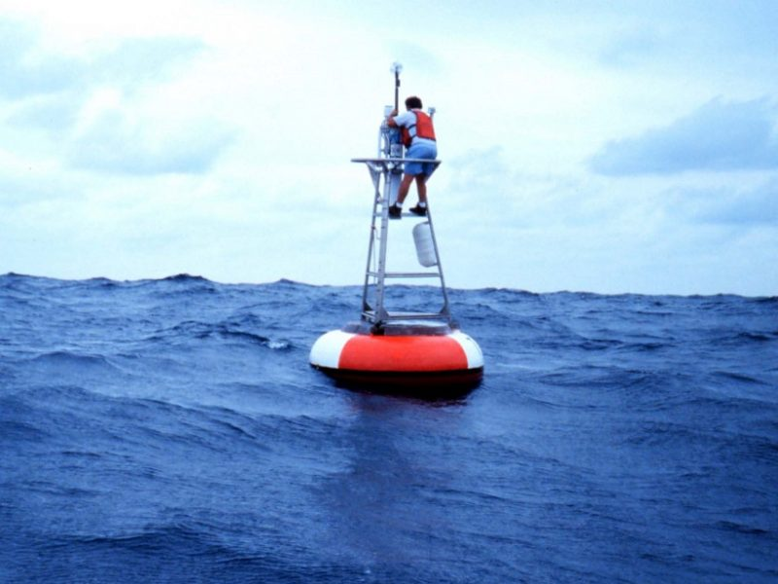We appreciate that many researchers go to great lengths to collect their data but making data sets fully accessible to others via public repositories is important for the future of science. Credit: NOAA
By Peter Breweron 14 September 2017
As Editor-in-Chief of a major AGU journal I frequently deal with inquiries from authors about the process of having their papers accepted for publication. Nothing in the recent past has generated more correspondence than the matter of data reporting requirements, particularly the fact that we no longer permit the statement of “Data available by contacting the author.” I would like to describe, using some personal examples, why AGU’s new data policy is both necessary and a benefit to all. https://eos.org/editors-vox/do-you-expect-me-to-just-give-away-my-data
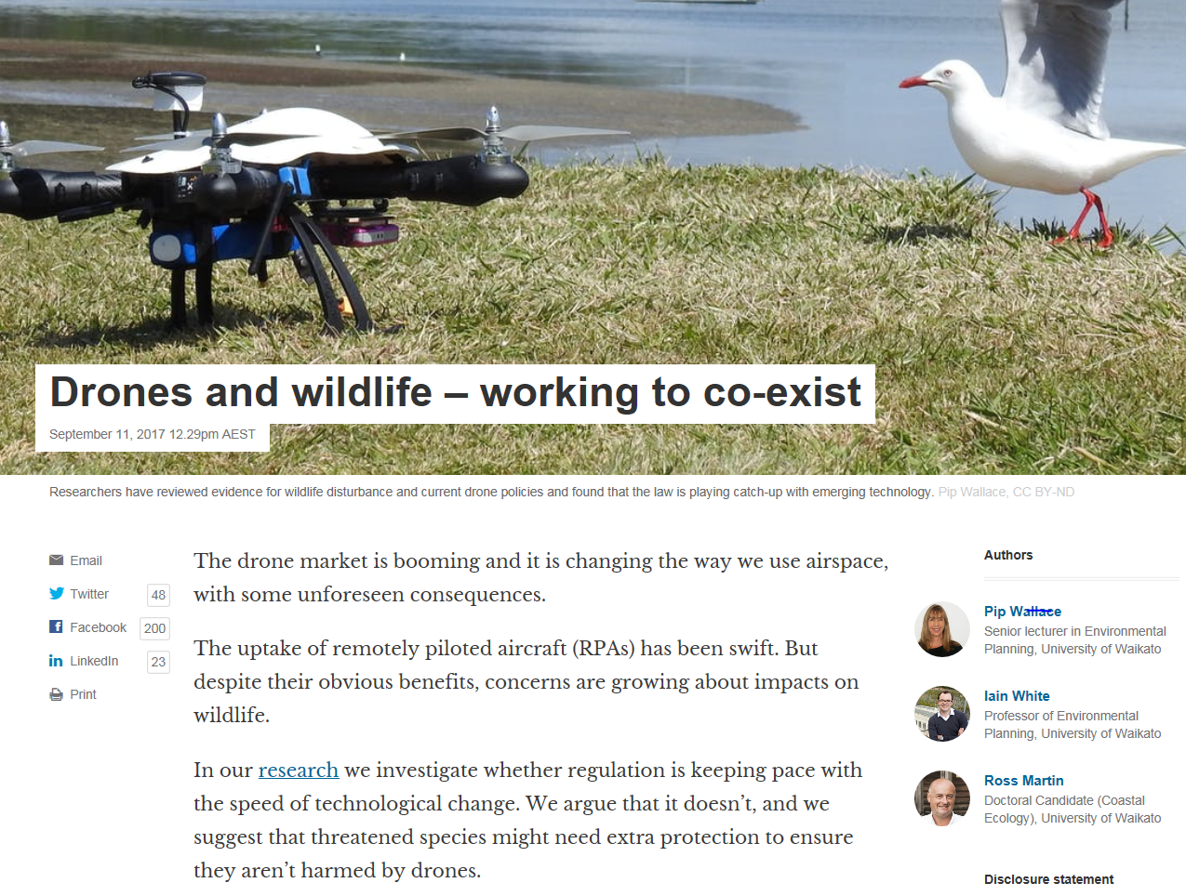
https://theconversation.com/drones-and-wildlife-working-to-co-exist-83488

Environment and energy debate: back to the future as old battlelines re-emerge


Mark Kenny
Parliament this week summoned the nauseating atmosphere Leonard Cohen described in The Future: "things are gonna slide, slide in all directions".
The cause? A surprising new fluidity in the Prime Minister's environmental, er... convictions.
For Labor, it's an intriguing prospect. Charting how the greenest of all Liberals, who lost his leadership for backing emissions trading in 2009 and crossed the floor to support it, has wound up as chief advocate of retaining coal.
Prime Minister Malcolm Turnbull during Question Time at Parliament House. Photo: Alex Ellinghausen
http://www.smh.com.au/federal-politics/political-opinion/environment-and-energy-debate-back-to-the-future-as-old-battlelines-reemerge-20170913-gygu2p.html

http://www.smh.com.au/photogallery/federal-politics/cartoons/illustrations-and-cartoons-by-john-shakespeare-20090909-fhba

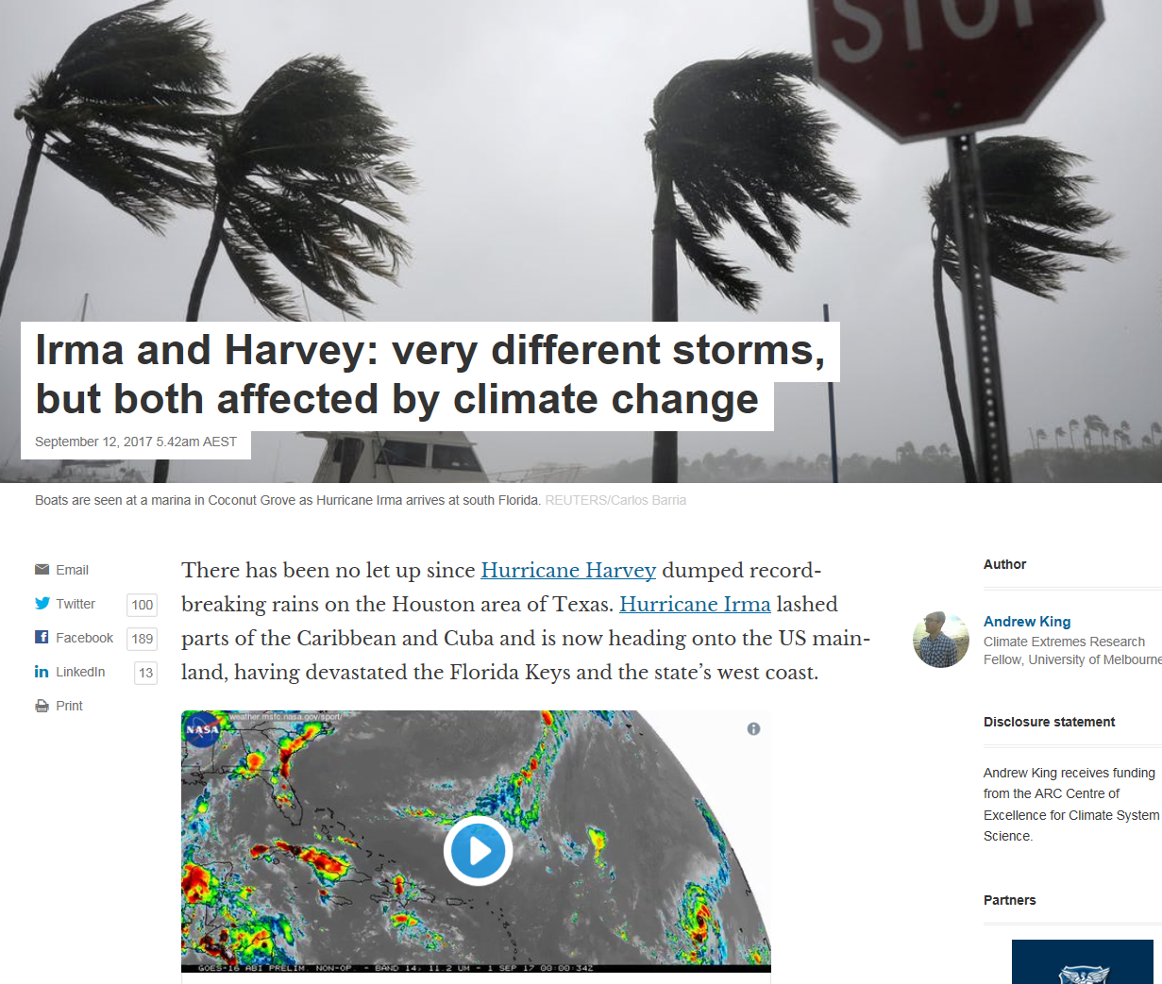
https://theconversation.com/irma-and-harvey-very-different-storms-but-both-affected-by-climate-change-83800
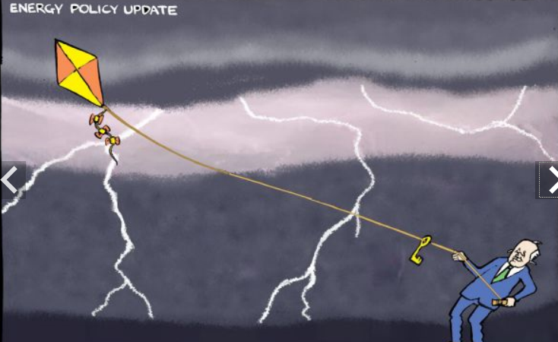
http://www.smh.com.au/photogallery/federal-politics/cartoons/andrew-dyson-20090819-epqv.html

You need to be in Canberra to comprehend the lunacy of politics in 2017


Tony Wright
The world has been stood on its head here in Canberra.
The government that insisted it couldn't decide whether same-sex marriage could be legalised contracts out the question to a divided community through a non-compulsory, non-binding vote...and then, with overwhelming support from across the Parliament, is able to introduce without even need of a vote draconian legislation to stop the hate speech it knew would ensue.
Meanwhile, a government that has no settled energy policy publicly tries to bully a large energy company to keep open a clapped-out coal-burning power station because its own lack of a plan is looming as an electoral disaster, tempting blackouts. http://www.smh.com.au/federal-politics/political-opinion/you-need-to-be-in-canberra-to-comprehend-the-lunacy-of-politics-in-2017-20170913-gygpkc.html

Connecting Science to Policy in New York
Posted by shanlon 15 September 2017
AddThis Sharing Buttons
Share to FacebookShare to TwitterShare to PrintShare to EmailShare to More1
By Arianna Varuolo-Clarke, Claudia Hinrichs, Tara Dolan, & Kylie Langlois
We are a group of graduate students from Stony Brook University’s School of Marine and Atmospheric Sciences (SoMAS) that got to meet with congressional staff from our representative’s district office as part of AGU’s District Days. The meeting was organized by Dr. Kevin Reed, a professor of Atmospheric Science here at SoMAS, and we met with Legislative Assistant, Kevin Dowling of Representative Lee Zeldin (NY-1) district office. We are Arianna Varuolo-Clarke (Atmospheric Science), Claudia Hinrichs (Physical Oceanography), Kylie Langlois (Microbial Ecology), and Tara Dolan (Fisheries Science).
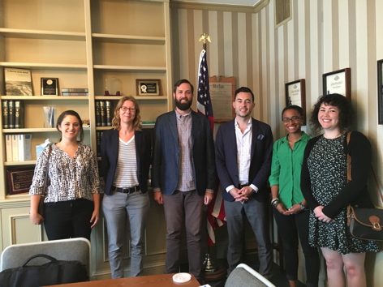Prior to the meeting, Elizabeth Landau and Timia Crisp of the AGU science policy team, along with Dr. Reed, gave us a brilliant crash-course in how to effectively communicate with our district office. It even included a throwback to the Schoolhouse Rock’s “I’m just a bill” . One of the important things we learned is that the Representative’s staffers are your best friend: they are smart, often young, and highly informed individuals who run the show behind the scenes. Staffers have a lot of influence on the Representative’s position on key issues, agenda, and even specific talking points. We were ready to meet with Rep. Zeldin’s team and we had a message. http://blogs.agu.org/sciencecommunication/2017/09/15/connecting-science-policy-new-york/
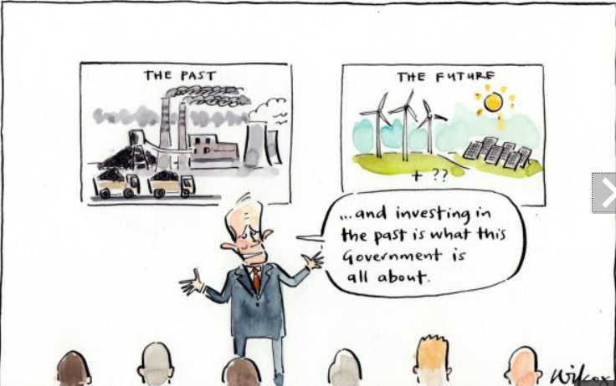
http://www.smh.com.au/photogallery/federal-politics/cartoons/cartoons-by-cathy-wilcox-20090909-fhd6

Wind farms loom as ballot box issue
ED GANNON, The Weekly Times
September 13, 2017 3:06pm
SEVEN years ago, in my first column in this series, I wrote of how wind farms were causing much angst in the bush.
The column was written less than a week after Julia Gillard became the nation’s first female Prime Minister and days after the federal Renewable Energy Target was legislated, mandating that 20 per cent of Australia’s energy supply must be from renewable resources by 2020.
At the time there were eight wind farms in Victoria operating 266 turbines
http://www.weeklytimesnow.com.au/news/opinion/wind-farms-loom-as-ballot-box-issue/news-story/43e7cd054ef1752e4bab5a2490b52c05
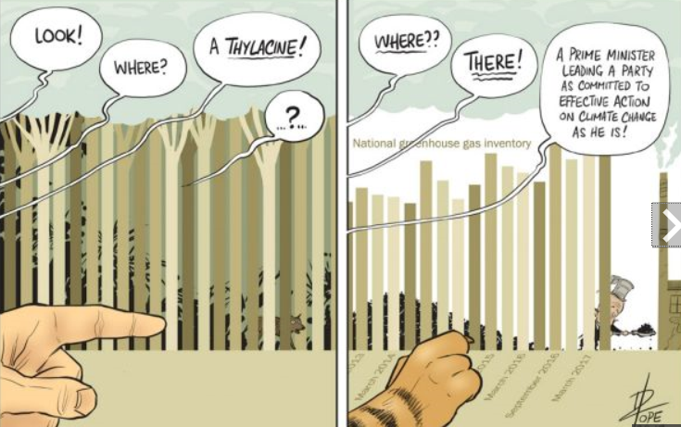
http://www.smh.com.au/photogallery/federal-politics/cartoons/david-pope-20120214-1t3j0
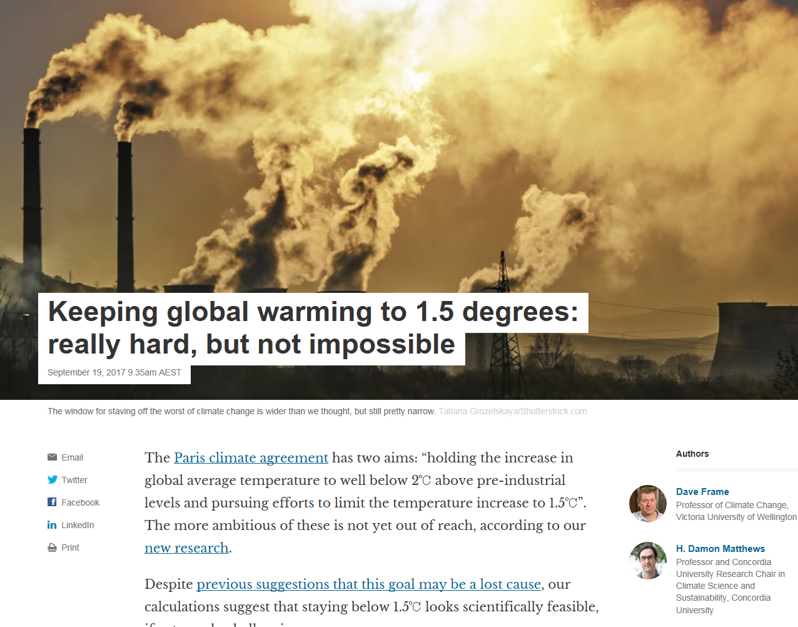
https://theconversation.com/keeping-global-warming-to-1-5-degrees-really-hard-but-not-impossible-84203
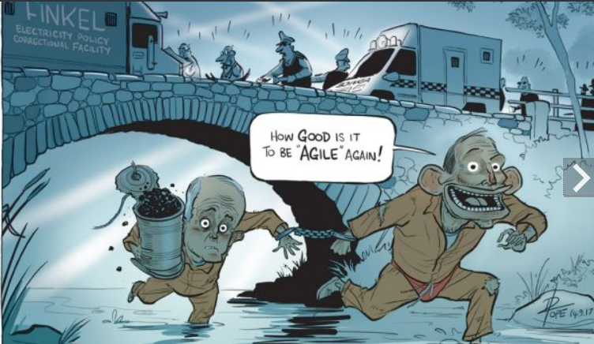
http://www.smh.com.au/photogallery/federal-politics/cartoons/david-pope-20120214-1t3j0
“Even if I’m unwilling to advocate for particular policies in my role as a scientist, I am more than ready to advocate for what we do” Robert Pincus, EOS News

