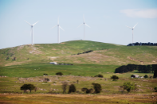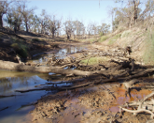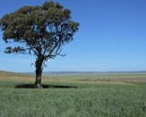

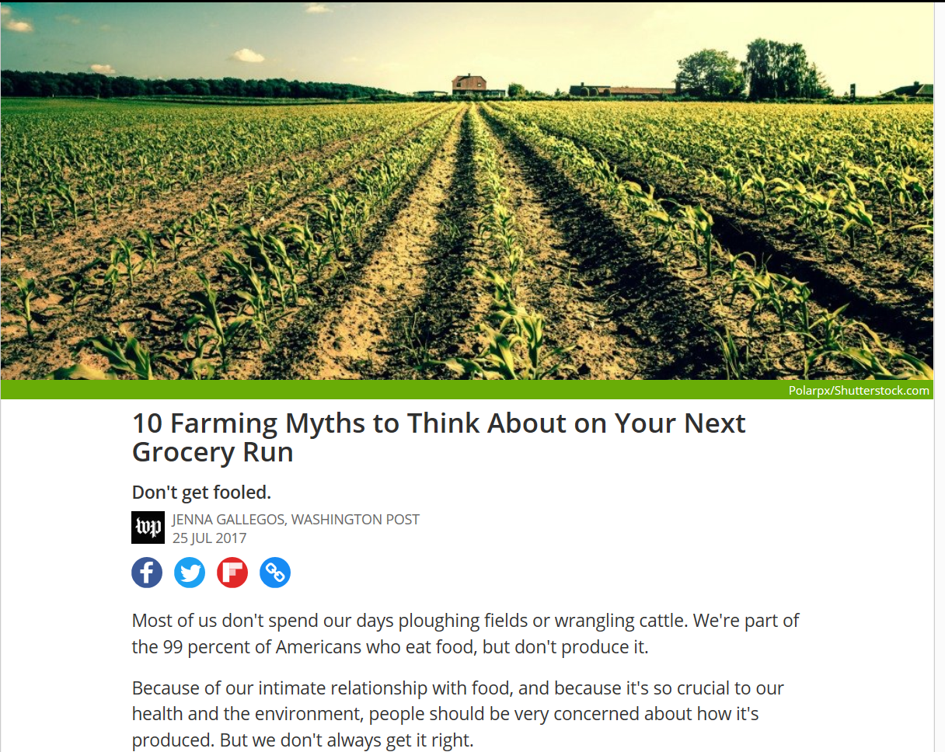

http://www.sciencealert.com/10-farming-myths-to-think-about-on-your-next-grocery-run

Opinion

Building soil fertility in a sustainable way

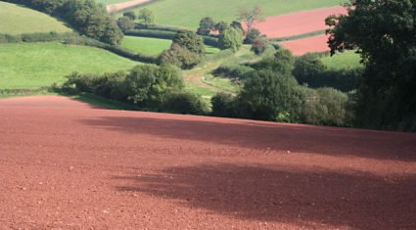
By John McHugh, dairy farmer, Portlaoise, Co. Laois
Recently, soil scientists from Rothemsted Research in the UK, and Wageningen University in the Netherlands, undermined the French proposal to increase soil carbon by 0.4% per year, stating the figures don’t add up. http://www.agriland.ie/farming-news/opinion-building-soil-fertility-sustainably/

Living Soils: The Role of Microorganisms in Soil Health
5 JULY 2017
In his paper titled “Living Soils: The Role of Microorganisms in Soil Health” Christopher Johns, Research Manager of the Northern Australia and Land Care Research Programme, writes that The wealth of biodiversity below ground is vast and unappreciated: millions of microorganisms live and reproduce in a few grams of topsoil and these organisms are critical to soil health and fertility. Soil biological fertility is, however, the least well-understood soil fertility component. Soil microorganisms also play essential roles in the nutrient cycles that are fundamental to life on the planet. A better understanding of soil microbiology is essential if agricultural production is to sustainably meet the needs of a growing world population. http://www.futuredirections.org.au/publication/living-soils-role-microorganisms-soil-health-2/

Government’s letter to conservation groups has ominous implications
Lenore Taylor
New reporting rules seem to represent a big win for the campaign by the mining sector and conservative politicians to stifle environmental advocacy
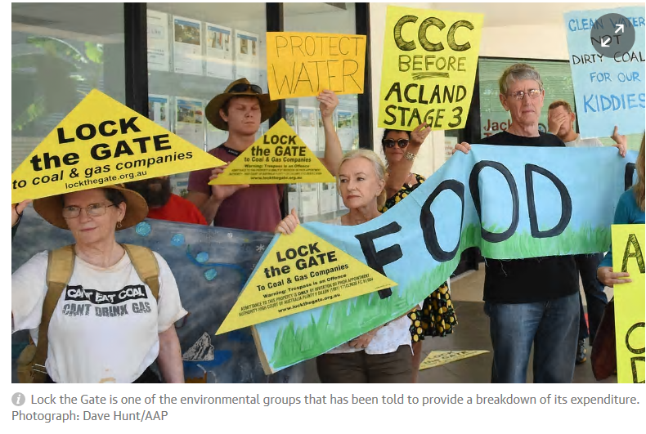
Saturday 15 July 2017 10.00 AEST Last modified on Saturday 15 July 2017 10.19 AEST
The environment department has recently begun sending letters to conservation groups registered as eligible for tax deductible donations, as they do every year. But this year the correspondence is different, in a disturbing way.
In the past the groups, which include all the big names such as the Australian Conservation Society, The Wilderness Society, Lock the Gate, Greenpeace etc, as well as small local conservation organisations, were simply asked to reveal the total expenditure from their public fund. This year they have also been asked to break down their expenditure into the amounts spent on “on ground environmental remediation”, “campaign and advocacy”, “research” and other administration. https://www.theguardian.com/environment/2017/jul/15/governments-letter-to-conservation-groups-has-ominous-implications

Avoiding Predators in Publishing
As the number of publishers that choose profit over ethics grows, find out how to avoid their scams and support organizations promoting best practices in scholarly communication.
Credit: iStock.com/Rasmus-Raahauge
By Brooks Hanson and Jenny Lunn 19 June 2017
As the saying goes, when no one is talking about money, you can be sure that it’s really all about money. We assume that organizations involved in scholarly communication, primarily publishing and conferences, aim foremost to share and promote good research. However, journals and meetings are big business, and financial viability is a key concern. This inherent conflict of interest, as highlighted in an Editors’ Vox post that published today, deserves more attention and awareness. https://eos.org/opinions/avoiding-predators-in-publishing
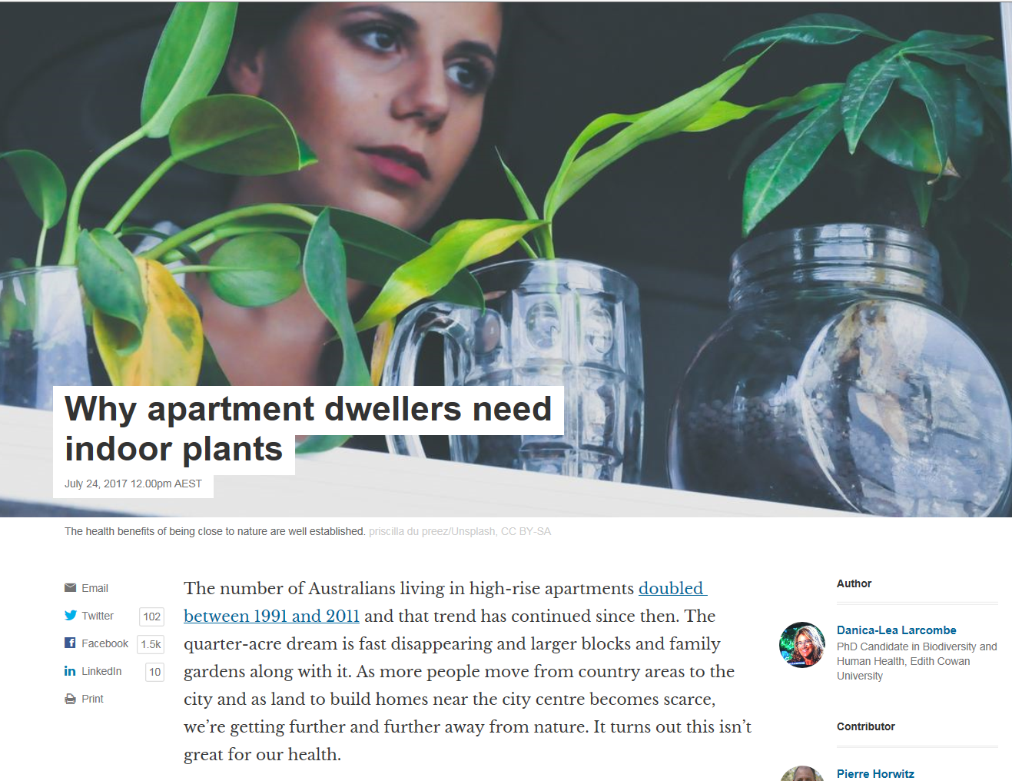
https://theconversation.com/why-apartment-dwellers-need-indoor-plants-80196

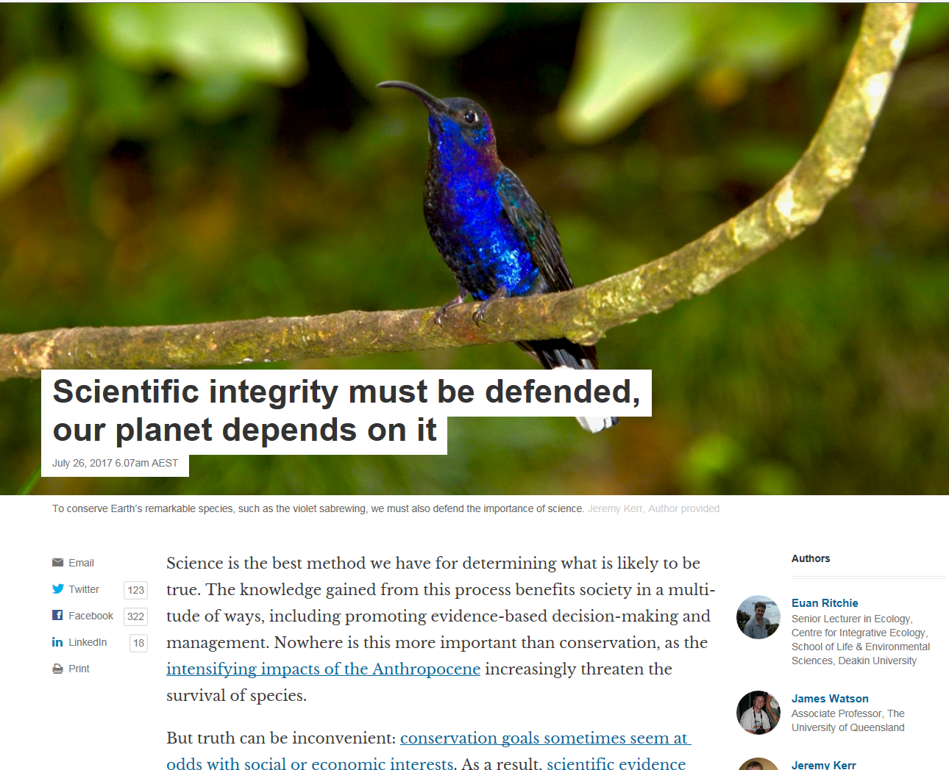
https://theconversation.com/scientific-integrity-must-be-defended-our-planet-depends-on-it-79034

What is the point of the $262m? The mine can still go ahead.
Editorial22 Jul 2017, 4:55 a.m.
Editorial
Aa
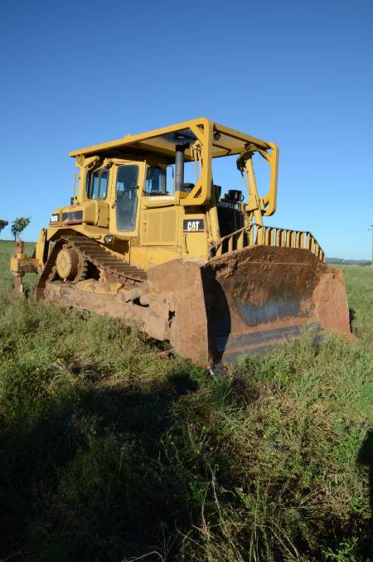
Farmers on the Liverpool Plains are not buying the government’s spin that the $262 million partial buy-back of Shenhua’s Watermark exploration area is a win for them. Nor should tax payers.
Logic says the depth of the mine means it will go below the aquifers, also the lifeblood of the plains. Productive black soil is only part of the equation – water is what makes that dirt worth fighting for, and that is what is most at risk. http://www.theland.com.au/story/4799171/the-coalitions-black-soil-plains-masquerade/?cs=4765

Rise of mega farms: how the US model of intensive farming is invading the world
Demand for cheaper food and lower production costs is turning green fields into industrial sheds to process vast amounts of meat and poultry
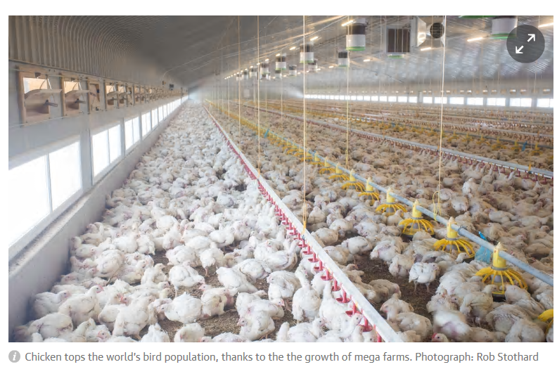Fiona Harvey, Andrew Wasley, Madlen Davies and David Child
Wednesday 19 July 2017 01.06 AEST Last modified on Wednesday 19 July 2017 03.30 AEST
Since the days of the wild west frontier, the popular image of American farming has been of cowboys rounding up steers on wide open ranches, to whoops, whips and hollers. Today, the cowboys on their ranches under wide open skies have been replaced by vast sheds, hulking over the plains, housing tens of thousands of animals each, with the noises and smells spreading far beyond their fences. https://www.theguardian.com/environment/2017/jul/18/rise-of-mega-farms-how-the-us-model-of-intensive-farming-is-invading-the-world

Trust must be earned and Turnbull needs it
Mal Peters23 Jul 2017, 4:47 a.m.
Opinion
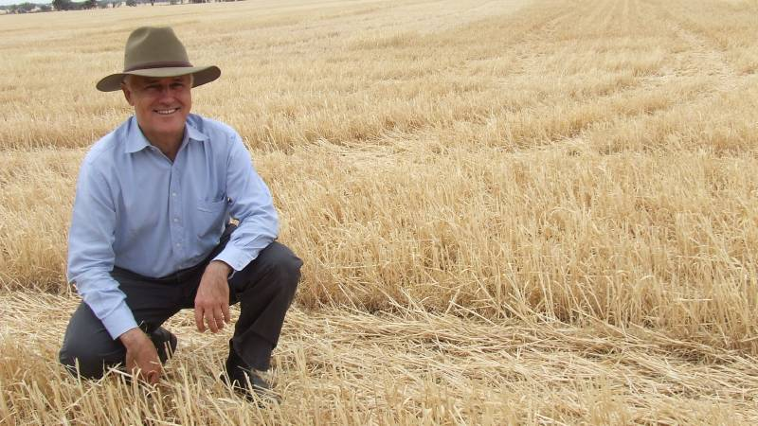
It will take more than a pair of RM Williams and an Akubra for Prime Minister Malcolm Turnbull to win the hearts and minds of Australians.
CENSUS data reveals the average age of farmers is 56, which means our industry is getting younger. Yet we still have a problem with young people getting a foot in the door. Now a liveable area with stock and plant can cost $2 million, making it bloody hard. Young people should not be daunted, as 38 years ago I recall the impossibility of getting into the industry myself without family support, but with learning to pick myself up after each fall, we eventually made it. http://www.theland.com.au/story/4793415/trust-must-be-earned-and-turnbull-needs-it/?cs=4763
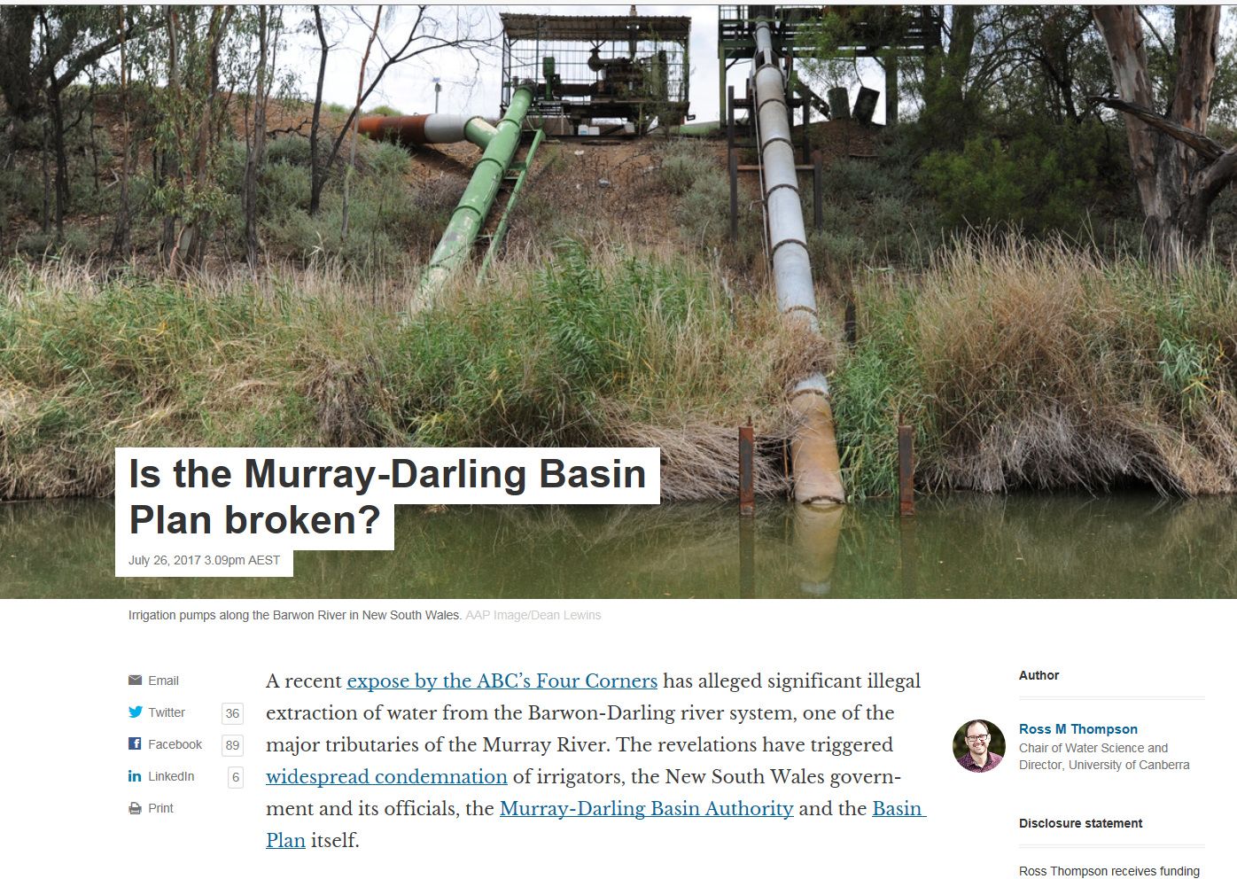
https://theconversation.com/is-the-murray-darling-basin-plan-broken-81613

Independent inquiry needed to restore community confidence in MDBA plan​
Mal Peters26 Jul 2017, 3:30 p.m.
Opinion
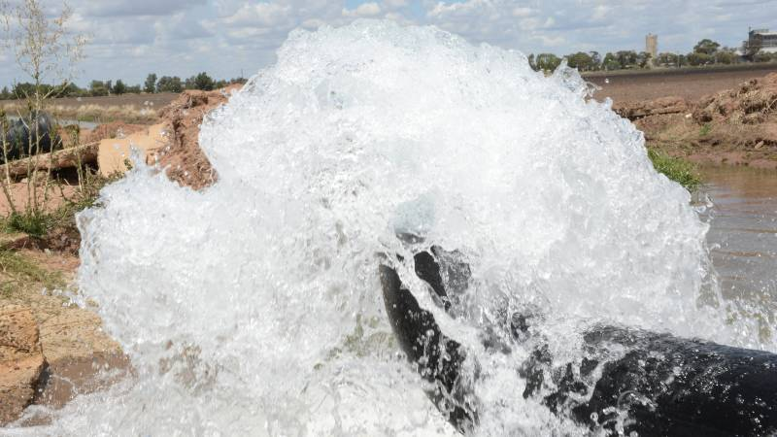
Irrigators and basin communities will not be impressed if the government sits on their hands following recent allegations of water theft.

Opinion
IRRIGATION communities have endured the heartache of three major water reforms and each have been extremely disrupting and stressful.
The current Murray Darling Basin Plan (MDBA) was meant to be the last but anomalies in the Barwon Darling River mean that will not be the case. http://www.theland.com.au/story/4813983/independent-inquiry-needed-to-restore-community-confidence-in-mdba-plan/?cs=4763
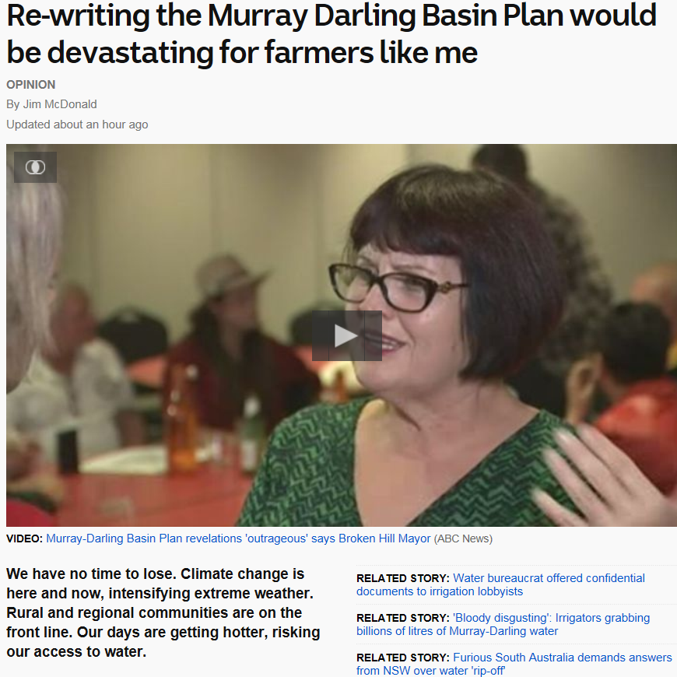
http://www.abc.net.au/news/2017-07-27/rewriting-murray-darling-basin-plan-would-be-devastating/8746532
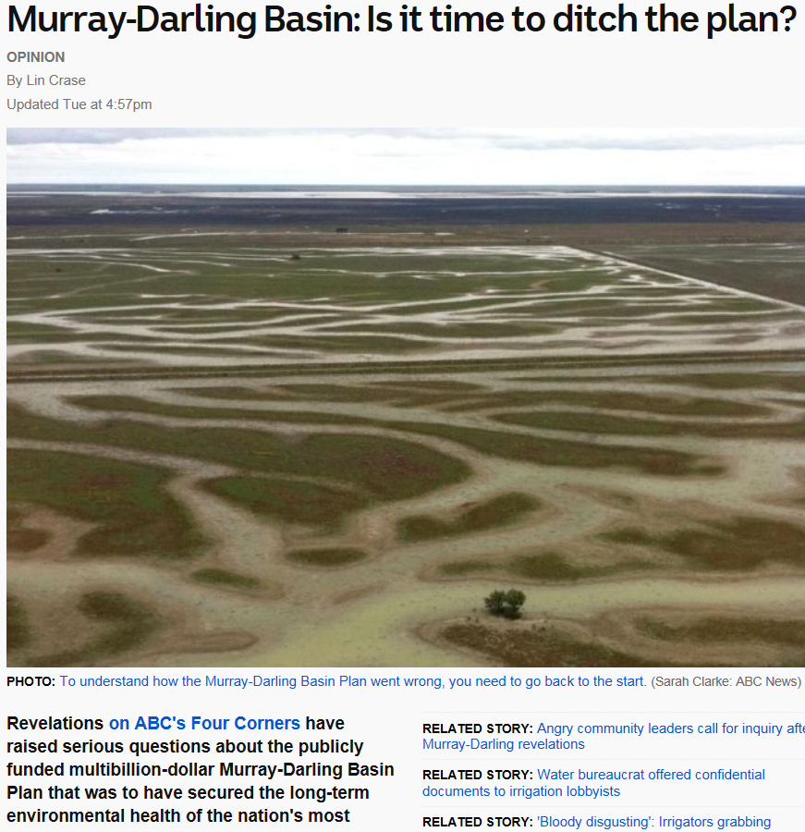
http://www.abc.net.au/news/2017-07-25/lin-crase-is-it-time-to-ditch-murray-darling-basin-plan/8741404

http://www.abc.net.au/radionational/programs/ockhamsrazor/fighting-ignorance-in-ivory-towers/8521114
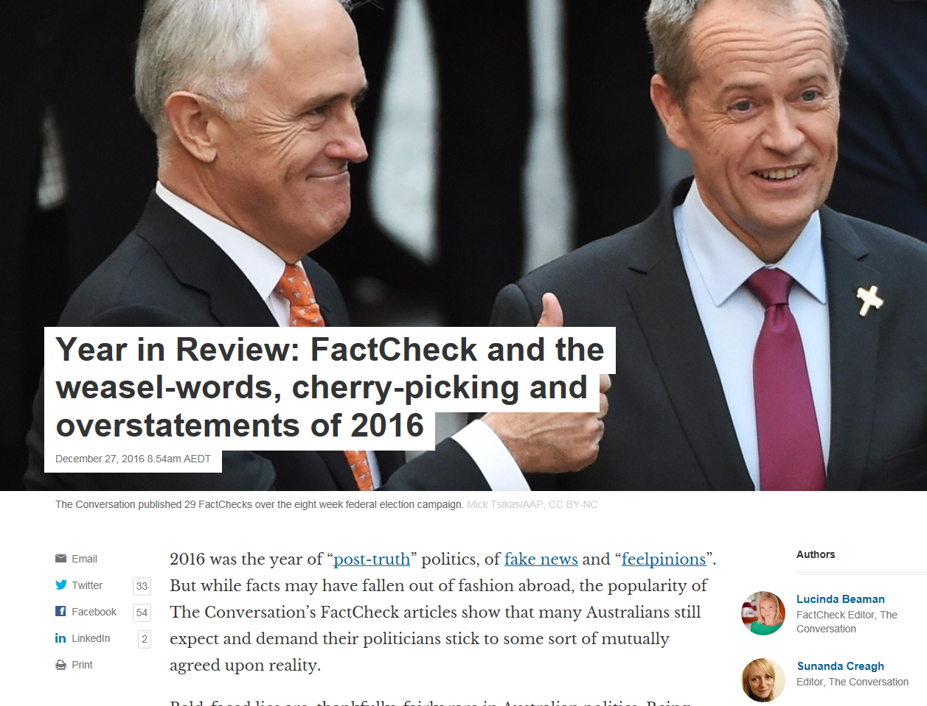
https://theconversation.com/year-in-review-factcheck-and-the-weasel-words-cherry-picking-and-overstatements-of-2016-70593
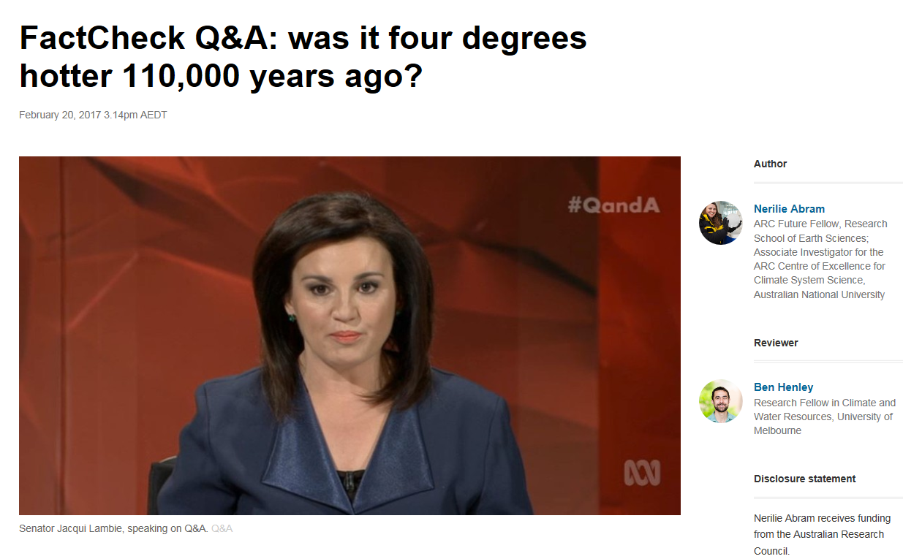
https://theconversation.com/factcheck-qanda-was-it-four-degrees-hotter-110-000-years-ago-73045
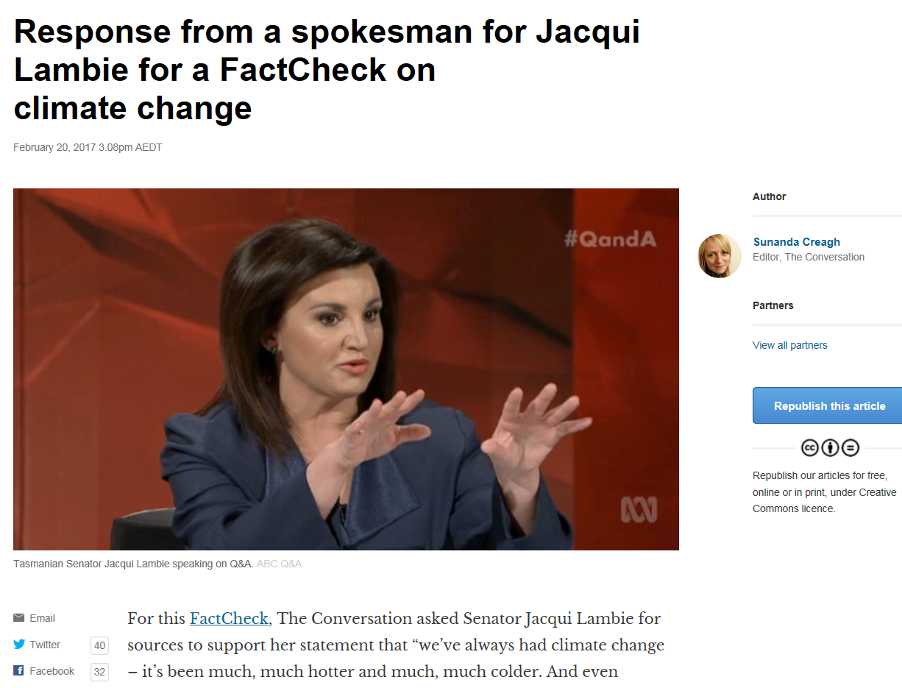
https://theconversation.com/response-from-a-spokesman-for-jacqui-lambie-for-a-factcheck-on-climate-change-73064
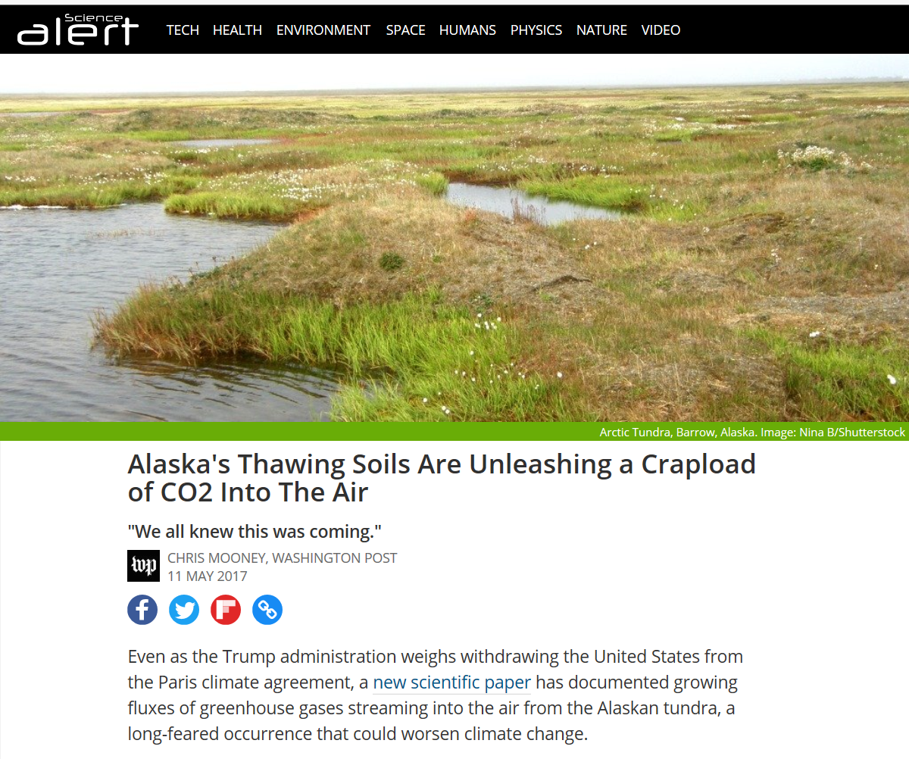
https://www.sciencealert.com/alaska-s-thawing-soils-are-now-pouring-carbon-dioxide-into-the-air?perpetual=yes&limitstart=1

Keeping the faith in the bush
NSW Farmers22 Jul 2017, 3 p.m.
Opinion
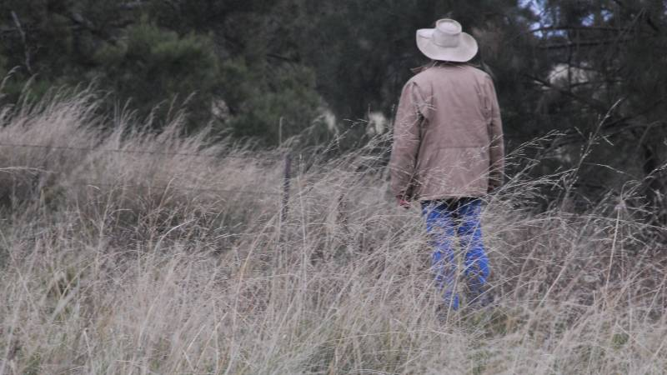
MORE than 120 years ago, the pastoralists and graziers of NSW gathered to argue for their interests, influence government policy and get a fair deal for their operations.
Continuing that tradition, NSW Farmers’ 2017 annual conference remains the foundation of grassroots advocacy for agriculture in New South Wales. Our three-day conference in Sydney sets the agenda for rural advocacy http://www.theland.com.au/story/4799455/keeping-the-faith-in-the-bush/?cs=4763

Turning the climate crisis into a TV love child of Jerry Springer and Judge Judy
Graham Readfearn
As a Trump appointee pushes for televised slanging match, a New York magazine cover story sparks a different debate – should we talk about how bad global warming could actually get?
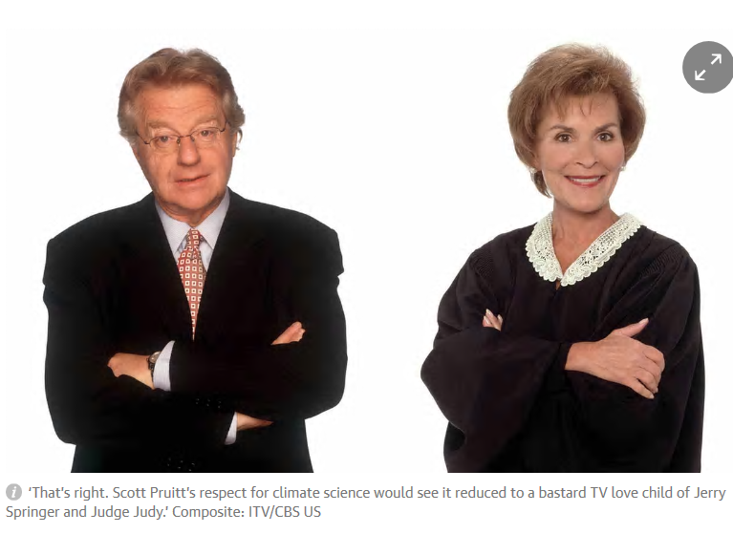
Thursday 13 July 2017 10.49 AEST Last modified on Saturday 15 July 2017 02.44 AEST
In the United States, people who refuse to accept even some of the basic tenets of climate science are calling for a heated debate.
“Who better to do that than a group of scientists … getting together and having a robust discussion for all the world to see,” the boss of the Environmental Protection Agency, Scott Pruitt, told Reuters. https://www.theguardian.com/environment/planet-oz/2017/jul/13/turning-the-climate-crisis-into-a-tv-love-child-of-jerry-springer-and-judge-judy
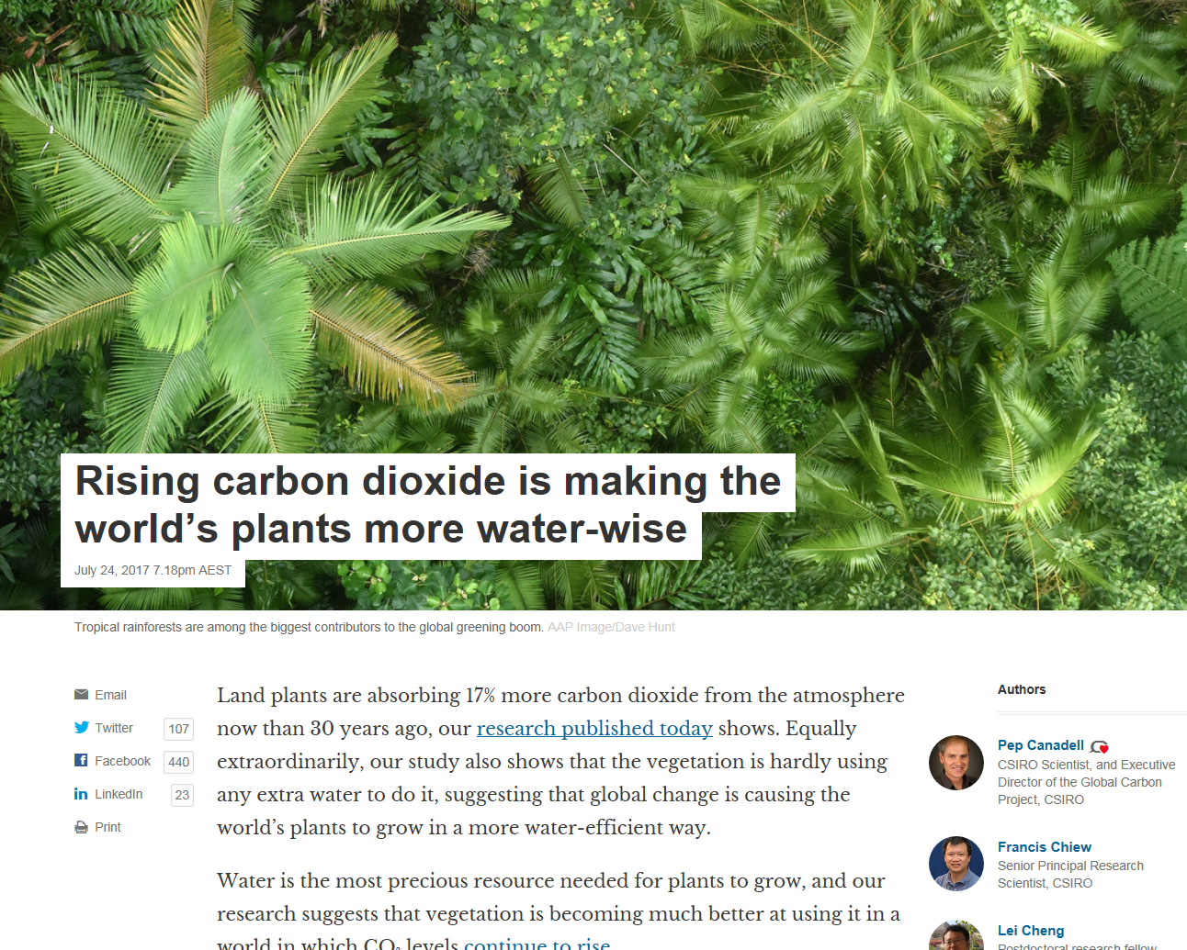
https://theconversation.com/rising-carbon-dioxide-is-making-the-worlds-plants-more-water-wise-79427

Ireland's staggering hypocrisy on climate change
The national climate policy is a greenwash – the country is certain to miss its 2020 emissions target and still handing out drilling licences
John Gibbons
Wednesday 26 July 2017 16.30 AEST Last modified on Wednesday 26 July 2017 22.26 AEST
On the face of it, Ireland appears to be acting on climate change. Last year it appointed its first ever “climate action minister”, and in June it outlawed onshore fracking. What’s more, the telegenic new taoiseach Leo Varadkar dedicated much of the first day of his Cabinet retreat to discussing climate change.
Last week Varadkar introduced Ireland’s first national mitigation plan (NMP) in more than a decade, and said that addressing climate change would “require fundamental societal transformation and, more immediately, allocation of resources and sustained policy change.” If success could be measured simply by repetition – the word “sustainable” appears no fewer than 110 times in the NMP – Ireland would undoubtedly be among the world’s leading countries. https://www.theguardian.com/environment/2017/jul/26/irelands-staggering-hypocrisy-on-climate-change

Let’s talk about soil: Food and Agriculture Organization of the United Nations
The current state of global soil resources around the world presents environmentalists, farmers and indeed, everyone who’s concerned about long-term survival, with a major challenge.
Our soils have suffered as the result of widespread degradation, urbanisation, land-grabbing and over-exploitation; this animated short film, made by the Food and Agriculture Organization of the United Nations (FAO) depicts the way in which soils become depleted and degraded, and offers options for managing the world’s soils in a more sustainable way. http://www.aginnovators.org.au/news/let%E2%80%99s-talk-about-soil-food-and-agriculture-organization-united-nations

Water quality more important than volumes in Murray-Darling Basin

Pennie Scott@bushgoddess
6 Jul 2017, 4 p.m.
News
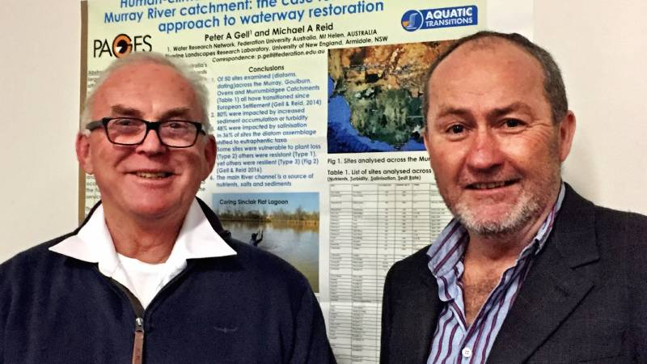
Southern Riverina Irrigators chairman, Graeme Pyle, Berrigan, with Professor Peter Gell, guest speaker at the annual Water and Weather Event at Deniliquin last week.
HIGH volume water occurring as releases from the Murray-Darling Basin Plan’s environmental flows, are causing more harm to the Murray River’s health than help, says one researcher who spoke at last week’s annual Deniliquin Weather and Water Event. http://www.theland.com.au/story/4768920/more-harm-than-help/

Climate Change Indicators Are Not Enough
Extreme events capture the public’s attention, but gradual climate shifts will more profoundly affect civilization and life on Earth. Scientists must get better at conveying this to the public.
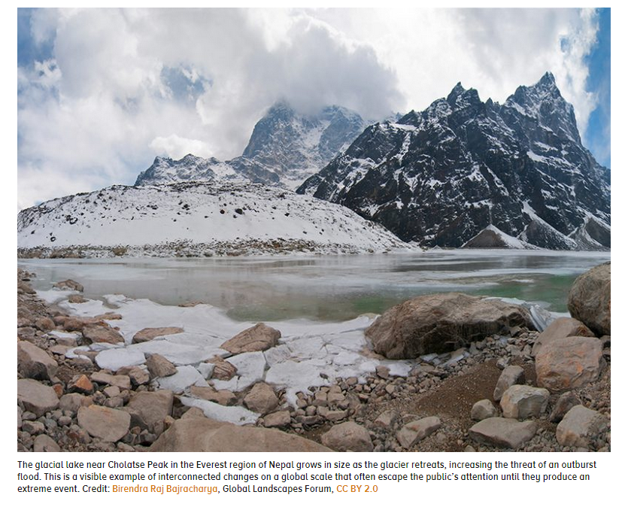
The glacial lake near Cholatse Peak in the Everest region of Nepal grows in size as the glacier retreats, increasing the threat of an outburst flood. This is a visible example of interconnected changes on a global scale that often escape the public’s attention until they produce an extreme event. Credit: Birendra Raj Bajracharya, Global Landscapes Forum, CC BY 2.0
By Alan K. Betts 14 July 2017
Dealing with climate change will require transforming both science and society in the coming decades. Society is struggling to accept the idea that Earth’s climate will change radically this century unless we double or triple energy efficiency and rapidly shift from burning fossil fuels to renewable energy sources. https://eos.org/opinions/climate-change-indicators-are-not-enough

Clean energy target: how the states might make it work
Victoria and South Australia have suggested a states-led initiative if the federal government continues to stall on a clean energy target. Could it work?
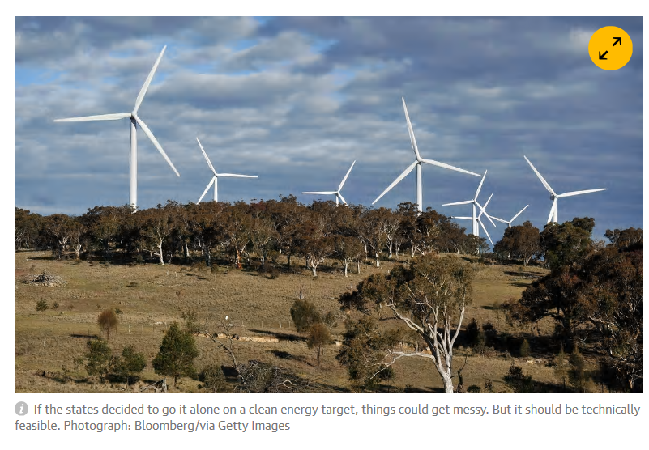
Friday 14 July 2017 10.39 AEST Last modified on Friday 14 July 2017 10.40 AEST
Australian states exasperated by federal government inaction on the key Finkel review recommendation of a clean energy target have indicated they might band together and go it alone if the federal Coalition does not provide the required leadership.
Before Friday’s meeting of energy ministers, for which the federal government refused to put a CET on the agenda, Labor-led Victoria and South Australia called for consideration of a linked-up state-based scheme, and urged Coalition-led NSW to join up. Given recent comments by the NSW energy minister, Don Harwin, who indicated support for the CET, such a move seems plausible. https://www.theguardian.com/environment/2017/jul/14/clean-energy-target-how-the-states-might-make-it-work

Shenhua coal 'buyout' set a low watermark that should prompt mining reform
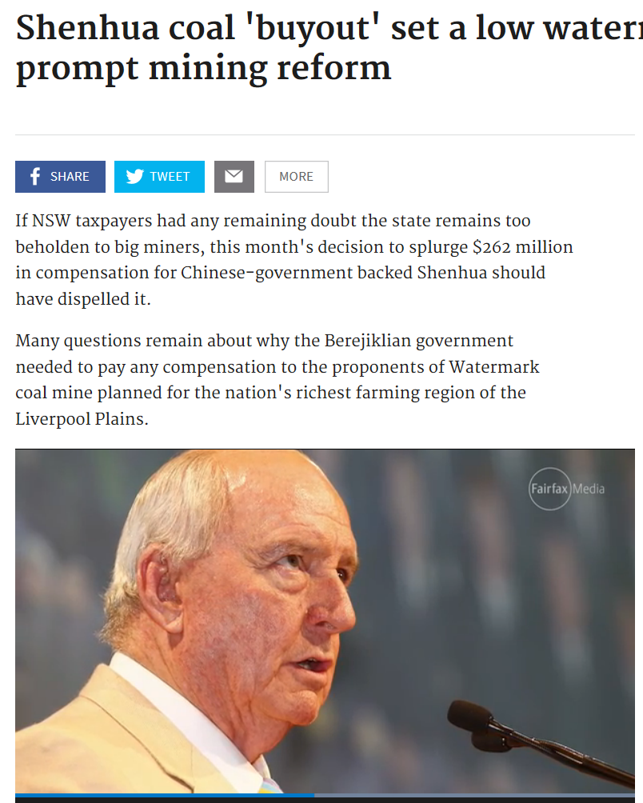If NSW taxpayers had any remaining doubt the state remains too beholden to big miners, this month's decision to splurge $262 million in compensation for Chinese-government backed Shenhua should have dispelled it.
Many questions remain about why the Berejiklian government needed to pay any compensation to the proponents of Watermark coal mine planned for the nation's richest farming region of the Liverpool Plains. http://www.smh.com.au/comment/smh-editorial/shenhua-coal-buyout-set-a-low-watermark-that-should-prompt-mining-reform-20170722-gxgmdh.html

Ideologies are increasingly driving policy
EDITORIAL15 Jul 2017, 5:30 a.m.
Editorial
Aa
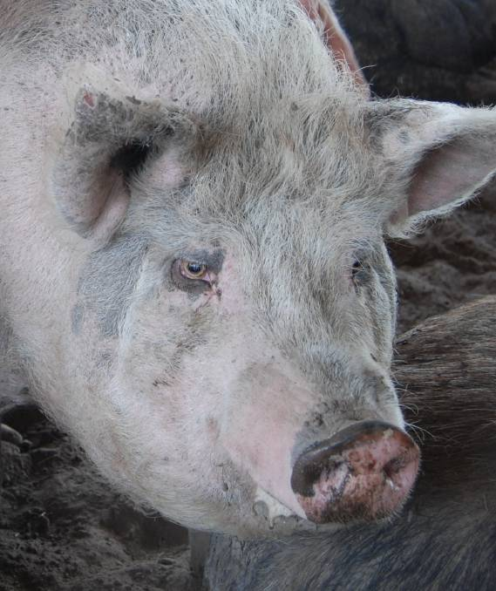
THE pressures of ideological groups and their views are gradually, but surely, squeezing agriculture from all sides.
In this week’s paper, just looking at the livestock sector, we have competing bodies on the back page offering alternative welfare standards for wool, we also have a report on the Harden town meeting where the pros and cons were debated about a proposed piggery for which the outcome was already determined by the Environment Protection Authority (EPA) (pending a potential Land and Environment Court application). http://www.theland.com.au/story/4785411/ideologies-are-increasingly-driving-policy/?cs=4765

Catherine Bertini: Ending Hunger Is Within Our Grasp
In this guest blog post, Catherine Bertini, distinguished fellow, Global Food and Agriculture at the Chicago Council on Global Affairs, and professor of public administration and international affairs, Maxwell School, Syracuse University, reflects on the progress made in tackling malnutrition, and the challenge that remains to achieve zero hunger.
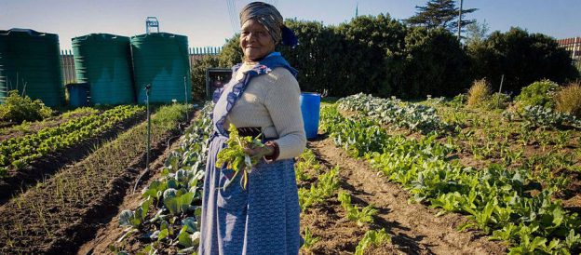
After years of incremental progress in the fight against poverty and malnutrition, eradicating hunger is now within our grasp. The world is changing, and we face growing challenges and new risks—but we’ve also never been as well prepared to meet these challenges. Ending hunger will require action, engagement, commitment, and collaboration from all sectors, across generations, and from every corner of the world. https://farmingfirst.org/2017/03/catherine-bertini-ending-hunger-is-within-our-grasp/?utm_source=feedburner&utm_medium=email&utm_campaign=Feed%3A+FarmingFirst+%28Farming+First%29
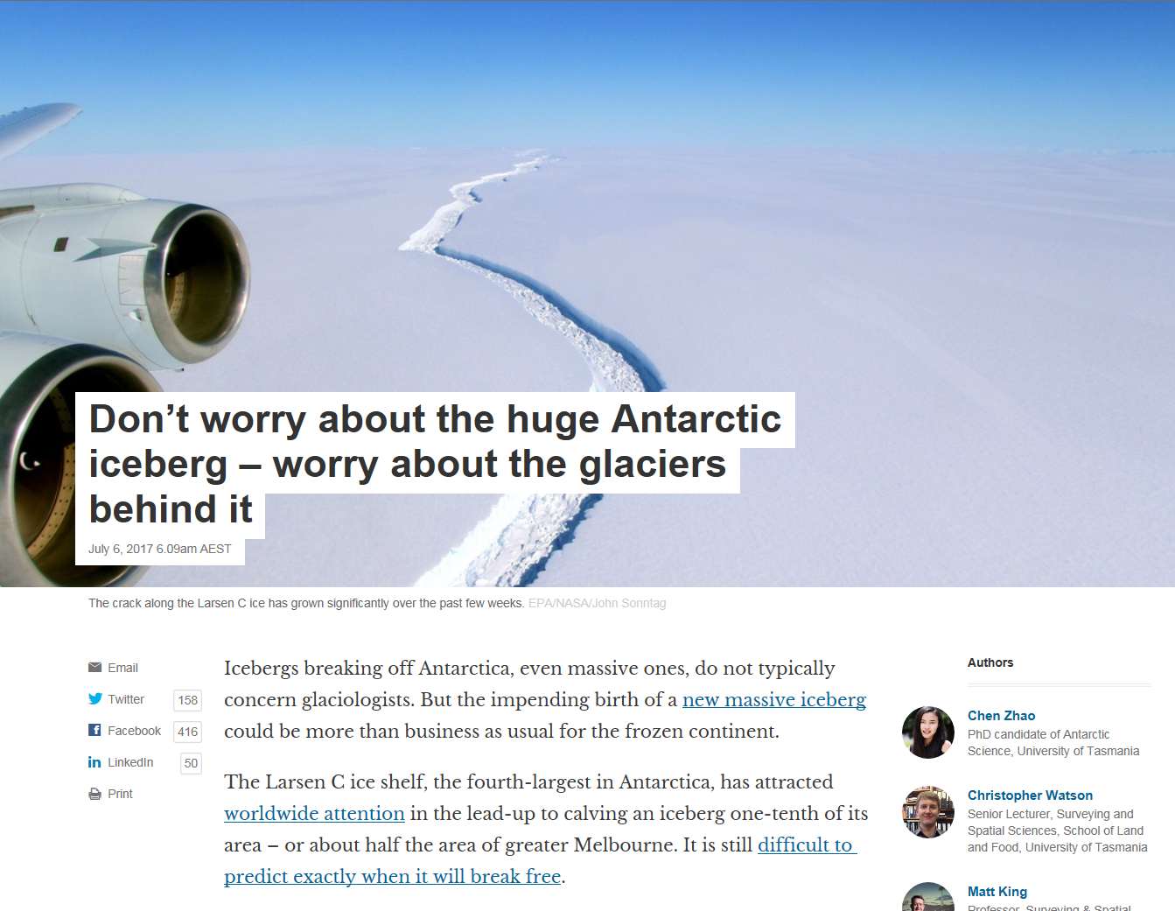
https://theconversation.com/dont-worry-about-the-huge-antarctic-iceberg-worry-about-the-glaciers-behind-it-80314

Climate and Other Models May Be More Accurate Than Reported
Replacing a commonly used statistical measure of average error with an alternative measure would give a more meaningful assessment of model performance.
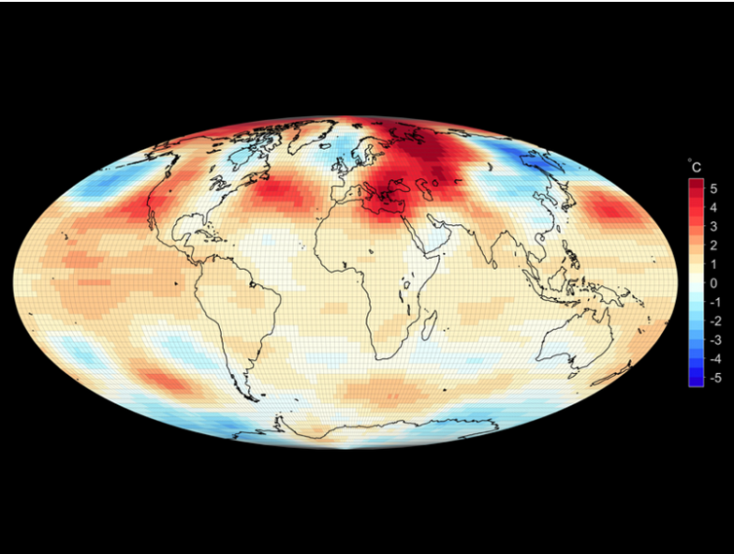

Temperature anomalies (deviations from the 1981–2010 monthly mean in degrees Celsius) estimated from advanced microwave sounding unit data for February 2016. Estimates of their spatially averaged magnitude, using sum-of-squares-based average-deviation measures, such as the root-mean-square or standard deviation, would erratically overestimate their true spatially averaged magnitude. Data are from theNational Space Science and Technology Center, University of Alabama in Huntsville.
By Cort J. Willmott, Scott M. Robeson, and Kenji Matsuura 21 June 2017
Almost all areas of the sciences use models to study and predict physical phenomena, but predictions and conclusions are only as good as the models on which they are based. The statistical assessment of errors in model prediction and model estimation is of fundamental importance. Recent reports of the Intergovernmental Panel on Climate Change (IPCC), for example, present and interpret several commonly used estimates of average error to evaluate and compare the accuracies of global climate model simulations [Flato et al., 2013]. https://eos.org/opinions/climate-and-other-models-may-be-more-accurate-than-reported

Why the Republican party's climate policy obstruction is indefensible
Dana Nuccitelli
It’s unscientific, fails basic risk management, is bad for the economy, and immoral
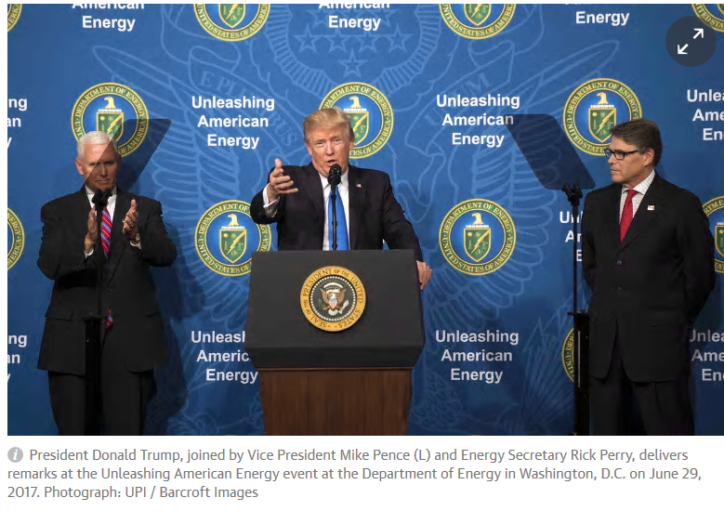Wednesday 5 July 2017 20.00 AEST Last modified on Thursday 6 July 2017 03.32 AEST
Two weeks ago, Senator Al Franken (D-MN) had an exchange with Trump’s Department of Energy Secretary Rick Perry about climate change.
Facebook Twitter Pinterest
Senator Al Franken and Energy Secretary Rick Perry in a US Senate energy budget hearing.
Perry’s responses perfectly summarized the Republican Party’s current position on the subject. The problem is that it’s an indefensible position.

Wrong on the science
The Republican position is based upon a rejection of established climate science. When confronted with the conclusion that global warming is 100% due to human activities, Perry responded, “I don’t believe that ... don’t buy it.” But of course it’s not a matter of belief – that’s what the scientific evidence indicates. There have been dozens of studies quantifying the various contributions to recent global warming. I summarized ten of them in the chart below (details here), and the answer is clear: https://www.theguardian.com/environment/climate-consensus-97-per-cent/2017/jul/05/why-the-republican-partys-climate-policy-obstruction-is-indefensible

How Haiti is Becoming More Resilient to Extreme Weather
In this guest blog post, Caryl Merten, an associate in Chemonics’ West and Central Africa and Haiti Division continues our brand new series “SDG2 Countdown“. For five weeks, we will count down to the United Nations’ meeting that will track SDG progress, by exploring the five targets related to SDG2: ending hunger. This week, we explore SDG2.4: resilient food systems.
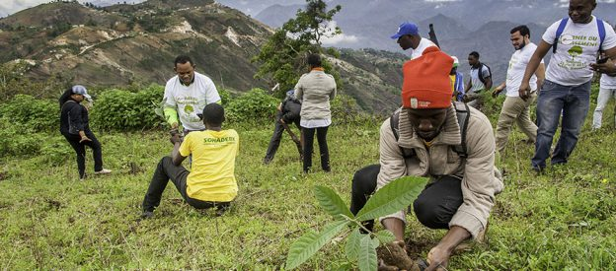
Haiti is no stranger to bouts of extreme weather and changes in climate patterns, namely droughts and harsh hurricanes that threaten food security. Due to the vulnerability of much of the rural population, many trees have been cut down for charcoal, increasing susceptibility to dangerous mudslides off the mountainous terrain during heavy rains. Erosion and changes in precipitation patterns have contributed to recent flooding, which in turn destroys crops and livestock.
These experiences prove that climate change hits the
https://farmingfirst.org/2017/06/how-haiti-is-becoming-more-resilient-to-extreme-weather/?utm_source=feedburner&utm_medium=email&utm_campaign=Feed%3A+FarmingFirst+%28Farming+First%29
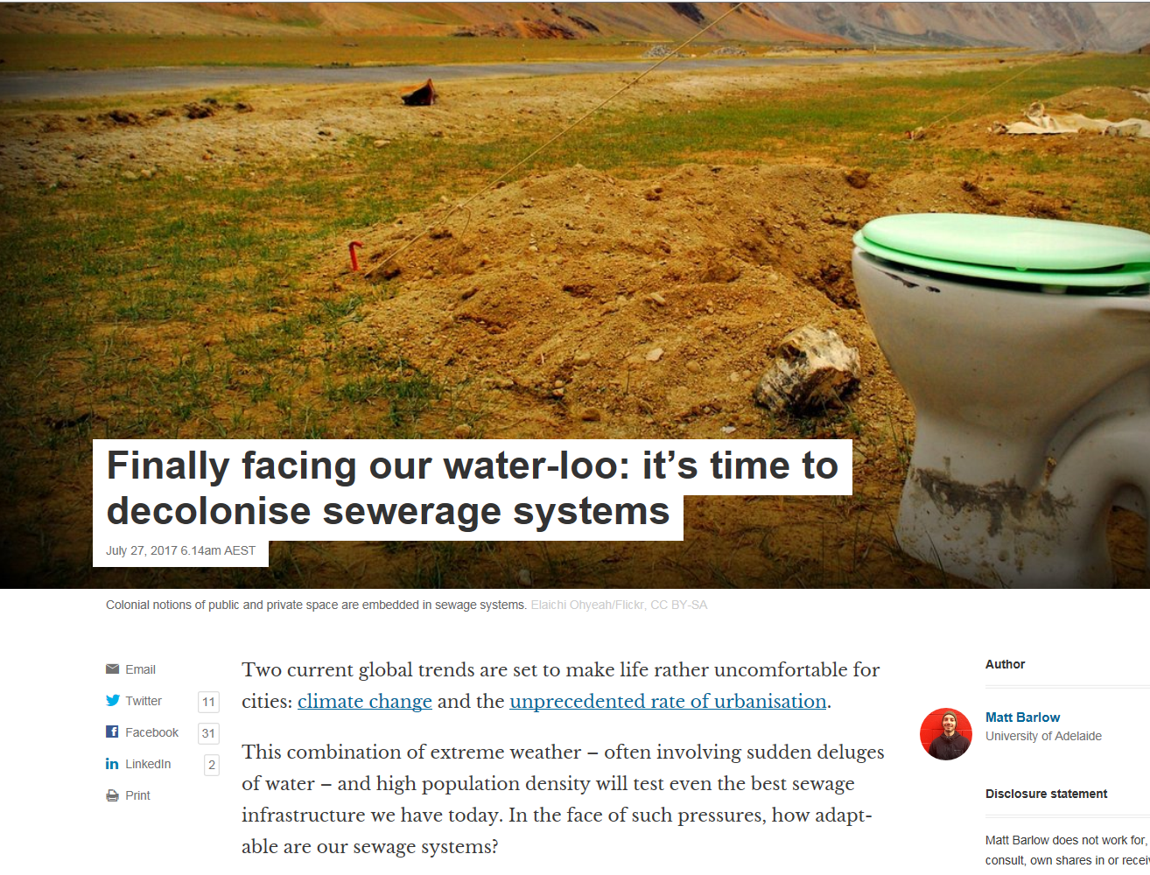
https://theconversation.com/finally-facing-our-water-loo-its-time-to-decolonise-sewerage-systems-78095

The scary stories get scarier
By Don Aitkin - posted Monday, 24 July 2017
President Trump's decision to pull the USA out of the Paris climate Accord seems to have had an outcome in the intensification of alarm both at his doing so and at what he is thought to have overlooked. I saw a number of examples of this reaction, and will deal with another one next week. But the one I'm focussing on now is a story that appeared in the 17 July New York Times Magazine entitled 'The Uninhabitable Earth'. I wouldn't normally have gone to read it, and did so because none other than Dr Michael Mann had panned it, about which more in a moment. You can read it here.
Don Aitkin has been an academic and vice-chancellor. His latest book, Moving On, was published in 2016.
http://www.onlineopinion.com.au/view.asp?article=19177

Harvesting knowledge
30 June 2017
Researchers to learn the language of Indigenous food and biology
Share
Agricultural scientists are working with the Indigenous community, farmers and food processors in Narrabri to understand and share knowledge about the biology and ecology of native food plants, and their agricultural potential.

Researchers from the School of Life and Environmental Sciences and theSydney Institute of Agriculture at the University’s I.A. Watson Grains Research Centre at Narrabri, are learning the language of Indigenous foods and biology in projects to engage with the local Indigenous community and local farmers to further understand and revive the use of native foods.
We want to support the pride that the local community has for traditional foods and practices, and these initiatives have great potential for education and investigation from diverse groups...
Dr Peter Ampt, lecturer in natural resource management.
Indigenous people have been sustainably cultivating nutritious foods from native species for thousands of years. There is much we can learn about the types of food plants that are suitable to grow in particular places, and how we can incorporate modern scientific equipment and practices to work with the community to revive their use, improve the ecology of the region and open up potential agricultural enterprises. http://sydney.edu.au/news-opinion/news/2017/06/30/harvesting-knowledge.html
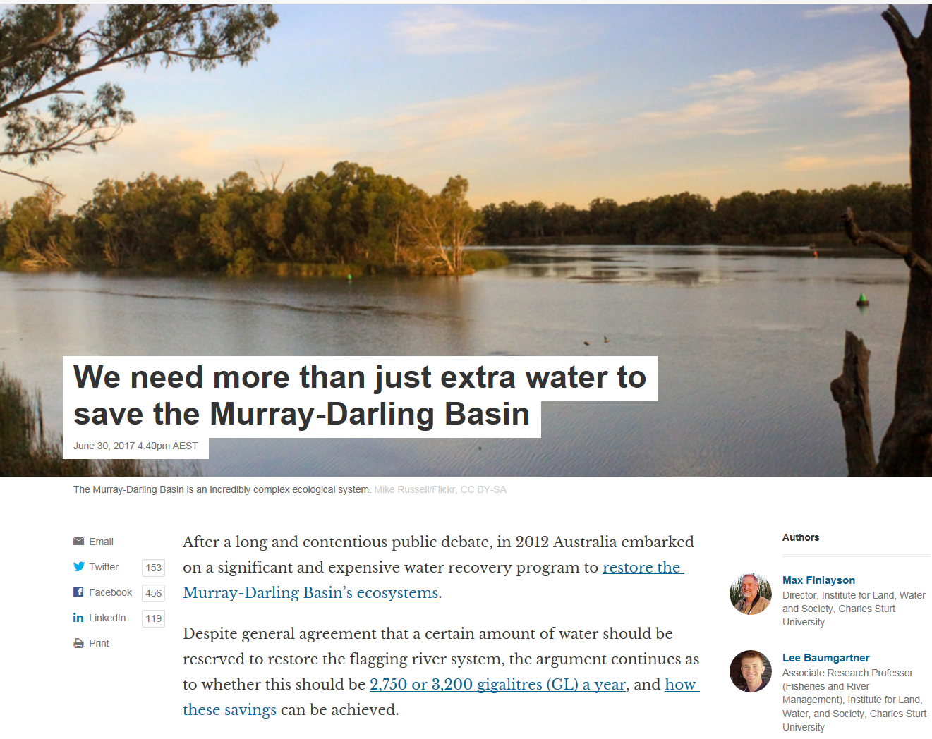
https://theconversation.com/we-need-more-than-just-extra-water-to-save-the-murray-darling-basin-80188
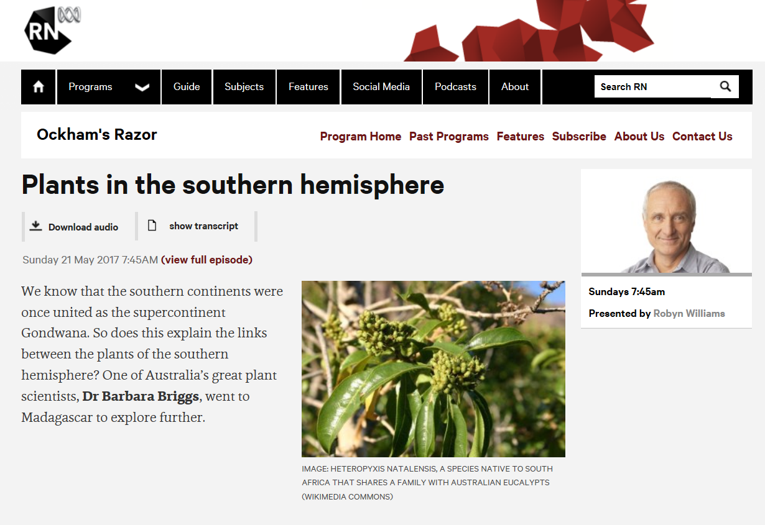
http://www.abc.net.au/radionational/programs/ockhamsrazor/plants-in-the-southern-hemisphere/8527624

Climate change and the catastrophe of Trumpism
By Sam Ben-Meir - posted Tuesday, 25 July 2017
In its attack on the very foundations of science, Trumpism constitutes an epistemic disaster: we are facing a crisis in terms of knowledge and objective inquiry.
Epistemology (or the theory of knowledge) is concerned with, among other things, what right we have to the beliefs we hold – in other words, it is a normative enterprise: it asks not merely the descriptive-psychological question of how people happen to come to acquire their beliefs, but rather how they should do so.
Sam Ben-Meir is professor of philosophy at Eastern International College.
http://www.onlineopinion.com.au/view.asp?article=19179

http://www.abc.net.au/radionational/programs/ockhamsrazor/innovation-on-a-grand-scale/8730754

Michael Gove’s green dream: like Brexit, the reality awaits
Gove’s vision for the environment is undoubtedly ambitious but it is at odds with much government action – making it real will be a gargantuan task
Saturday 22 July 2017 00.39 AEST Last modified on Saturday 22 July 2017 00.40 AEST
Who knew? Environment secretary Michael Gove, arch Brexiter and seen just months ago grinning and thumbs up in eco-villain Donald Trump’s lair, turns out to be – in words, at least – a deep green.
His first major speech railed against “corporate greed and devil-take-the-hindmost individualism”, “extractive and exploitative political systems” and the “selfish agenda” of vested interests. https://www.theguardian.com/environment/2017/jul/21/michael-goves-green-dream-like-brexit-the-reality-awaits

https://theconversation.com/a-focus-on-goals-rather-than-behaviour-is-creating-workplace-monsters-79926
Where soil is, men grow,
Whether to weeds or flowers
John Keats

