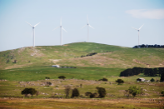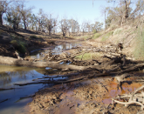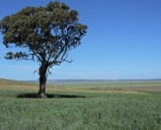

# Nutrient availability in model wetlands helps regulate microbial metabolism and soil carbon cycling rates

##### 6 September 2017

[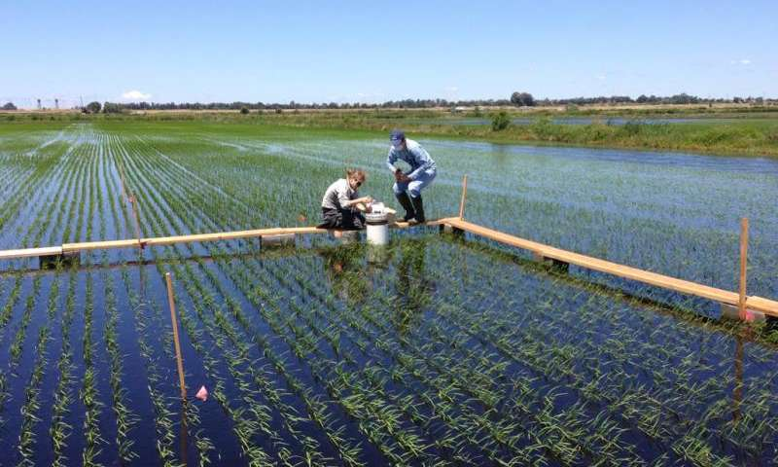](https://3c1703fe8d.site.internapcdn.net/newman/gfx/news/hires/2017/nutrientavai.jpg)

Study co-author Rhonzhong Ye and graduate student Jennifer Morris collecting greenhouse gas fluxes from the rice fields studied on Twitchell Island, Calif. Credit: Wyatt Hartman

Studying microbial communities in San Joaquin Delta rice fields, researchers linked microbial metabolism and nutrient availability to soil carbon cycling rates.

Read more at: <https://phys.org/news/2017-09-nutrient-availability-wetlands-microbial-metabolism.html#jCp>

# The outsized role of soil microbes

[](https://3c1703fe8d.site.internapcdn.net/newman/gfx/news/hires/2017/theoutsizedr.jpg)

The soil microbial carbon pump (MCP) moves carbon derived from microbial anabolism into soil where it can become stabilized by the entombing effect. The yin-yang symbol represents a key part of soil MCP that links aboveground vegetation to belowground soil, and creates a sense of movement to illustrate that the movement is driven, but driven differently, by fungi and bacteria. Credit: Xuefeng Zhu

Many complexities of the carbon sequestration process remain poorly understood, despite years of research and the significant impact of this process on global climate.

Read more at: <https://phys.org/news/2017-08-outsized-role-soil-microbes.html#jCp>

# Plant, soil recovery takes time after wildfire

* By Kylene Scott
* 5 Sept 2017

[[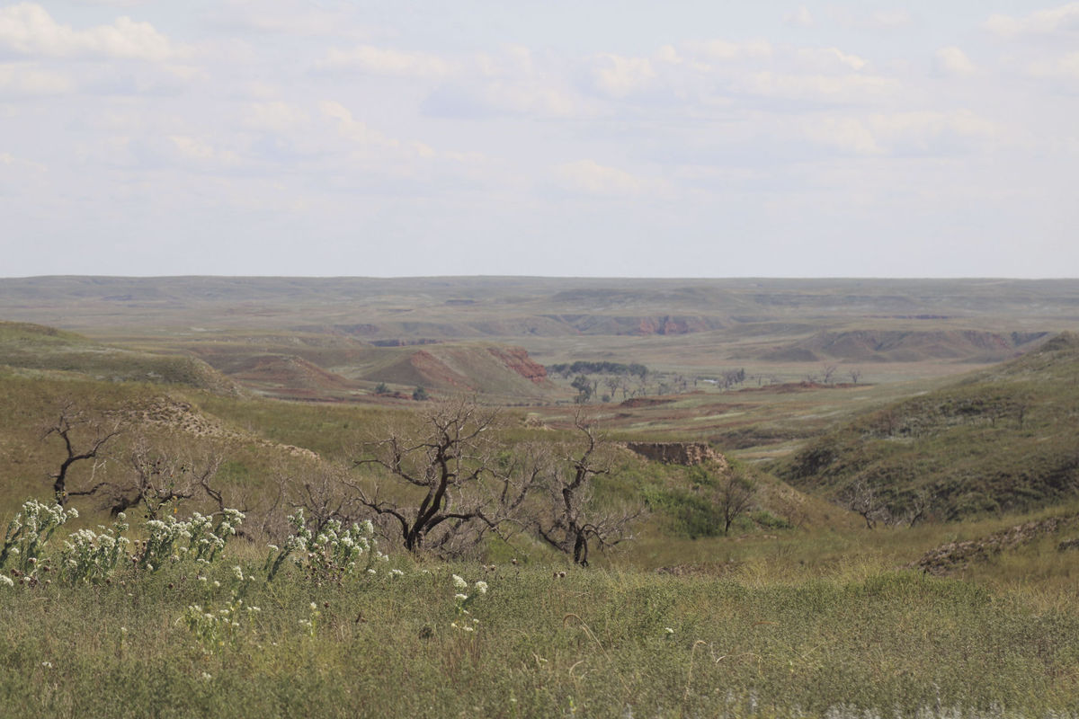](http://www.hpj.com/content/tncms/live/#1)](http://www.hpj.com/content/tncms/live/" \l "1)

Good spring and early summer rains have helped pastures turn green in Clark County, Kansas, following March wildfires. This pasture is part of the Giles Ranch and was photographed Aug. 22. (Journal photo by Kylene Scott.)

Bottom of Form

The sight of blackened earth after a fire is hard to take. But have faith: Mother Nature will restore the grass ecosystem.

At a meeting hosted by Oklahoma State University and Kansas State University in mid-May at the Snake Creek Ranch near Ashland, Kansas, Laura Goodman, range Extension specialist at Oklahoma State University, discussed how plants and soils recover following a wildfire. Goodman said it’s hard not to wonder what will happen to rangeland in this scenario.

<http://www.hpj.com/ag_news/plant-soil-recovery-takes-time-after-wildfire/article_f3cc3571-887a-56a4-bbcc-cb42749facc4.html>

# Researchers create first global map of water in Moon's soil

##### 13 September 2017

[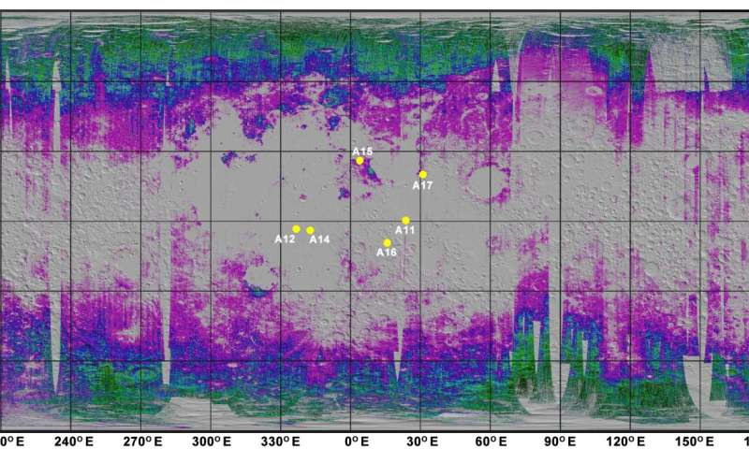](https://3c1703fe8d.site.internapcdn.net/newman/gfx/news/hires/2017/56-researchersc.jpg)

A new map reveals quantities of water trapped in the lunar soil. The amounts increase toward the poles, suggesting that much of the water was implanted by the solar wind (yellow dots mark Apollo landing sites). Credit: Milliken lab / Brown University

In research that may prove useful to future lunar explorers, scientists from Brown University have created the first quantitative map of water and its chemical building blocks trapped in the uppermost portion of the Moon's soil.

Read more at: <https://phys.org/news/2017-09-global-moon-soil.html#jCp>

# Lasers zap decontaminates from soil

[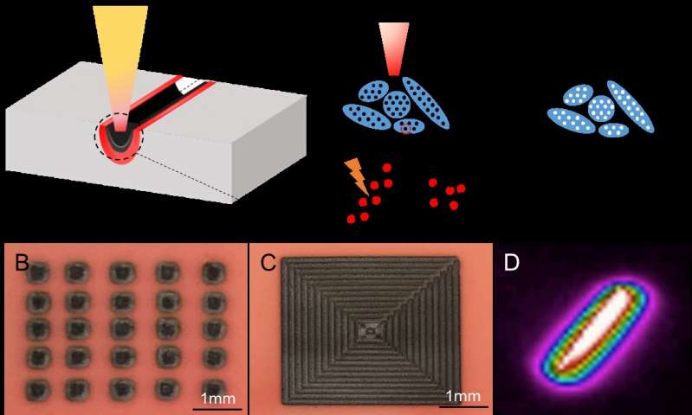](https://3c1703fe8d.site.internapcdn.net/newman/gfx/news/hires/2017/laserszapdec.jpg)

Laser-induced soil decontamination (A), laser-generated patterns (B and C), and an infrared image of temperature distribution along track of laser movement (D). Credit: AIP Publishing

There might be a new and improved way to rid contaminated soil of toxins and pollutants: zap it with lasers. By directly breaking down pollutants, researchers say, high-powered lasers can now be more efficient and cheaper than conventional decontamination techniques.

Read more at: <https://phys.org/news/2017-08-lasers-zap-decontaminates-soil.html#jCp>

**The 'underground astronaut' in search of ancient bones**

Elen Feuerriegel risked her life to recover bones hidden in a cave below the rolling hills of South Africa. What she found helped open a new chapter in the story of human evolution.

**[ABC Science](http://www.abc.net.au/science/)**

By [Genelle Weule](http://www.abc.net.au/news/genelle-weule/7098742) for [Science Friction](http://www.abc.net.au/radionational/programs/sciencefriction/)

(Supplied: Elen Fuerriegel)



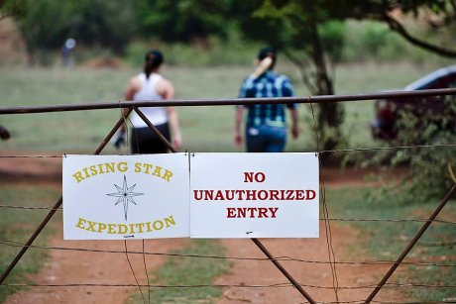

Four years ago, Dr Elen Feuerriegel was trawling the internet when she saw an ad.

The ad was unusual — it asked for three or four people for a short-term project, but they had to be skinny, preferably small and could not be claustrophobic.

They also needed to be fit, have some caving experience, a good attitude and be a team player.

And they had to be willing to work in cramped quarters.

<http://www.abc.net.au/news/science/2017-08-26/elen-feuerriegel-the-underground-astronaut/8825148?utm_source=sfmc&utm_medium=email&utm_campaign=abc_science_newsletter%3a125&user_id=473dc1dcb743dd2eb5ee92f206c233e4cc5e2ba4d67a0a5218c8372de441e572&WT.tsrc=email&WT.mc_id=Email%7cabc_science_newsletter%7c125&utm_content=story_2_title>

|  |  |
| --- | --- |
| **[http://1.gravatar.com/avatar/dd58a06904ba5a522e606e97fb55a1b3?s=50&d=http%3A%2F%2F1.gravatar.com%2Favatar%2Fad516503a11cd5ca435acc9bb6523536%3Fs%3D50&r=G](https://blogs.reading.ac.uk/soil-security/?author=711)** | [**Two New Film STARS**](http://blogs.reading.ac.uk/soil-security/two-new-film-stars/) **by** [**Soil Security**](https://blogs.reading.ac.uk/soil-security/?author=711) |

The STARS Centre for Doctoral Training are developing resources to support the soil science community. As part of this endeavour a number of short films have been commissioned highlighting key areas of research.

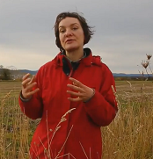The first of these to be available online is Malika Mezeli’s “[**Phosphorus and Soils**](https://youtu.be/Ci_Zc31rhMc?list=PLnXQ8mf7sS8HDMsuBX0mR-_ofpoyFIF7B)”. In the film, Malika explores the determination of phosphorus in soils and how this can be used to close the loop on the global phosphorus cycle. Phosphorus is a major limiting nutrient for plant growth, making it a key player in global food production. Humans impact the natural Phosphorus cycle by mining rock phosphates and applying them to land as fertilisers. However, upon application up to 90% of phosphorus fertiliser becomes unavailable to plants so that it is essential to employ efficient and sustainable management of phosphorus in soils.

Most recently added is Paul George’s film, “[**A Life in Soil**](https://youtu.be/hS46Z2GMepg)”. In this film Paul discusses the macrofauna, mesofauna, microfauna and microbes which constitute the living aspects of the soil. He explains how living organisms play crucial roles in maintaining soil health across the planet; providing plants and animals with the water, nutrients and habitat they need to survive. Greater understanding of these organisms and their interactions has the potential to promote sustainable and healthy agricultural systems.

These films, and others, are available on the [**STARS Soil Science YouTube channel**](https://www.youtube.com/channel/UCQF4JwyJuUGDP_dsi34Epag).

# 'Lost city' used 500 years of soil erosion to benefit crop farming

[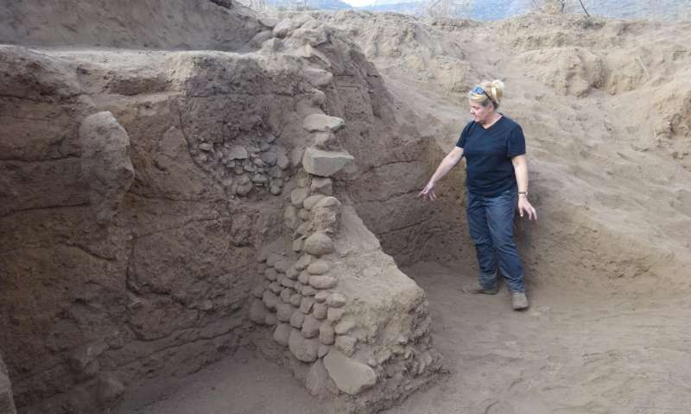](https://3c1703fe8d.site.internapcdn.net/newman/gfx/news/hires/2017/lostcityused.jpg)

Carol Lang, University of York, examines the terrace systems of Engaruka. Credit: University of York

Researchers at the University of York working on a 700-year old abandoned agricultural site in Tanzania have shown that soil erosion benefited farming practices for some 500 years.

Read more at: <https://phys.org/news/2017-08-lost-city-years-soil-erosion.html#jCp>

# Panama's native tree species excel in infertile tropical soils

Smithsonian's Panama canal watershed experiment compares monocultures and mixes

Smithsonian Tropical Research Institute

[[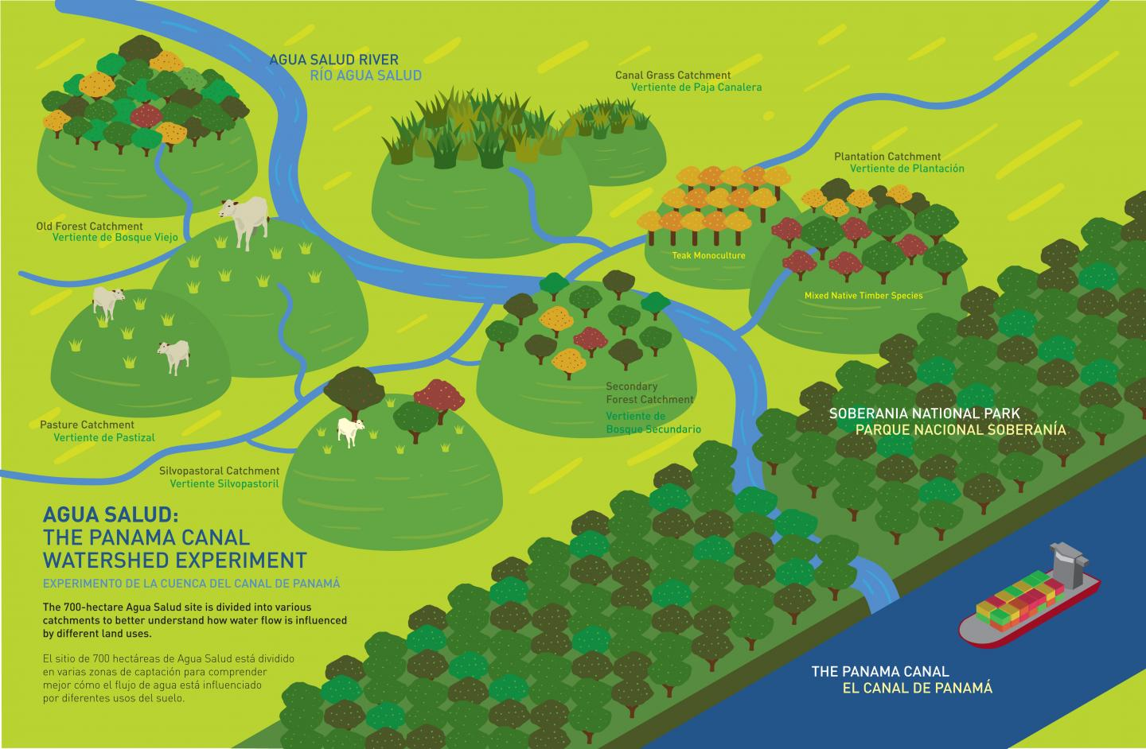](https://www.eurekalert.org/multimedia/pub/149479.php)](https://www.eurekalert.org/multimedia/pub/149479.php)

**IMAGE:**What is the best way to use land to prevent flooding, maximize water storage during dry periods, store carbon, protect tropical diversity and maximize timber value? The Agua Salud project... [view more](https://www.eurekalert.org/multimedia/pub/149479.php)

Credit: Jorge Aleman_STRI

Teak, the most valuable species for tropical reforestation, often performs poorly in the acid soils of steeply sloping land in the tropics. As human population skyrockets and land becomes a scarce resource, balancing tradeoffs between reforestation, conservation, water availability and carbon storage becomes paramount. In a recent publication from the Smart Reforestation Program, Smithsonian scientists and collaborators including the Panama Canal Authority confirm that native tree species performed very well in field trials and would be preferable to teak in this situation.

"The take-home message of this experiment is that if you want to reforest to maximize timber harvest on poor, acidic soils in the Panama Canal watershed, plant Amarillo (Terminalia amazonia)," said Carolina Mayoral, post-doctoral fellow at the Smithsonian Tropical Research Institute (STRI) in Panama and first author of the paper. "It's spectacular. It grows amazingly fast and the trunks are straight and have excellent timber value. It accumulates biomass much faster than teak in these soils." <https://www.eurekalert.org/pub_releases/2017-08/stri-pnt083117.php>

# Survival of soil organisms is a wake-up call for biosecurity

[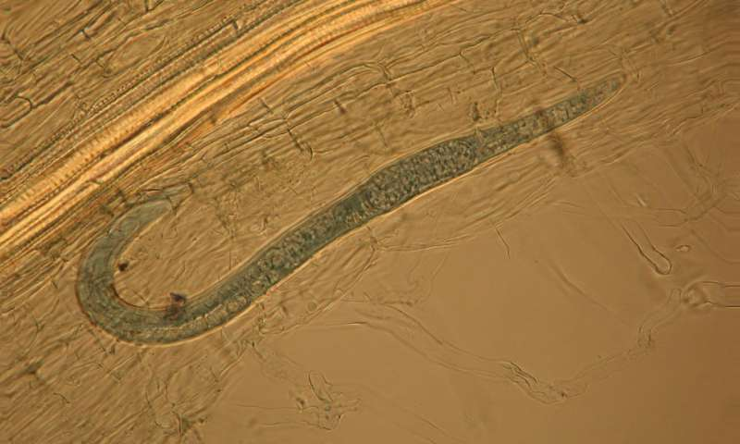](https://3c1703fe8d.site.internapcdn.net/newman/gfx/news/hires/2017/survivalofso.jpg)

Female lesion nematode in white clover roots, having invaded from soil stored for 13 months (nematode is less than 1mm in length). Credit: Lee T. Aalders

Tiny creatures in soil that attack plants have shown the ability to survive for at least three years stored in dry conditions in a recent AgResearch study, giving new insights into the biosecurity threats posed by passenger travel and trade between countries. The research article is published in the open access journal *Neobiota*.

Read more at: <https://phys.org/news/2017-08-survival-soil-wake-up-biosecurity.html#jCp>

# A New Platform for Managing Soil Carbon and Soil Health

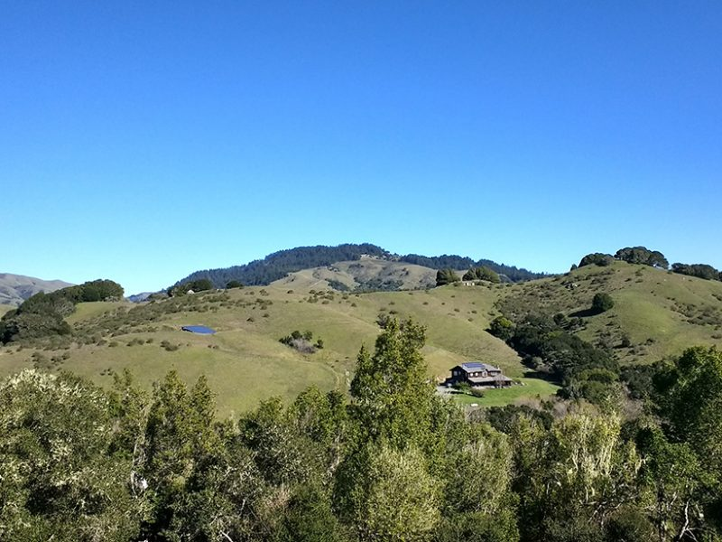International Soil Carbon Network Workshop participants visited this rangeland, a part of the Marin Carbon Project in California. This grazing area provides an example of a successful partnership among landowners, land managers, and scientists. These stakeholders have identified potential soil carbon stabilization opportunities that are scientifically sound, financially feasible, and scalable. Credit: Avni Malhotra.

By [Julie Loisel](mailto:julieloisel@tamu.edu), Avni Malhotra, and Claire Phillips 25 August 2017

Soil organic matter and its carbon content (SOM-C) are key indicators of soil health, ecosystem productivity, and resilience. However, the scientific data sets, tools, and terminology used to describe and analyze processes related to SOM-C differ between managed and unmanaged lands. Carbon cycling studies typically focus on unmanaged systems that are vulnerable to climatic changes (e.g., northern [peatlands](https://eos.org/research-spotlights/a-wetter-climate-increases-methane-production-in-peat) and [permafrost soils](https://eos.org/research-spotlights/modeling-permafrosts-role-in-the-global-carbon-cycle)), whereas soil health studies are related to actively managed lands (e.g., grazing land, cropland, and forestry). Because the goals and needs of scientists and land managers are converging toward enhancing SOM-C stocks and soil health, the need for an interdisciplinary collaboration has emerged. <https://eos.org/meeting-reports/a-new-platform-for-managing-soil-carbon-and-soil-health>

# Plants love microbes, and so do farmers

The Australian Sunshine Coast's plant diversity has helped University of Queensland researchers confirm that nurture has the upper hand -- at least when it comes to plant microbes.

**Journal Reference**:

1. Yun Kit Yeoh, Paul G. Dennis, Chanyarat Paungfoo-Lonhienne, Lui Weber, Richard Brackin, Mark A. Ragan, Susanne Schmidt, Philip Hugenholtz. **Evolutionary conservation of a core root microbiome across plant phyla along a tropical soil chronosequence**. Nature Communications, 2017; 8 (1) DOI: [10.1038/s41467-017-00262-8](http://dx.doi.org/10.1038/s41467-017-00262-8)

<https://www.sciencedaily.com/releases/2017/08/170810104857.htm>

# A flexible, mobile measuring system for Earth observation

##### 14 September 2017

[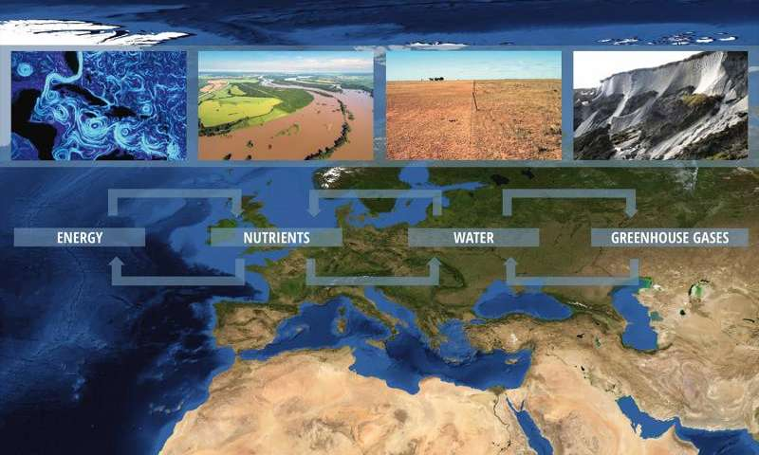](https://3c1703fe8d.site.internapcdn.net/newman/gfx/news/hires/2017/intherightpl.jpg)

The Helmholtz Association is setting up a flexible, mobile measuring system for Earth observation. Credit: NASA / ESKP

Over the next five years, nine research centres of the Helmholtz Association will collaborate to create a flexible, mobile measuring system for Earth observation: MOSES – Modular Observation Solutions for Earth Systems. Researchers will use this system to investigate how short-term dynamic events such as heatwaves and heavy rainfall are linked to the long-term development of Earth and environmental systems. MOSES is being coordinated at the Helmholtz Centre for Environmental Research (UFZ) in Leipzig.

Read more at: <https://phys.org/news/2017-09-flexible-mobile-earth.html#jCp>

# New gravity map suggests Mars has a porous crust

##### 13 September 2017 by Elizabeth Zubritsky

[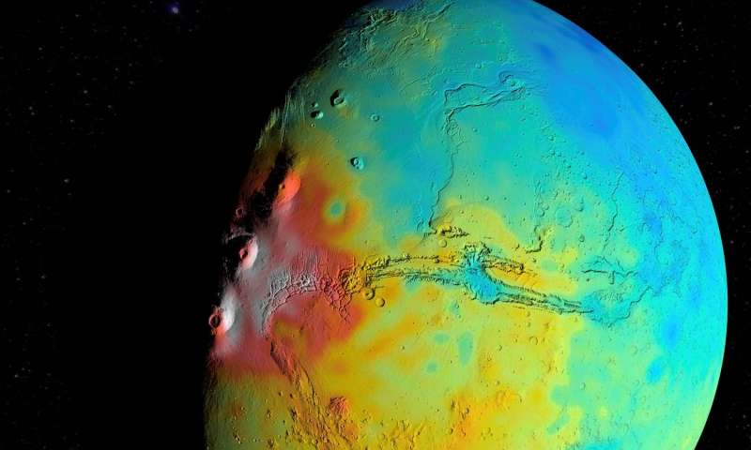](https://3c1703fe8d.site.internapcdn.net/newman/gfx/news/hires/2017/newgravityma.jpg)

A new map of the thickness of Mars' crust shows less variation between thicker regions (red) and thinner regions (blue), compared to earlier mapping. This view is centered on Valles Marineris, with the Tharsis Montes near the terminator to …more

NASA scientists have found evidence that Mars' crust is not as dense as previously thought, a clue that could help researchers better understand the Red Planet's interior structure and evolution.

Read more at: <https://phys.org/news/2017-09-gravity-mars-porous-crust.html#jCp>

# Canada’s soils still degrading, albeit more slowly

## **Guelph summit shows much more still to learn about managing soils**

AddThis Sharing Buttons

Share to FacebookShare to TwitterShare to EmailShare to PinterestShare to More

By [John Greig](https://www.agcanada.com/contributor/john-greig/)

Published: 8 September 2017   
[**Crops**](https://www.manitobacooperator.ca/category/crops/), [**Weather**](https://www.manitobacooperator.ca/category/weather/)

[](https://static.agcanada.com/wp-content/uploads/2017/09/jg_sandford1000.jpg)

Bob Sandford of the United Nations University says agriculture productivity needs to be increased, but with limited impact on earth systems. (John Greig photo)

The rate of degradation of soils in Canada has slowed, but it still is happening at a significant rate and there is still a lot to learn.

There are no soil-perfect systems yet for crop production, attendees at the Summit on Canadian Soil Health held recently in Guelph heard repeatedly.

No-till farming has declined in Ontario, creating more chance for soil erosion and degradation, mostly because it is difficult to consistently and easily get similar yields from no-till compared to fields that have some tillage. <https://www.manitobacooperator.ca/daily/canadas-soils-still-degrading-albeit-more-slowly>

[Christopher Hitchens](http://www.goodreads.com/author/show/3956.Christopher_Hitchens)

**“That which can be asserted without evidence, can be dismissed without evidence.” ―** [**Christopher Hitchens**](http://www.goodreads.com/author/show/3956.Christopher_Hitchens)