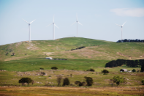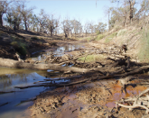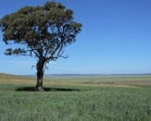

The Strategic Importance of Soil, Water and Food in the Early to Mid-21st Century
15 December 2016 JHJ Cribb, FTSE, FDI Senior Visiting Fellow
Key Points
- Freshwater scarcity is emerging as a critical systemic risk worldwide. While the global population has tripled over the past century, our use of water has increased sixfold.
- More than 95 per cent of humanity’s present food supply is produced from the soil.
- Some 40 per cent of soil used for agriculture globally, is classed as degraded or seriously degraded – i.e. 70 per cent of the topsoil has been lost.
- The UN FAO has projected that for the planet, net land under crops may have to increase by some 700 million hectares by 2050 to meet predicted global food needs.
- The loss of food security – through climate change or the loss of soil and water resources – is a major factor in people deciding to quit their homelands in search of new life, whether as economic migrants ahead of a crisis they have foreseen or as refugees fleeing a disaster.
- Food, land and water security are central to Australian security.
http://www.futuredirections.org.au/publication/strategic-importance-soil-water-food-early-mid-21st-century/

Soil adds up

The way soil properties combine can be used to mathematically determine soil quality
AddThis Sharing Buttons
Share to FacebookShare to TwitterShare to EmailShare to PinterestShare to More
By Staff
Published: 9 January 2017
Did you know?, News
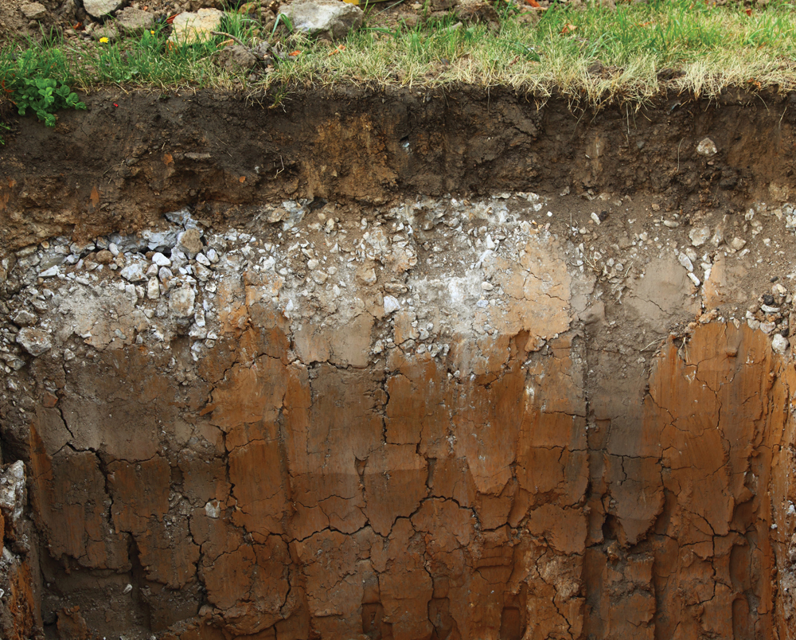
Determining the broad strokes of soil quality could all boil down to doing the math. Photo: Thinkstock
To most people the quality of a soil is the sum of its physical properties — is it healthy and full of microbes? Does water infiltrate it readily or run off? How much air and water can it provide plant roots? Is it hard for roots or equipment to penetrate?
http://www.manitobacooperator.ca/news-opinion/news/how-soil-properties-combine-can-determine-a-soils-quality/

Soil Carbon Can’t Fix Climate Change By Itself—But It Needs to Be Part of the Solution
Marcia DeLonge, agroecologist
A rigorous study just published in the prestigious journal Science argues that soil alone cannot be can be counted on to save us from climate change. Yet the stark analysis does not undermine the importance of better understanding, protecting, and building carbon in soils (“carbon farming”). In fact, the findings reinforce the need for soil carbon science and action to remain priorities, especially when it comes to agriculture. Read more >
http://blog.ucsusa.org/marcia-delonge/soil-carbon-cant-fix-climate-change-by-itself-but-it-needs-to-be-part-of-the-solution

13 January 2017

Talking Agronomy with Chris Martin: Thinking about soils in 2017
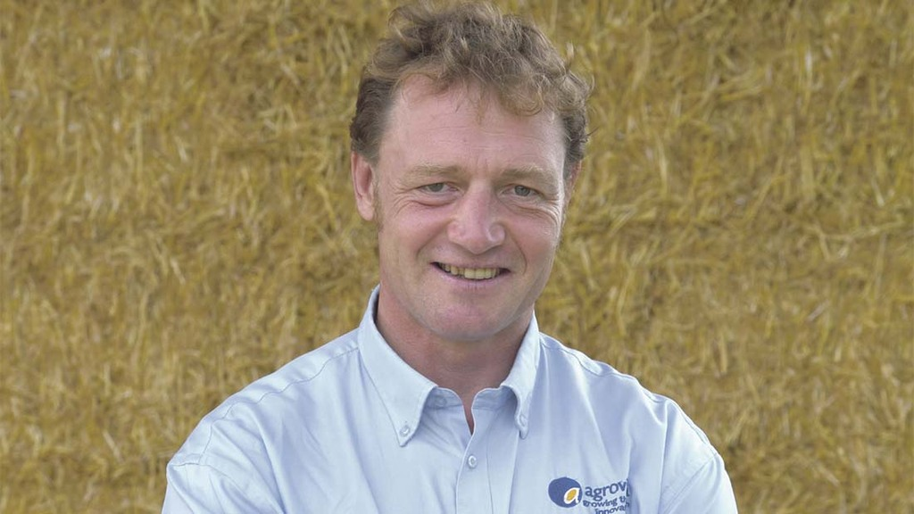
Winter has finally arrived allowing sprayers to be put to bed for a well-earned rest following a very hectic period of work facilitated by the unusually open autumn. The vast majority of crops across the region are going into winter in good fettle, having pretty much received all planned herbicide and insecticide applications. https://www.fginsight.com/blogs/talking-agronomy-with-chris-martin-thinking-about-soils-in-2017
15 January 2017

Russell McKenzie: 'With all the hype about soil degradation isn't it time to wake up and smell the coffee'
farm lifeSoilCrops
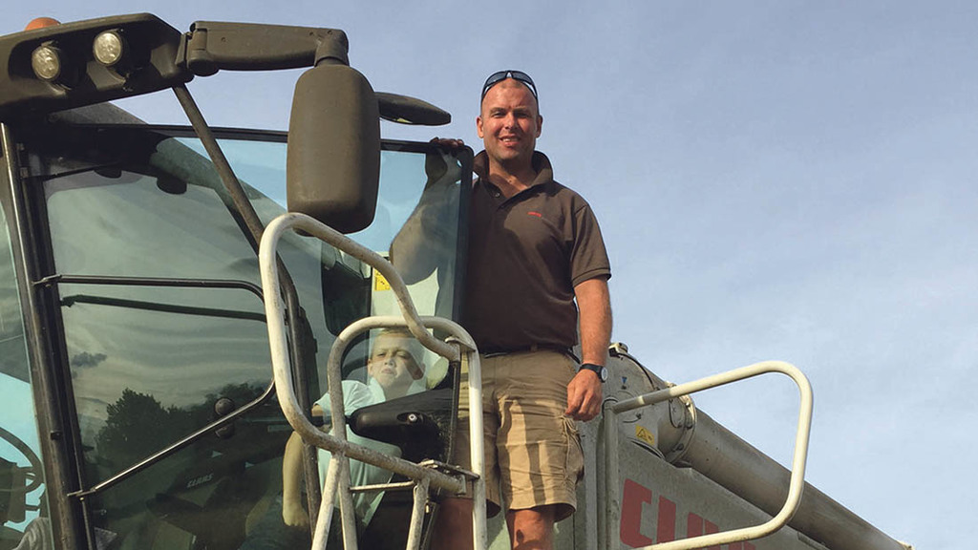
My initial thoughts when I started writing this blog was I was glad I actually made it through to 2017, as 2016 seemed to be an ‘annus horribilis’ for departing celebrities.

It certainly makes you appreciate why we should make the most of the brief journey we have on this planet, and perhaps youth really is wasted on the young.

Early January has seen the usual round of pigeon chasing and assessing what state oilseed rape crops are in after a tricky autumn where lack of moisture hampered establishment rather than the previous year where flea beetle pressure was the domineering force. https://www.fginsight.com/blogs/russell-mckenzie-with-all-the-hype-about-soil-degradation-isnt-it-time-to-wake-up-and-smell-the-coffee
15 January 2017

Opinion- Patrick Holden, founding director, Sustainable Food Trust
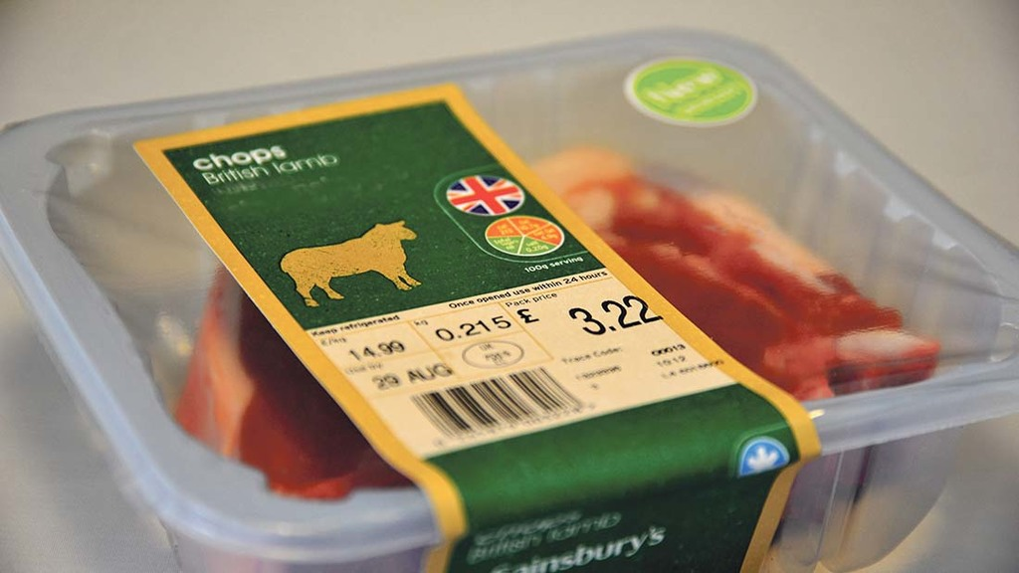
For me, one of the most inspiring aspects of last week’s Oxford Real Farming Conference (ORFC) was the predominance of the voices of practical farmers in the speaker line-up.
Some delegates quite literally crossed the road from the other, better-known conference, swelling the ORFC numbers to 800 on both days.

However, there was one session, organised by the Eating Better Alliance, focusing on the role of livestock farming post-Brexit, which upset the mainly producer audience every bit as much as it would have done at the traditional Oxford Farming Conference. https://www.fginsight.com/blogs/opinion--patrick-holden-founding-director-sustainable-food-trust-

Opinion: Reinforce the value of our soils
Murukesan Krishnapillai and Mohammad Golabi Published 6:17 p.m. ChT
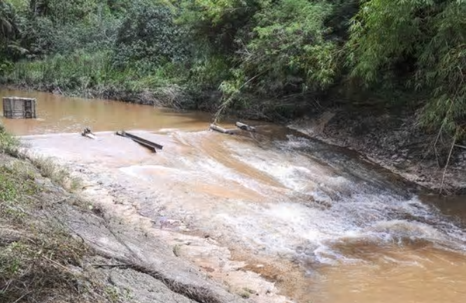
In this Aug. 19, 2015 file photo, murky water cascades down the Ugum River in Talofofo.(Photo: PDN file photo)
One annual celebration you might be forgiven for not knowing about is World Soil Day. Sadly, our ignorance about the importance of soil and the degree to which we take advantage of it has led to a drastic reduction in its quality and productivity the world over.
Leonard Da Vinci once said, “We know more about the movement of celestial bodies than about the soil underfoot.” David Hillel, a prominent soil scientist, said so commonplace and seemingly abundant are soils that we tend to treat them contemptuously. Terms such as “dirt,” and “muddled” show our disdain. But in denigrating and degrading these precious resources, we do our environment and ourselves great and perhaps irreparable harm Hillel said. http://www.guampdn.com/story/opinion/2016/12/17/reinforce-value-our-soils/95510564/


http://www.abc.net.au/radionational/programs/ockhamsrazor/science-literacy-in-parliament/8142506

Collaboration on Drought Resilience is Delivering Results for America’s Communities and Economy
Posted by Ann Mills, Deputy Under Secretary for Natural Resources and Environment, on 18 January 2017
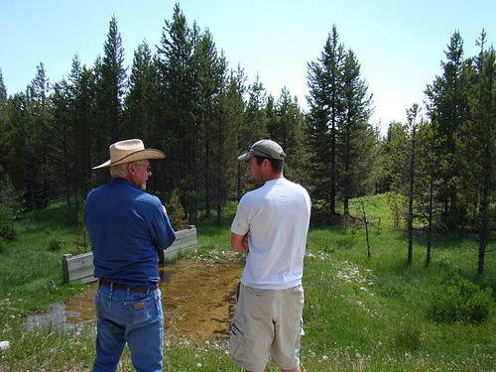
An MT Fish, Wildlife and Parks department biologist and a local rancher discuss water management in the Big Hole Valley, MT. The National Drought Resilience Partnership and the State of Montana are working to build long term drought resilience.
Over the past year, we have seen alarming mass tree mortality in California, the development of severe drought conditions in New England and the Southeast, and dropping water tables in regions throughout the United States. The five-year Western drought and recent droughts in other states threaten our communities, our farms, our freshwater fisheries, our forests, and our grasslands that depend on and provide clean, accessible water supplies. http://blogs.usda.gov/2017/01/18/collaboration-on-drought-resilience-is-delivering-results-for-americas-communities-and-economy/

Lawrence Biyika Songa: The Cost of Climate Change for Ugandan Farmers
Posted: 10 Jan 2017 03:09 AM PST
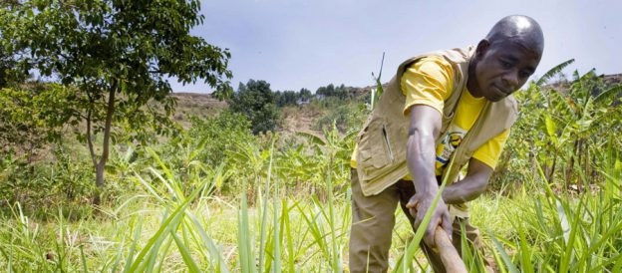

Q&A with Lawrence Biyika Songa, COP representative for Uganda
At the COP22 conference on climate change, held in Marrakech in November, the spotlight fell squarely on Africa and the impact of global warming on agriculture. Farming First caught up with Lawrence Biyika Songa, Uganda’s representative at the talks, to delve deeper into the issues facing farmers in the country. https://farmingfirst.org/2017/01/lawrence-biyika-songa-the-cost-of-climate-change-for-ugandan-farmers/?utm_source=feedburner&utm_medium=email&utm_campaign=Feed%3A+FarmingFirst+%28Farming+First%29

“Soils and pulses, a symbiosis for life”
14 December 2016 Geoffrey Craggs, JP, Research Analyst, Northern Australia and Land Care Research Programme
Background
The UN General Assembly resolved in 2013 that World Soil Day (WSD) would be celebrated on 5 December each year. The aim of WSD is to raise global awareness about the importance of soil as a critical component in nature and as a vital contributor to human wellbeing. http://www.futuredirections.org.au/publication/world-soil-day-2016-soils-pulses-symbiosis-life/

Global ‘Compost Bomb’ Slowly Detonates as Previously Frozen Soil ‘Breathes Out’ Greenhouse Gases
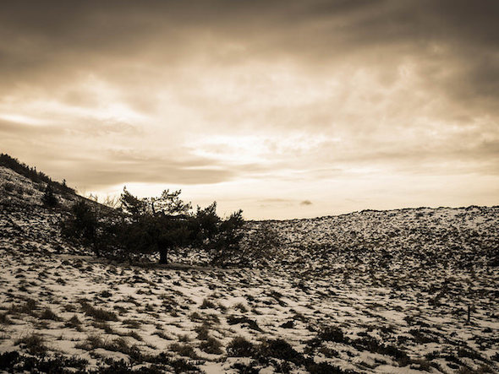
gwenole camus
Global warming is causing microorganisms that dwell in previously frozen soil to release carbon dioxide in a potentially catastrophic process that could add at least as much carbon to the atmosphere as the fossil fuel industry emitted in the mid-20th century, a study published in the journal Nature reports.
Dahr Jamail reports at Truthout:
Microorganisms in soil generally consume carbon, then release CO2 as a byproduct. Large areas of the planet—such as Alaska, northern Canada, Northern Europe and large swaths of Siberia in Russia—have previously been too cold for this process to occur. However, they are now warming up, and soil respiration is happening there. As a result, these places are contributing far, far more CO2 and methane to the atmosphere than they ever have. ...
This means that even if all human fossil fuel emissions were halted immediately, soils would continue to release approximately the same amount of CO2 and methane emissions as the amount produced by the fossil fuel industry during the mid-20th century. http://www.truthdig.com/eartotheground/item/a_compost_bomb_is_detonating_as_previously_20161229

Alcoa bail-out opens up a new front in an old culture war
The right's insistence on maintaining the Alcoa aluminium smelting plant is reactionary: the greenies want Portland to close, and therefore it must be kept open, writes John Quiggin.
AddThis Sharing Buttons
Share to FacebookShare to TwitterShare to LinkedInShare to Google+

Reports that the federal government is committed to bailing out Alcoa’s Portland aluminium smelter — and has pressured AGL to offer a below-market deal on electricity supply — will be welcomed by the 600 workers at the plant, and by the people of Portland more generally. For the rest of us, it provides an object lesson on the policy incoherence of the Abbott-Turnbull government in just about every dimension.
https://www.crikey.com.au/2017/01/20/alcoa-bail-out-opens-up-a-new-front-in-an-old-culture-war/

Three shrewd options for climate change
By David Leyonhjelm - posted Thursday, 5 January 2017
Once again, the Government has been getting its knickers in a knot over climate change. And once again, despite three politically shrewd options to choose from, it is choosing a dumb fourth option.
The first of the shrewd options is to withdraw from the Paris agreement and abandon the pledge to force Australian emissions in 2030 to be 26 to 28 per cent lower than emissions in 2005. In the process, the Government could announce that it would commit to reduce emissions as part of an enforceable international agreement based on equal effort, but that the Paris agreement is neither enforceable nor based on equal effort.
This option would enable the Government to abolish the renewable energy target, the emissions reduction fund (i.e. 'direct action'), the renewable energy agency, the clean energy finance corporation and the clean energy innovation fund. It would save taxpayers at least $150 million over the next three years alone, and would also cut electricity bills. What's more, there would be no need to introduce a carbon price.

David Leyonhjelm is the Liberal Democrat Senator for NSW.
http://www.onlineopinion.com.au/view.asp?article=18763

The Global Implications of Increased Biofuel Production
14 December 2016 Madeleine Lovelle, Research Analyst, Global Food and Water Crises Research Programme
Background
Biofuels have been a major source of renewable energy, aimed at curbing carbon dioxide emissions from traditional diesel and ethanol. Biofuels are commonly made from crops by converting corn or sugarcane into ethanol, or by turning palm oil into biodiesel. FDI has previously written about the challenges of balancing food and biofuel production in an increasingly food-scarce world.
http://www.futuredirections.org.au/publication/global-implications-increased-biofuel-production/
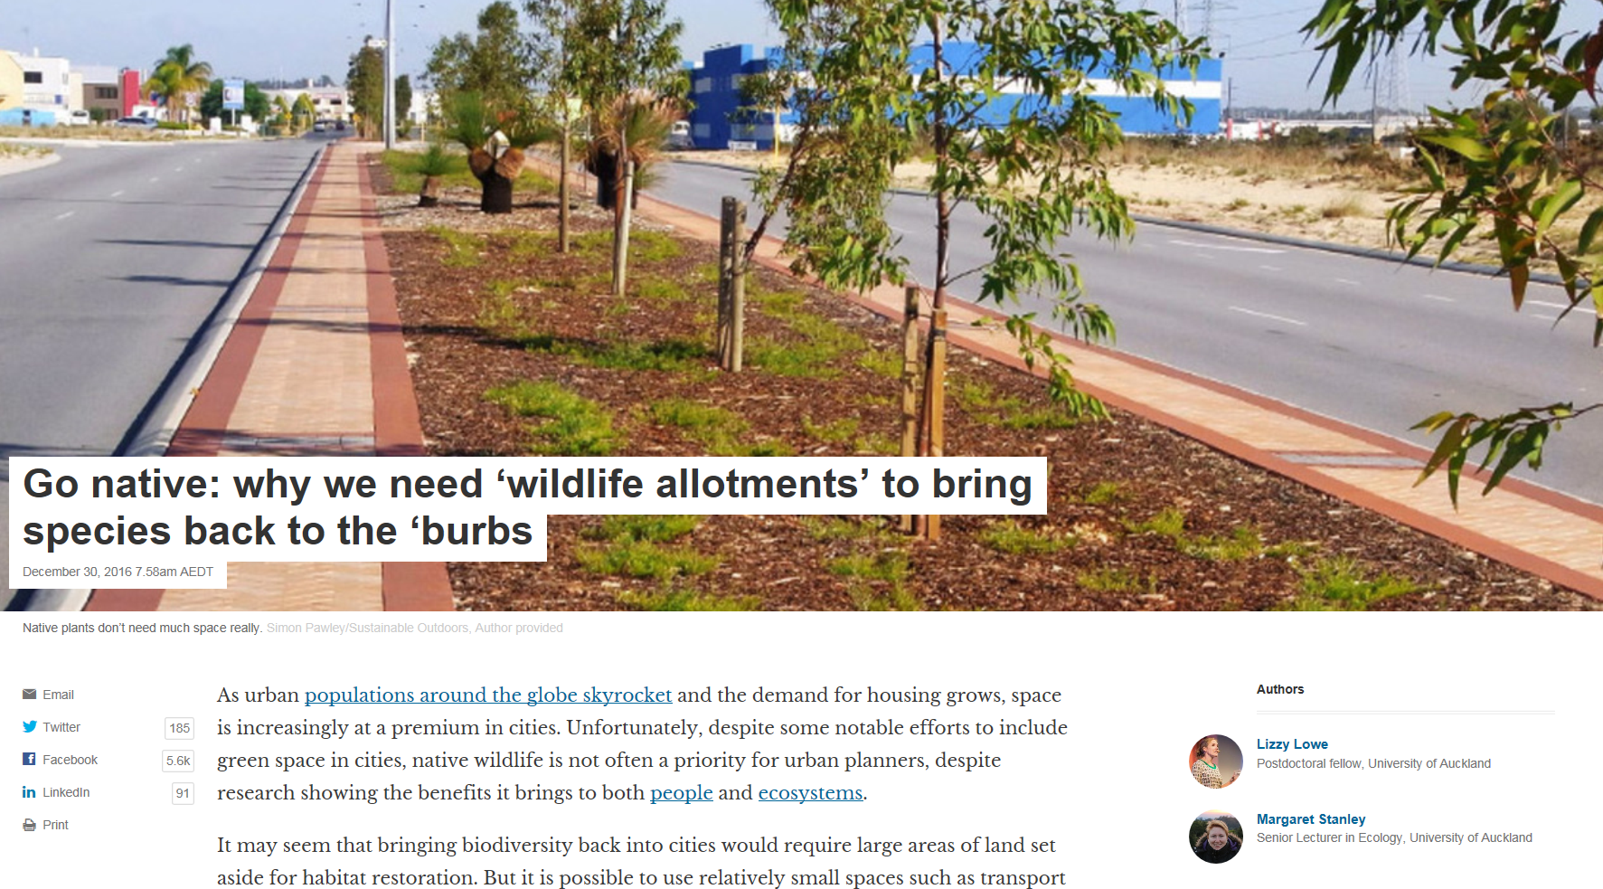
https://theconversation.com/go-native-why-we-need-wildlife-allotments-to-bring-species-back-to-the-burbs-69631

Australian climate change policy isn't working
By Peter Schrader - posted Wednesday, 18 January 2017 | Sign Up for free e-mail updates!

With summer here, the brown, crunchy, lifeless patches on my lawn in Perth remind me that much of Australia is getting hotter and drier. Working in public health, it also reminds me of a call to action – not just for me, but for all of us. Not for more wetting agent and regular watering (although, yes, that will be needed).
But a call to action on climate change.
For decades, higher average temperatures have been experienced across WA, and below average rainfall in the west coast and the south-west land division. Some estimate autumn and winter rainfall to drop by 50% over the next several decades
Peter Schrader is a general practitioner and a member of Doctors for the Environment Australia
http://www.onlineopinion.com.au/view.asp?article=18793

2016 crowned hottest year on record: Australia needs to get heat smart
Opinion
The Conversation
Liz Hanna, Kathryn Bowen, and Mark Howden
Posted Thu at 12:53pmThu 19 Jan 2017, 12:53pm 
Photo: Acclimatisation to heat has an upper limit, beyond which humans need to rest or risk overheating and potential death. (AAP: Joel Carrett, file)
It's official: 2016 set another record for being the world's hottest. Three international agencies have confirmed today that last year was the hottest on record.
NASA reported that 2016 was 0.99 degrees Celsius hotter than the 20th-century average, while the US National Oceanographic and Atmospheric Administration (NOAA) called it at 0.94 degrees Celsius. NOAA also calculated that global land temperatures were 1.43 degrees Celsius higher. The UK Met Office, using its own data, also reported that 2016 is one of the two hottest years on record. http://www.abc.net.au/news/2017-01-19/2016-hottest-year-on-record-australia-needs-to-get-heat-smart/8194182

Julian Wolfson: The iDEal Way to Expand Drip Irrigation

In this guest post, the Chief Executive of iDE Europe details how technical assistance through a social enterprise is ensuring that drip irrigation is successful.
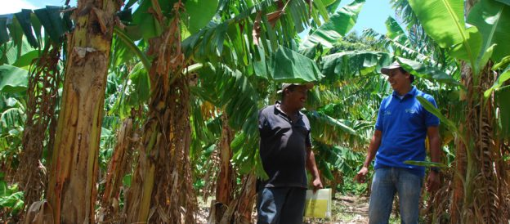
Without the right knowledge or necessary tools, poor farmers in Nicaragua have been unable to undertake a second growing season during the dry season. However, with micro-irrigation equipment and techniques, these farmers have the potential of doubling their annual production and incomes. Until 2010, their needs were ignored by the commercial sector, who failed to see these farmers as a large enough market for their products. This is the market gap that can be filled by a social enterprise, which exists not simply to make a profit, but to ensure that community and societal objectives can be met. In Nicaragua, that gap is being met by iDEal Tecnologías. https://farmingfirst.org/2016/11/julian-wolfson-the-ideal-way-to-expand-drip-irrigation/?utm_source=feedburner&utm_medium=email&utm_campaign=Feed%3A+FarmingFirst+%28Farming+First%29

The end of coal is nigh – someone just needs to tell the Turnbull government
By Suzanne Harter - posted Tuesday, 20 December 2016

Malcolm Turnbull stated that coal will be an important part of Australia's future "for many, many decades to come."
But that statement has been undermined by the bipartisan Senate Environment and Communications Committee, which released an interim report on the Retirement of coal fired power stations in Australia.
The report is timely because coal is currently Australia's biggest source of climate pollution, and with Australia having recently ratified the Paris Climate Agreement, it's very clear that our commitment to cut carbon pollution is inconsistent with using coal to generate energy.
Suzanne Harter is a climate campaigner for ACF http://www.onlineopinion.com.au/view.asp?article=18741

100 years ago: Winter reigns over the land
Esthwaite Water, English Lake District, Cumbria. Photograph: Keith Taylor/Alamy
Thomas Coward
Monday 23 January 2017 09.30 AEDT
The biting east wind played on the swaying wires beside the road, striking notes now melancholy moans, now high-pitched screams; it swept across the mere, lashing white foam from the wavelets; it drove floating ice fragments into the rushes and reeds, scrunching and churning them against the ice-discs which clung to each stalwart stem. The western shore was caked with ice, each grass stem which had caught the splashing waters deep within a transparent icicle; a dead mallard was coated in an icy blanket, driving the hungry rats from the meal they had begun. To the south-east broad shafts, like beams from a searchlight, crossed the sullen clouds which hid the wintry sun, and, beyond, the snow-clad hills of the Derbyshire border faded into the misty horizon. The coots, weary of tossing, chilly waters, fed in a mob on the grass, where they were joined by fifty clonking Canada geese. The hungry redwings searched the frozen fields so unsuccessfully that one bird, separated from its companions, had only energy for an occasional flutter. One felt indeed that
Winter reigneth o’er the land,
Freezing with its icy breath.
https://www.theguardian.com/environment/2017/jan/22/country-diary-winter-reigns-over-land-1917

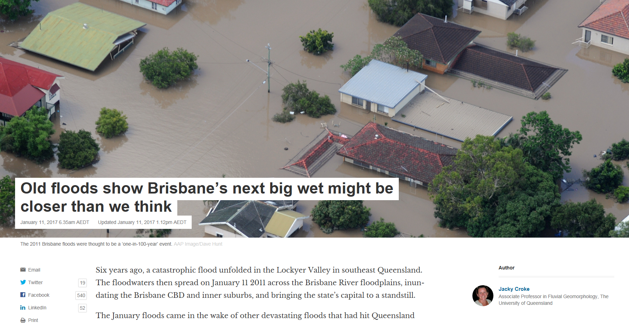
https://theconversation.com/old-floods-show-brisbanes-next-big-wet-might-be-closer-than-we-think-70392

Australian climate politics in 2017: A guide for the perplexed
Opinion
The Conversation
By Marc Hudson, University of Manchester
Updated 2 Jan 2017, 1:54pmMon 2 Jan 2017, 1:54pm
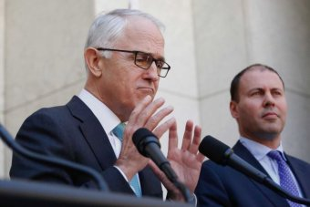
Photo: There will be a fierce battle over climate policy in 2017, writes Marc Hudson. (ABC News: Ross Nerdal)

If you thought the climate debate has been ugly, you haven't seen anything yet. In 2017 Australia will review its climate policies, and the process is not off to a good start.
To recap: with the release of the climate review's terms of reference at the end of 2016, Federal Environment and Energy Minister Josh Frydenberg appeared to place on the table an emissions intensity scheme (a widely supported form of carbon pricing). He then wisely went to Antarctica. http://www.abc.net.au/news/2017-01-02/australian-climate-politics-in-2017-a-guide-for-the-perplexed/8157510

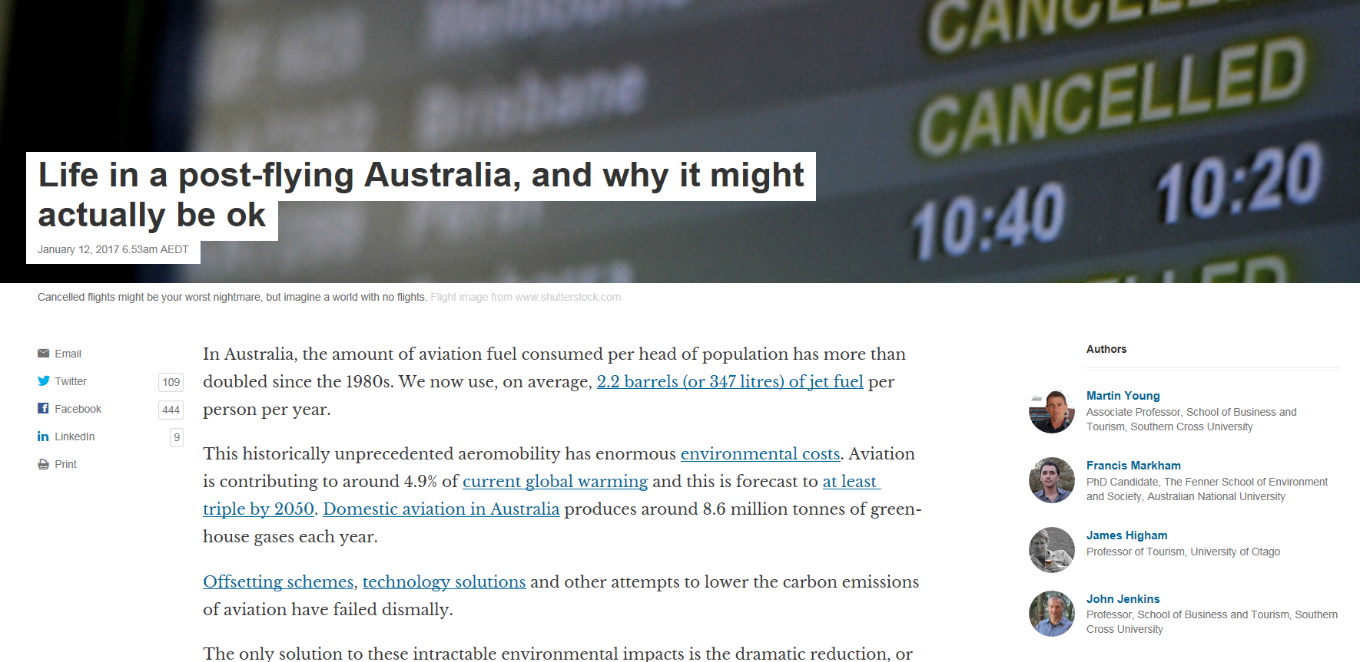
https://theconversation.com/life-in-a-post-flying-australia-and-why-it-might-actually-be-ok-70388

How the free market might just save the Earth
And what will we see once we embrace cheap renewables? An end to the internal combustion engine, for a start, writes freelance journalist Doug Hendrie.
AddThis Sharing Buttons
Share to FacebookShare to TwitterShare to LinkedInShare to Google+
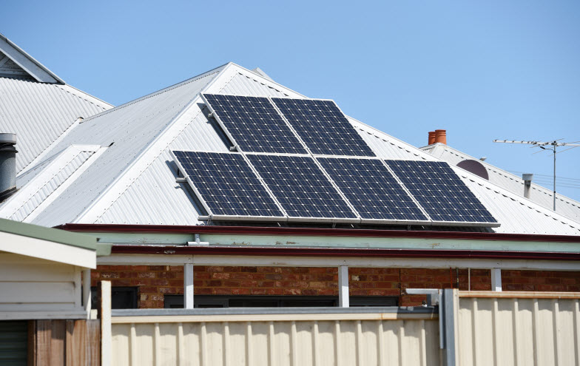
This year, the stakes for action on climate change — the number one threat to humanity — jumped tenfold. https://www.crikey.com.au/2016/12/14/cheap-renewables-will-outcompete-fossil-fuels-across-the-board-soon/

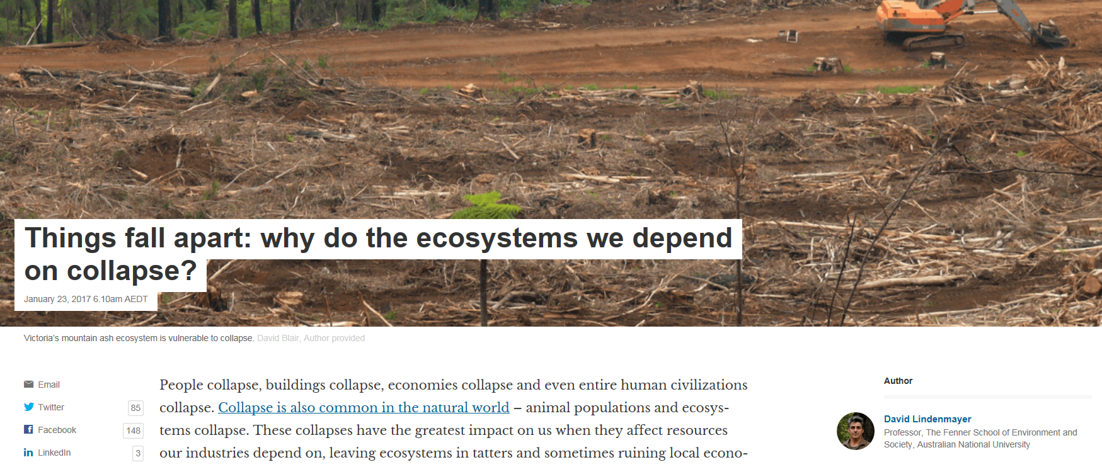

https://theconversation.com/things-fall-apart-why-do-the-ecosystems-we-depend-on-collapse-71491

Risks from deadly soil bacteria rise in NT
Getting stuck in the mud has never been so dangerous in the Top End, as monsoons boost the risk of a deadly bacteria found in soil.
There's been 17 cases of melioidosis in the Northern Territory since October, and one person has already died.
That's higher than usual, and authorities are warning that contact with mud, puddles and wind-blown soil during heavy rain increases the chance of exposure to the tropical disease. http://www.theaustralian.com.au/news/latest-news/risks-from-deadly-soil-bacteria-rise-in-nt/news-story/e564c1fb57c82911e04ec5b1400a1680

 “… the small patches in towns and cities that people cultivate by hand – contains a third more organic carbon than agricultural soil and 25% more nitrogen.” George Monbiot, published in the Guardian 25th March 2015

