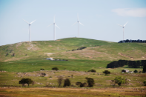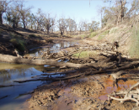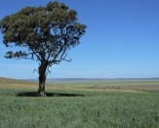

Composting to build better soils, reduce chemical inputs
Pat Hannan, CEO 2 Jan 2017, 4 p.m.
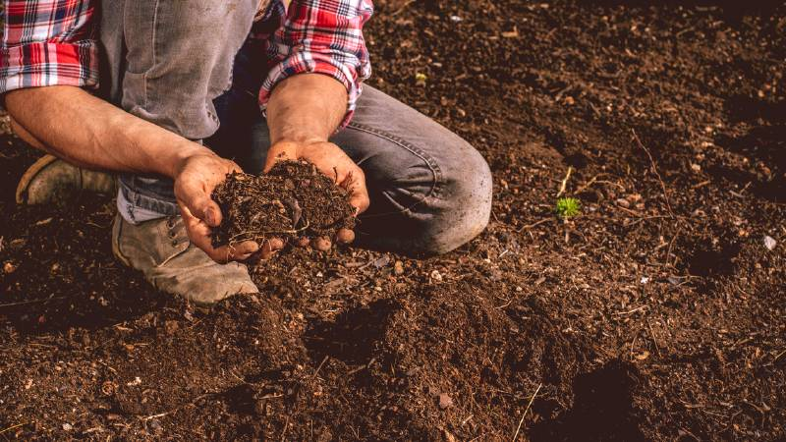
Sustainable farmers will lead the way making practices such as composting and cover cropping commonplace.
Bowen and Ayr growers late last year attended a composting workshop which aimed to motivate them to look at how traditional farming practices can be modified to promote continual soil improvements, reduce fertiliser and chemical inputs, and improve production outcomes. http://www.stockandland.com.au/story/4368811/composting-to-build-better-soils-reduce-chemical-inputs/?cs=4770
Field Indicators of Hydric Soils, version 8

The updated version of the Field Indicators includes all changes made in the errata for version 7.0. There are also two general format changes that were made to some indicators to provide better consistency and clarity that have no effect on the requirements of the indicator.

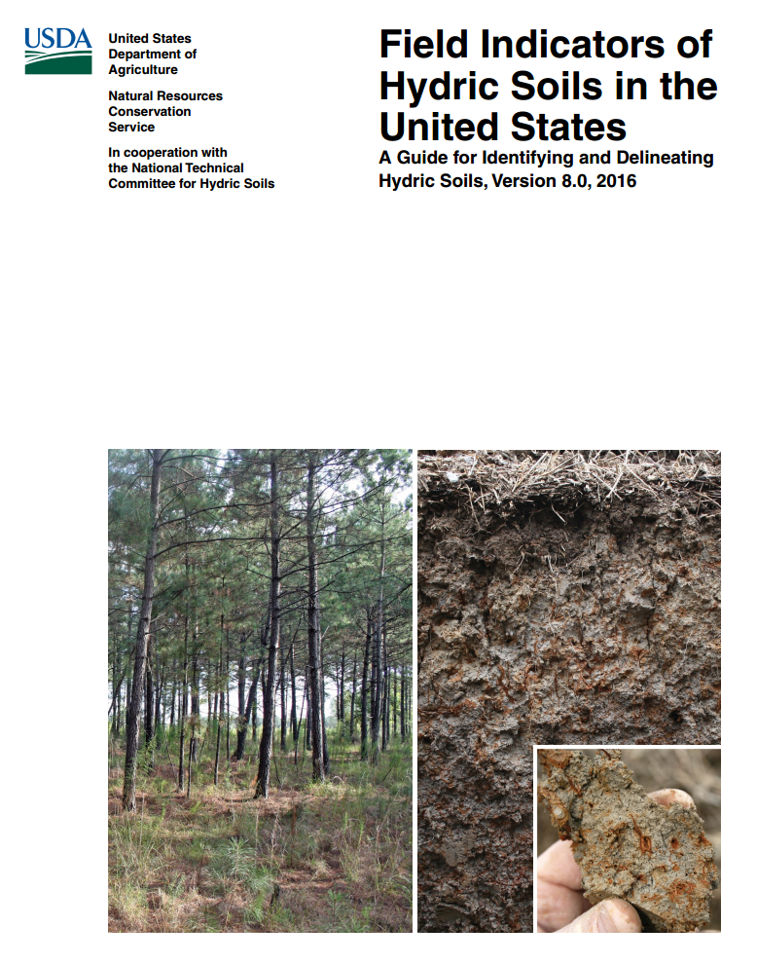
https://www.nrcs.usda.gov/Internet/FSE_DOCUMENTS/nrcs142p2_053171.pdf

Farmers in Sudan battle climate change and hunger as desert creeps closer
Haphazard rains and increasing desertification in the eastern state of Gedaref are destroying previously fertile soil and leaving villagers unable to farm

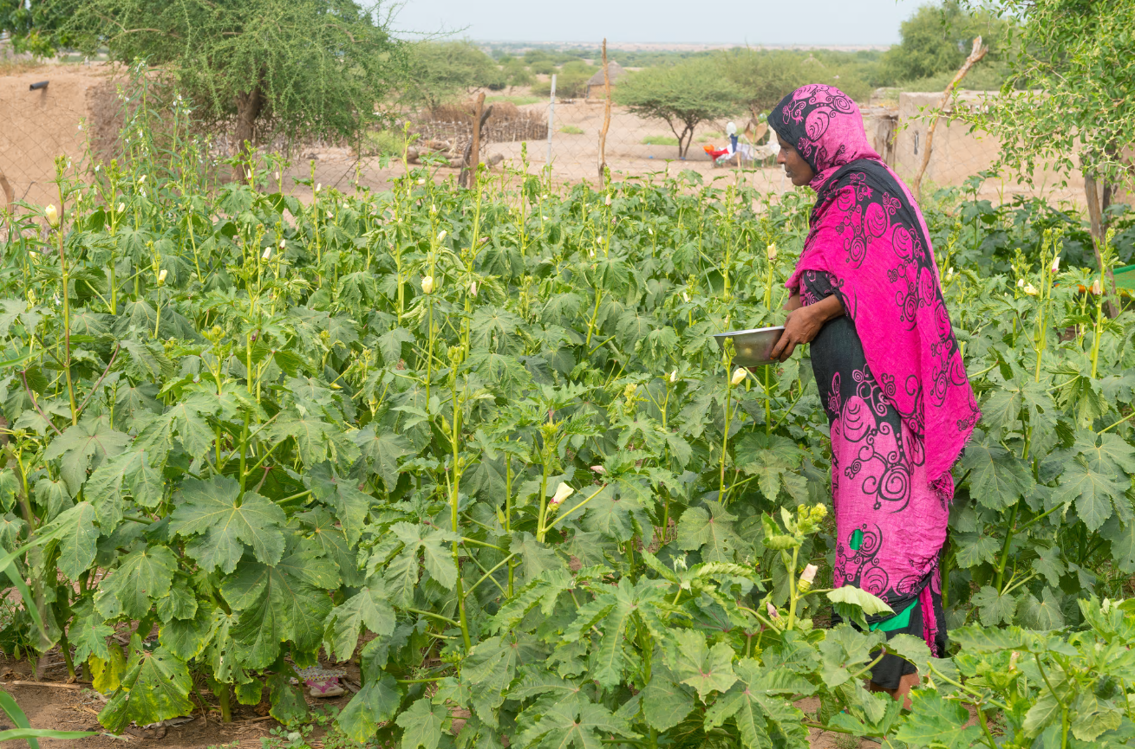

The ‘women’s garden’ in Wad Hassan village

In Sudan’s eastern state of Gedaref, nicknamed “the granary” for its vast rows of sesame, sorghum and millet, banks of sediment and gravel are popping up as high as hills around the farms – the result of deforestation and erratic rains causing watering holes to overflow.
Locals call them karab, meaning “something useless”, says environmental scientist Tarig El Gamri, standing atop one such mound. He points out the water mark swirls etched around one of many deep gullies near the village of Wad Hassan, a 45-minute drive east of Gedaref city. https://www.theguardian.com/global-development/2016/dec/19/sudan-faremers-battle-climate-change-hunger-desertification

Blair charts new course for LLS

Mike Foley@micksfoley
20 Dec 2016, 11:30 a.m.
News
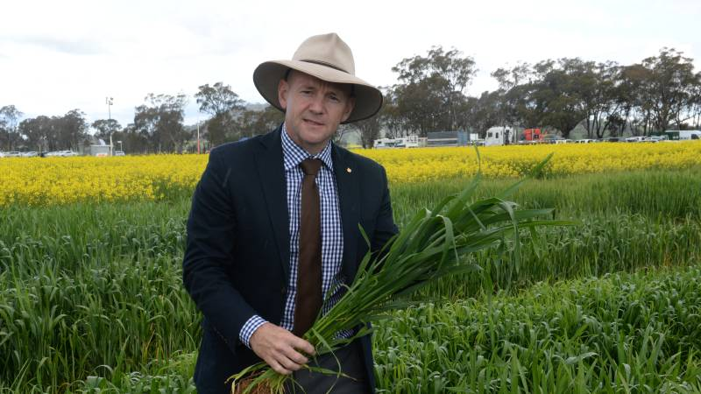
Primary Industries, Lands and Water Minister Niall Blair.
Local Land Services is set for a shake up in the New Year with broad reforms to be rolled out across the ratepayer body.
Primary Industries Minister Niall Blair, speaking this morning at Coolamon, announced a new, binding charter for performance agreements with LLS staff - from the chairman through to regional offices. http://www.theland.com.au/story/4367097/blair-charts-new-course-for-lls/
Report calls for improved methods to assess earthquake-caused soil liquefaction
Several strong earthquakes around the world have resulted in a phenomenon called soil liquefaction, the seismic generation of excess porewater pressures and softening of granular soils, often to the point that they may not be able to support the foundations of buildings and other infrastructure. The November 2016 earthquake in New Zealand, for example, resulted in liquefaction that caused serious damage to the Port of Wellington, which contributes approximately $1.75 billion to the country's annual GDP. An estimated 40 percent of the U.S. is subject to ground motions severe enough to cause liquefaction and associated damage to infrastructure. https://www.sciencedaily.com/releases/2016/12/161221125443.htm

Soil water app ready for wireless rain gauges
Author: Liz Wells
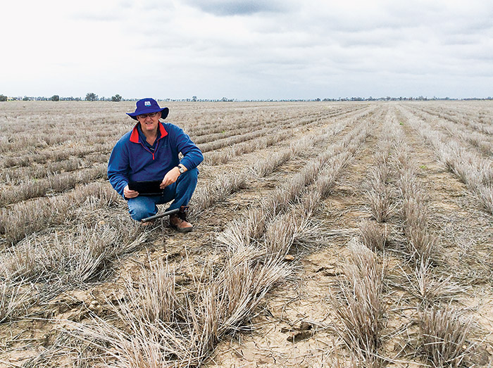
MCA Ag agronomist Paul Gardoll uses the SoilWaterApp on a client’s Goondiwindi property to assess soil moisture available for planting of the next crop.
PHOTO: Liz Wells
Its marriage of climate data and soil-type information is giving SoilWaterApp (SWApp) the know-how to bring on board new technologies set to help growers make better-informed decisions about what to grow and when.
SWApp, released in March, is helping growers to navigate management decisions through notoriously unreliable rainfall patterns.
The paddock-based app links with data from Bureau of Meteorology (BoM) weather stations and has already attracted more than 500 registered users. https://grdc.com.au/Media-Centre/Ground-Cover/Ground-Cover-Issue-125-NovemberDecember-2016/Soil-water-app-ready-for-wireless-rain-gauges

Effective gypsum application
Jemma Pearl, BCG 31 Dec 2016, 6:30 a.m.
Gypsum is an important and common input in Wimmera farming systems, and understanding when an application is effective and efficient to ensure a response and return on investment in paramount.
Calcium sulfate, more commonly known as gypsum, is used on heavy clay soils throughout the Wimmera to help break down the clay and enhance the calcium component of soils.
A soil is said to be sodic when there is an abundance of sodium cations bound to clay particles. This causes dispersion when wet, leading to the degradation of soil structure which in turn has effects on compaction, crop emergence and root growth.
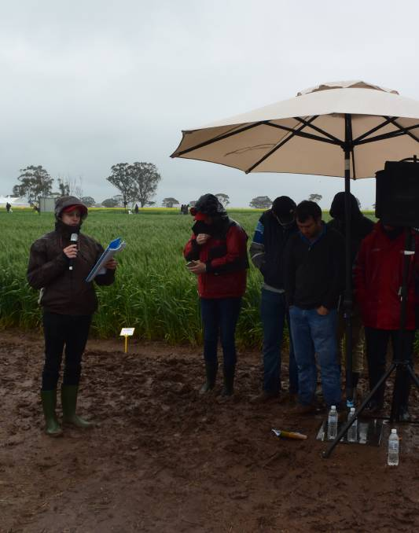
Hardy presenter Tim McClelland addresses the crowd huddled under shelter at a soggy Birchip Cropping Group (BCG) main field day earlier in the month. http://www.stockandland.com.au/story/4372464/effective-gypsum-application/?cs=4786

Coal seam gas mining costs farmers millions, CSIRO study finds
By Anna Gibbs
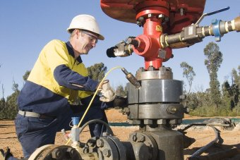
Photo: The study measures the losses to productive land under 24 different scenarios. (Supplied: Eastern Star Gas)
A CSIRO study has for the first time put a dollar figure on the losses to farmers due to coal seam gas (CSG) mining on their land.

Key points:
- Sample area averages a loss of $2.17 million over 20 years
- Biggest cause of losses to agricultural production from gas industry access tracks, lease areas
- Peak body says industry has brought benefits for farmers in many cases
According to the model used by the CSIRO, a sample area averaged a loss of $2.17 million over 20 years when CSG mining activity was present. http://www.abc.net.au/news/2016-12-16/coal-seam-gas-mining-costs-farmers-millions-csiro-study-finds/8124834

Study shows wheat, sandy soils face greater wireworm risk
AddThis Sharing Buttons
Share to FacebookShare to TwitterShare to PrintShare to EmailShare to More
John O’Connell
Capital Press
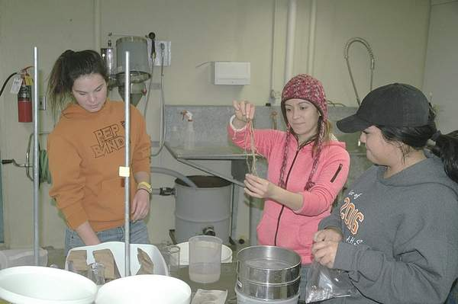
John O’Connell/Capital Press From left to right, Cindrie Lowder, Fabiola Aguilar and Pamela Flores, field research assistants at the University of Idaho’s Aberdeen Research and Extension Center, clean wheat plant roots on Dec. 12. The wheat was raised in a greenhouse study to quantify biomass loss due to wireworm feeding.

ABERDEEN, Idaho — Wheat planted in sandy soil may be especially susceptible to damage when wireworms are present, according to new University of Idaho research findings.
The new paper represents one of the many studies under the umbrella of a collaboration of researchers from Idaho, Oregon, Washington, Montana, Canada and Europe, seeking ways to better control the troublesome pest in cereals. Researchers participated in an international conference call in May to discuss opportunities to work together on wireworm research and to pursue funding as a team. http://www.capitalpress.com/Research/20161215/study-shows-wheat-sandy-soils-face-greater-wireworm-risk

Soil test results represent real power for farmers
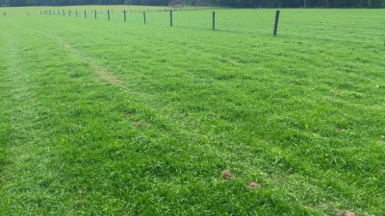
Average soil P, K and pH levels remain low and are holding back Irish farmers from meeting the full production potential of their land, according to Teagasc Soil Fertility Specialist David Wall.
Approximately 37,000t of chemical phosphate was spread on Irish farms last year and this figure is up from the 20,000t spread in 2009, the year when we hit rock bottom, he said. http://www.agriland.ie/farming-news/soil-test-results-represent-real-power-for-farmers/#

Planting Chickpeas and Lentils Can Improve Soil

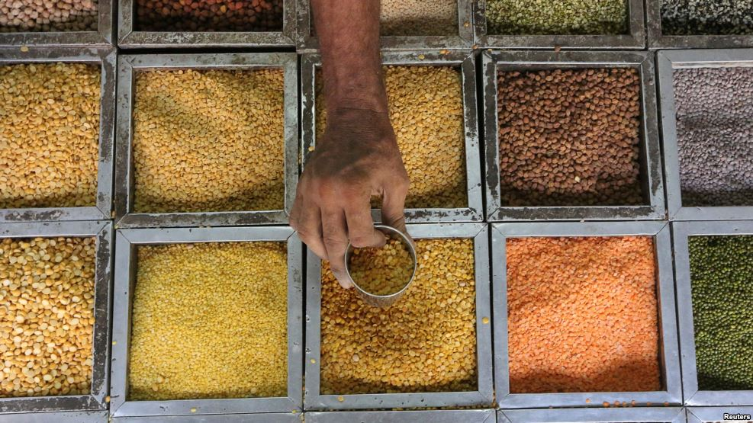
An employee collects lentils from a container inside a grocery store at a residential area in Mumbai, India. (Credit Reuters)
Planting more lentils, chickpeas or other crops known as pulses will improve the health of the world’s soils.
That information comes from the United Nations Food and Agriculture Organization (FAO).
The health of soils around the world have reached critical levels, according to the U.N. agency. It says that means hunger and poverty levels could worsen. http://learningenglish.voanews.com/a/planting-chickpeas-and-lentils-can-improve-soil/3630070.html

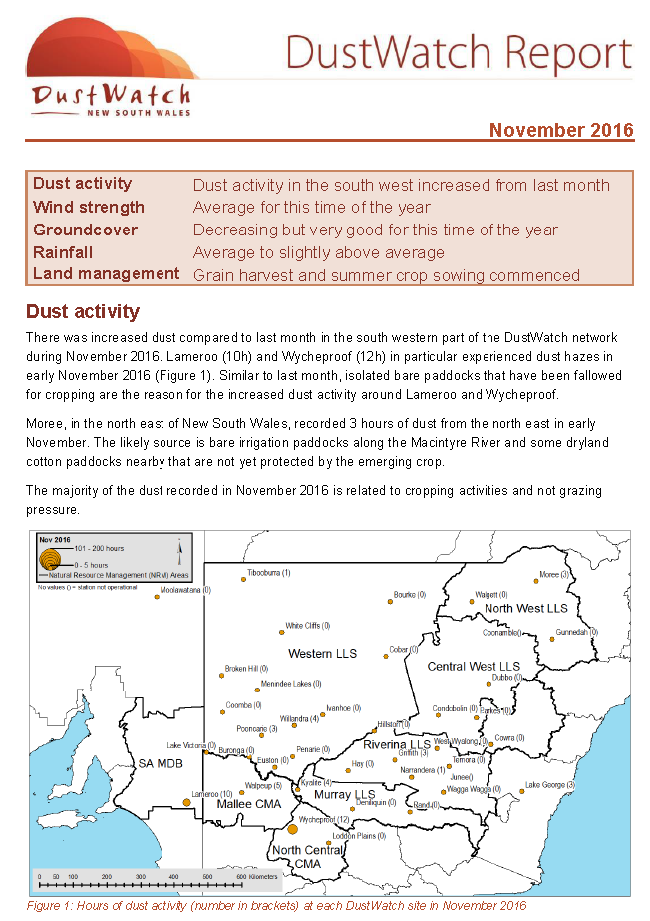
http://www.environment.nsw.gov.au/resources/dustwatch/160804DWNL.pdf

Strait between Bali and Lombok

Oceanic nonlinear waves spotted by satellite in the Lombok Strait.
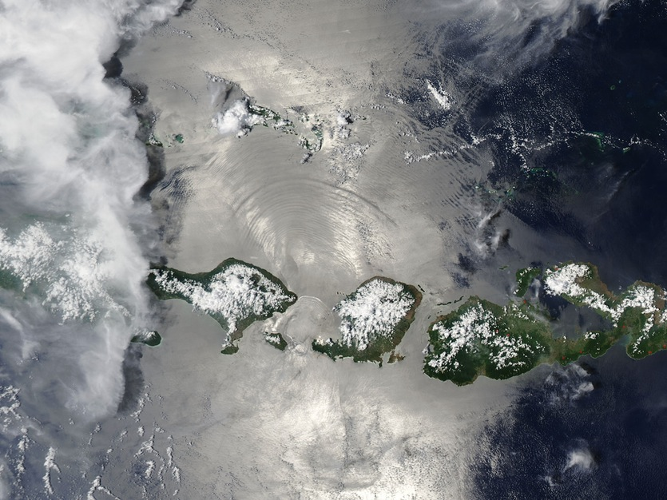
Jeff Schmaltz, MODIS Land Rapid Response Team, NASA GSFC
NASA’s Aqua satellite passed over Indonesia in November, allowing the Moderate Resolution Imaging Spectroradiometer (MODIS) on board to capture a stunning true-colour image of oceanic nonlinear internal solitary waves from the Lombok Strait.
A bank of clouds covers East Java along the western edge of the image, with a bright sun overhead casting shadows from the clouds along the ocean surface. Away from the clouds, the ocean surface appears a bright silver due to “sunglint”, an optical effect caused by the mirror-like reflection of sunlight off the water surface directly back at the satellite sensor. Although sunglint washes out many features, it also reveals details about the water surface that are usually hidden from view. In this case, sunglint exposes the waves created by the movement of currents in the ocean water. https://cosmosmagazine.com/geoscience/strait-between-bali-and-lombok?utm_source=Today+in+Cosmos+Magazine&utm_campaign=d66c48fa2e-RSS_EMAIL&utm_medium=email&utm_term=0_5f4ec2b124-d66c48fa2e-179982353
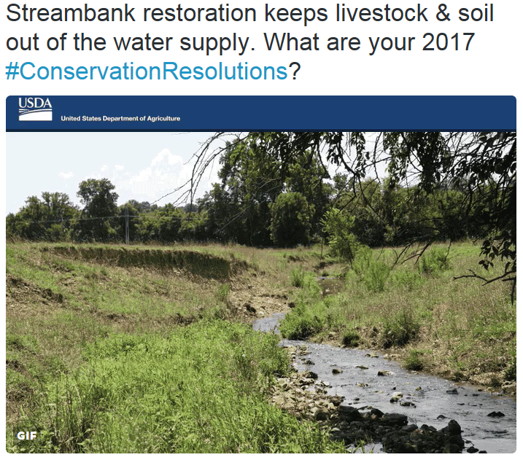
https://twitter.com/USDA_NRCS/status/816339187427180544/photo/1

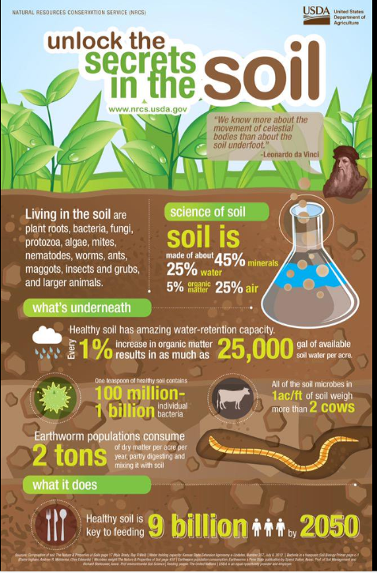
https://twitter.com/USDA_NRCS

Carbon capture scheme collapsed 'over government department disagreements'
Publicly funded competition had already cost £100m when it was cancelled by the Treasury amid concerns over cost to consumers
Equipment used to capture carbon dioxide emissions at a coal-fired power plant in Thompsons, Texas. Photograph: Ernest Scheyder/Reuters
Rajeev Syal
Friday 20 January 2017 11.01 AEDT Last modified on Friday 20 January 2017 11.03 AEDT
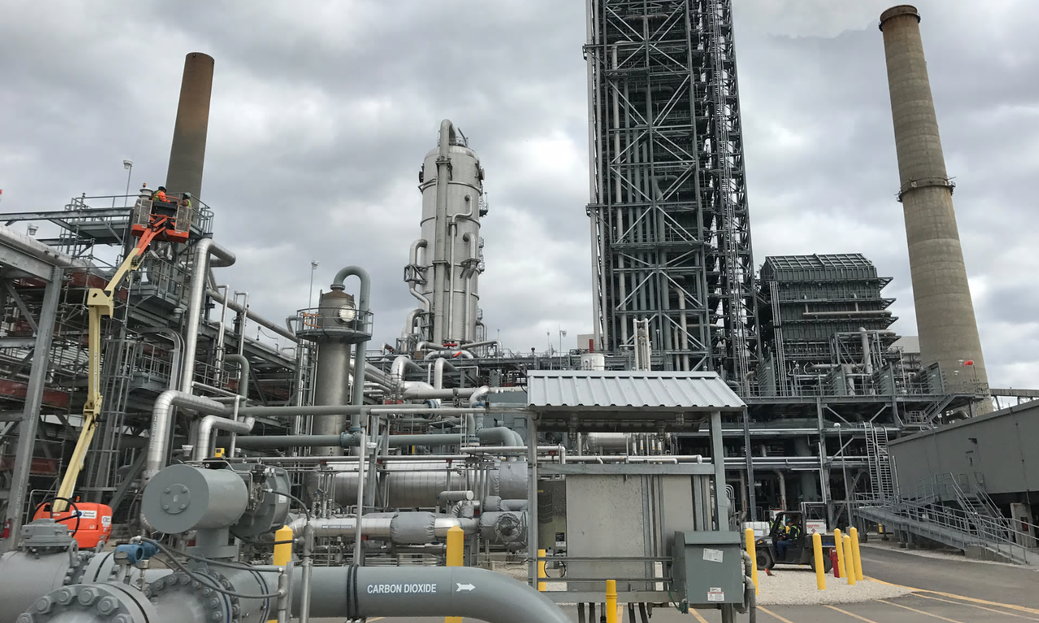
A publicly funded scheme to reduce carbon emissions collapsed, after running up costs of £100m, following a disagreement between government departments, Whitehall’s spending watchdog has concluded. https://www.theguardian.com/environment/2017/jan/20/carbon-capture-scheme-collapsed-over-government-department-disagreements

Harvests in the U.S. to suffer from climate change, according to study

19 January 2017
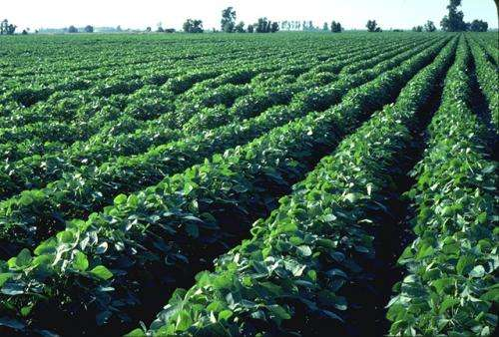
Credit: SC Department of Agriculture
Some of the most important crops risk substantial damage from rising temperatures. To better assess how climate change caused by human greenhouse gas emissions will likely impact wheat, maize and soybean, an international team of scientists conducted an unprecedentedly comprehensive set of computer simulations of U.S. crop yields. The simulations reproduced a strong reduction in past crop yields induced by high temperatures, thereby confirming that they capture one main mechanism for future projections. Importantly, the scientists find that increased irrigation can reduce the negative effects of global warming on crops—but this is possible only in regions where sufficient water is available. Eventually, limiting global warming is needed to keep crop losses in check. https://phys.org/news/2017-01-harvests-climate.html#nRlv

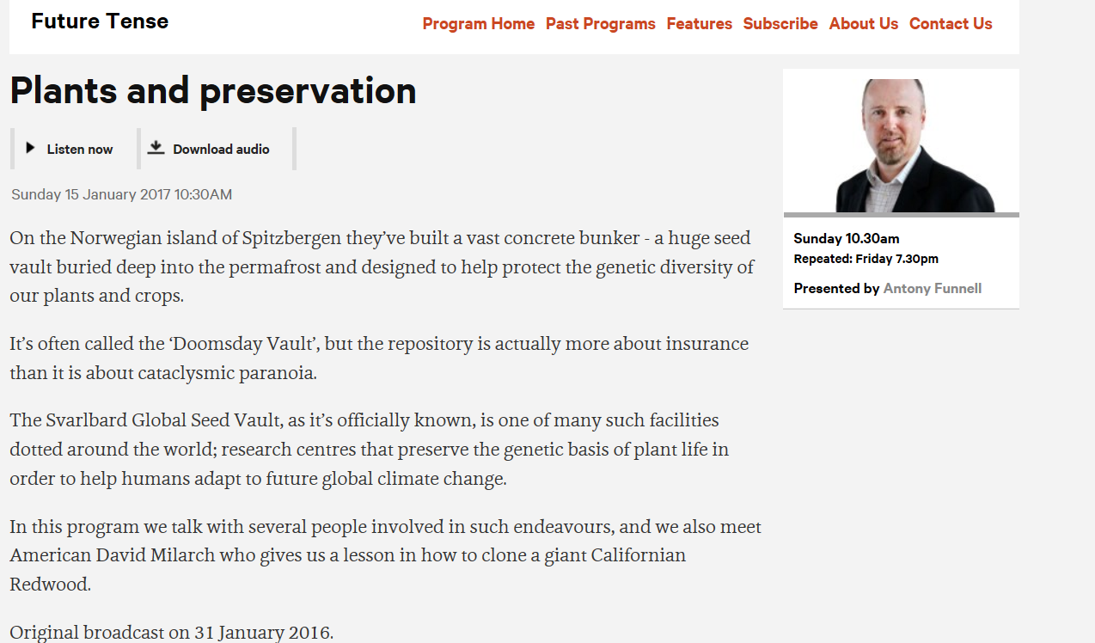
http://www.abc.net.au/radionational/programs/futuretense/summer-seeds/7926186

Why is Mars red?

The planet’s rusted iron dust was most likely caused by liquid water, says Roger Rassool.
A ‘selfie’ of the Mars Curiosity rover taken on the red planet in January 2015. – NASA / JPL-Caltech / MSSS
You don't need a powerful telescope to see the deep reddish glow of Mars. It’s easily spotted through binoculars and, on clear nights at certain times of the year, with the naked eye. The ancient Romans revered the planet for its colour and the Egyptians called her “desher”, or “the red one”.
But of all the planets in our Solar System, Mars is the only one that’s red. Why is it so?
The reddish colour is caused by the presence of oxidised or “ferric” iron in the form of red hematite (Fe₂O₃). We have plenty of that rusted red rock here on Earth. To form, it required oxygen and the source of that oxygen was life. https://cosmosmagazine.com/space/why-mars-red

Strewn dunes

Students can snap photos from space, such as this false-colour image of the Sahara Desert.
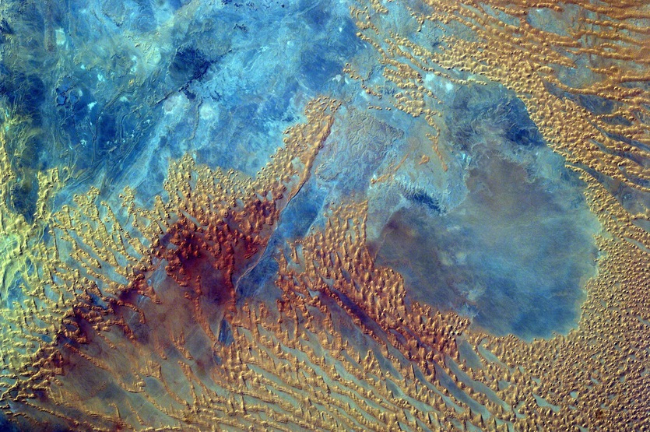
Sally Ride EarthKAM
Middle school students programmed a camera aboard the International Space Station – the Sally Ride EarthKAM – to photograph this portion of the Sahara desert in western Libya on 3 October.
In early November, the Expedition 50 crew set up the EarthKAM gear once again in the Harmony module’s Earth-facing hatch window, to allow students to photograph targets on Earth and downlink the imagery. https://cosmosmagazine.com/geoscience/strewn-dunes?utm_source=Today+in+Cosmos+Magazine&utm_campaign=cf64ff76ff-RSS_EMAIL&utm_medium=email&utm_term=0_5f4ec2b124-cf64ff76ff-179982353

Study of past warming signals major sea level rise ahead

19 January 19, 2017 by Kerry Sheridan

Scientists have already predicted the Earth is likely to see multiple meters of sea level rise in the years to come, a development that will swallow many of the planet's coastal communities
Scientists who study patterns of natural shifts in the Earth's climate said Thursday they have uncovered a "worrisome" signal that major sea level rise could be on the way. https://phys.org/news/2017-01-major-sea.html#nRlv

Caves in central China show history of natural flood patterns

19 January 2017
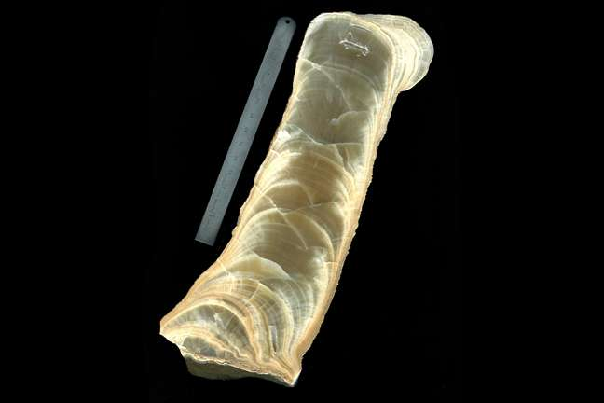
Scanned image of a polished stalagmite showing growth layers. As stalagmites grow, they incorporate trace amounts of naturally occurring magnetic minerals, primarily from soils overlying the cave. The concentration of these magnetic …more
Researchers at the University of Minnesota have found that major flooding and large amounts of precipitation occur on 500-year cycles in central China. These findings shed light on the forecasting of future floods and improve understanding of climate change over time and the potential mechanism of strong precipitation in monsoon regions.
Read more at: https://phys.org/news/2017-01-caves-central-china-history-natural.html#jCp


“It is the absence of facts that frightens people: the gap you open, into which they pour their fears, fantasies, desires.”
― Hilary Mantel, Wolf Hall

