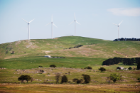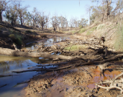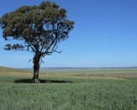

Changing climate changes soils
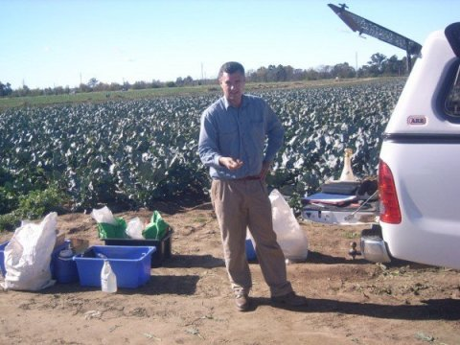
Gray collecting soil carbon data in the field, Hawkesbury Region, New South Wales.
Credit: D. King, Office of Environment and Heritage

The hottest months. The snowiest winters. Catastrophic floods and droughts.
Climate change impacts lives across the world in drastic and unpredictable ways. This unpredictability also extends to the more subtle -- yet still important -- effects of climate change.
For example, it is uncertain how climate change will affect soils and their ability to support productive farms or healthy natural ecosystems.
Journal Reference:
- Jonathan M. Gray, Thomas F.A. Bishop. Change in Soil Organic Carbon Stocks under 12 Climate Change Projections over New South Wales, Australia. Soil Science Society of America Journal, 2016; 80 (5): 1296 DOI: 10.2136/sssaj2016.02.0038
https://www.sciencedaily.com/releases/2017/01/170111133851.htm

Sub-performing soils in southern research spotlight
Author: Rebecca Jennings

The GRDC, along with agricultural research organisations, is co-investing in two projects worth nearly $18 million over five years to rectify soil constraints in the southern region
Two major new research initiatives are aimed at providing growers with a guide to how, when and where they can incorporate organic matter and other ameliorants to overcome constraints to root growth, crop yield and profitability arising from poor soil structure.
One project addresses amelioration processes for heavy clay subsoils mainly in medium to high-rainfall zones, while the other focuses on increasing agricultural production on sandy soils in low and medium-rainfall areas.
Although the two projects are separate, both tackle challenges facing growers across the southern region (and into southern NSW) and build on past research into subsoil constraints.
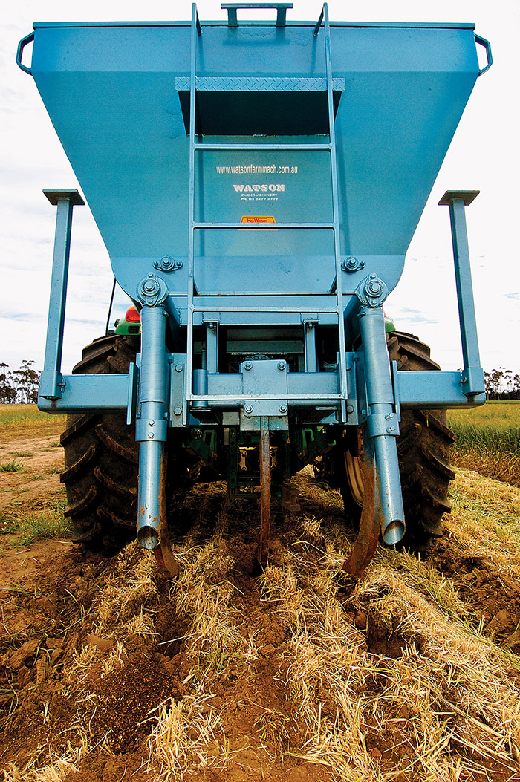

Incorporating chicken manure can significantly lift yields, but the challenge is to make the practice economical on a large scale.
PHOTO: Brad Collis

https://grdc.com.au/Media-Centre/Ground-Cover/Ground-Cover-Issue-125-NovemberDecember-2016/Sub-performing-soils-in-southern-research-spotlight

Targeting soil pH with precision mapping
Author: Alistair Lawson
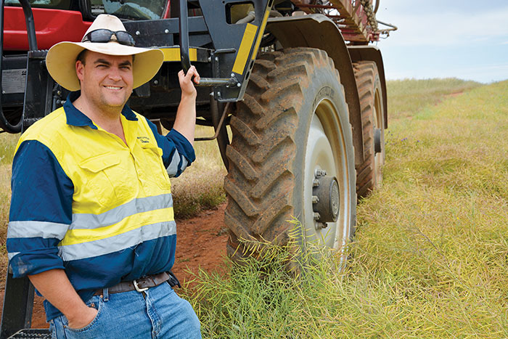
South Australian grower Damien Sommerville uses precision pH mapping to help better manage his lime applications.
PHOTO: Alistair Lawson
Growers: Eric, Judith, Ben, Damien and Ruth Sommerville
Location: Spalding and Burra, SA
Farm size: 1600 hectares
Enterprises: cropping, contracting
Average annual rainfall: 440 millimetres
Soil pH: 4.5 to 8.5
Soil types: predominantly red-brown clay
Crops: wheat, barley, canola, oaten hay
Healthy soils are the ultimate goal for South Australian grower Damien Sommerville, and addressing soil acidity through liming is one way he is looking to improve crop productivity.
He cites acidic clay soils as one of the biggest yield constraints on his family’s grain-growing properties at Spalding and Burra in SA’s Mid North region. https://grdc.com.au/Media-Centre/Ground-Cover/Ground-Cover-Issue-126-January-February-2017/Targeting-soil-pH-with-precision-mapping

Data from 2012 earthquake suggests new plate boundary may be forming in Indian Ocean

5 January 2017 by Bob Yirka report
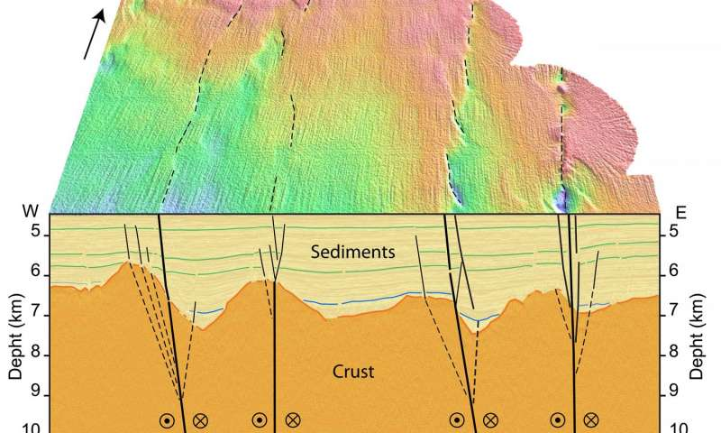
Reactivated fracture zones ruptured during Wharton Basin earthquakes in 2012. Credit: Yanfang Qin, Satish C. Singh
(Phys.org)—A team of researchers with members from several institutions in Singapore, France and Indonesia has found evidence of a possible new plate boundary forming on the floor of the Indian Ocean in the Wharton Basin. In their paper published in the journal Science Advances, the team reports that they studied seismic and ocean floor topology to learn more about tectonic plate deformations in the region and what they found by doing so.
Read more at: https://phys.org/news/2017-01-earthquake-plate-boundary-indian-ocean.html#jCp

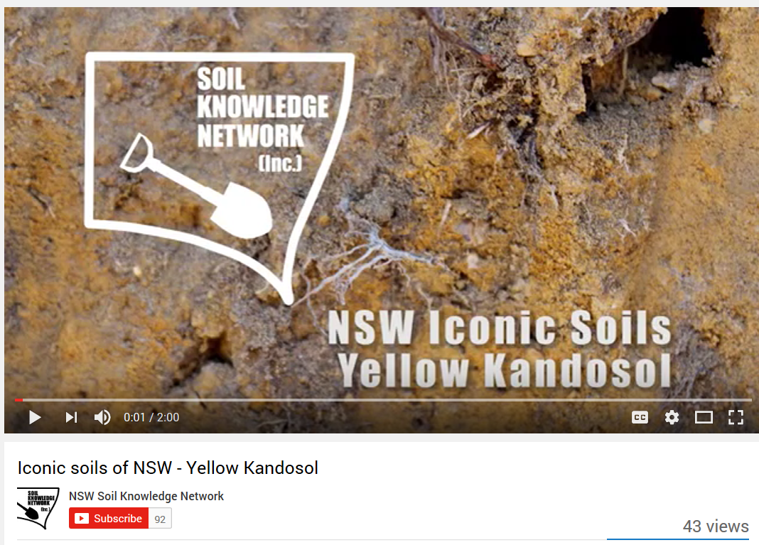
https://www.youtube.com/watch?v=oSYrzLS94Mc

Lead levels in Sydney soil dangerously high

William McInnes January 2017
Sydneysiders could be facing a severe health risk, with soils in Sydney's gardens containing high traces of lead.
Up to 40 per cent of soils sampled showed lead levels three times the recommended Australian guidelines, with older homes in the inner west most at risk.
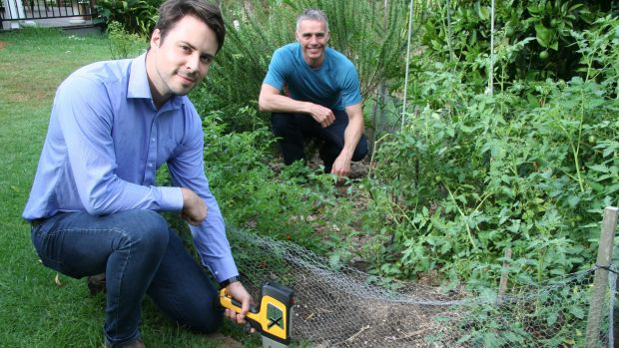Health risk: Marek Rouillon (left) and Professor Mark Taylor test lead concentration in garden soil. Photo: Macquarie University
The information comes from a paper released as part of VegeSafe, an ongoing community science program run by Macquarie University, that measures the contamination levels of soils across Australia. http://www.smh.com.au/nsw/lead-levels-in-sydney-soil-dangerously-high-20170119-gtuea6.html

1st World Conference on soil and water conservation under global change (CONSOWA)
A joint Conference of the “International Soil Conservation Organization” (19th ISCO Conference), the “World Association for Soil and Water Conservation” (Conference on Soil and Water Conservation of WASWAC), the “European Society for Soil Conservation” (8th ESSC Congress), the “International Union of Soil Science (IUSS-Commissions 3.2, 3.6), the Soil and Water Conservation Society (SWCS), the “International Erosion Control Association” (IECA) and the “World Association for Sedimentation and Erosion Research” (WASER), in parallel with the VIII Simposio Nacional sobre Control de la Degradación y Restauración de Suelos (SECS). Abstract deadline: 15 January 2017
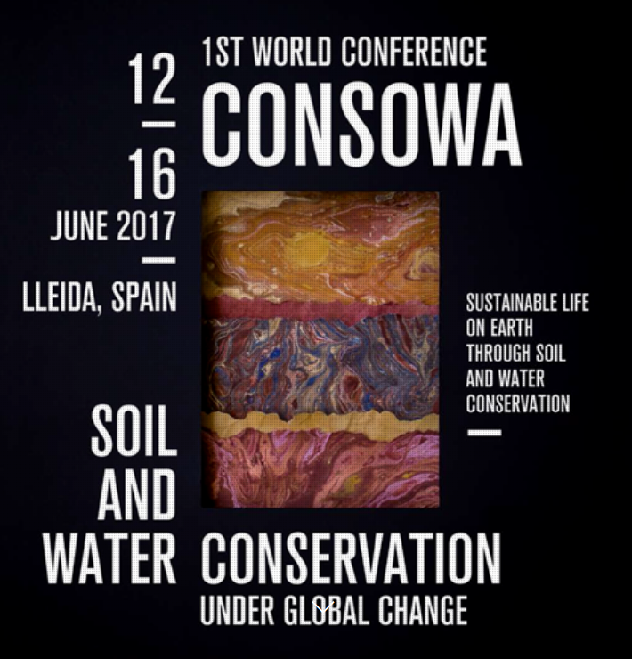
Venue: 12-16 June 2017, Lleida (Spain) http://www.consowalleida2017.com/

Modified ripper treats acidic subsoils
Author: Nicole Baxter
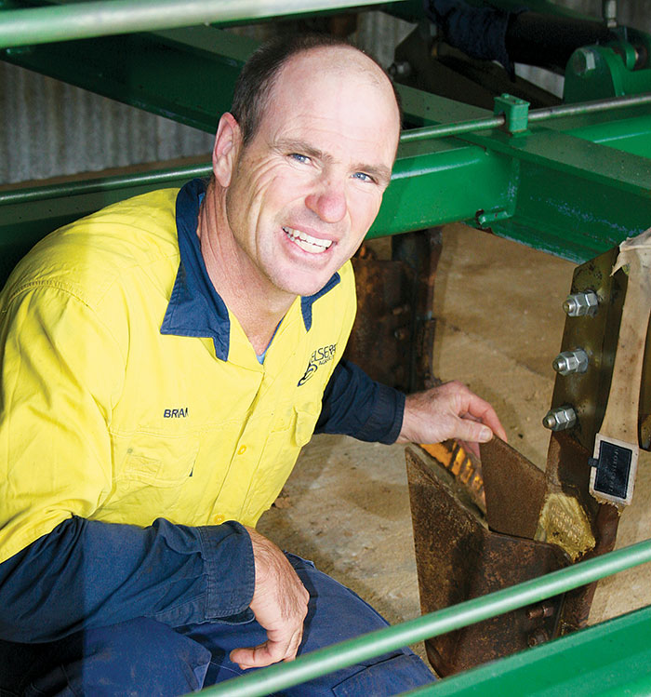
Brian McAlpine showing topsoil inclusion plates on the Gessner deep-ripper he has used across his cropping country near Latham, Western Australia.
PHOTO: Tracy McAlpine
Although Western Australian grower Brian McAlpine has spread lime on his soils for more than 20 years, a recent nutrient analysis showed the ameliorant was not moving into the subsoil as he had hoped.
Brian, who farms with his wife Tracy near Latham, about 320 kilometres north-east of Perth, says the nutrient analysis shows topsoil pH is conducive to growing crops at about 6.0 (calcium chloride), but a pH of 4.7 (calcium chloride) in the subsoil is constraining root growth.
He investigated mouldboard ploughing and spading to push lime into the subsoil, but their cost and practicality did not make them viable options. https://grdc.com.au/Media-Centre/Ground-Cover/Ground-Cover-Issue-126-January-February-2017/Modified-ripper-treats-acidic-subsoils

Protecting soils to mitigate climate change

17 January 2017
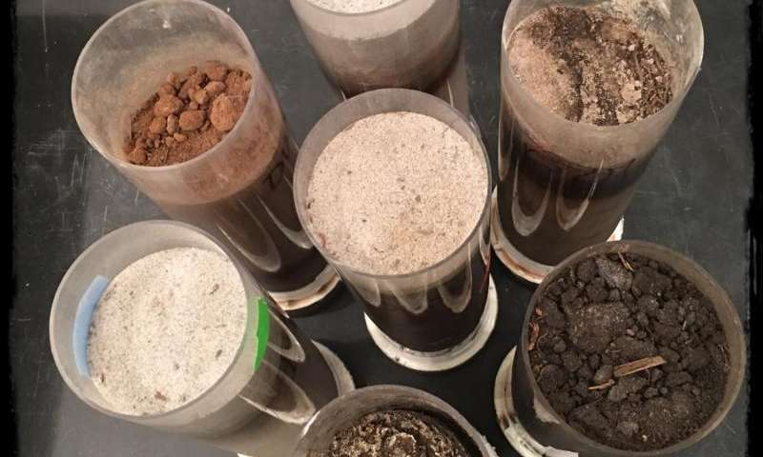
Soils used in the study. Credit: Pacific Northwest National Laboratory
If you were an ant, you would see that soil has networks of pores and channels that weave through the soil like interconnected straws. They're formed underground by the different minerals that compose soil and as a result of movements or growth by roots, insects, and other living organisms. The pores in soil house gases and liquids, such as soil organic carbon and water.
Read more at: https://phys.org/news/2017-01-soils-mitigate-climate.html#jCp

Soil test for nematodes critical for summer crop choices
Author: Toni Somes
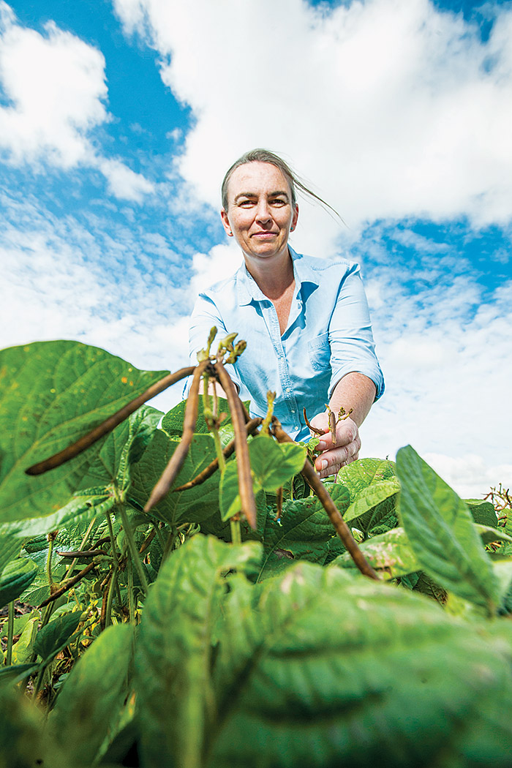
Dr Kirsty Owen from USQ’s Centre for Crop Health inspects a mungbean crop for signs of nematode damage at a 20-hectare trial site on a property at Jondaryan as part of a GRDC-funded research project.
PHOTO: David Martinelli, USQ

New research has highlighted the need for northern growers to soil test for root lesion nematode (RLN) species and population size ahead of summer planting to ensure the right crop choices are made to reduce the parasitic pests’ impact
GRDC-funded research by the University of Southern Queensland’s (USQ) Centre for Crop Health indicates some summer crops previously regarded as ‘resistant’ may now be ‘susceptible’ to specific RLN species.
The research was led by USQ nematologist Kirsty Owen, who also heads the Queensland team working on the national GRDC program researching the impact of nematodes on crop production. https://grdc.com.au/Media-Centre/Ground-Cover/Ground-Cover-Issue-125-NovemberDecember-2016/Soil-test-for-nematodes-critical-for-summer-crop-choices

Soils investment ploughs profitability back into business
Author: Clarisa Collis
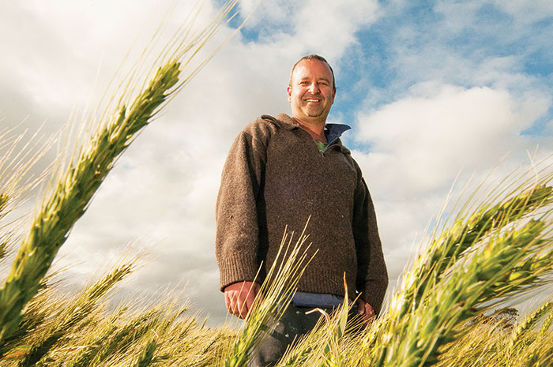
Delving and spading has not only lifted the productivity and profitability of David Giddings’s farm business, but also led to a suite of new on-farm practices that are adding to these gains on his 3000-hectare property at Wanilla on the Lower Eyre Peninsula.
PHOTO: Clarisa Collis

A three-year investment in soil restructuring has created a step-change in practices and more profitable crop options for South Australian grower David Giddings

Snapshot
Growers: David Giddings and Kerri Thompson
Location: Wanilla, Lower Eyre Peninsula, South Australia
Farm size: 3000 hectares; 2000ha cropping, 1000ha livestock
Average annual rainfall: 450 to 500 millimetres
Soil types: predominantly yellow sand
Enterprises: wheat, barley, canola, lupins, oats, breeding ewes, prime lambs
Soil pH: 4 to 6
A strategic approach to cropping as a ‘numbers game’, calculatedly governed by the business’s gross margins, became the catalyst for South Australian grower David Giddings to invest in soil amelioration works that have changed the way he farms at Wanilla on the Lower Eyre Peninsula.
https://grdc.com.au/Media-Centre/Ground-Cover/Ground-Cover-Issue-126-January-February-2017/Soils-investment-ploughs-profitability-back-into-business

NASA study finds solar storms could spark soils at moon's poles

6 January 2017 by Bill Steigerwald

A map showing the permanently shadowed regions (blue) that cover about 3 percent of the moon's south pole. Credit: NASA Goddard/LRO mission
Powerful solar storms can charge up the soil in frigid, permanently shadowed regions near the lunar poles, and may possibly produce "sparks" that could vaporize and melt the soil, perhaps as much as meteoroid impacts, according to NASA-funded research. This alteration may become evident when analyzing future samples from these regions that could hold the key to understanding the history of the moon and solar system.
Read more at: https://phys.org/news/2017-01-nasa-solar-storms-soils-moon.html#jCp

Sensor network builds soil moisture knowledge bank
Author: Rebecca Thyer

Key points
- Thirty-three public-access soil moisture probes exist across the WA wheatbelt
- Data from soil moisture probes is being used with Yield Prophet® modelling to improve soil type characterisations
- The data can better inform on-farm decisions in dry years and help growers better understand water-holding capacity in wet years
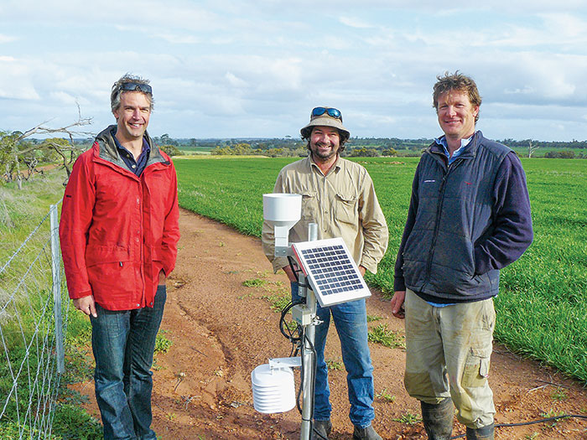
(From left) Frank D’Emden with Brad Tonkin and Kristin Lefroy from the Moora-Miling Pasture Improvement Group at the Bindi Bindi soil moisture probe site. Data from soil moisture probes is being used with Yield Prophet® modelling to improve soil type characterisations.

Theories on the water-holding capacity of soils across Western Australia’s wheatbelt are being tested after the wet winter in 2016, utilising a network of moisture probes
A wet winter across parts of Western Australia’s wheatbelt in 2016 has helped researchers recalibrate soils’ ‘bucket size’. The recalibrations are part of a broader project designed to give growers access to real-time soil moisture and weather data and periodic Yield Prophet® reports. https://grdc.com.au/Media-Centre/Ground-Cover/Ground-Cover-Issue-126-January-February-2017/Sensor-network-builds-soil-moisture-knowledge-bank

Building Weather Ready Soils with Manure and Mulch
By Linda Schott, University of Nebraska Extension Graduate Research Assistant, December 30, 2016 | 6:09 am EST
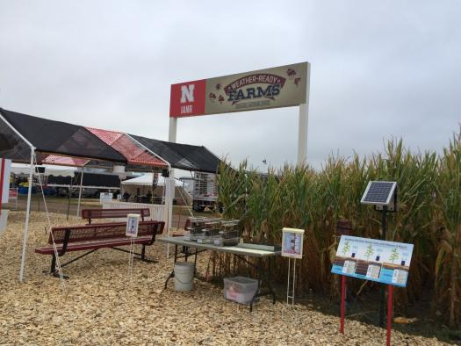Visitors to “Building Weather Ready Soils with Manure and Mulch” were shown how manure and mulch increase resilience to heavy rainfall events and droughts using a desktop rainfall simulator.
Manure is often an undervalued and underutilized resource. It has many soil health benefits. When manure is managed properly and applied at appropriate rates, soil benefits include better drought tolerance and greater resilience to heavy rainfall events when compared to non-manured soil. Manure has been shown to increase soil organic matter, increasing the amount of water that soil can hold for later plant use. Manured soils also have greater soil aggregate stability, allowing more water to infiltrate during heavy rainfall events and decreasing erosion caused by runoff. Additionally, manured soils have enhanced microbial activity, which increases nutrient cycling in the soil. Overall, manure has been shown to increase soil infiltration rates by 40% and water holding capacity by 15% when compared to non-manured soil. Crop yields are also generally higher for manured fields. http://www.porknetwork.com/advice-and-tips/building-weather-ready-soils-manure-and-mulch

Relationship between soil colour and climate

What is the first colour that comes to mind when you envision soil? Is it brown, black, yellow, or red? How about white, gray, green, or blue? The Soil Science Society of America (SSSA) September 1 Soils Matter blog post explains that of these answers are correct depending on where you are from! It is true; soils come in an incredible range of colours. https://www.sciencedaily.com/releases/2016/09/160901125646.htm

Soil pores, carbon stores, and breathing microbes

16 January 2017
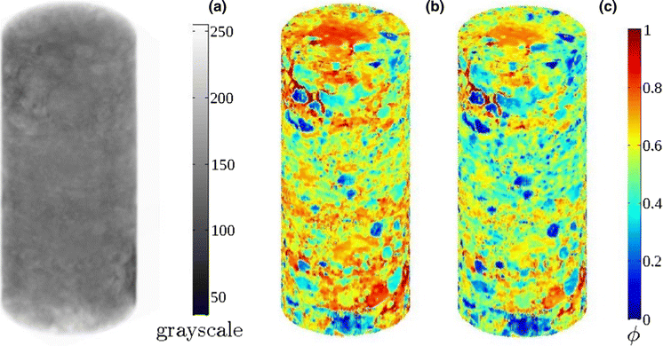
X-ray tomography images of soil cores pinpoint the concentrations of solids (left, in grey) and the distribution of solids and pores (right, in color). Credit: Pacific Northwest National Laboratory
Researchers at the Pacific Northwest National Laboratory (PNNL) recently studied how moisture influences soil heterotrophic respiration. That's the breathing-like process by which microbes convert dead organic carbon in the soil to carbon dioxide.
Read more at: https://phys.org/news/2017-01-soil-pores-carbon-microbes.html#jCp

Resolve to Build Healthy Soils on Rented Land
Posted by Melissa Erdman, NRCS District Conservationist, on 3 January 2017 at 1:46 PM

Five questions.
Do you rent out your land for agriculture? If you do, don’t forget about your farm when you’re making your New Year’s resolutions. Here are five questions from USDA’s Natural Resources Conservation Service (NRCS) that you need to ask the folks who rent your land: Do you build organic matter in the soil? Do you test the soil at least once every four years? Do you use no-till practices? Do you use cover crops? What can we do together to improve soil health on your land? http://blogs.usda.gov/2017/01/03/resolve-to-build-healthy-soils-on-rented-land/

Soil Biomass Productivity maps of grasslands and pasture, of croplands and of forest areas in EU
Soil biomass productivity of grasslands and pastures
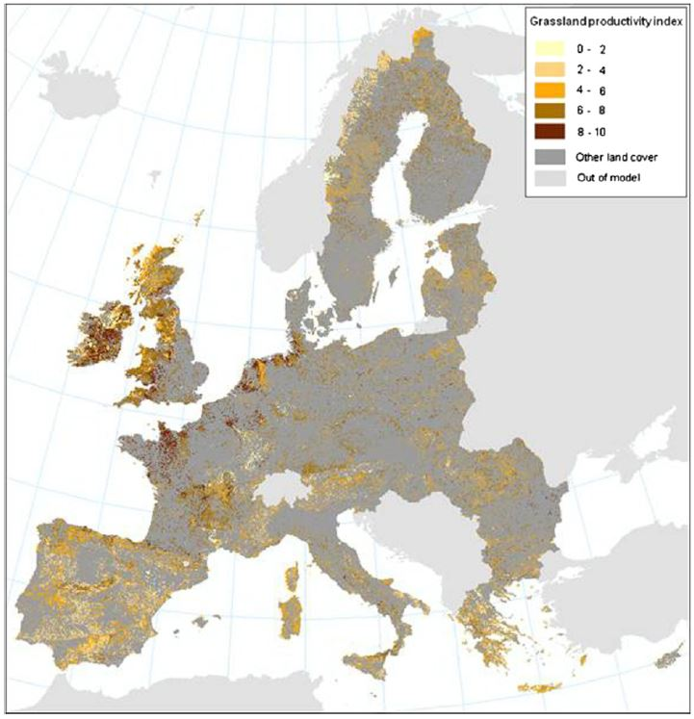
Figure 5. Soil biomass productivity of croplands

This dataset consists of 3 GIS maps that indicate the soil biomass productivity of grasslands and pasture, of croplands and of forest areas in the European Union (EU27). The degree to which the soil carries out its biomass production service was evaluated on the basis of soil properties under prevailing climatic and topographical conditions. Since productivity is a result of the interaction of soil, climatic, and topographical conditions, these factors need to be assessed in their complexity. In addition to geophysical conditions, soil productivity also depends on the type of land use. Results are presented in land use–specific maps (e.g. cropland productivity for areas of rain-fed arable lands, forest biomass productivity for forest lands and grassland productivity for pastures).
http://esdac.jrc.ec.europa.eu/content/soil-biomass-productivity-maps-grasslands-and-pasture-coplands-and-forest-areas-european

Study tracks 'memory' of soil moisture

16 January 2017

A composite image of the Western hemisphere of the Earth. Credit: NASA
The top 2 inches of topsoil on all of Earth's landmasses contains an infinitesimal fraction of the planet's water—less than one-thousandth of a percent. Yet because of its position at the interface between the land and the atmosphere, that tiny amount plays a crucial role in everything from agriculture to weather and climate, and even the spread of disease.
Read more at: https://phys.org/news/2017-01-tracks-memory-soil-moisture.html#jCp

Dahr Jamail | We Have Released a Monster: Previously Frozen Soil Is "Breathing Out" Greenhouse Gases
Wednesday, 28 December 2016 By Dahr Jamail, Truthout | Report

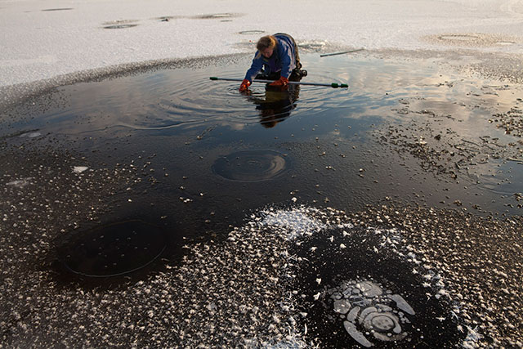Katey Walter Anthony, a leading scientist in studying the escape of methane, at her research site where methane is collecting beneath the ice, in Fairbanks, Alaska, on October 21, 2011. With temperatures warming across much of that region, which scientists primarily believe is because of the rapid human release of greenhouse gases, permafrost is also warming, and signs are emerging that frozen carbon may be destabilizing. (Josh Haner/The New York Times)
Want to see more stories like this in 2017? It was made possible by readers like you -- click here to make a tax-deductible donation to Truthout’s independent journalism!
A study published in the journal Nature has revealed an alarming new climate feedback loop: As Earth's atmosphere continues to warm from anthropogenic climate disruption (ACD), soils are respirating carbon -- that is, carbon is being literally baked out of the soils. http://www.truth-out.org/news/item/38885-we-have-released-a-monster-previously-frozen-soil-is-breathing-out-greenhouse-gases

Facts, beliefs, and identity: The seeds of science skepticism

22 January 2017

Credit: CC0 Public Domain
Psychological researchers are working to understand the cognitive processes, ideologies, cultural demands, and conspiracy beliefs that cause smart people to resist scientific messages. Using surveys, experiments, observational studies and meta-analyses, the researchers capture an emerging theoretical frontier with an eye to making science communication efforts smarter and more effective. https://phys.org/news/2017-01-facts-beliefs-identity-seeds-science.html

What lies beneath - what creepy critters are in our soils?

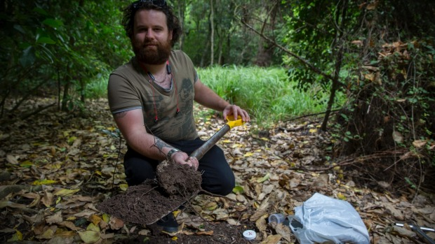
Murray Wilson/ Fairfax NZ
Massey student Ben Bridgeman is using new research techniques to survey what microbes and invertebrates are in our soil.
A cutting-edge genetic study will tell us more about what critters live in our soils.
A range of different types of soil habitats in Manawatu are being sampled, and put through DNA testing. This will tell scientists what types of invertebrates and microbes are present, and the differences in the populations at the sites.
Massey science masters graduate Ben Bridgeman is carrying out the work, and said few studies had been done previously on what organisms are present in our soils. http://www.stuff.co.nz/manawatu-standard/news/88352395/What-lies-beneath-what-creepy-critters-are-in-our-soils

Light Detection and Ranging Helps USDA Pinpoint and Protect Archaeological Mounds
Posted by Sharron Santure, Cultural Resources Specialist, Natural Resources Conservation Service, Illinois,
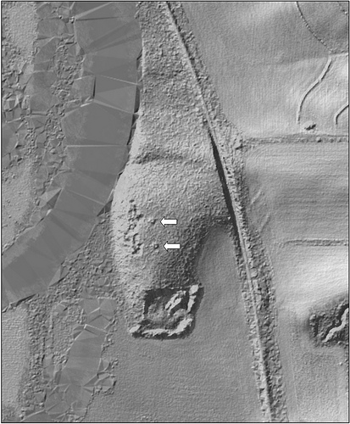
Light Detection and Ranging LiDAR image shows the archaeological mounds in this restored wetland in Illinois. NRCS photo.
Sometimes to stop soil erosion, prevent nutrient and sediment runoff and improve habitat, conservation work does disturb the ground. Because of this, USDA’s Natural Resources Conservation Service relies on its archaeologists on staff to review locations prior to implementing these conservation practices. As the cultural resources specialist for NRCS in Illinois, I’m never quite sure what will turn up in my daily work. http://blogs.usda.gov/2014/06/02/light-detection-and-ranging-helps-usda-pinpoint-and-protect-archaeological-mounds/

Video shows drainage issues tackled by tech
14 Jan 2017, 5:17 p.m.
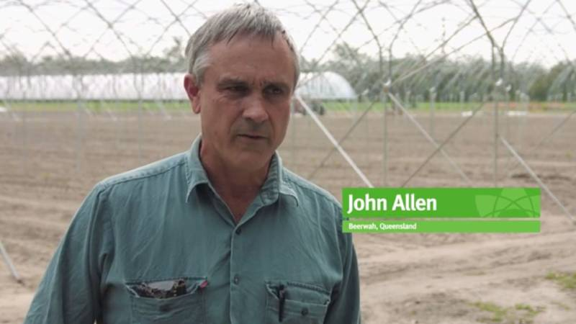
SOIL HEALTH: A screenshot from the video showing strawberry and ginger grower, John Allen, Beerwah, Qld explaining the process of tackling drainage and soil health.
GROWCOM’S Hort360 program has developed a new case study video highlighting how technology is being used on-farm to tackle drainage and soil health.
Hort360 is a best management practice program for horticulture.
Strawberry and ginger grower, John Allen, grows around 600 000 strawberry plants and 28 hectares (70 acres) of ginger annually in Beerwah on the Sunshine Coast. http://www.stockandland.com.au/story/4351727/video-shows-drainage-issues-tackled-by-tech/?cs=4582

Potential biofuel crops in Hawaii may successfully sequester carbon in soil

4 January 2017
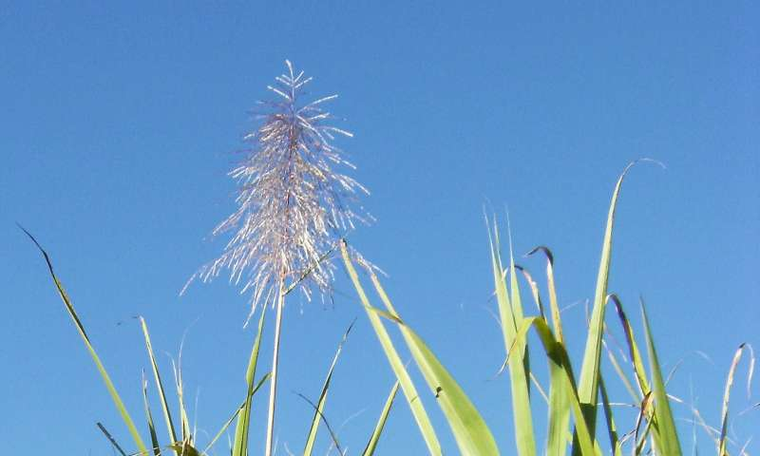
Potential biofuel crops in Hawaii may successfully sequester carbon in soil. Credit: Theo Crazzolara, Flickr
Two potential biofuel crops in Hawaii—sugarcane and napiergrass—may sequester more carbon in soil than is lost to the atmosphere, according to a study published January 4, 2017 in the open-access journal PLOS ONE by Meghan Pawlowski from University of Hawaii Manoa, U.S., and colleagues.
Read more at: https://phys.org/news/2017-01-potential-biofuel-crops-hawaii-successfully.html#jCp

Scientists get down and dirty to unlock northern Australia's agricultural potential
By national rural and regional correspondent Dominique Schwartz
Updated 19 Dec 2016, 6:41pm Mon 19 Dec 2016, 6:41pm
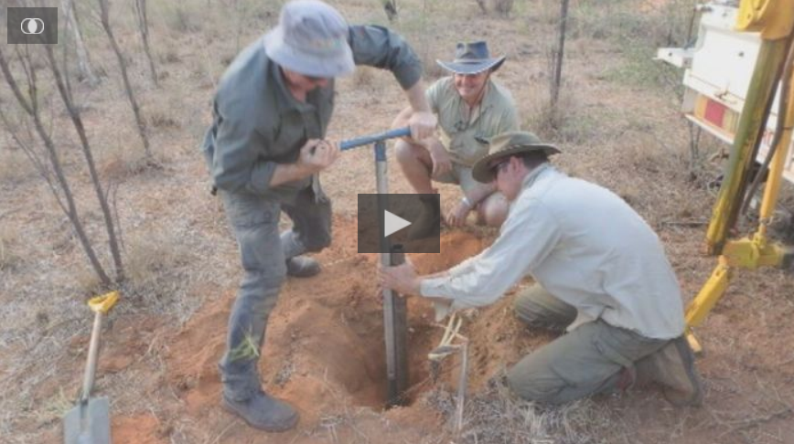
Scientists have been digging up the dirt on northern Australia's potential to become an agricultural powerhouse.
In the biggest undertaking of its kind in Australia, thousands of soil samples were collected from water catchments in Western Australia, the Northern Territory and Queensland.
The samples are now being analysed as part of the Federal Government's multi-billion-dollar plan to develop the Top End and double the nation's agricultural output. http://www.abc.net.au/news/2016-12-18/scientists-dig-up-the-dirt-on-northern-australia/8124142

Rising Carbon Emissions from Warming Soil Highlight Benefits of Land Restoration
by John-Rob Pool and Robert Winterbottom - January 09, 2017
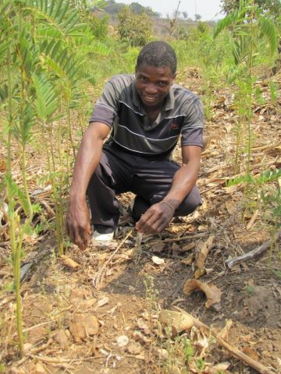
Farmers in Malawi use nitrogen-fixing plants to rebuild soil carbon and boost yields. Photo by Robert Winterbottom/WRI
A new study in the journal Nature explores a vicious cycle: as a changing climate driven by greenhouse gas emissions warms the planet, soils heat up and the micro-organisms that live in the soil start to expel heat-trapping carbon dioxide, reinforcing the problem of climate change.
The analysis of 49 empirical studies of soil-carbon emissions from different parts of the world suggest a globally predictable pattern. By 2050 the planet could see an additional 200 billion tons of carbon dioxide released from soils, especially in the higher latitudes. This soil-carbon feedback has often previously been excluded from calculations of the […] http://www.wri.org/blog/2017/01/rising-carbon-emissions-warming-soil-highlight-benefits-land-restoration

Innovation in the Tropics Helps Farmers Conserve Resources and Improve Soil Health
Posted by Jolene Lau, Natural Resources Conservation Service, Hawaii, on February 17, 2016 at 1:00 PM
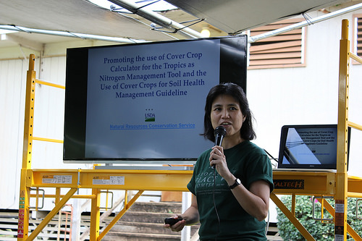
Dr. Koon-Hui Wang of the University of Hawaii is the lead principal in the national Conservation Innovation Grant on Cover Crop Calculator for the Tropics. Photo by Jolene Lau.
Farmers in the Tropics needed a better tool to estimate the nitrogen contribution from cover crops to reduce their commercial fertilizer rates.
Cover crops, which may appear as weeds to the untrained eye, are healthy plants that enhance soil health and minimize erosion. Covering the soil helps protect this precious resource that provides our food and fiber.

Soil fungi help tree seedlings survive, influence forest diversity

13 January 2017
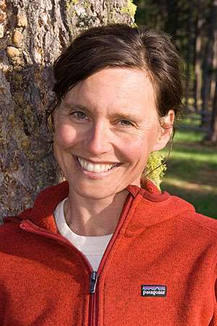
Ylva Lekberg. Credit: University of Montana
A new paper published Jan. 13 in Science reveals that the relationship between soil fungi and tree seedlings is more complicated than previously known. The paper was co-written by Ylva Lekberg, an assistant professor of soil community ecology at the University of Montana.
Read more at: https://phys.org/news/2017-01-soil-fungi-tree-seedlings-survive.html#jCp

20 things you didn’t know about soils
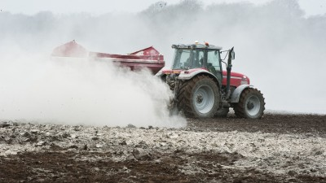
Close to 55% of Irish and UK soils analysed by Yara Analytical Services are deficient in either Phosphate (P), Potash (K) or Magnesium (Mg).
These represent some of the key nutrients for healthy plant growth, according to Yara Ireland. http://www.agriland.ie/farming-news/20-things-you-didnt-know-about-soils/

Fertiliser surge isn’t delivering crop results

Andrew Marshall@BurrenAndrew
9 Jan 2017, 5:30 a.m.

Queensland University of Technology's Professor Peter Grace says ideally smaller, but more regular nitrogen applications are needed during the cropping season to make plant usage more efficient and avoid wasting farmers' money.
Australian farmers spend almost $500 million a year on nitrogen fertiliser which apparently never delivers a cropping advantage.
At the same time, the rest of the world is gaining greater productivity results from rising fertiliser use while Australian crop production has basically plateaued. http://www.stockandland.com.au/story/4389497/fertiliser-surge-isnt-delivering-crop-results/?cs=4598

Organic matter improves soil
9 Jan 2017
Even though the weather is still relatively cool and there is not much going on in the garden, now would be a good time to pay attention to the health of your garden soil and to perhaps give it a shot of organic matter.
Southern Arizona soils are notorious in their ability to pack down into hard, impenetrable layers that prevent the entry of the essentials for good plant growth even after they have been well spaded, raked and smoothed prior to planting. One way to soften soils and to ease the hard, labor-intensive work that it takes to get a garden soil ready for planting is to frequently add a healthy dose of compost, decomposed manure, or other types of we-rotted organic matter. http://www.pinalcentral.com/home_and_hearth/organic-matter-improves-soil/article_772ff4ef-a738-59a4-82ab-e079102b0bbb.html

Flaxleaf fleabane threat increases
Birchip Cropping Group11 Jan 2017, 2:20 p.m.
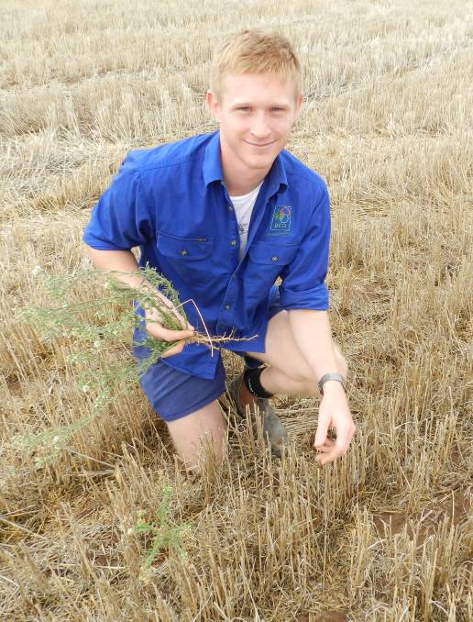
ACT NOW: Birchip Cropping Group contract services manager Cameron Taylor says growers should control flaxleaf fleabane early and protect future yields.
Summer showers have brought about a flush of weed growth in recently harvested paddocks, including the emergence of flaxleaf fleabane.
The hardy perennial weed has proliferated in the Mallee and Wimmera in recent years. And, as farmers are discovering, it is not a simple weed to manage.
The best way to control fleabane – which saps both nutrients and moisture from the soil and is notoriously hard to kill – was researched by Birchip Cropping Group (BCG) after the 2011 floods. http://www.stockandland.com.au/story/4393097/difficult-weeds-a-growing-problem/

Finding may offer farmers a way to reduce harmful emissions from fertilized soil

16 January 2017 by David Malmquist
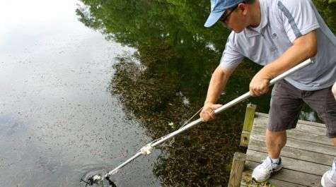
B.K. Song collects water samples from an over-fertilized lake for analyses of microbial communities and nutrients. Credit: David Malmquist
Those concerned with the health of Chesapeake Bay are familiar with nitrogen as a major pollutant whose excess runoff into bay waters can lead to algal blooms and low-oxygen dead zones. Perhaps less familiar is the significant role that a form of nitrogen gas plays in greenhouse warming and the destruction of Earth's ozone layer.
Read more at: https://phys.org/news/2017-01-farmers-emissions-fertilized-soil.html#jCp

Spreading the good news

The list of companies with soil amendment products continues to grow — as does recognition of their value
AddThis Sharing Buttons
Share to FacebookShare to TwitterShare to EmailShare to PinterestShare to More
By Ralph Pearce FOLLOW

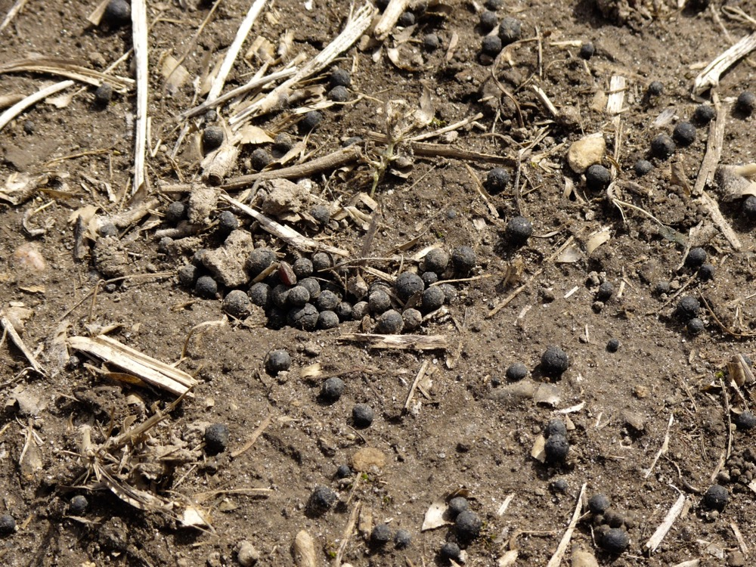
Processed biosolids pellets are an excellent source of nitrogen, phosphorus, organic matter, and micro-nutrients. Photo: Photo courtesy of OMAFRA
For 10 years, the bumper stickers said “Farmers Feed Cities.” Today, by contrast, cities may expand their role in feeding farms.
For those who are backing the trend, the drive to make the use of soil amendments standard and commonplace is reaching a tipping point. http://www.country-guide.ca/2016/12/28/urban-biosolid-materials-could-help-boost-agricultural-soils/50070/

Adaptive management of soil conservation is essential to improving water quality, research shows

13 January 2017
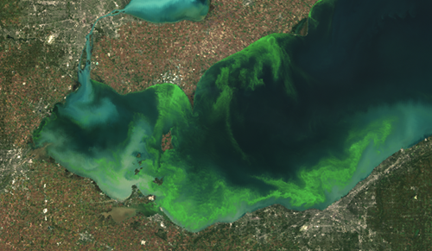
Algal bloom in the Western Lake Erie Basin, 2011. Credit: NASA NOAA
The quality of our rivers and lakes could be placed under pressure from harmful levels of soluble phosphorus, despite well-intended measures to reduce soil erosion and better manage and conserve farmland for crop production, a new study shows.
Read more at: https://phys.org/news/2017-01-soil-essential-quality.html#jCp

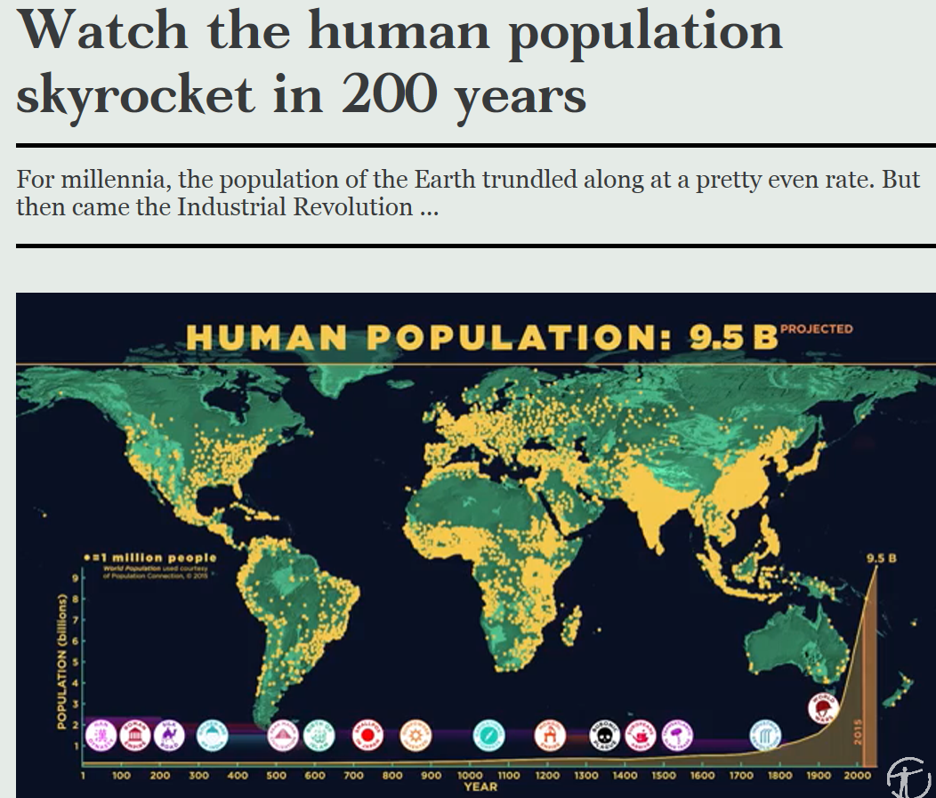
https://cosmosmagazine.com/society/how-human-population-grew-through-time?utm_source=Today+in+Cosmos+Magazine&utm_campaign=8a6ceee3b2-RSS_EMAIL&utm_medium=email&utm_term=0_5f4ec2b124-8a6ceee3b2-179982353

Massive Antarctic ice shelf ready to break apart

20 January 2017
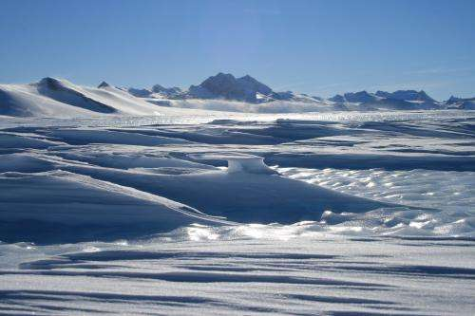
Credit: Newcastle University
A chunk of ice half the size of Jamaica which is breaking away from West Antarctica is now attached to its parent ice shelf just by a thread, scientists reported Friday. https://phys.org/news/2017-01-massive-antarctic-ice-shelf-ready.html

2016 declared hottest year on record

Another a record broken we really shouldn't break.
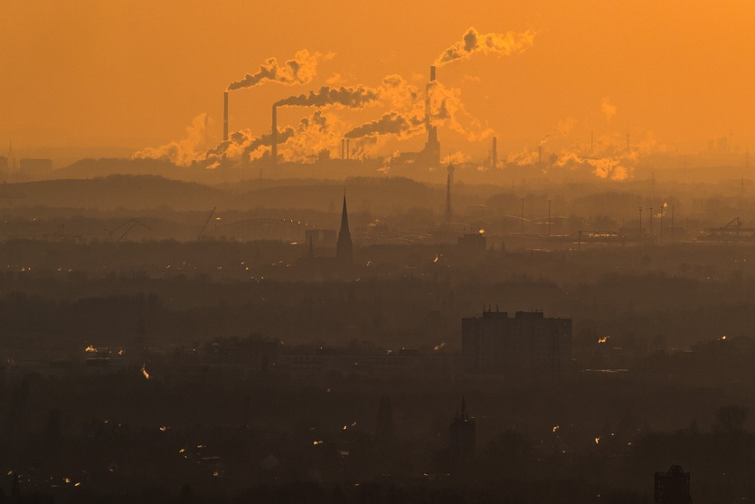
Steam and exhaust spew from factories on a cold winter day in Oberhausen, Germany. Greenhouse gases are among the chief causes of global warming and climate change.
Lukas Schulze / Getty Images
It's official: 2016 was the hottest year on record, according to the World Meteorological Organisation.
The average global temperature was around 0.07 ºC warmer than the previous record-holder year – 2015 – and around 1.1 ºC higher than pre-Industrial times.
And this isn't a chance event, says University of Melbourne climate scientist Andrew King: "Without our influence on the climate we wouldn't be reaching these temperatures." https://cosmosmagazine.com/climate/2016-confirmed-the-hottest-year-on-record?utm_source=Today+in+Cosmos+Magazine&utm_campaign=2f5d503402-RSS_EMAIL&utm_medium=email&utm_term=0_5f4ec2b124-2f5d503402-179982353

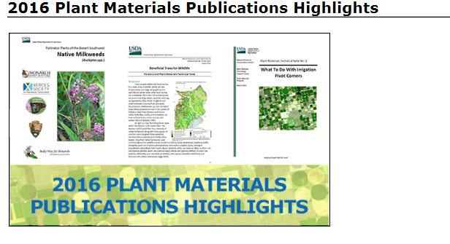
https://www.nrcs.usda.gov/wps/portal/nrcs/detail/plantmaterials/home/?cid=NRCSEPRD1309223

Barnaby Joyce won't rule out dumping Renewable Energy Target
Deputy prime minister criticises ‘romantic’ targets set by states as some Coalition MPs call to ditch RET if US pulls out of Paris climate deal

Barnaby Joyce has ruled out pulling out of the Paris agreement but won’t commit to maintaining Australia’s Renewable Energy Target. Photograph: Lukas Coch/AAP
Paul Karp

Monday 23 January 2017 08.54 AEDT Last modified on Monday 23 January 2017 14.09 AEDT
Barnaby Joyce has refused to commit the government to maintain the Renewable Energy Target, after a report that conservative Coalition MPs want to ditch it if the United States pulls out of the Paris climate agreement.
The deputy prime minister ruled out pulling out of the Paris agreement, but criticised “romantic” renewable targets set by states and said MPs were free to think and say what they like about the RET. https://www.theguardian.com/environment/2017/jan/23/barnaby-joyce-says-government-wont-rule-out-dumping-renewable-energy-target

Ancient tree rings suggest sunspot cycles have been ongoing for 290 million years

20 January 20, 2017 by Bob Yirka report

The Sun by the Atmospheric Imaging Assembly of NASA's Solar Dynamics Observatory. Credit: NASA
(Phys.org)—A pair of researchers affiliated with the Natural History Museum in Chemnitz and Technische Universität Bergakademie Freiberg, both in Germany, has found evidence in ancient tree rings of a solar sunspot cycle millions of years ago similar to the one observed in more modern times. In their paper published in the journal Geology, Ludwig Luthardt and Ronny Rößler describe how they gathered an assortment of petrified tree samples from a region in Germany and used them to count sunspot cycles. https://phys.org/news/2017-01-ancient-tree-sunspot-ongoing-million.html#nRlv

Field Maps Can Help You Better Understand Soils
Maps keying in on such factors as topography can help you better understand soils so you are better at applying inputs to your crops.
By
Gil Gullickson
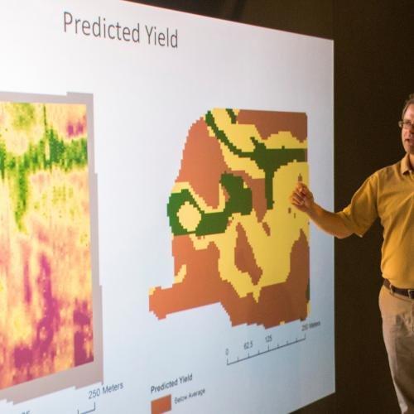
For decades, NRCS soil maps have been a great way to detect soil types in a field. There’s a new generation of technologies and maps, though, that better decipher those differences and the way soils function. This enables you to more efficiently plant seed and apply inputs.
“We are lucky to have had NRCS maps and to understand them as we have,” says Bruce Erickson, Purdue University education distance and outreach director. “But in precision farming, we are ready to go to the next step.” http://www.agriculture.com/crops/fertilizers/field-maps-can-help-you-better-understand-soils

The Twelve Orders of Soil Taxonomy
Click on each soil order for a high-resolution, printable PDF file. For a high resolution PDF version of the entire poster, click on the title on the right side of the poster. (All of these links are also listed below.)
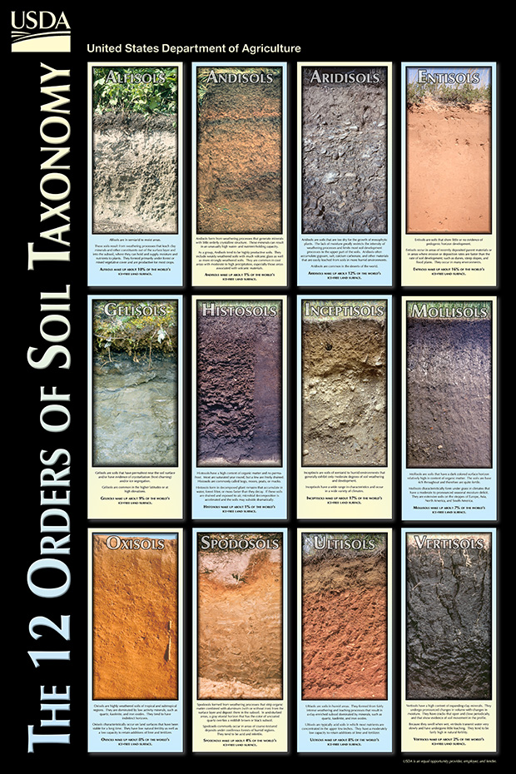
To order a free copy of the poster, go to the NRCS Distribution Center website at http://nrcspad.sc.egov.usda.gov/DistributionCenter/ and search for “Twelve Orders”.

Soil Health Web PSA
 Noted astronomer urges viewers to unlock the secrets in the soil
Dr. Laura Danly of California’s Griffith Observatory is helping USDA’s Natural Resources Conservation Service promote its “healthy soils” campaign. But why is an astronomer talking about soil, rather than the stars? “Studying Earth is just like studying the planets. Earth is a planet, and it’s the most amazing planet we know. It’s the only one we know that has life on it, so it’s a natural for me to want to talk about Earth and share some important messages with people about how we can make Earth healthier,” Danly says
https://www.youtube.com/watch?v=6tJIkAjDjjo&index=6&list=PL4J8PxoprpGZ-uMTxScBBn9nYT6CMX8aD

Regional Partnerships Help De-Clutter Arizona Grasslands
By Valentino Reyes, Natural Resources Conservation Service, 12/01/2017
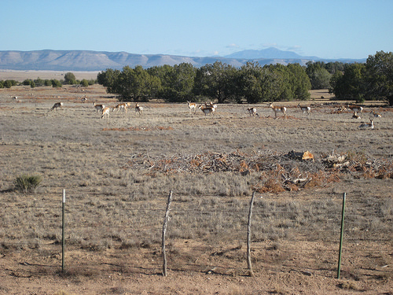
Pronghorn are able to return to brush controlled grasslands in Northern Arizona that were previously dominated by invasive-woody brush. Photo: Steve Cassady.
A popular new year’s resolution is to de-clutter our homes. But what if a clutter-free home was the only way you could survive and thrive? http://blogs.usda.gov/2017/01/12/regional-partnerships-help-de-clutter-arizona-grasslands/

Five reasons to love brush turkeys
ABC Science
By Anna Salleh
Posted 17 Jan 2017, 6:45amTue 17 Jan 2017, 6:45am
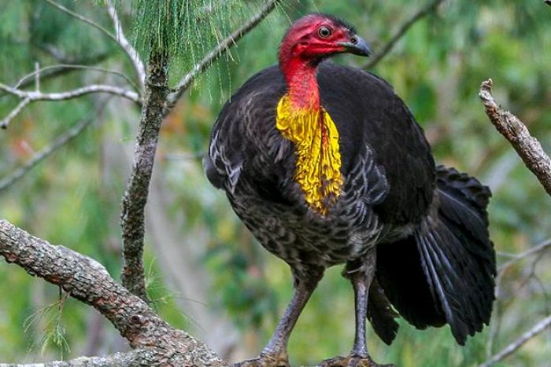Photo: Brush turkeys are just returning home when they invade urban parks and gardens (Supplied: Di Donovan)
Have brush turkeys taken over your garden? The Australian brush turkey (Alectura lathami), also known as the bush or scrub turkey, has a bad reputation.
Brush turkeys are blamed for damaging gardens and darting across roads. Found in eastern Australia from Far North Queensland to the Illawarra in New South Wales, they've managed to adapt to life in cities such as Brisbane and Sydney, and have also been introduced to Kangaroo Island in South Australia. http://www.abc.net.au/news/2017-01-17/five-reasons-to-love-brush-turkeys/7199724

Humans, not climate change, wiped out Australian megafauna

20 January 2017
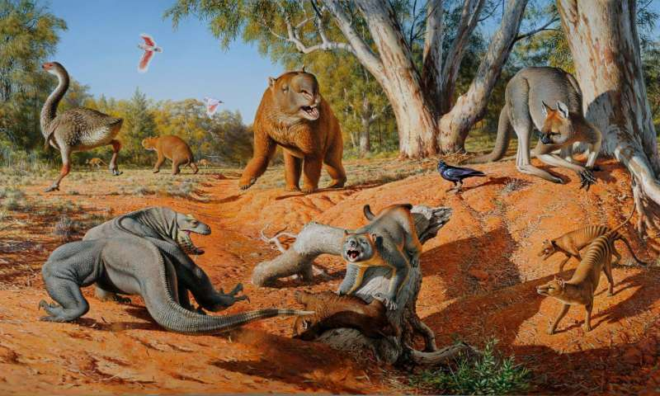
A menagerie of megafauna that inhabited Australia some 45,000 years ago. Credit: Peter Trusler, Monash University
New evidence involving the ancient poop of some of the huge and astonishing creatures that once roamed Australia indicates the primary cause of their extinction around 45,000 years ago was likely a result of humans, not climate change.
Read more at: https://phys.org/news/2017-01-humans-climate-australian-megafauna.html#jCp

Arctic soils are set to release a lot of carbon -- probably more than plants can absorb
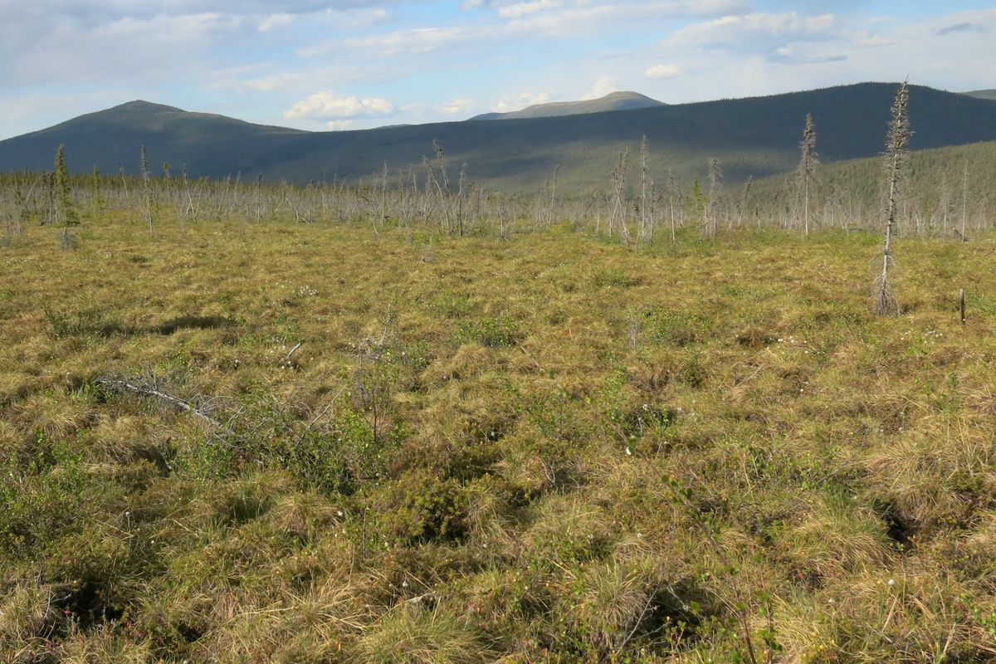
Soils around the world are warming and emitting more carbon, but in tundra regions like this one in northern Alaska, emissions are unusually high — and plants are less capable of absorbing the new carbon through photosynthesis. (Ned Rozell / Alaska Geophysical Institute)
As temperatures have risen in the Arctic and worldwide, so have worries about how much carbon might stream into the atmosphere from warmer soils.
Will enough new carbon be released from the ground, potentially exacerbating the global warming cycle? And will new-growth carbon dioxide-absorbing plants growing in warmer conditions be able to keep pace?
Now scientists have some better answers to both questions — and they're troubling.
https://www.adn.com/arctic/2016/12/01/led-by-arctic-warmed-soil-poised-to-pour-vast-amounts-of-carbon-into-atmosphere/

Advanced biomass cookstoves provide benefits in field settings, but less than expected from lab testing

19 January 2017 by Matt Shipman
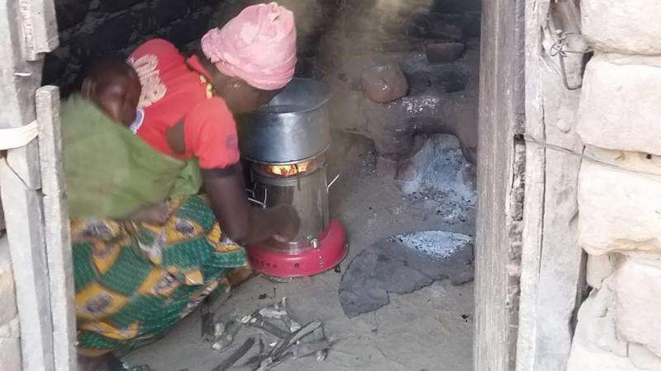
A woman, with sleeping infant on her back, cooking with a forced-draft cookstove in her kitchen in rural Malawi. A traditional cook fire, and the sooty walls that result from its use indoors, are seen in the background. Credit: Andrew Grieshop
Researchers from North Carolina State University and the Liverpool School of Tropical Medicine have found that while advanced wood-burning cookstoves can provide benefits to the environment and climate, these benefits are less than expected due to higher emissions measured in the field compared to laboratory settings. The study, conducted in rural Malawi, found that pollutant emissions from these stoves were much higher than was reported in laboratory testing, due in part to how the stoves were being used.
Read more at: https://phys.org/news/2017-01-advanced-biomass-cookstoves-benefits-field.html#jCp

Seven of the biggest volcanic explosions to rock the Earth

You're probably familiar with Yellowstone and Krakatoa, but they're just a couple of the huge volcanoes dotted around the planet. Jana Howden takes us through some of the major players.
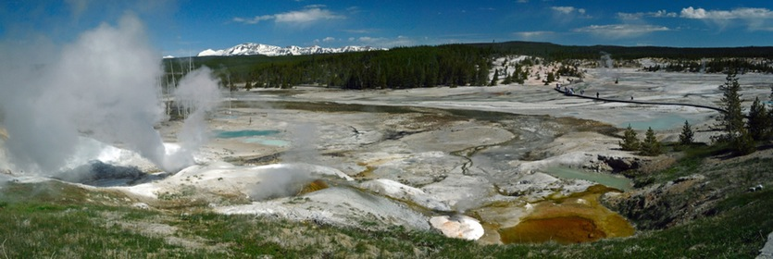
Norris Geyser Basin in Yellowstone National Park.
Images Etc Ltd / Getty Images

Yellowstone, US
The past 2.1 million years has seen Yellowstone explode in three significant events – 2.1 million, 1.3 million, and 640,000 years ago – each of which blanketed the whole North American continent with debris and ash.
Each eruption caused the ground beneath the volcano to collapse, forming the huge caldera which today comprises almost a third of Yellowstone National Park’s total area. While there’s no hard evidence to suggest that a large-scale eruption of this supervolcano will occur anytime soon, the consequences could be extreme. Research suggests that a Yellowstone super-eruption could spread volcanic ash as reflective as snow across most of North America, and significantly cool the world’s climate for years.
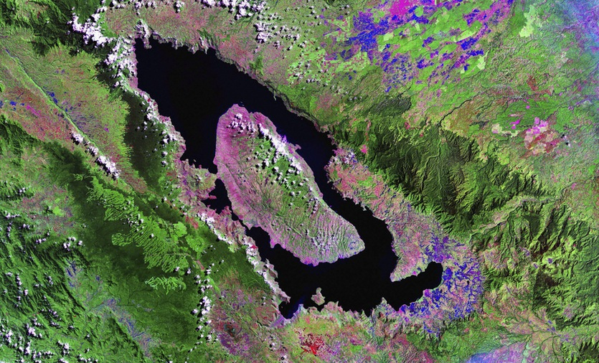
Landsat image of Lake Toba volcano. Water is blue, vegetation is green, bare land is pink and clouds are white.
Science Photo Library / Getty Images

Toba, North Sumatra, Indonesia
The explosion of this Indonesian supervolcano 75,000 years ago is regarded as one of the world’s most explosive volcanic events. https://cosmosmagazine.com/geoscience/seven-of-the-biggest-volcanic-explosions-the-world-has-ever-seen?utm_source=Today+in+Cosmos+Magazine&utm_campaign=626d354953-RSS_EMAIL&utm_medium=email&utm_term=0_5f4ec2b124-626d354953-179982353

Global development

Rising seas sweep away land and livelihoods in Bangladesh – in pictures

Rising seas sweep away land and livelihoods in Bangladesh – in pictures
Kutubdia, an island of fishing villages and salt farms, has halved in size in 20 years, with family homes destroyed by ever-encroaching tides. In nearby Cox’s Bazar, more frequent storms have had a severe impact on fishermen’s catches
All photographs by Noor Alam/Majority World

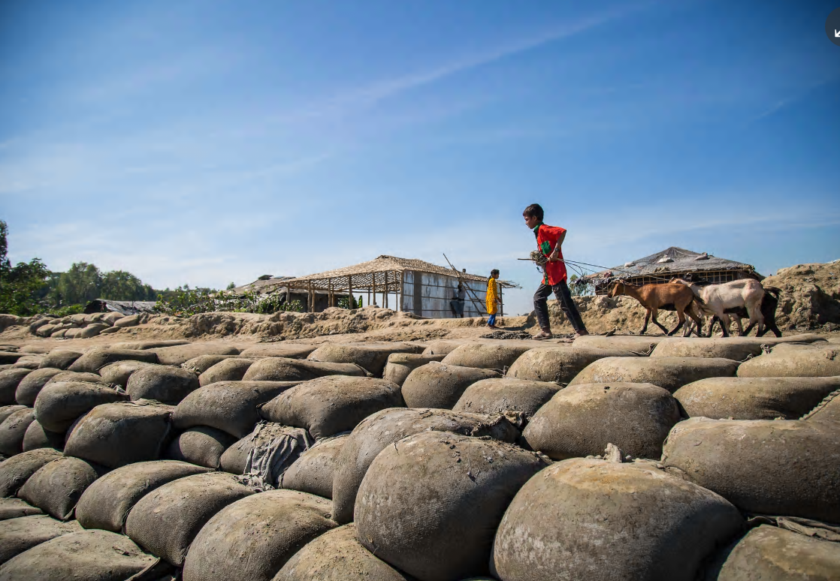
Villagers in Ali Akbar Dale have piled up sandbags at the most vulnerable spots, where the concrete embankment has been breached, to try to stop water flooding their homes https://www.theguardian.com/global-development/gallery/2017/jan/19/rising-seas-sweep-away-land-livelihoods-in-bangladesh-in-pictures

 “Soil without biology is just geology.” Gabe Brown, Keys to Building a Healthy Soil

