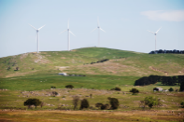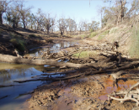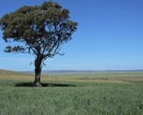

# Glinka World Soil Prize

The Glinka World Soil Prize honors individuals and organizations whose leadership and activities have contributed, or are still contributing to the promotion of sustainable soil management and the protection of soil resources.

The Glinka Prize is a an annual award for dynamic change-makers dedicated to solving one of our world’s most pressing environmental issue: Soil Degradation.

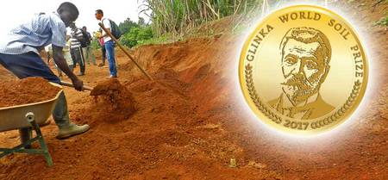

The first Glinka World Soil Prize was awarded on the occasion of the World Soil Day 2016. The nomination process for the Glinka World Soil Prize 2017 is now officially launched and organizations/individuals are invited to nominate appropriate candidates and submit the [nomination form](http://www.fao.org/fileadmin/user_upload/GSP/WSP/Glinka_World_Soil_Prize_nomination2017.docx) by 30 September 2017 to [GSP-Secretariat@fao.org](mailto:GSP-Secretariat@fao.org).

<http://www.fao.org/global-soil-partnership/pillars-action/2-awareness-raising/glinka-world-soil-prize/en/>

# Seeing Soil Moisture from the Sky

A recent paper in Reviews of Geophysics describes techniques for improving the spatial resolution of satellite data on soil moisture.

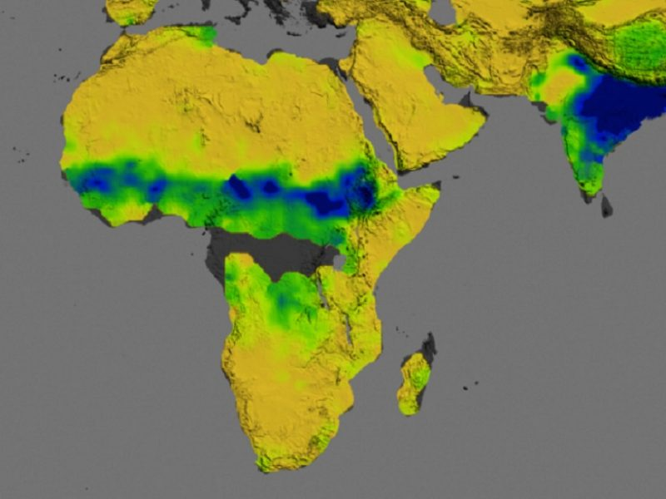Soil naturally radiates microwaves, and NASA’s Aquarius sensor aboard a satellite can detect the microwave signals that vary with changes in the wetness of the soil. This map indicates moisture in the top 5cm of soil across Africa, the Middle East and South Asia in August 2013. Blue indicates highest levels of soil moisture while yellow are the lowest; dark gray indicates locations where the signals are difficult to interpret. Being able to monitor the condition of soils has applications including improving crop forecasts and planning for food emergencies. Credit: [NASA](https://earthobservatory.nasa.gov/IOTD/view.php?id=84017)

By [Jian Peng](mailto:jian.peng@mpimet.mpg.de)on

It’s a hidden part of the hydrological cycle but moisture in the soil plays an important role in many processes and influences the climate. Soil moisture can be measured by instruments in the field or by remote sensing techniques. A recent [review article](http://onlinelibrary.wiley.com/doi/10.1002/2016RG000543/full) in Reviews of Geophysics discussed soil moisture data obtained from satellite observations and the methods for “downscaling” the information so that it can be applied in particular contexts. The editors  <https://eos.org/editors-vox/seeing-soil-moisture-from-the-sky>

# Carbon cycling in forest soils research presented

##### 12 September 2017

Just as individual humans have different microbial communities in their guts, the microbial communities living in soils vary from site to site as well. Recent research compared the decomposition rates of wood stakes over eight sites to gain an understanding of soil microbes in forests. The activity of soil microbes can also tell a story of the value of carbon storage in soil.

The "Belowground Wood Stake Decomposition in Forest Soil" presentation planned at the Managing Global Resources for a Secure Future ASA, CSSA, SSSA International Annual Meeting in Tampa, FL, will address this important topic. The symposium will be held Monday, October 23, 2017, at 8:45 AM. The meeting is sponsored by the American Society of Agronomy, Crop Science Society of America, and the Soil Science Society of America.

Read more at: <https://phys.org/news/2017-09-carbon-forest-soils.html#jCp>

**EUROPEAN SOIL DATA CENTRE (ESDAC) - Map Viewer**

## Welcome

The ESDAC Map Viewer allows the user to navigate key soil data for Europe. It provides access to the attributes of the European Soil Database and some additional data related to main soil threats as identified in the Soil Thematic Strategy. The ESDAC Map Viewer is developed according to standards (OGC WMS) so that they are interoperable with similar information allowing real-time integration of environmental data from around the world.   
The Viewer integrates the European Soil Database layers and some other soil layers in one single web-based application.   
You may navigate and select each of the: 70 layers derived from the European Soil Database;

<https://esdac.jrc.ec.europa.eu/viewer>

# Secrets of Bonsai: Uncovering the mechanism of root regeneration

##### 14 September 2017

[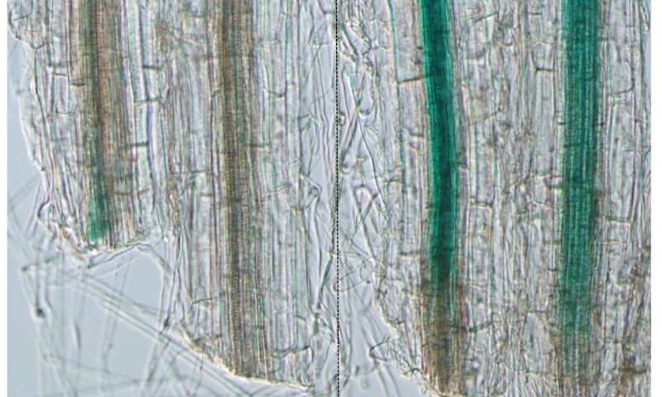](https://3c1703fe8d.site.internapcdn.net/newman/gfx/news/hires/2017/secretsofbon.jpg)

Increased levels of AUX/IAA19, which indicate an activation of auxin signaling, were observed in the cut-end of root-cut plants compared to intact plants. Scale bar = 0.1 mm. Credit: Xu D. et al., *Plant and Cell Physiology*, September 1, 2017

The molecular mechanism behind root regeneration after root cutting in plants has been discovered. A finding which could lead to the development of new methods for regulating plant growth in agriculture and horticulture.

Read more at: <https://phys.org/news/2017-09-secrets-bonsai-uncovering-mechanism-root.html#jCp>

# Tectonic plates 'weaker than previously thought,' say scientists

##### 13 September 2017

[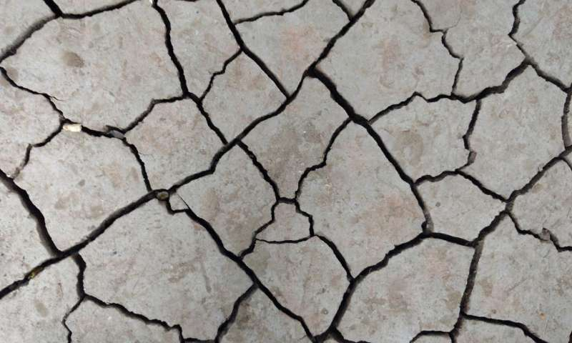](https://3c1703fe8d.site.internapcdn.net/newman/gfx/news/hires/2017/tectonicplat.jpg)

Credit: CC0 Public Domain

Experiments carried out at Oxford University have revealed that tectonic plates are weaker than previously thought. The finding explains an ambiguity in lab work that led scientists to believe these rocks were much stronger than they appeared to be in the natural world. This new knowledge will help us understand how tectonic plates can break to form new boundaries.

Read more at: <https://phys.org/news/2017-09-tectonic-plates-weaker-previously-thought.html#jCp>

# Healthy Soils for Healthy Societies

Soil: The Foundation of Life; Washington, D. C., 5 December 2016

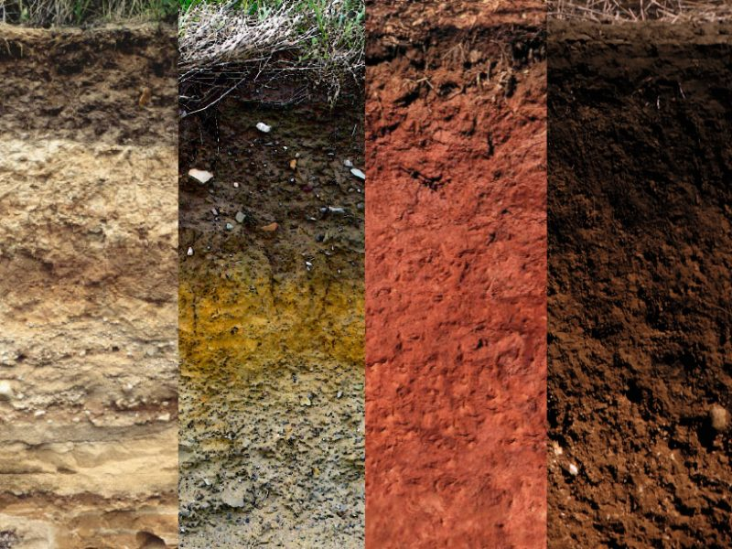From left to right: soil profiles representing the Antigo (very deep, well-drained soils developed on alluvium), Stagnogley (shallow, often acidified and waterlogged woodland soils with stony subsoil), Cecil (very deep, well-drained, highly weathered soils of Piedmont uplands), and Clarion (very deep, moderately drained, organic-rich upland soils formed in glacial till) [soil series](https://soilseries.sc.egov.usda.gov/osdname.aspx). These and other series are used to classify soil types around the world. Credit: USDA, HolgerK

By [Asmeret Asefaw Berhe](mailto:aaberhe@ucmerced.edu), Ronald Amundson, and A. Ester Sztein 6 July 2017

Human security and existence are inextricably linked to soils. Soil is the thin skin of the Earth that provides essential ecosystem services that all terrestrial life forms depend on. <https://eos.org/meeting-reports/healthy-soils-for-healthy-societies>

## **Back To Earth**

Dr Maarten Stapper is a man with some fascinating ideas on how to manage our land better.

He is unconventional, stubborn and difficult. Not even a near fatal car accident could slow him down in his mission to feed the world using less chemicals.

As an advocate for biological farming, Dr Stapper has paid a high price for promoting a greener, cleaner way to grow food. Originally a CSIRO scientist, he left when it became clear his views on biological farming were incompatible with his employer.

Today, he travels the country to educate farmers on how to use less chemicals in their soil and on their crops. <http://www.abc.net.au/austory/specials/stapper/default.htm>

# Measuring a crucial mineral in the mantle

## New research resolves 40 years of debate on the strength of olivine, the most abundant mineral in the Earth's mantle

**Date:** 13 September 2017

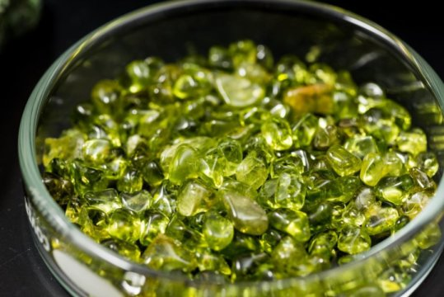

Olivine, the most abundant mineral found in the Earth's mantle, is considered to be a robust model of the interior of the Earth's composition.

Credit: Evan Krape/ University of Delaware

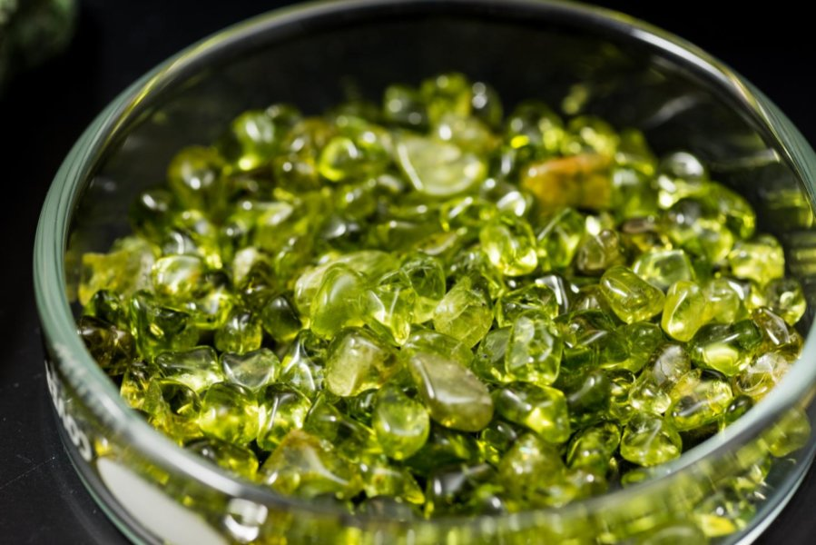

Olivine, the most abundant mineral found in the Earth's mantle, is considered to be a robust model of the interior of the Earth's composition.

Credit: Evan Krape/ University of Delaware

Close

University of Delaware professor Jessica Warren and colleagues from Stanford University, Oxford University and University of Pennsylvania, reported new data that material size-effects matter in plate tectonics.

**Journal Reference**:

1. Kathryn M. Kumamoto, Christopher A. Thom, David Wallis, Lars N. Hansen, David E. J. Armstrong, Jessica M. Warren, David L. Goldsby, Angus J. Wilkinson. **Size effects resolve discrepancies in 40 years of work on low-temperature plasticity in olivine**. Science Advances, 2017; 3 (9): e1701338 DOI: [10.1126/sciadv.1701338](http://dx.doi.org/10.1126/sciadv.1701338)

<https://www.sciencedaily.com/releases/2017/09/170913192943.htm>

# Ants dominate waste management in tropical rainforests

A study by the University of Liverpool has found that ants are responsible for moving more than half of food resources from the rainforest floor, playing a key role in maintaining a healthy ecosystem.

**Journal Reference**:

1. Hannah M. Griffiths, Louise A. Ashton, Alice E. Walker, Fevziye Hasan, Theodore A. Evans, Paul Eggleton, Catherine L. Parr. **Ants are the major agents of resource removal from tropical rainforests**. Journal of Animal Ecology, 2017; DOI: [10.1111/1365-2656.12728](http://dx.doi.org/10.1111/1365-2656.12728)[acdsefyuyxedfesttvzededqyr](https://www.sciencedaily.com/releases/2017/08/fvrquxebsayzrdzfvruddxytus.html)

<https://www.sciencedaily.com/releases/2017/08/170809214055.htm>

# Study finds organic farming better at sequestering carbon

**The researchers found that soils from organic farms had a 26 percent greater potential for long-term carbon storage than soils from conventional farms.**

AddThis Sharing Buttons

Share to FacebookShare to TwitterShare to PrintShare to EmailShare to More

[**Carol Ryan Dumas**](http://www.capitalpress.com/apps/pbcs.dll/section?category=staff&template=staffProfilePages&staffID=crdumas)

**Capital Press**

Published on 13 September 2017 9:12AM

Carol Ryan Dumas/Capital Press File
A new study found that organic agriculture stores more carbon in the soil than conventional agriculture.

Carol Ryan Dumas/Capital Press File A new study found that organic agriculture stores more carbon in the soil than conventional agriculture.

[Buy this photo](http://eopubco.mycapture.com/mycapture/remoteimage.asp?BackText=Back%20to%20Article&image=http%3A%2F%2FEOR-CPwebvarnish.newscyclecloud.com%2Fstoryimage%2FCP%2F20170913%2FARTICLE%2F170919961%2FAR%2F0%2FAR-170919961.jpg&BackURL=http%3A%2F%2Fwww.capitalpress.com%2Fapps%2Fpbcs.dll%2Farticle%3FAID%3D%2F20170913%2FARTICLE%2F170919961%26utm_content%3Dcrowdfire&ThumbPath=http%3A%2F%2FEOR-CPwebvarnish.newscyclecloud.com%2Fstoryimage%2FCP%2F20170913%2FARTICLE%2F170919961%2FAR%2F0%2FAR-170919961.jpg%26MaxW%3D90&PreviewPath=http%3A%2F%2FEOR-CPwebvarnish.newscyclecloud.com%2Fstoryimage%2FCP%2F20170913%2FARTICLE%2F170919961%2FAR%2F0%2FAR-170919961.jpg%26Q%3D50%26MaxW%3D550&PricingSheetID=2837&AffPhotographerName=%7bnull%7d&notes=http%3A%2F%2FEOR-CPwebvarnish.newscyclecloud.com%2Fstoryimage%2FCP%2F20170913%2FARTICLE%2F170919961%2FAR%2F0%2FAR-170919961.jpg%26q%3D100)

A new study shows organic farms store more carbon in the soil and keep it out of the atmosphere longer than conventional farms.

The findings of the study by Northeastern University’s National Soil Project and The Organic Center suggest organic farming could help reduce one of the causes of climate change.

Eighty percent of the Earth’s terrestrial carbon is stored in soils, and human management practices can deplete the soil’s carbon stores by releasing it into the atmosphere. Agriculture in particular has been linked to large losses of soil carbon worldwide, the researchers said. <http://www.capitalpress.com/Organic/20170913/study-finds-organic-farming-better-at-sequestering-carbon>

# Follow Earthworm Tracks to Better Simulate Water Flow in Soils

Incorporating paths carved by the critters and by tree roots helps scientists align simulations of tropical soils more closely with real-world data.

Source: Water Resources Research

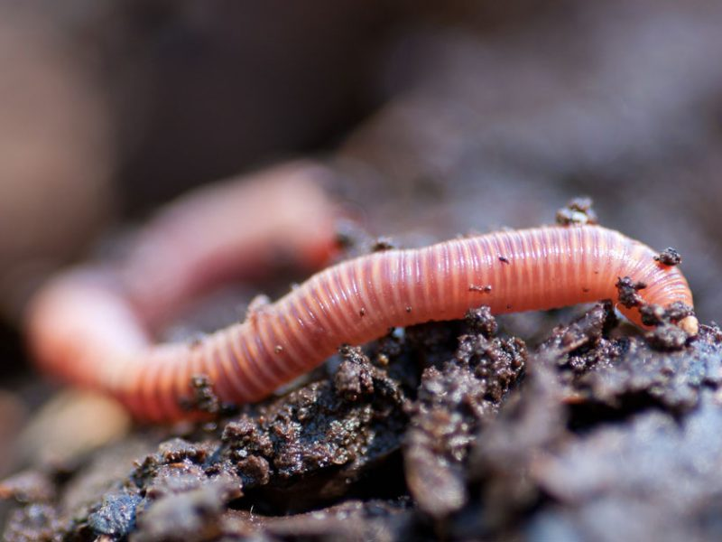An earthworm moves over damp soil. What role do earthworms and tree roots play in facilitating water movement through soils? A new study seeks answers. Credit: jlmcloughlin/iStock/Getty Images Plus

By [Sarah Stanley](https://eos.org/author/s-stanley) 1 August 2017

In humid tropical forests, intense biological activity shapes the ground below. Tree roots and earthworms carve paths through the soil that are followed by rainwater, some of which eventually flows into deep groundwater reservoirs. The influence of roots and earthworms has been difficult to quantify. <https://eos.org/research-spotlights/follow-earthworm-tracks-to-better-simulate-water-flow-in-soils>

# Murray-Darling basin: NSW government changes could be causing water loss

Rules put in place before the national Murray-Darling basin plan favour larger irrigators, say experts and farmers

Wednesday 2 August 2017 17.38 AEST Last modified on Friday 4 August 2017 09.47 AEST

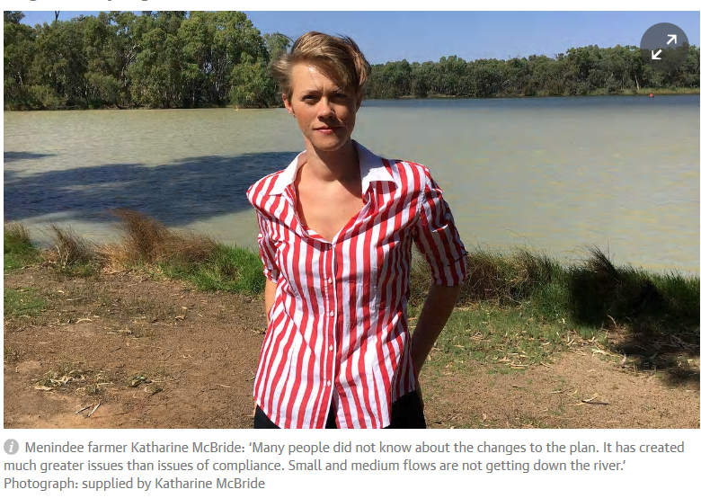

Farmers and water experts say [New South Wales](https://www.theguardian.com/australia-news/new-south-wales) government rule changes could be causing more water loss to the Murray-Darling river system than before the national plan was put in place.

The [Barwon-Darling](https://www.mdba.gov.au/discover-basin/catchments/barwon-darling) water-sharing plan, which governs the rules in the north of NSW, was signed off by the then primary industries minister and Nationals MP, Katrina Hodgkinson, in 2012, just before the national [Murray-Darling basin](https://www.theguardian.com/australia-news/murray-darling-basin) plan was approved. <https://www.theguardian.com/australia-news/2017/aug/02/murray-darling-basin-nsw-government-changes-could-be-causing-water-loss>

# Can dung beetles rein in cattle’s methane emissions?

## Dung beetles were introduced from Europe to save us from being buried in manure. Now researchers believe they might also help us mitigate greenhouse gas emissions. Belinda Smith reports.



Cattle produce 300 million cow pats a day.

IPG GUTENBERGUK LTD / GETTY IMAGES

When European settlers brought cattle and sheep to Australia, they didn’t just bring food sources – they brought veritable poop factories. The solution to the problem came in the form of foreign dung beetles. The University of New England’s Min Raj Pokhrel aims to find out how the little critters are faring – what temperatures they prefer and how they might mitigate greenhouse gas emissions – in the New South Wales Northern Tablelands. <https://cosmosmagazine.com/climate/can-dung-beetles-rein-in-cattle-s-methane-emissions>

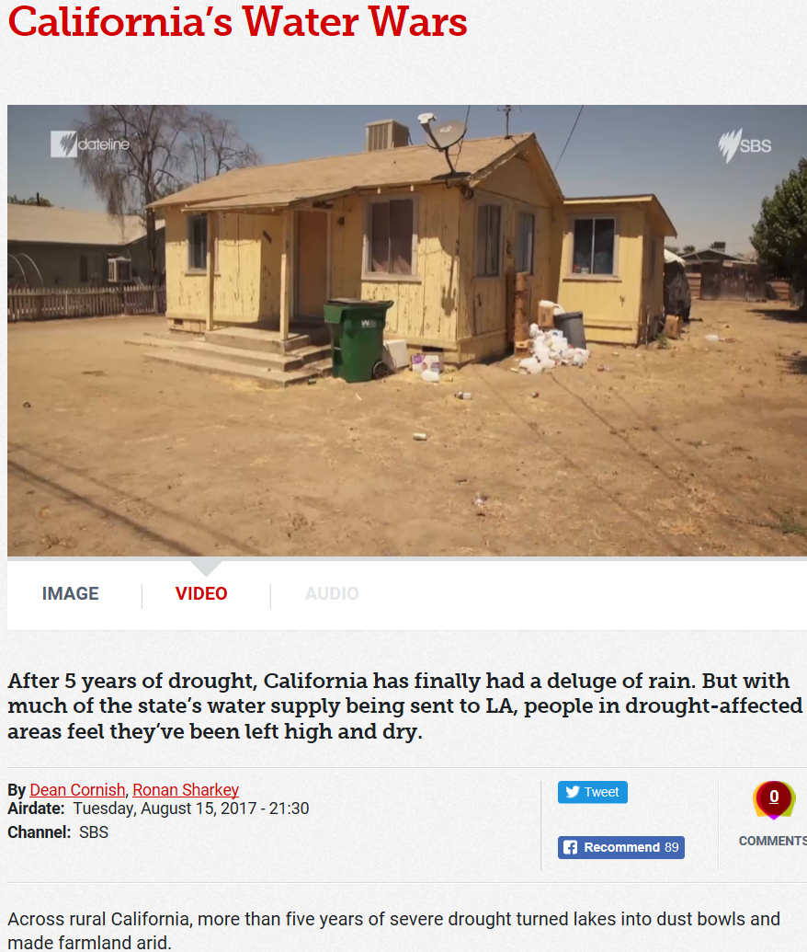

<http://www.sbs.com.au/news/dateline/story/californias-water-wars>

# Deforestation drives climate change more than we thought

Posted by [Lindsey Hadlock-Cornell](http://www.futurity.org/author/lindsey-hadlock/) 6th September 2017

Share Article

* [Facebook](https://www.facebook.com/sharer/sharer.php?u=http://www.futurity.org/deforestation-climate-change-1534362/)
* [Twitter](https://twitter.com/share?url=http://www.futurity.org/deforestation-climate-change-1534362/&via=FuturityNews&text=Deforestation%20drives%20climate%20change%20more%20than%20we%20thought)
* [Email](mailto:?subject=Deforestation%20drives%20climate%20change%20more%20than%20we%20thought&body=http://www.futurity.org/deforestation-climate-change-1534362/)

You are free to share this article under the Attribution 4.0 International license.

Follow Futurity

* [RSS](http://www.futurity.org/?feed=rss2)
* [Twitter](https://twitter.com/FuturityNews)
* [Facebook](https://www.facebook.com/futuritynews)
* [Newsletter](http://www.futurity.org/subscribe/)

Deforestation and use of forest lands for agriculture or pasture, particularly in tropical regions, contribute more to climate change than previously thought, research finds.

“When we think about climate change, we can’t stop at the end of the century.”

The study also shows just how significantly that impact has been underestimated. Even if all fossil fuel emissions are eliminated, if current tropical deforestation rates hold steady through 2100, there will still be a 1.5 degree increase in global warming.

“A lot of the emphasis of climate policy is on converting to sustainable energy from fossil fuels,” says Natalie M. Mahowald, the paper’s lead author and faculty director of environment for the Atkinson Center for a Sustainable Future at Cornell University. <http://www.futurity.org/deforestation-climate-change-1534362/>

18 September 2017

[**Landslides from the Kaikoura Earthquake Part 4: partially failed slopes**](http://blogs.agu.org/landslideblog/2017/09/18/partially-failed-slopes/)

Posted by [*Dave Petley*](http://blogs.agu.org/landslideblog/author/dr-dave/)

AddThis Sharing Buttons

Share to FacebookShare to TwitterShare to PrintShare to EmailShare to More

*Landslides from the Kaikoura Earthquake Part 4: partially failed slopes*

A characteristic of every large landslide-inducing large earthquake that I have studied is the large number of partially failed slopes.  These are slopes that have started to fail during the earthquake, but have not completely collapsed.  Typically, in an earthquake-affected mountain chain we see numerous examples of this phenomenon.  The [Kaikoura Earthquake](https://en.wikipedia.org/wiki/2016_Kaikoura_earthquake) was no exception.  I present here a number of examples.  Sometimes these partially failed slopes are very obvious incipient landslides – this one for example is very clear:-

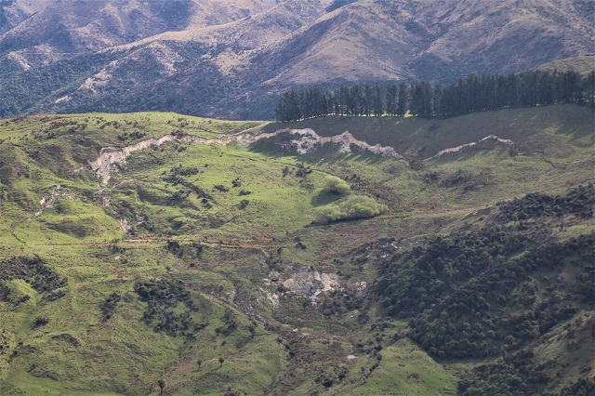

An example of a partially failed slope from the Kaikoura earthquake.

In other cases the features are much more subtle.  This is an example of a highly deformed slope that has the complex morphology of several arcuate tension cracks and lateral scarps, but it is clear that the amount of strain (movement) is quite limited to date:-

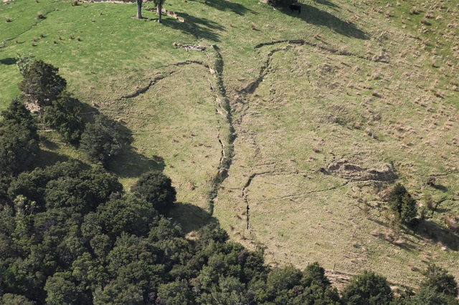

The complex arcuate scarps of a partially failed slope from the Kaikoura earthquake.

<http://blogs.agu.org/landslideblog/2017/09/18/partially-failed-slopes/>

# 3D Soil Hydraulic Database of Europe at 1 km and 250 m resolution

Top of Form

A consistent spatial soil hydraulic database at 7 soil depths up to 2 m calculated for Europe based on SoilGrids250m and 1 km datasets and pedotransfer functions trained on the European Hydropedological Data Inventory. Saturated water content, water content at field capacity and wilting point, saturated hydraulic conductivity and Mualem-van Genuchten parameters for the description of the moisture retention, and unsaturated hydraulic conductivity curves have been predicted. The derived 3D soil hydraulic layers (EU-SoilHydroGrids ver1.0) can be used for environmental modelling purposes at catchment or continental scale in Europe. Currently, only EU-SoilHydroGrids provides information on the most frequently required soil hydraulic properties with full European coverage up to 2 m depth at 250 m resolution.

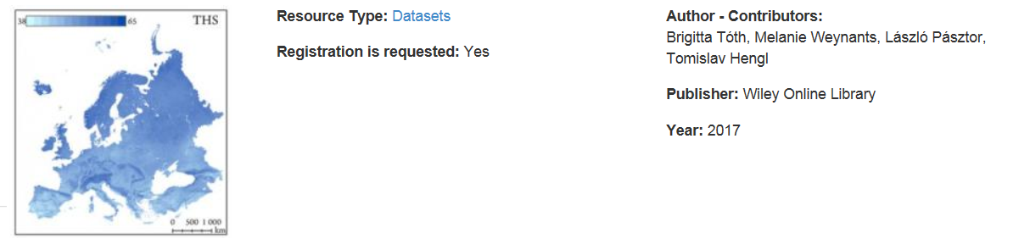

Bottom of Form

<https://esdac.jrc.ec.europa.eu/content/3d-soil-hydraulic-database-europe-1-km-and-250-m-resolution>

# Image: Portugal burn scars

##### 14 September 2017

[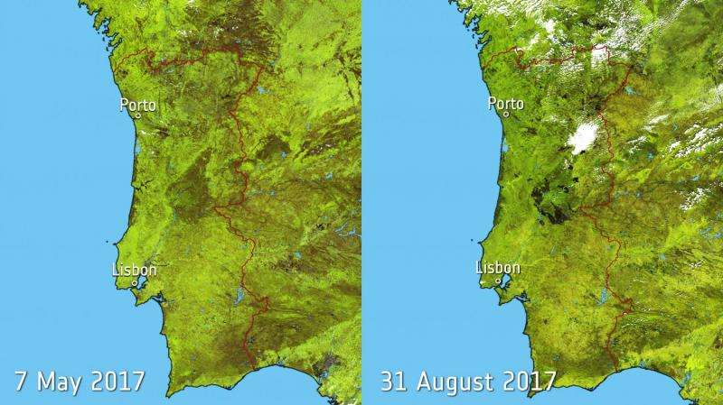](https://3c1703fe8d.site.internapcdn.net/newman/gfx/news/hires/2017/imageportuga.jpg)

Credit: contains modified Copernicus Sentinel data (2017), processed by ESA, CC BY-SA 3.0 IGO

Southern Europe experienced a relentless heatwave this summer, fuelling wildfires in a number of countries

Read more at: <https://phys.org/news/2017-09-image-portugal-scars.html#jCp>



<https://www.theguardian.com/environment/gallery/2017/sep/06/upto-381-new-species-discovered-in-the-amazon-in-pictures>

**The goals and needs of scientists and land managers are converging toward enhancing soil organic matter stocks and soil health** -- A new platform for managing soil carbon and soil health, *Eos, 98*