

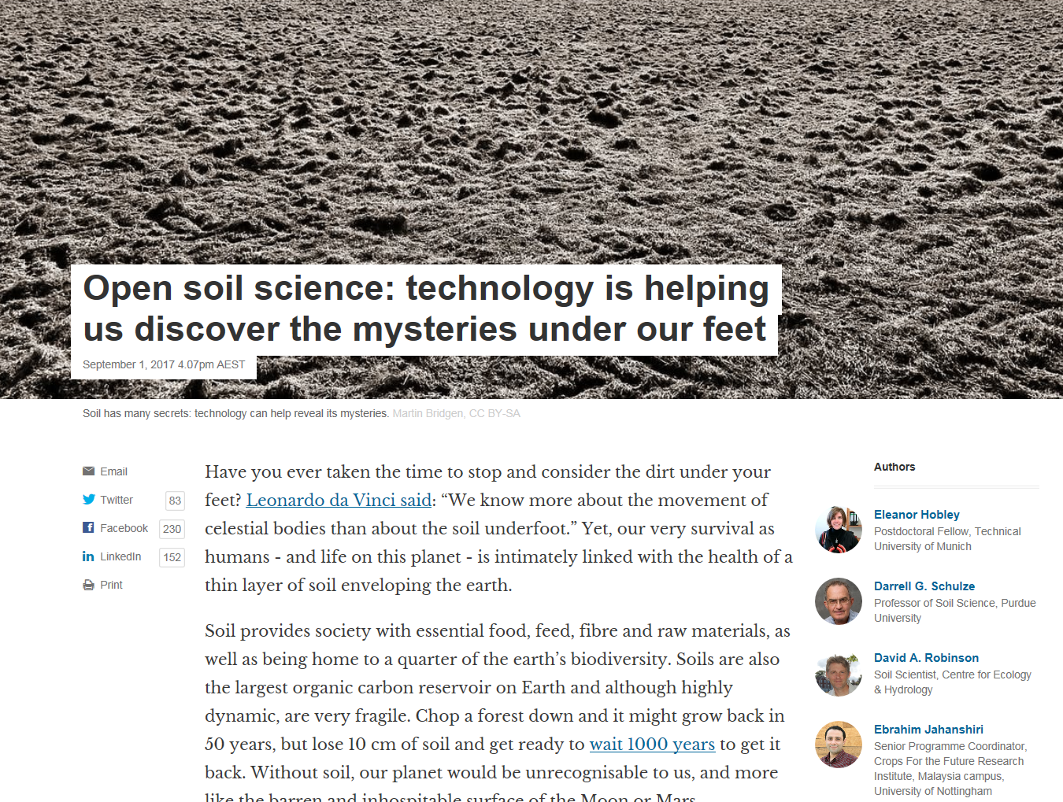

<http://theconversation.com/open-soil-science-technology-is-helping-us-discover-the-mysteries-under-our-feet-81727>

**Healthy soils can boost food security and climate resilience for millions (commentary)**

**Commentary by** [**Inger Andersen**](https://news.mongabay.com/by/inger-andersen/) **on 6 September 2017**

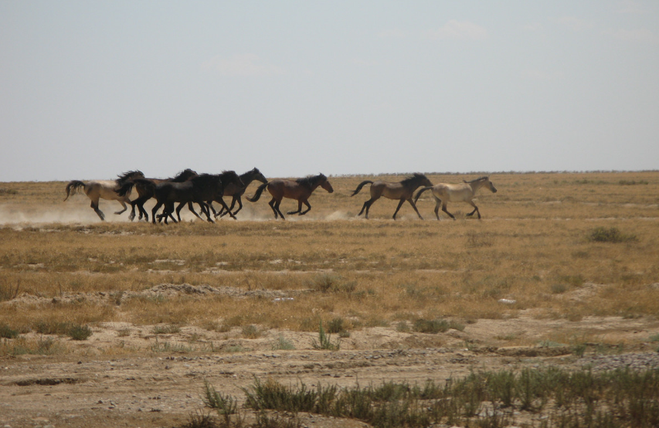

* *Drylands take centre stage this week as world leaders gather in Ordos, in the Inner Mongolia region of China, for the thirteenth session of the Conference of the Parties to the UN Convention to Combat Desertification (UNCCD COP13).*
* *The health of many dryland ecosystems has declined dramatically over recent decades, largely due to unsustainable farming methods, increasing drought, deforestation, and clearance of natural grasslands.*
* *Changing the way drylands are farmed to conserve life underground is the only way of restoring these ecosystems and the agricultural outputs they sustain.*
* *This post is a commentary. The views expressed are those of the author, not necessarily Mongabay.*

<https://news.mongabay.com/2017/09/healthy-soils-can-boost-food-security-and-climate-resilience-for-millions-commentary/>

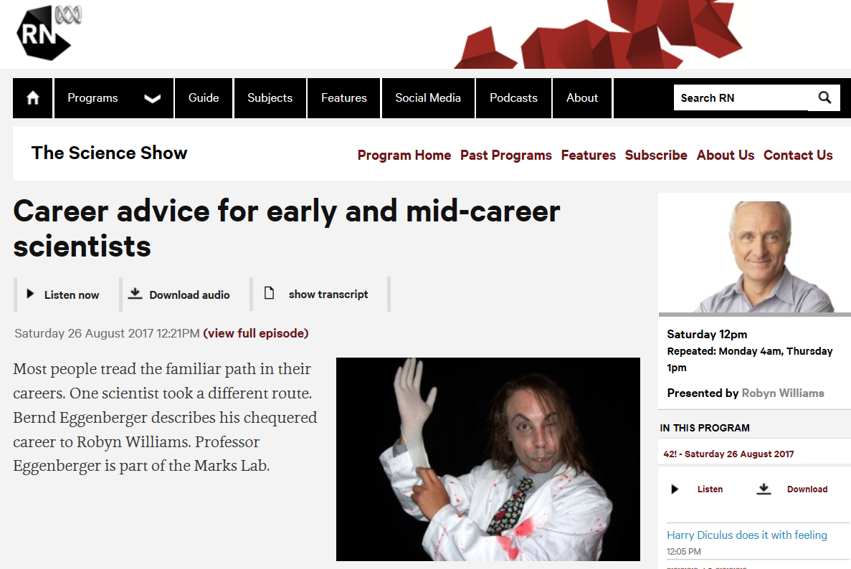

<http://www.abc.net.au/radionational/programs/scienceshow/career-advice-for-early-and-mid-career-scientists/8843242?utm_source=sfmc&utm_medium=email&utm_campaign=abc_science_newsletter%3a125&user_id=473dc1dcb743dd2eb5ee92f206c233e4cc5e2ba4d67a0a5218c8372de441e572&WT.tsrc=email&WT.mc_id=Email%7cabc_science_newsletter%7c125&utm_content=catchup_title_3>

# Ten electorates contain 600 threatened species – but will MPs fight to save them?

Federal funding for biodiversity conservation has dropped by 37% since 2013 and all MPs need to take greater action

Thursday 7 September 2017 10.54 AEST Last modified on Thursday 7 September 2017 11.59 AEST

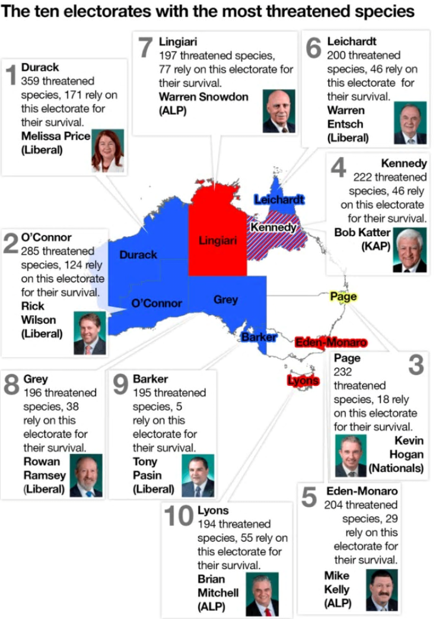

Australia is rapidly losing its world-famous biodiversity. [More than 90 species have gone extinct since European colonisation](http://www.environment.gov.au/cgi-bin/sprat/public/publicthreatenedlist.pl?wanted=flora) (including [three in just the past decade](http://onlinelibrary.wiley.com/doi/10.1111/cobi.12852/abstract)) and [more than 1,700 species are now](http://www.environment.gov.au/biodiversity/threatened/species) formally recognised as being in danger of extinction.

Despite the pride many Australians feel in our unique natural heritage (and the [billions of dollars](https://www.griffith.edu.au/__data/assets/pdf_file/0007/725758/GIFT-TRA-Nature-Based-Tourism-Fact-SheetQANTASFINAL-1.pdf) made from nature-based tourism), the amount of [federal funding for biodiversity conservation has dropped by 37% since 2013](https://www.acf.org.au/myefo_lands_another_punch). <https://www.theguardian.com/environment/commentisfree/2017/sep/07/ten-seats-contain-600-of-our-threatened-species-but-will-their-mps-fight-to-save-them>

# The Fakel Report: Finkel’s fake Economics 2.0

|  |  |
| --- | --- |
| By [Darren Nelson](http://www.onlineopinion.com.au/author.asp?id=7776) - posted Monday, 17 July 2017 |  |

This is a sequel to my article from last week entitled [*The Fakel Report: Finkel's Fake Economics*](https://libertyworks.org.au/the-fakel-report-finkels-fake-economics/). Since then there have been [media reports](https://www.theguardian.com/australia-news/2017/jun/20/malcolm-turnbull-leaves-open-alternative-to-clean-energy-target) that the **Turnbull 'flip-flop' Government** is already having second thoughts about the one-and-only solid reform recommendation from the *Finkel Review,* that is the so called "technology neutral" Clean Energy Target (CET). This is not surprising given that only when 'hell freezes over' will a CET result in "lower residential and industrial electricity prices". It is unclear, however, if they are also backing off a new federal Renewable Energy Target (RET) of 42 per cent in 2030.

**Darren Brady** Nelson is an Austrian School economist, conservative-libertarian and Christian who lives in Brisbane Queensland but is originally from Milwaukee Wisconsin. He is currently the economic policy adviser to Australian **Senator Malcolm Roberts** of Pauline Hanson's One Nation party as well as on the advisory board of LibertyWorks. He has also been an economic policy adviser for the American Republican party presidential campaign of Donald Trump. <http://www.onlineopinion.com.au/view.asp?article=19163>

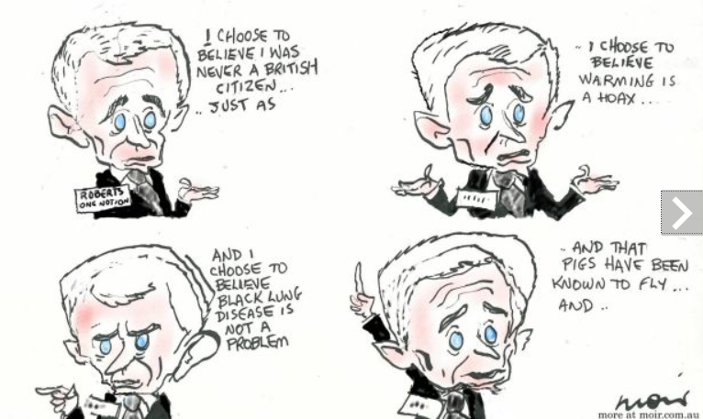

<http://www.smh.com.au/photogallery/federal-politics/cartoons/alan-moir-20150921-gjrcxr.html>

# Grattan: King Coal is wearing big boots in the Turnbull Government

**Opinion**

[**The Conversation**](http://theconversation.com/)

By Michelle Grattan, University of Canberra

Updated Fri at 4:15pmFri 15 Sep 2017, 4:15pm

[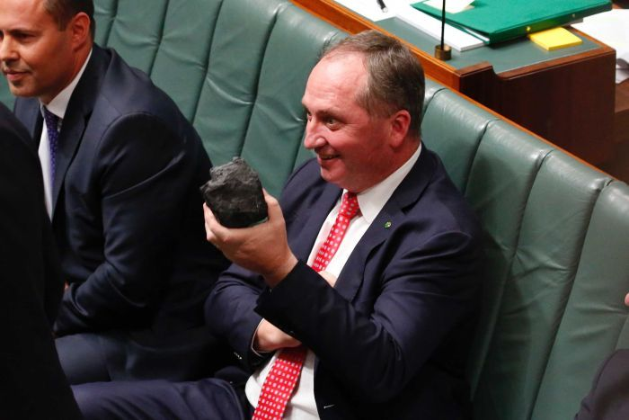**Photo:** Just as it did in the dying days of his leadership in 2009, the coal cloud hangs darkly over Malcolm Turnbull. (ABC News: Nick Haggarty)](http://www.abc.net.au/news/2017-09-15/barnaby-joyce-holds-a-lump-of-coal-in-the-house-of-reps/8949004)

It took quite a while, but the Turnbull Government this week finally "landed" its package for the biggest shake-up of media rules in decades.

[The Senate deal](http://www.abc.net.au/news/2017-09-14/media-law-changes-bill-passes-senate/8946864) was done thanks to a sprinkling of sugar for crossbenchers. Handouts for Nick Xenophon to help regional and small publishers, so he could say he was promoting "diversity". Promises to Pauline Hanson to put some burdens on the ABC, so One Nation could brag it was chasing "the elephant in the room".

**Michelle Grattan is a professorial fellow at the University of Canberra and chief political correspondent at The Conversation.**

<http://www.abc.net.au/news/2017-09-15/king-coal-wearing-big-boots-in-the-turnbull-government-grattan/8948826>

# From flooding rains to dead dry in a year, stark graphs of change

[John Ellicott](http://www.theland.com.au/profile/451/john-ellicott)

28 Aug 2017, 10:30 a.m.

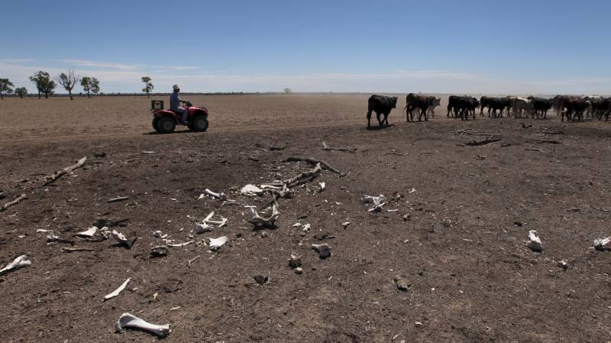

 A Coonamble property, "Yuma", two years ago. Are we headed for the same thing again?

The following graphs show how quickly soil moisture has dropped in NSW in the last year. The insidious rise in dryness is lurking behind the little episodes of rainfall we have had in the last eight months.

With dry and windy months ahead, the drop in moisture levels show no sign of abating in most parts of the state. In some small pockets of NSW, soil moisture levels are at their lowest of all time.

The Bureau of Meteorology compiles the maps <http://www.theland.com.au/story/4883046/the-difference-a-year-makes-graphic-tale-of-soil-moisture-loss/>

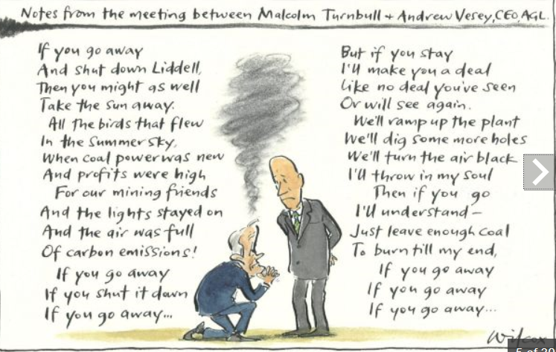

<http://www.smh.com.au/photogallery/federal-politics/cartoons/cartoons-by-cathy-wilcox-20090909-fhd6>

# Enabling Findable, Accessible, Interoperable and Reusable Data

AGU is convening a partnership in the Earth and space science community to develop the standards to connect researchers, publishers, and data repositories.

The inconsistent ways in which vast amounts of scientific data are stored make their discovery, linking and reuse difficult for researchers. The “Enabling FAIR Data” project will develop a set of data management best practices for publishing in the Earth and space science community. Credit: [iStock / liuzishan](http://www.istockphoto.com/vector/wavy-abstract-graphic-design-gm626777936-110830029)

By [Shelley Stall](mailto:sstall@agu.org)on 15 September 2017

Scientific results, particularly in the Earth and space sciences, are increasingly dependent on large and complex data sets, as well as models that transform these data. In many cases, the data are difficult to acquire, such as one-time observations of the Earth or other planets that cannot be repeated, for example, [40-year-old data from the Voyager mission](https://eos.org/editors-vox/new-findings-from-old-data).

<https://eos.org/editors-vox/enabling-findable-accessible-interoperable-and-reusable-data>

# How denialists Kenny and Bolt royally screwed up reporting of climate paper

Wrong again, fellas. Master's student in sustainability **Tom Allen** helps Andrew Bolt and Chris Kenny understand basic climate science.

Last week, Chris Kenny and Andrew Bolt broke a story that Kenny said deserved to be on front pages everywhere. But the story didn’t make a front page anywhere. Because the story didn’t exist. <https://www.crikey.com.au/2017/07/11/how-andrew-bolt-and-chris-kenny-got-a-nature-geoscience-climate-paper-totally-wrong/>

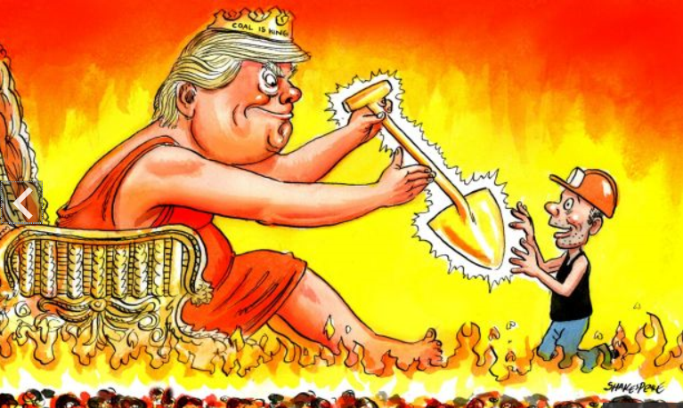

<http://www.smh.com.au/photogallery/federal-politics/cartoons/illustrations-and-cartoons-by-john-shakespeare-20090909-fhba>

# Just how bullshit is the fantasy of 'clean coal'?

No viable technology exists that allows coal to be burnt without adding significant carbon pollution to the atmosphere. Freelance energy writer **Simon Holmes a Court** reports.

What’s that you say? Australia has “clean coal” power stations?

Well, it depends how you define “clean coal”. Most power sector observers eschew the phrase because, well, the concept is a unicorn: a lovely idea, but the stuff of fantasy. <https://www.crikey.com.au/2017/06/16/just-how-bullshit-is-the-fantasy-of-clean-coal-and-ccs/>

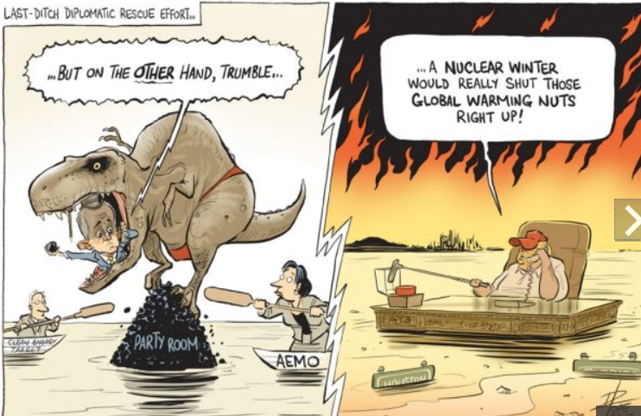

<http://www.smh.com.au/photogallery/federal-politics/cartoons/david-pope-20120214-1t3j0>

# Taking the Pulse of the Planet

How fast is Earth warming? Ocean heat content and sea level rise measurements may provide a more reliable answer than atmospheric measurements.

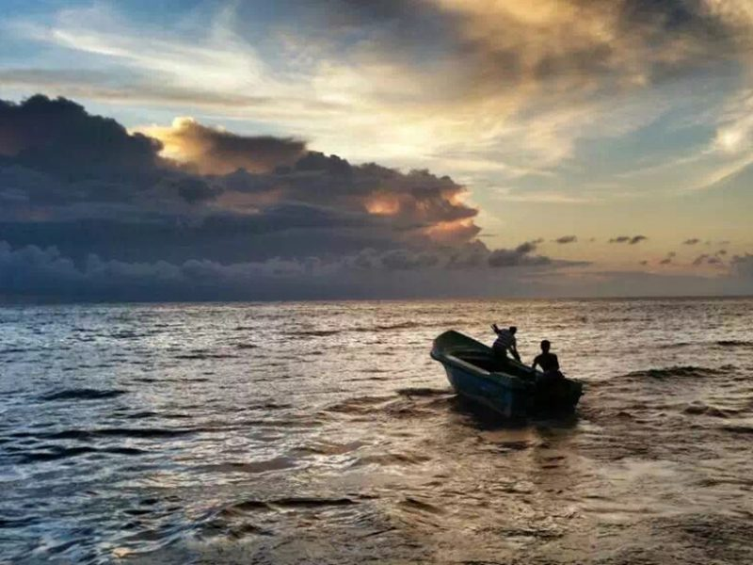Fishermen ply their trade in the Gulf of Mannar in the Indian Ocean near Sri Lanka, one example of the vital importance of oceans to planet Earth and humankind. Measurements of ocean heating and sea level rise could prove more reliable than atmospheric measurements for tracking vital signs for the health of the planet. Credit: Jiang Zhu

By [Lijing Cheng](mailto:chenglij@mail.iap.ac.cn), [Kevin E. Trenberth](mailto:trenbert@ucar.edu), John Fasullo, John Abraham, [Tim P. Boyer](mailto:tim.boyer@noaa.gov), Karina von Schuckmann, and Jiang Zhu 13 September 2017

Humans have released carbon dioxide and other greenhouse gases in sufficient quantity to change the composition of the atmosphere (Figure 1). The result is an accumulation of heat in Earth’s system, commonly referred to as global warming. Earth’s climate has responded to this influx of heat through higher temperatures in the atmosphere, land, and ocean. This warming, in turn, has melted ice, raised sea levels, and increased the frequency of extreme weather events: heat waves and heavy rains, for example. The results of these weather events include wildfires and flooding, among other things [Intergovernmental Panel on Climate Change, 2013].

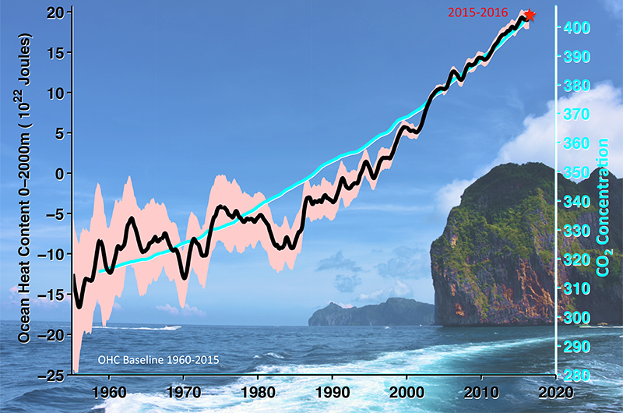Fig. 1. Ocean heat content (OHC) and atmospheric carbon dioxide (CO2) concentration measurements since 1958, shown as 12-month running means. The black line represents ocean heating for the upper 2,000 meters of ocean, and light red shading represents the 95% confidence interval. CO2 concentration observed at Mauna Loa Observatory is displayed by light blue. Mean values for 2015–2016 are highlighted with a red star. The OHC is relative to a 1960–2015 baseline. Ocean heat data are from *Cheng et al.* [2017], and CO2 information is from the [National Oceanic and Atmospheric Administration](https://www.esrl.noaa.gov/gmd/ccgg/trends/data.html).

<https://eos.org/opinions/taking-the-pulse-of-the-planet>

# Avoiding Predators in Publishing

As the number of publishers that choose profit over ethics grows, find out how to avoid their scams and support organizations promoting best practices in scholarly communication.

Credit: iStock.com/Rasmus-Raahauge

By [Brooks Hanson](mailto:bhanson@agu.org) and [Jenny Lunn](mailto:jlunn@agu.org) 19 June 2017

As the saying goes, when no one is talking about money, you can be sure that it’s really all about money. We assume that organizations involved in scholarly communication, primarily publishing and conferences, aim foremost to share and promote good research. However, journals and meetings are big business, and financial viability is a key concern. This inherent conflict of interest, as highlighted in an [*Editors’ Vox* post](https://eos.org/editors-vox/the-inherent-conflict-of-interest-in-for-profit-journals) that published today, deserves more attention and awareness.

<https://eos.org/opinions/avoiding-predators-in-publishing>

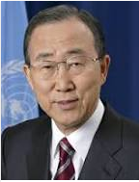 "Together, we can promote the cause of soils, a truly solid ground for life," Former UN Secretary-General Ban Ki-moon in a message for World Soil Day.