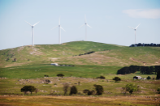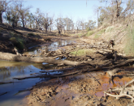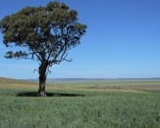

# Our Soil Needs Better Science

# https://media.licdn.com/mpr/mpr/AAEAAQAAAAAAAAsVAAAAJGU1NTMzM2M5LTlkOGMtNGU0Yy1hOGNlLTQ2YjI5YTg2NTcyMQ.jpg

## [Gerry Gillespie](https://www.linkedin.com/in/gerry-gillespie-66b37556)

## Follow Gerry Gillespie

### **Returning Organics to Soil**

I have been at a conference in Paris on soil carbon in the past two weeks and have heard that the world’s soils are in crisis through lack of soil organic matter and the loss of soil carbon. The conference attendees were among some of the more outstanding representatives of alternative methods of agriculture and its application in food production I have ever met in my travels.

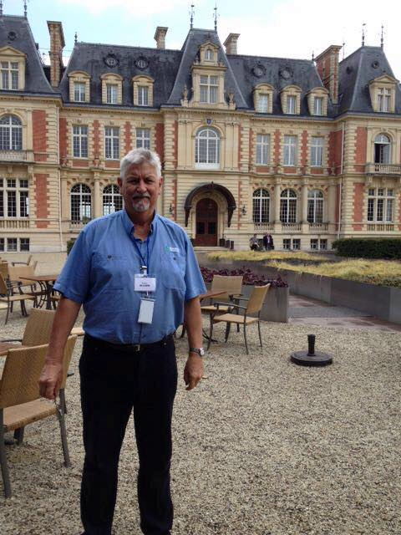

The situation our soils are in is dire, and it is so important that we listen to the experts and begin changing a number of things if we are to have a healthy, productive planet that can feed the world into the future. <https://www.linkedin.com/pulse/our-soil-needs-better-science-gerry-gillespie>

Three Reasons to Raise the Profile of Soils in Business

22 [May, 2017](https://www.soilsecurity.org/three-reasons-to-raise-the-profile-of-soils-in-business/) [News](https://www.soilsecurity.org/category/news/)[Agriculture](https://www.soilsecurity.org/tag/agriculture/), [Business](https://www.soilsecurity.org/tag/business/), [Soil Security](https://www.soilsecurity.org/tag/soil-security/), [Supply Chain](https://www.soilsecurity.org/tag/supply-chain/), [Sustainability](https://www.soilsecurity.org/tag/sustainability/)

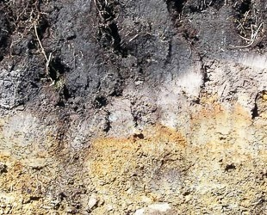What have podzols got to do with profits or brown earths with balance sheets? As summarised in my recent [**Nature Comment**](http://www.nature.com/news/the-business-case-for-soil-1.21623), the answer is: a lot! Sustainable soils are everyone’s business and the connections go far beyond farming and food sectors. Yet soils are largely missing from the corporate sustainability agenda. On Global Soil’s Week, here are three reasons why I believe we as scientists should team-up with global corporations on the path to soil security:

* **Supply Chain Power**Many business sectors, from food to fashion to pharmaceuticals, have a huge influence on soils across the world through their global supply chains. As scientists […]<https://www.soilsecurity.org/three-reasons-to-raise-the-profile-of-soils-in-business/>

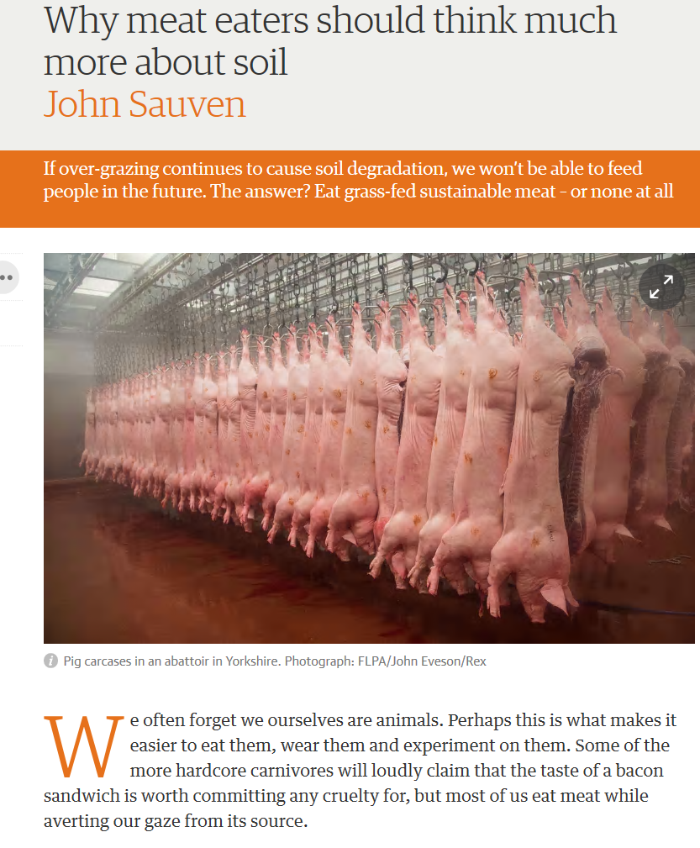

<https://www.theguardian.com/commentisfree/2017/may/16/meat-eaters-soil-degradation-over-grazing>

**Soil on the Screen**

[By Greg D Horstmeier](https://www.dtnpf.com/agriculture/web/ag/news/author?authorFullName=Greg%20D%20Horstmeier), DTN Editor-in-Chief

24/2/2017 | 1:51 PM CST

[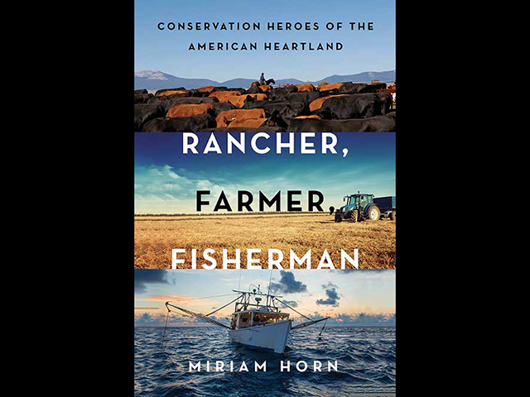](https://www.dtnpf.com/agriculture/web/ag/perspectives/blogs/editors-notebook/blog-post/2017/02/24/soil-screen)

The documentary "Rancher, Farmer, Fisherman," directed by Susan Froemke and John Hoffman, is based on a book of the same name by Miriam Horn. (Courtesy photo)

Recently, I highlighted the rapidly rising interest in soil health, including the "Underground Movement" package of stories in the Mid-February issue of The Progressive Farmer.

You can see the digital version by checking our "Resources" section on [www.dtnpf.com](http://www.dtnpf.com/).

If you want a sneak peek at one of the next big steps in all things soil-related, you'll want to check out the Commodity Classic in San Antonio. This year's gathering of the major crop commodity groups has a special treat for the soil-minded. <https://www.dtnpf.com/agriculture/web/ag/perspectives/blogs/editors-notebook/blog-post/2017/02/24/soil-screen>

**Why I Believe in Soil Health**

[By Pam Smith](https://www.dtnpf.com/agriculture/web/ag/news/author?authorFullName=Pam%20Smith), Crops Technology Editor

2/28/2017 | 12:18 PM CST

[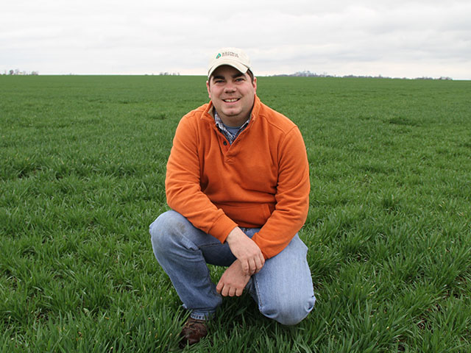](https://www.dtnpf.com/agriculture/web/ag/perspectives/blogs/production-blog/blog-post/2017/02/28/believe-soil-health)

Corn and soybeans may dominate the landscape in central Illinois, but Chase Brown, of Warrensburg, Illinois, likes to add a bit of wheat to his rotations. (DTN/ Progressive Farmer image by Pamela Smith)

Chase Brown is one of my kids. He was a member of the Warrensburg Liberty Belles and Beaus 4-H Club when I was one of the adult leaders. It's been a few yesterdays since he started his 4-H poultry project and egg sales. However, from the beginning, it was clear that Chase was going to farm and understood the necessity to make money doing it.

So it came as no surprise when I learned that he and his family had signed up as one of the farmer cooperators for the National Corn Growers Soil Health Partnership, a farmer-driven group focused on identifying, testing and measuring soil management practices. Nor was I surprised to learn that Chase was the driving force behind the farm's involvement. He believes deeply in the value of cover crops and forages; he understands the need for rotation and livestock diversification. <https://www.dtnpf.com/agriculture/web/ag/perspectives/blogs/production-blog/blog-post/2017/02/28/believe-soil-health>

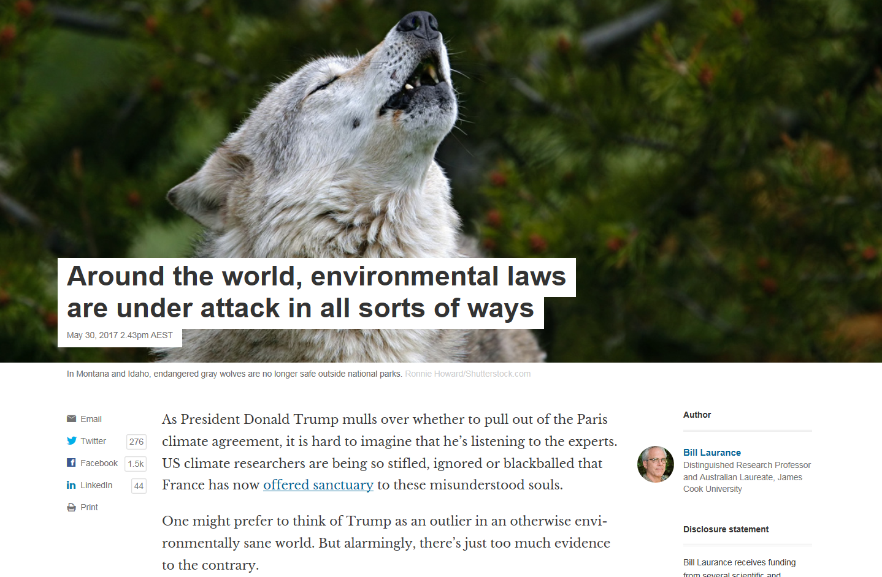

<https://theconversation.com/around-the-world-environmental-laws-are-under-attack-in-all-sorts-of-ways-77590>

**Start of a Soil Security Fellowship**

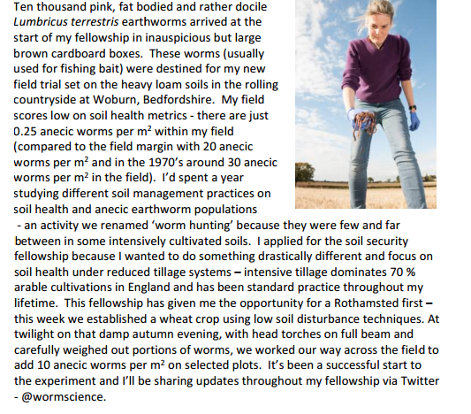

<http://blogs.reading.ac.uk/soil-security/files/2017/01/Soil-Security-News-Volume-1-Issue-3.pdf>

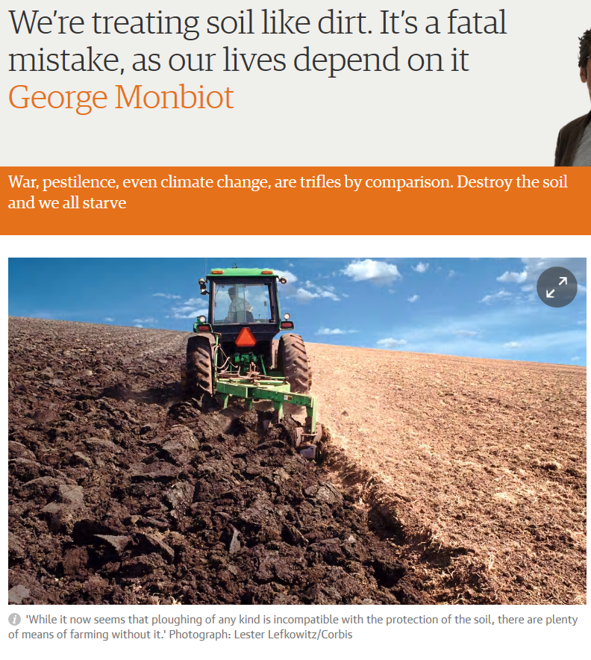

Imagine a wonderful world, a planet on which there was no threat of climate breakdown, no loss of freshwater, no antibiotic resistance, no obesity crisis, no terrorism, no war. Surely, then, we would be out of major danger? Sorry. Even if everything else were miraculously fixed, we’re finished if we don’t address an issue considered so marginal and irrelevant that you can go for months without seeing it in a newspaper.

<https://www.theguardian.com/commentisfree/2015/mar/25/treating-soil-like-dirt-fatal-mistake-human-life>

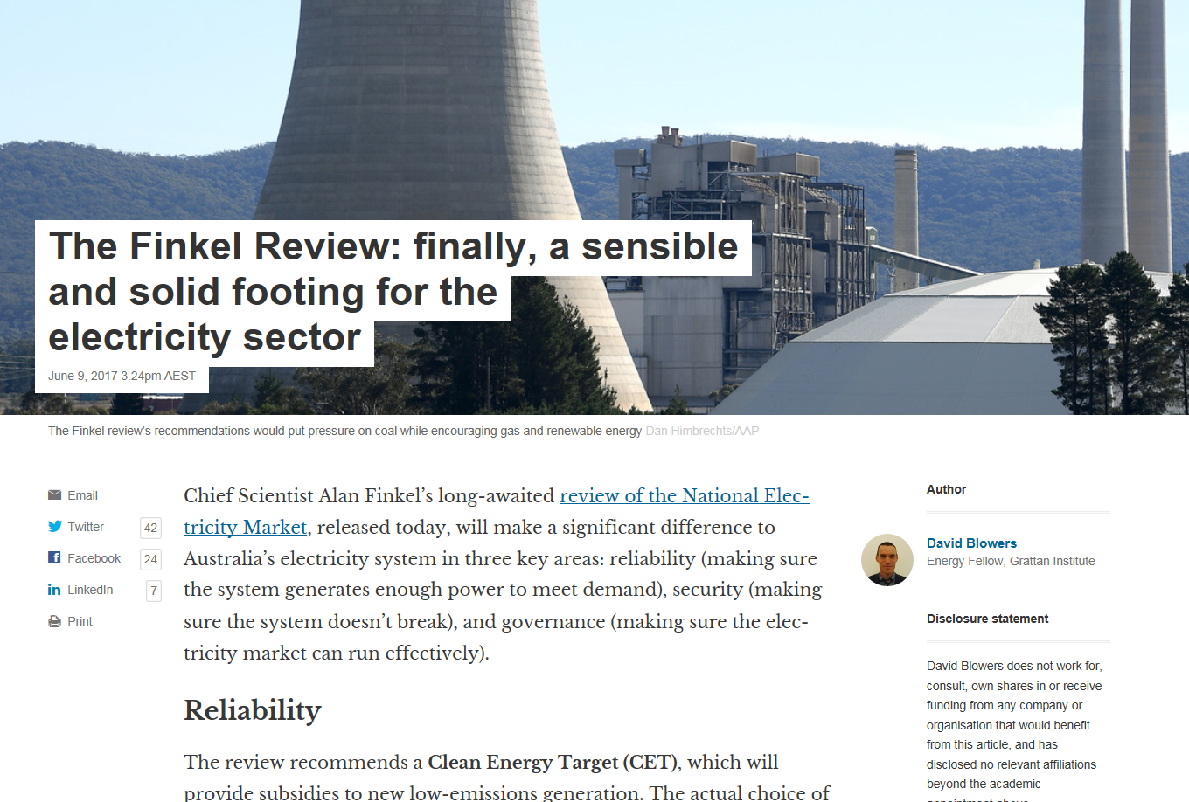

<https://theconversation.com/the-finkel-review-finally-a-sensible-and-solid-footing-for-the-electricity-sector-79118>

# Why It’s Time to Stop Punishing Our Soils with Fertilizers

*Researcher Rick Haney travels the U.S. preaching the benefits of healthy soils. In a*Yale Environment 360*interview, he talks about the folly of pursuing ever-greater crop yields using fertilizers and other chemicals and how farmland can by restored through natural methods.*

BY [RICHARD SCHIFFMAN](http://e360.yale.edu/authors/richard-schiffman) **•** 3 MAY 2017

The soil health movement has been in the news lately, and among its leading proponents is U.S. Department of Agriculture (USDA) researcher Rick Haney. In a world where government agencies and agribusiness have long pursued the holy grail of maximum crop yield, Haney preaches a different message: The quest for ever-greater productivity — using fertilizers, herbicides, pesticides, and whatever other chemicals are at hand — is killing our soil and threatening our farms.

[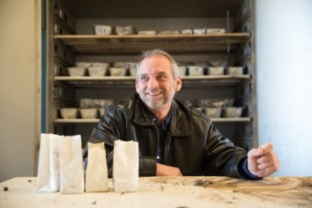](http://e360.yale.edu/assets/site/Haney_interior_050317.JPG)

Soil researcher Rick Haney of the U.S. Department of Agriculture USDA

Haney, who works with the USDA’s Agriculture Research Service in Texas, conducts online seminars and travels the country teaching farmers how to create healthy soil. His message is simple: Although the United States has some of the richest soils in the world, decades of agricultural abuse have taken their toll, depleting the dirt of essential nutrients and killing off bacteria and fungi that create organic material essential to plants.  “Our mindset nowadays is that if you don’t put down fertilizer, nothing grows,” says Haney, who has developed a well-known method for testing soil health. “But that’s just not true, and it never has been.”  <http://e360.yale.edu/features/why-its-time-to-stop-punishing-our-soils-with-fertilizers-and-chemicals>

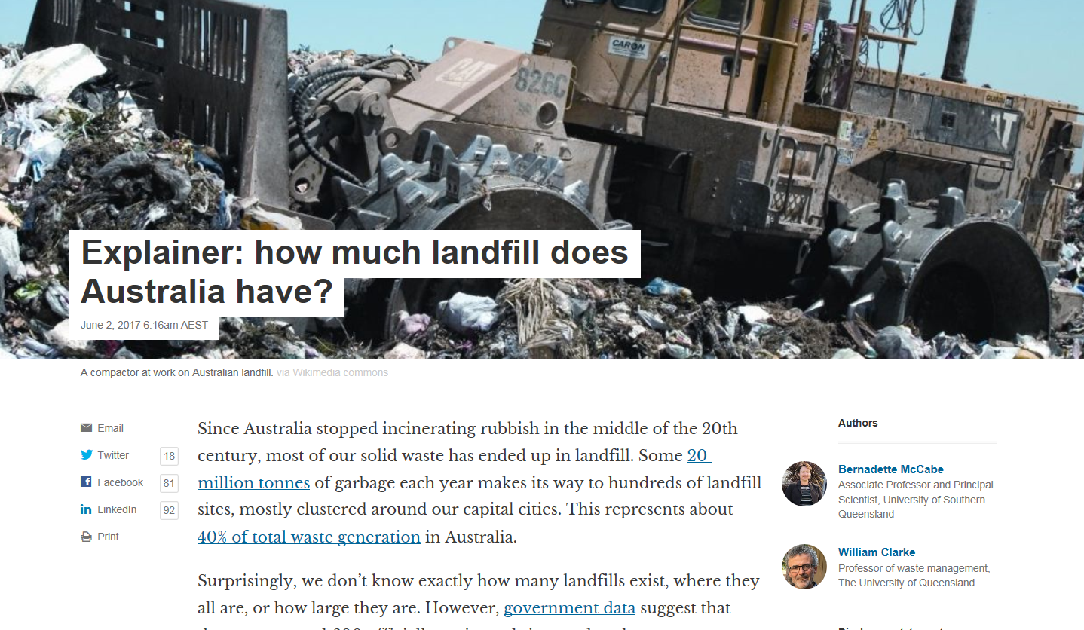

<https://theconversation.com/explainer-how-much-landfill-does-australia-have-78404>

# Guest Opinion: Healthier soil is key to cleaner water

# 

The solution to cleaner water is healthier soil. Healthy soil has great water-holding ability and retains nutrients. We get healthier soil by using organic fertilizer produced from livestock, using less tillage, and planting cover crops. I would like to quote National Resources Conservation Service soil-health specialist Doug Petersen: “There is no agronomic or economic reason for tillage to be justifiable anymore. It destroys everything that restores soil function.”. <http://daily-iowan.com/2017/06/13/guest-opinion-healthier-soil-is-key-to-cleaner-water/>

# Take control of soil compaction

[By CLAIRE LaCANNE Guest columnist](https://www.southernminn.com/users/profile/Suzy%20Rook) [Suzy Rook](https://www.southernminn.com/users/profile/Suzy%20Rook) 5 June 2017

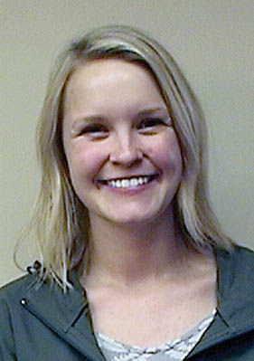

Bottom of Form

Imagine coming home with a bag of loose, fertile potting soil. Now imagine pouring the soil into a flower pot and dumping gallons of water into the pot too. Then, you smoosh the soil tightly into the pot, and when it dries, the soil more closely resembles a cement block than a nice loam. When soil is compacted like that, plants have a hard time growing in it.

Soil compaction occurs when soil particles are pressed together and the pore space between particles is reduced. Soil compaction is especially likely in crop fields when the soil is wet, has low organic matter content, or doesn’t have stable aggregate structure. Heavily compacted soils have reduced pore space which translates to less room for critters, water, air, roots, and gas exchange; all of these factors are vital to soil health. I am going to address some myths about agricultural soil compaction and advise how to reduce compaction. <http://www.southernminn.com/faribault_daily_news/opinion/article_5542ac87-e5c6-58e5-9c88-7c64c59ff79c.html>

# The NT must keep the door firmly closed to fracking

|  |  |
| --- | --- |
| By [Rosalie Schultz](http://www.onlineopinion.com.au/author.asp?id=7789) - posted Monday, 8 May 2017 |  |

There is growing concern in the NT that the Gunner Government may remove the moratorium on fracking. However, rejecting the moratorium would be a grave mistake, and Territorians know this. That's why we voted for the moratorium in the landslide ALP victory in August 2016.

People may think of fracking as an environmental or industrial issue, but ultimately fracking is an issue of health and wellbeing. Fracking is not safe, and that's why countries and states around the world - including Victoria - have permanently banned it.

**Rosalie Schultz** is a Northern Territory GP and public health physician, and a member of [Doctors for the Environment Australia](https://www.dea.org.au/)

<http://www.onlineopinion.com.au/view.asp?article=19021>

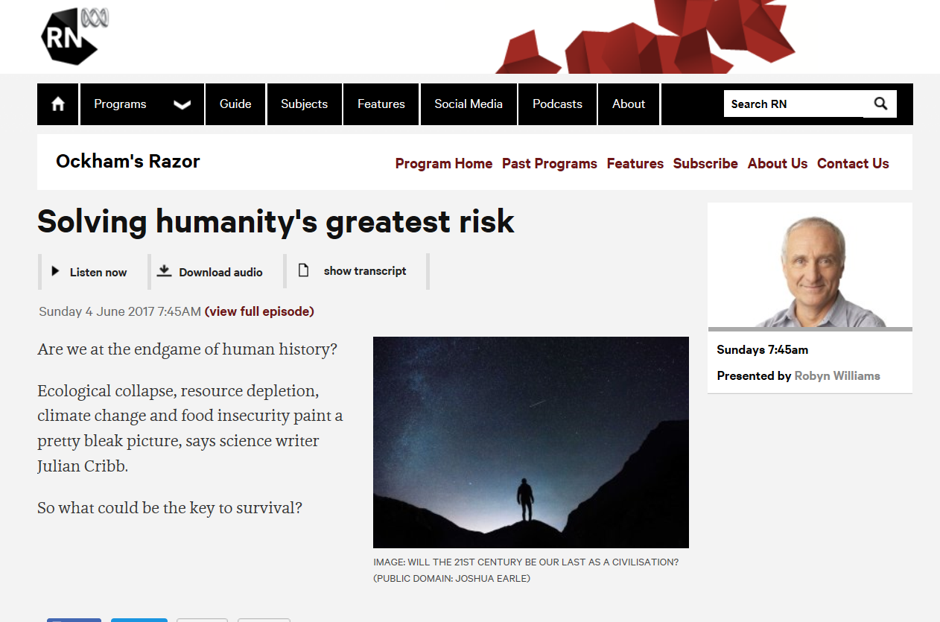

<http://www.abc.net.au/radionational/programs/ockhamsrazor/solving-humanitys-greatest-risk/8583142>

# Crikey Worm: coal lovers target Turnbull, Ten's last stand

Good morning, early birds. Almost two dozen coal-loving MPs are threatening the PM over the Clean Energy Target, and it might be time to switch off Channel Ten. It's the news you need to know, by **Cassidy Knowlton** and **Max Chalmers**.

<https://www.crikey.com.au/2017/06/14/tony-abbott-coalition-mps-threaten-turnbulls-leadership-over-clean-energy-target/>

# Exposed: the failures of pollution responses

**The Herald series Toxic State has revealed disturbing cases relating to the oversight and response mechanisms for contaminated sites in NSW.**

One reason climate change deniers get away with rejecting science and dismissing the benefits of pro-active emissions reductions is that global warming is, not surprisingly, a worldwide problem. It's difficult for an individual in Sydney or Pittsburgh or Paris today to put a finger on a symptom of human-induced climate change. Beyond seeing glaciers melt and suspecting that weather events are becoming more erratic and dangerous, the average person is not yet directly affected, other than having hazy concerns about the future.

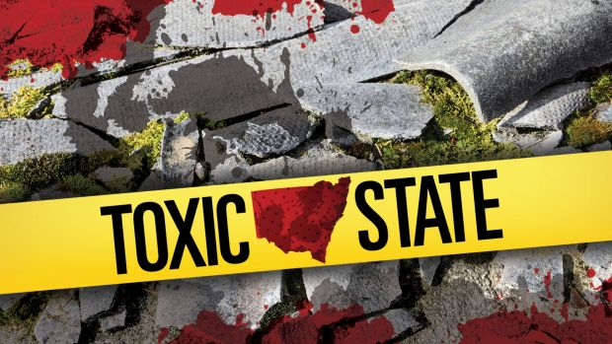The Environmental Protection Authority insists it can manage the dangers. But a Fairfax Media investigation has found the system is full of holes. Photo: Michael Howard

Politicians, mainly on the right, find it relatively simple to compare the far-off health of the planet with the risk climate change action poses to your job. They sell a counter-intuitive narrative that says protecting the planet is too dangerous for you to support. Hence, we see decisions like Donald Trump's dumping of the Paris climate accord this week. <http://www.smh.com.au/comment/smh-editorial/exposed-the-failures-of-pollution-responses-20170601-gwiqwv.html>

**“Our mindset nowadays is that if you don’t put down fertilizer, nothing grows, but that’s just not true, and it never has been.”** *Rick Haney, May 2017*