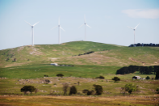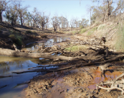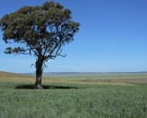

The business case for soil
Jess Davies
15 March 2017
Action on soil sustainability must move beyond the farm and into the boardroom, urges Jess Davies.

Article tools
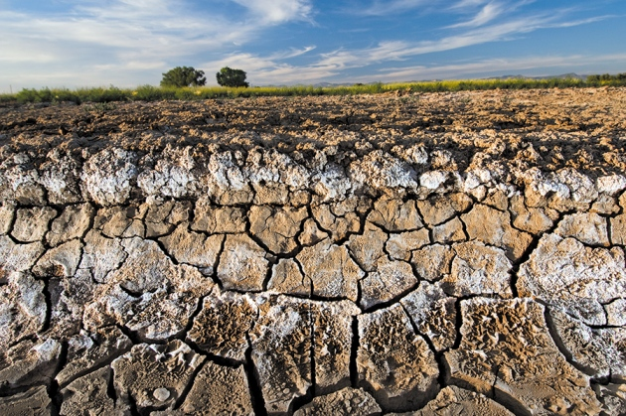
Jim Richardson/NGC
Salt in the soil in the Grand Valley, Colorado, leaches to the surface or is pushed up by groundwater.
Nobody likes dirty business, but the business world must get to grips with dirt. Soil provides food, fibres and fuels, and regulates water resources and climate. Yet most businesses are unaware that their bottom lines depend on soil; nor are they aware of the risks they face from its degradation. More must recognize that improving soil quality is a smart investment. http://www.nature.com/news/the-business-case-for-soil-1.21623

USING SOIL TO FIGHT CLIMATE CHANGE
Commentary
Rutland Herald | March 25, 2017
Seth ITZKAN & Karl THIDEMANN & Bill McKIBBEN
Wild asters bloom in front of a field of yellowing milkweed in Berlin. JEB WALLACE-BRODEUR / STAFF PHOTO
Lake Champlain, the crown jewel of New England, is sick. Every time it rains, fertilizer runs off farms, flowing downstream to pollute the rivers and lakes we cherish.
Two bills under consideration by the Vermont Legislature, S.43 and H.430, promise to address this problem — and fight global warming. These bills promote practices that enhance soil’s natural ability to retain water, nutrients and carbon. According to the Natural Resources Defense Council, a 1 percent increase in soil organic matter enables each acre to hold onto an additional 20,000 gallons of rainfall. More water absorbed into soil means less irrigation is needed and pollution of water bodies decreases. http://www.rutlandherald.com/articles/using-soil-to-fight-climate-change/

Save our soils: Why dirt matters
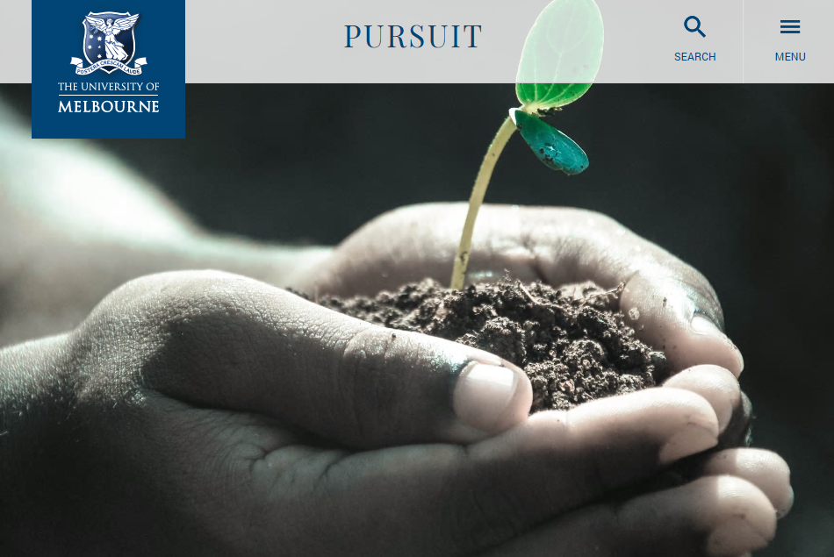
We are doing a poor job of looking after this finite resource, vital for our health and the environment
By Dr Ee Ling Ng and Professor Deli Chen, University of Melbourne
Share selection to:
The next time you bite into an apple, spare a thought for the soils that helped produce it. Soils play a vital role, not just in an apple’s growth, but in our own health too.
The formation of soil, pedogenesis, is a very slow process. It can take up to anywhere from a few years to a 1,000 years to form one millimetre of soil.
https://pursuit.unimelb.edu.au/articles/save-our-soils-why-dirt-matters
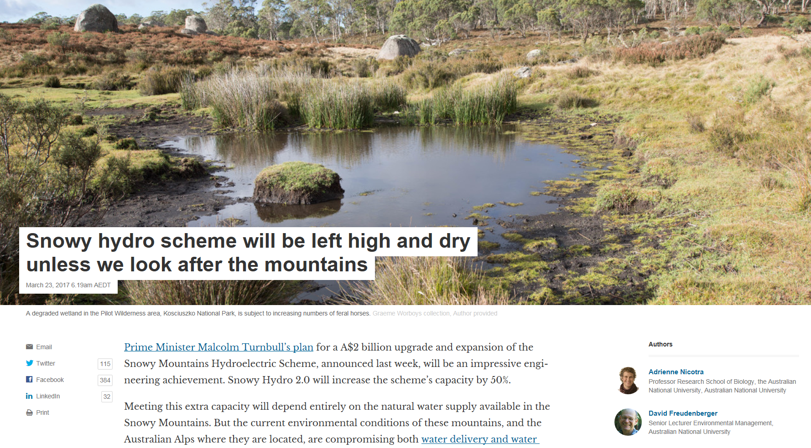
https://theconversation.com/snowy-hydro-scheme-will-be-left-high-and-dry-unless-we-look-after-the-mountains-74830
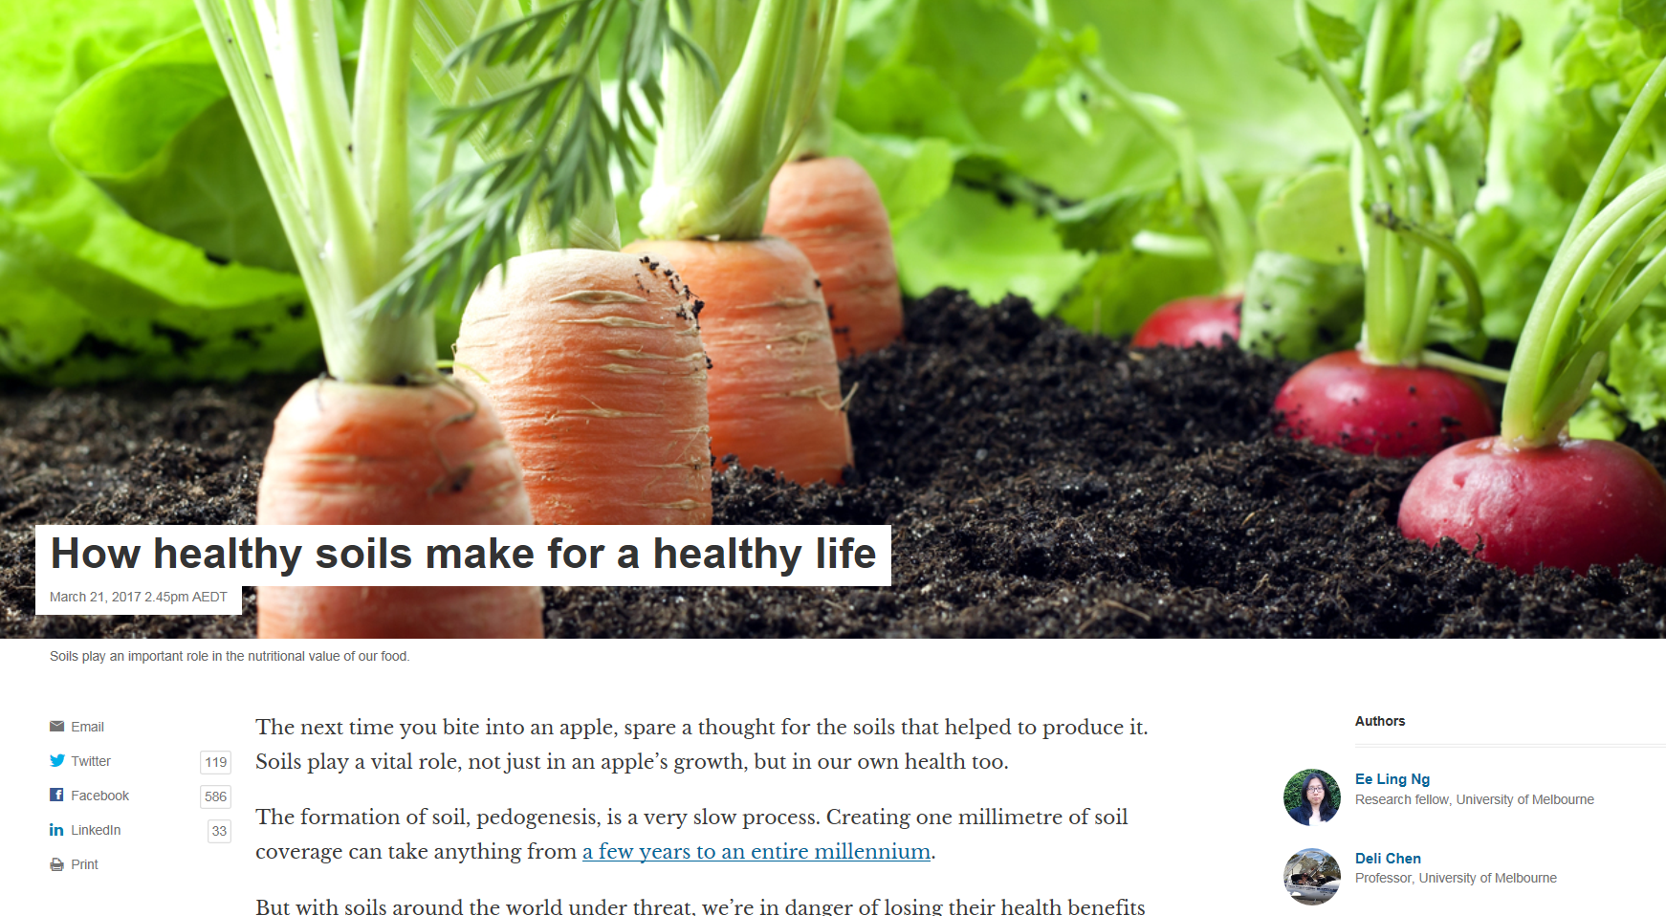
https://theconversation.com/how-healthy-soils-make-for-a-healthy-life-71790

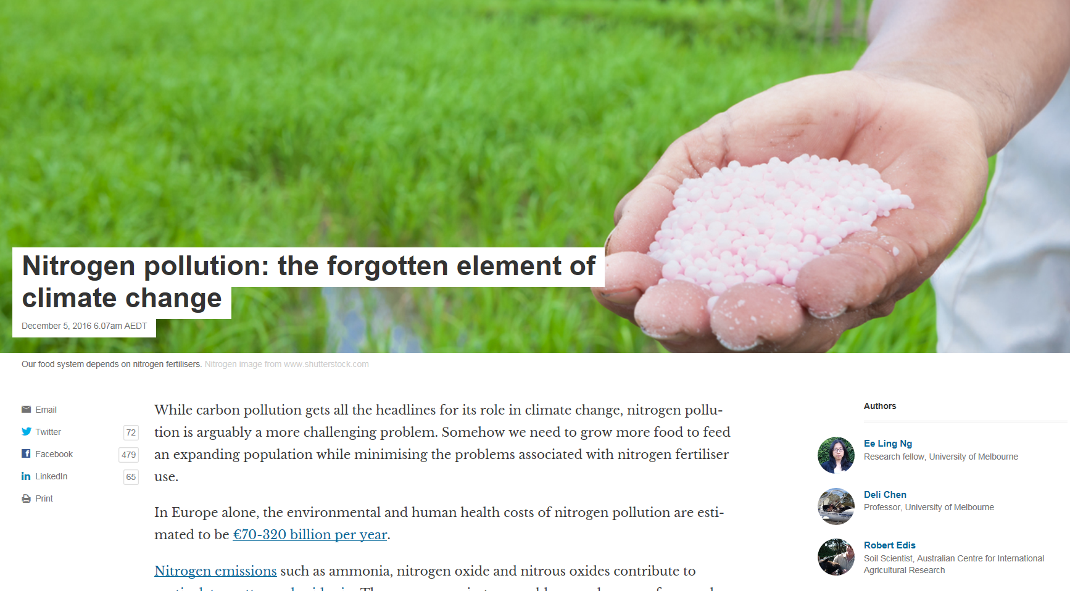
https://theconversation.com/nitrogen-pollution-the-forgotten-element-of-climate-change-69348
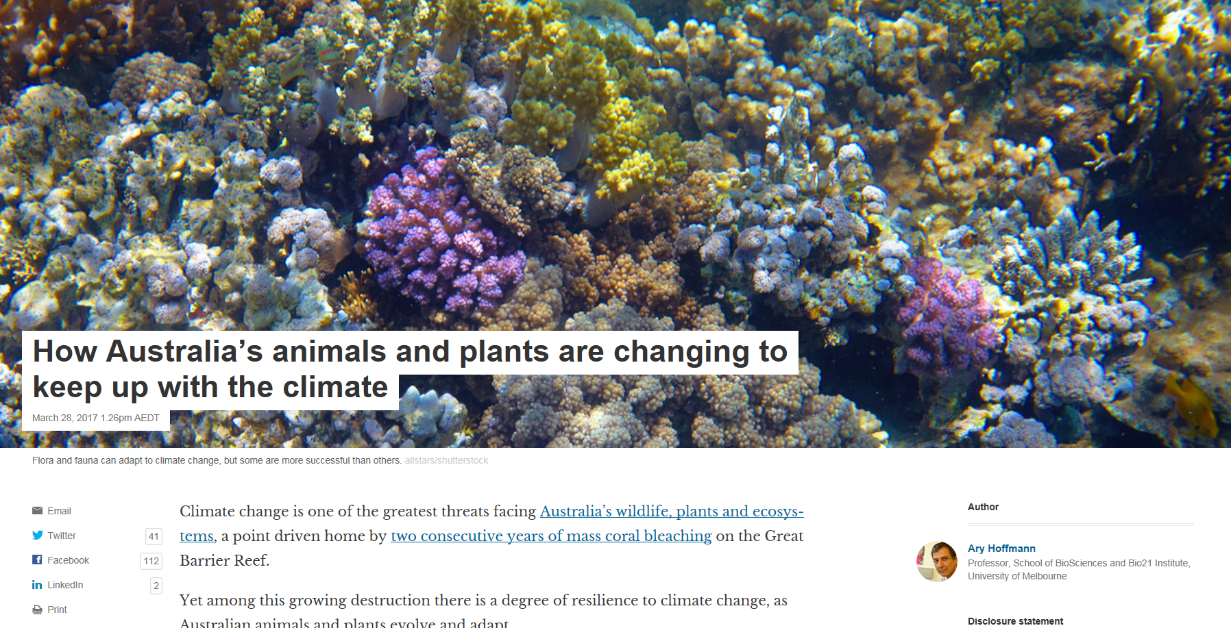
https://theconversation.com/how-australias-animals-and-plants-are-changing-to-keep-up-with-the-climate-74247

We’re treating soil like dirt. It’s a fatal mistake, as our lives depend on it

George Monbiot
War, pestilence, even climate change, are trifles by comparison. Destroy the soil and we all starve

'While it now seems that ploughing of any kind is incompatible with the protection of the soil, there are plenty of means of farming without it.' Photograph: Lester Lefkowitz/Corbis
Imagine a wonderful world, a planet on which there was no threat of climate breakdown, no loss of freshwater, no antibiotic resistance, no obesity crisis, no terrorism, no war. Surely, then, we would be out of major danger? Sorry. Even if everything else were miraculously fixed, we’re finished if we don’t address an issue considered so marginal and irrelevant that you can go for months without seeing it in a newspaper. https://www.theguardian.com/commentisfree/2015/mar/25/treating-soil-like-dirt-fatal-mistake-human-life

Stubble can be a benefit to soils
by
SHEPPARTON NEWS

22 MARCH 2017

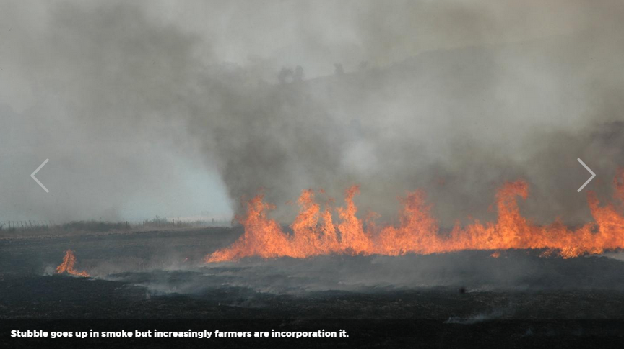Stubble goes up in smoke but increasingly farmers are incorporation it.

NSW DPI researcher Dr Bhupinder Pal Singh says research shows light tillage, when used strategically, could benefit the productivity of crop rotations.

Stubble goes up in smoke but increasingly farmers are incorporation it.

NSW DPI researcher Dr Bhupinder Pal Singh says research shows light tillage, when used strategically, could benefit the productivity of crop rotations.
Managing stubble as a nutrient bank in rotations can improve nutrient availability in soil for following crops according to a Grains Research and Development Corporation-funded research project.
Research conducted by NSW DPI scientist Dr Bhupinder Pal Singh monitored soil organic carbon and nutrient levels under different management practices and soil types. http://www.riverineherald.com.au/rural/2017/03/22/80087/stubble-can-be-a-benefit-to-soils

Why scientists are signing an open letter calling for a total ban on nuclear weapons
Opinion
The Conversation
By Toby Walsh and Rob Brooks, UNSW
Updated Tue at 9:11pmTue 28 Mar 2017, 9:11pm

Photo: The UN is debating a total ban on all nuclear weapons (Reuters: The National Archives)
These are dangerous times.
The Doomsday Clock sits at just two-and-a-half minutes before midnight, which represents global catastrophe.
The Doomsday Clock has been maintained by the Bulletin of the Atomic Scientists since 1947, and has only ever been closer to midnight back in 1953, when the United States and Soviet Union tested their first hydrogen bombs, and the world was locked in a very dangerous nuclear arms race http://www.abc.net.au/news/2017-03-28/why-scientists-signed-an-open-letter-on-banning-nuclear-weapons/8393330

Golden Soil & Wealth For Toil
By Cameron Colwell -
27 March, 2017

Share
Words || Joel Webber
With an estimated worth of AUD$21 billion, a proposed mine for central Queensland will be the largest mining project ever undertaken in Australia. Located west of Rockhampton in the Galilee Basin, the colossal mine will be built by the Adani Group and include six open pits and five underground mines. https://grapeshotmq.com.au/2017/03/golden-soil-wealth-toil/
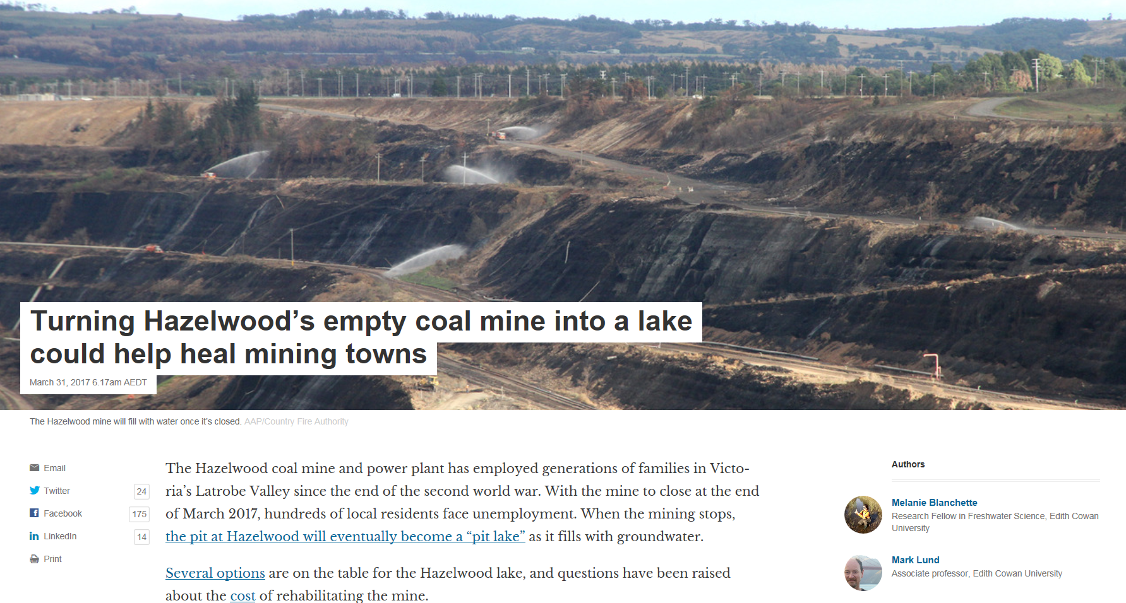
https://theconversation.com/turning-hazelwoods-empty-coal-mine-into-a-lake-could-help-heal-mining-towns-74258

Cyclone Debbie: How we can design cities to withstand natural disasters
Opinion
The Conversation
By Rob Roggema, UTS
Posted Wed at 2:12pmWed 29 Mar 2017, 2:12pm
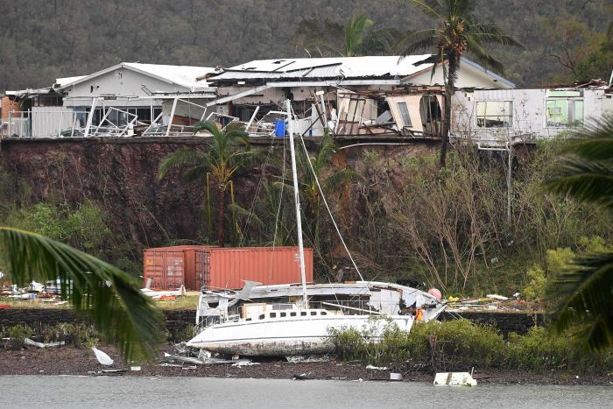Photo: The biggest risk to cities during cyclones comes from storm surge and rainfall. (AAP: Dan Peled)
What happens after Cyclone Debbie is a familiar process. It has been repeated many times in cities around the world.
The reason is that our cities are not designed for these types of events.
So we know what comes next.
Queenslanders affected by Debbie will complain about the damage, the costs and the need for insurers to act now to compensate their losses.
Rob Roggema is a renowned design expert on sustainable urbanism, climate adaptation, renewable energy landscapes and the design of urban agriculture. He has held positions at several universities in the Netherlands and Australia, state and municipal governments and design consultancies. http://www.abc.net.au/news/2017-03-29/cyclone-debbie-how-we-can-design-cyclone-proof-cities-and-towns/8397376
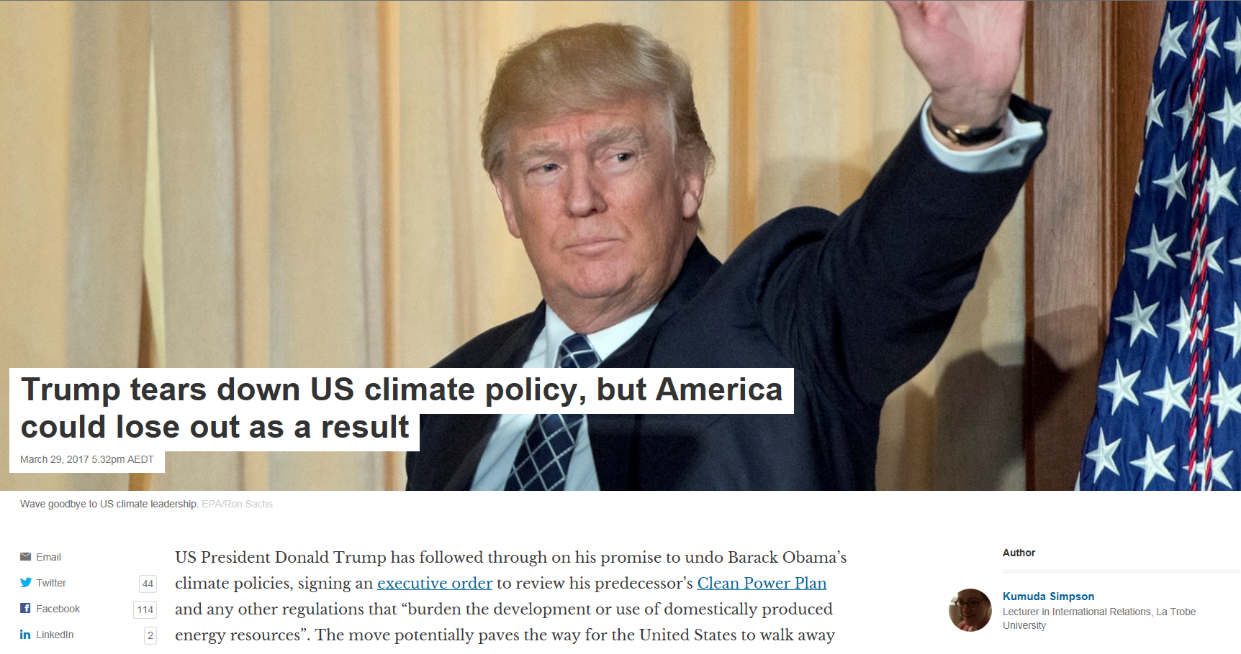
https://theconversation.com/trump-tears-down-us-climate-policy-but-america-could-lose-out-as-a-result-75391
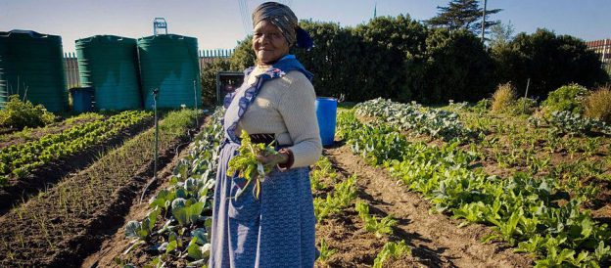

Catherine Bertini: Ending Hunger Is Within Our Grasp


In this guest blog post, Catherine Bertini, distinguished fellow, Global Food and Agriculture at the Chicago Council on Global Affairs, and professor of public administration and international affairs, Maxwell School, Syracuse University, reflects on the progress made in tackling malnutrition, and the challenge that remains to achieve zero hunger.
After years of incremental progress in the fight against poverty and malnutrition, eradicating hunger is now within our grasp. The world is changing, and we face growing challenges and new risks—but we’ve also never been as well prepared to meet these challenges. Ending hunger will require action, engagement, commitment, and collaboration from all sectors, across generations, and from every corner of the world. https://farmingfirst.org/2017/03/catherine-bertini-ending-hunger-is-within-our-grasp/

Food Security Podcast: Lisa Palmer, Hot Hungry Planet
23 March 2017|
Chicago Council on Global Affairs
by
Roger Thurow and Lisa Palmer
In the lead up to the 2017 Global Food Security Symposium, the Pulitzer Center on Crisis Reporting and the Chicago Council on Global Affairs collaborated to produce Food Security, a podcast examining nutrition, hunger, and food security around the world. This is the first of three episodes showcasing work from journalists whose projects tie into the big picture of global agriculture and food security.
http://pulitzercenter.org/reporting/food-security-podcast-lisa-palmer-hot-hungry-planet
“We are doing a poor job of looking after this finite resource [soil], vital for our health and the environment” Dr Ee Ling Ng and Professor Deli Chen, University of Melbourne

