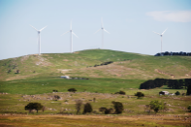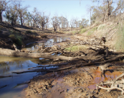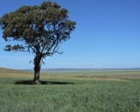

# **Dirty undies help American researchers to test Tennessee soil**

By [Amy McCosker](http://www.abc.net.au/news/rural/amy-mccosker/4519554)

Posted 7 September 2017 at 9:48 am

[[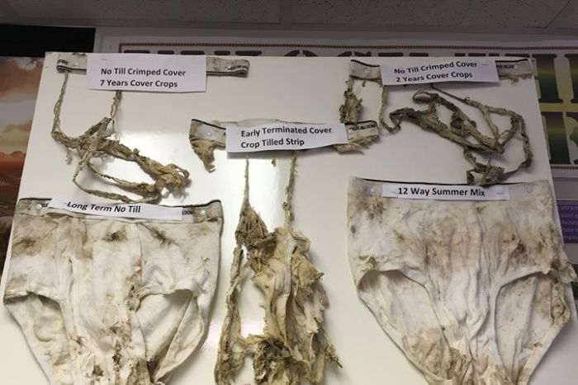](http://www.abc.net.au/news/rural/2017-09-07/dirty-undies-help-american-researchers-test-soil/8880612#lightbox-content-lightbox-6)](http://www.abc.net.au/news/rural/2017-09-07/dirty-undies-help-american-researchers-test-soil/8880612" \l "lightbox-content-lightbox-6" \o "Open lightbox)

[The underwear has been buried in different soils for 30 days and shows the different rates of degeneration.](http://www.abc.net.au/news/rural/2017-09-07/dirty-undies-help-american-researchers-test-soil/8880612" \l "lightbox-content-lightbox-6" \o "Open lightbox)

(Supplied: Coffee County Soil Conservation District)

Undies, jocks, drawers... There are plenty of names for underwear around the world.

Now, a group of farmers in Tennessee, in the United States, has found a new use for them: to test their soil.

The Coffee County Soil Conservation District is an environmental conservation organisation in Manchester, south of Nashville, where the main industries are corn, soybeans, and cattle grazing.

On July 3, the organisation buried several pairs of cotton underwear across the region in different soils that had been managed in varying ways.

"This is just a simple test where you can compare some different management systems," said district conservationist Adam Daugherty.

"The theory is, the more active the microbes in your soil are, the quicker the underwear cotton fibres will be consumed by the biology."

<http://www.abc.net.au/news/rural/2017-09-07/dirty-undies-help-american-researchers-test-soil/8880612>

# **Advancing a shared goal for farmers and conservation**

ASA, CSSA, SSSA, The Nature Conservancy enter memorandum of understanding

The Nature Conservancy and the American Society of Agronomy (ASA), Crop Science Society of America (CSSA), Soil Science Society of America (SSSA)—collectively known as the TriSocieties—today announced a new partnership to advance the science of soil health.



From left to right: Ellen Bergfeld (ASA-CSSA-SSSA CEO), Luther Smith (ASA-CSSA-SSSA Director of Professional Development and Business Relations) , Larry Clemens (The Nature Conservancy Director of North America Agriculture Program , and Carrie Vollmer-Sanders (The Nature Conservancy Nutrient Strategy Manager).

The two organizations signed a memorandum of understanding (MOU) based on the mutually held belief that farmers can remain profitable while protecting the environment. The steps outlined in the agreement are designed to empower America’s growers with pragmatic, science-based practices. <https://www.soils.org/newsroom/releases/2017/0915/934/>

Soil erosion in Maasai heartlands, Tanzania, is due to climate change and land management decisions. Photograph: Carey Marks/Plymouth University

[Soil](https://www.theguardian.com/environment/soil)

# Third of Earth's soil is acutely degraded due to agriculture

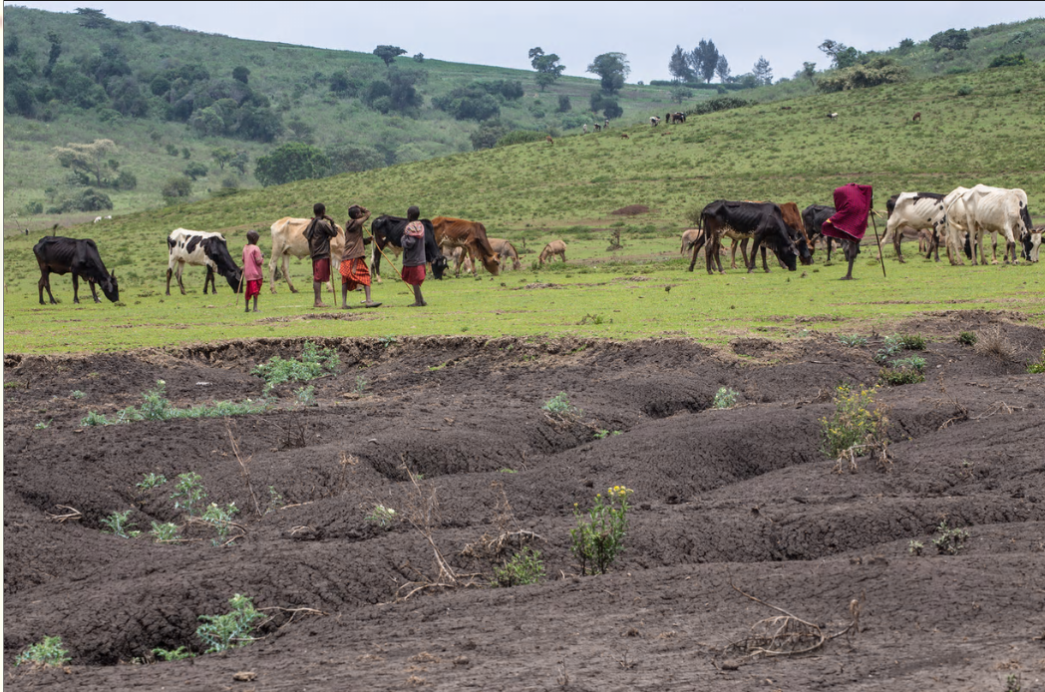

Fertile soil is being lost at rate of 24bn tonnes a year through intensive farming as demand for food increases, says UN-backed study

Wednesday 13 September 2017 03.18 AEST First published on Wednesday 13 September 2017 03.15 AEST

A third of the planet’s land is severely degraded and fertile soil is being lost at the rate of 24bn tonnes a year, according to a new United Nations-backed study that calls for a shift away from destructively intensive agriculture.

The alarming decline, which is forecast to continue as demand for food and productive land increases, will add to the risks of conflicts such as those seen in [Sudan](https://www.theguardian.com/global-development/2016/dec/19/sudan-faremers-battle-climate-change-hunger-desertification) and Chad unless remedial actions are implemented, warns the institution behind the report. <https://www.theguardian.com/environment/2017/sep/12/third-of-earths-soil-acutely-degraded-due-to-agriculture-study?CMP=Share_AndroidApp_Tweet>

# **The soil remembers: climatic legacies help explain the current global distribution of bacterial communities.**

The paper in Nature Ecology and Evolution is here: <http://go.nature.com/2vefk48>

Soil bacteria are the most abundant and diverse organisms on Earth. They support multiple ecosystem functions including litter decomposition, nutrient cycling, primary production and the regulation of greenhouse emissions, which are essential for humankind1. Because of their enormous functional importance, identifying new predictors that help explain the distribution of soil bacterial community globally is one of the major endeavors in which scientists are immersed today.

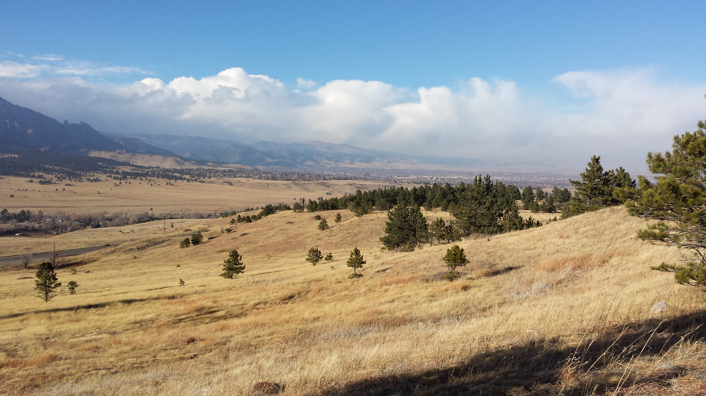

<https://natureecoevocommunity.nature.com/users/58180-manuel-delgado-baquerizo/posts/19244-the-soil-remembers-climatic-legacies-help-explain-the-current-global-distribution-of-bacterial-communities>

**World’s soils have lost 133 billion tonnes of carbon since the dawn of agriculture, study estimates**

Amount of carbon released from the Earth is about the same as released by deforestation

* [Ian Johnston](http://www.independent.co.uk/author/ian-johnston) Environment Correspondent
* [@montaukian](https://twitter.com/montaukian)
* Tuesday 29 August 2017 17:05 BST

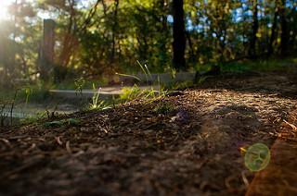Concern has been growing over a 'soil fertility crisis', a problem that can be masked by the use of artificial fertilisers Tina Reynolds/Flickr

The degradation of the Earth’s soil by humans has been an environmental catastrophe on a similar scale to the deforestation of much of the planet, a new study suggests.

Experts estimated that 133 billion tonnes of carbon has been removed from the top two metres of soil since farming began some 12,000 years ago, about the same as the total amount lost from vegetation.

However the figure is still dwarfed by the 450 billion tonnes of carbon emitted since the Industrial Revolution began and humans started burning fossil fuels on an unprecedented scale. <http://www.independent.co.uk/news/soil-lost-carbon-133-billion-tonnes-farming-agriculture-deforestation-a7918941.html>

# **What are Alaska’s soils telling us?**

*Unique soils show effects of climate change*

1 Sept. 2017 –  What can frozen soils teach us?  The Soil Science Society of America (SSSA) September 1 Soils Matter blog post explains how Alaskan soils are increasing our understanding of soils, water movement, and climate change.

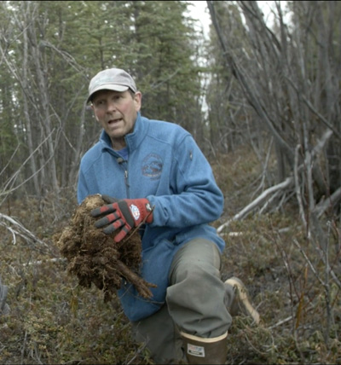

Clark holding a moss layer with soil in Alaska. Photo courtesy KTTZTV.

“Alaskan soils are telling us the climate is changing,” says Mark H. Clark. Clark is a Certified Professional Soil Scientist and former Natural Resources Conservation Services soil scientist in Alaska. “This is especially true in the extensive permafrost landscapes of Interior and Western Alaska. Winter temperatures are now significantly warmer. The amount of pack ice is in decline, and ice forms later in fall and melts earlier in spring.” <https://www.soils.org/newsroom/releases/2017/0901/930/>

# **Ginger production almost doubles in compost trial aimed at improving soil and boosting yields**

**[ABC Rural](http://www.abc.net.au/news/rural/)**

By Jennifer Nichols

Posted 5 September 2017 at 8:06 am

[[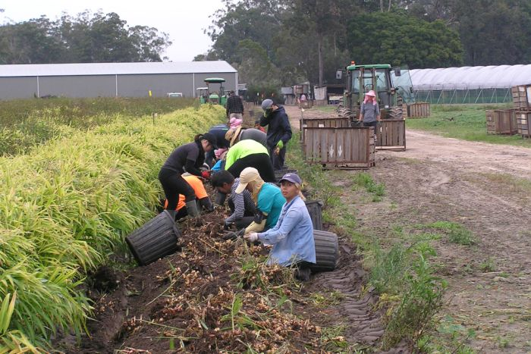](http://www.abc.net.au/news/rural/2017-09-05/ginger-compost-yield-food/8868618#lightbox-content-lightbox-7)](http://www.abc.net.au/news/rural/2017-09-05/ginger-compost-yield-food/8868618" \l "lightbox-content-lightbox-7" \o "Open lightbox)

[Picking ginger: The trial is looking at ways to increase organic matter to boost yields.](http://www.abc.net.au/news/rural/2017-09-05/ginger-compost-yield-food/8868618" \l "lightbox-content-lightbox-7" \o "Open lightbox)

(Supplied: Rob Abbas)

*A trial using cured compost, processed poultry manure pellets and clean seed has almost doubled ginger production in a test plot.*

Researchers with Queensland's Department of Agriculture and Fisheries are investigating ways to increase organic matter to improve soil health and boost yields for the ginger industry.

Senior scientist Dr Mike Smith said the cost of production per hectare for the trial was comparable to the industry practice of using untreated chicken manure, but had added benefits of reducing the nutrient budget and delivering a food safe product. <http://www.abc.net.au/news/rural/2017-09-05/ginger-compost-yield-food/8868618>

# **Helping Chinese farmers tackle erosion, increase profits**

Chili peppers grown with corn a winning recipe

13 Sept 2017 - On the steep farming slopes of China, Bozhi Wu and his research associates are finding ways to improve ec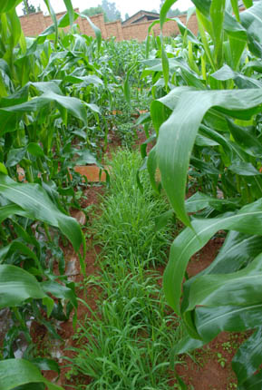

Corn grown with setaria grass intercropped reduces erosion, but has less economic return than the corn & chili system. Photo provided by Bozhi Wu.

onomic and environmental stability.

The research team studied the use of intercropping – growing more than one crop per season – on hilly land. They focused on a staple grain crop, corn. They compared intercropping the corn with either setaria grass, used in forage, or chili peppers. The results, you could say, will spice up Chinese farmers’ methods.

<https://www.soils.org/newsroom/releases/2017/0913/932/>

# **Spectroscopy: Simple solution for soil sample**

##### 30 August 2017

[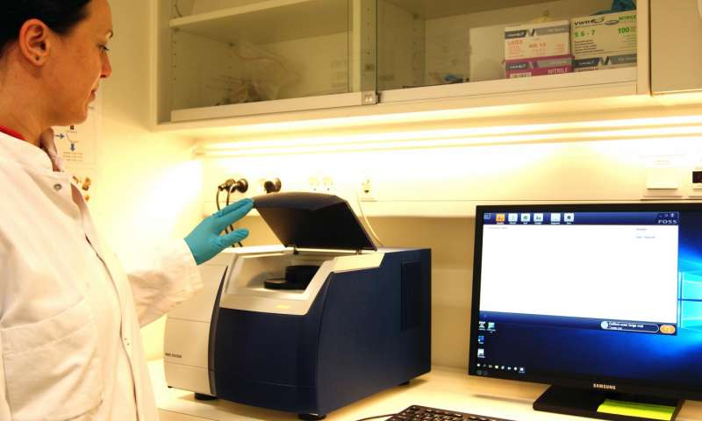](https://3c1703fe8d.site.internapcdn.net/newman/gfx/news/hires/2017/spectroscopy.jpg)

The sample cup is placed in the spectrometer for visible near-infrared spectroscopy measurement. The measurement takes approximately one minute and the spectrum is visualized on the computer screen for immediate quality check. Credit: Maria Knadel

Farmers and gardeners know their soil texture can make a big difference in their success. Different plants have different needs for water, nutrients, and air. When they grow in soil that has the right texture, it is easier to deliver the right amount of water, fertilizer, or pesticide to the plants. Then they grow better.

Traditional ways of analyzing soil texture are slow. Danish researchers have shown a new, high-tech method that is fast, cost-effective, and portable. This technique could make it much easier to understand the soil texture of a particular area—or even large areas across the globe.

Read more at: <https://phys.org/news/2017-08-spectroscopy-simple-solution-soil-sample.html#jCp>

# **Carbon cycling in forest soils research presented**

Understanding soil in forests can help guide management recommendations

12 Sept 2017— Just as individual humans have different microbial communities in their guts, the microbial communities living in soils vary from site to site as well. Recent research compared the decomposition rates of wood stakes over eight sites to gain an understanding of soil microbes in forests. The activity of soil microbes can also tell a story of the value of carbon storage in soil.

<https://www.soils.org/newsroom/releases/2017/0912/914/>

# **cid:image001.png@01D311BF.88791A20**

# **Plastic Film Covering 12% of China's Farmland Pollutes Soil**

Bloomberg News

‎6‎ ‎September‎ ‎2017‎ ‎7‎:‎00‎ ‎AM‎6‎ ‎September‎ ‎2017‎ ‎3‎:‎26‎ ‎PM

* Use of polyethylene mulch set to rise as farmers boost output
* ‘White pollution’ accumulating in soil stifles cotton crops

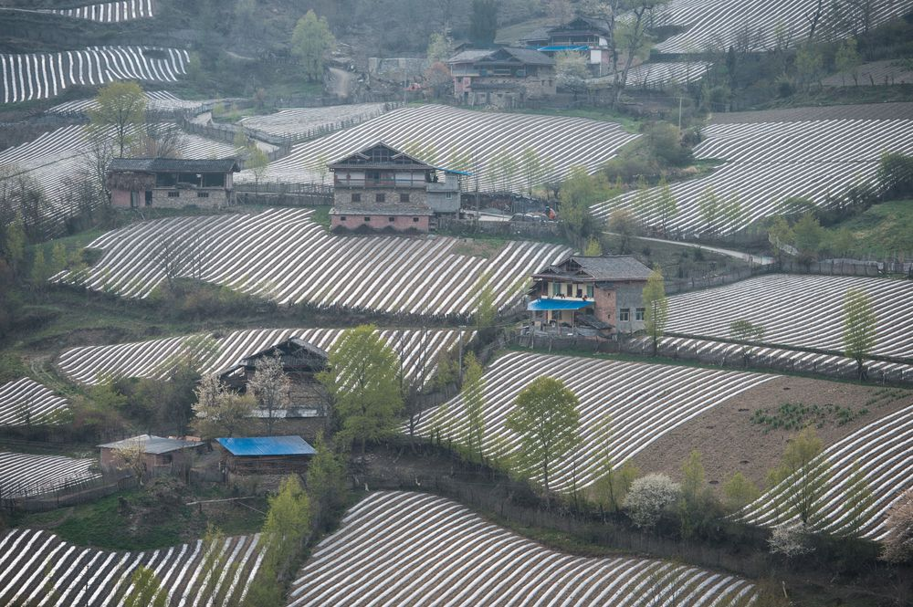

Aerial view of farm land with plastic soil cover in Sichuan province.

Photographer: Jie Zhao/Corbis via Getty Images

China will expand its agricultural use of environment-damaging plastic film to boost crop production even as authorities try to curb soil pollution, a government scientist said.

Some 1.45 million metric tons of polyethylene are spread in razor-thin sheets across 20 million hectares (49 million acres) — an area about half the size of California — of farmland in China. Use of the translucent material may exceed 2 million tons by 2024 and cover 22 million hectares, according to Yan Changrong, a researcher with the [Chinese Academy of Agricultural Sciences](http://www.caas.cn/en/index.shtml) in Beijing. <https://www.bloomberg.com/news/articles/2017-09-05/plastic-film-covering-12-of-china-s-farmland-contaminates-soil>

# **EPA testing on Wodonga's Hunchback Hill has uncovered lead pollution, prompting warning signs to be erected**

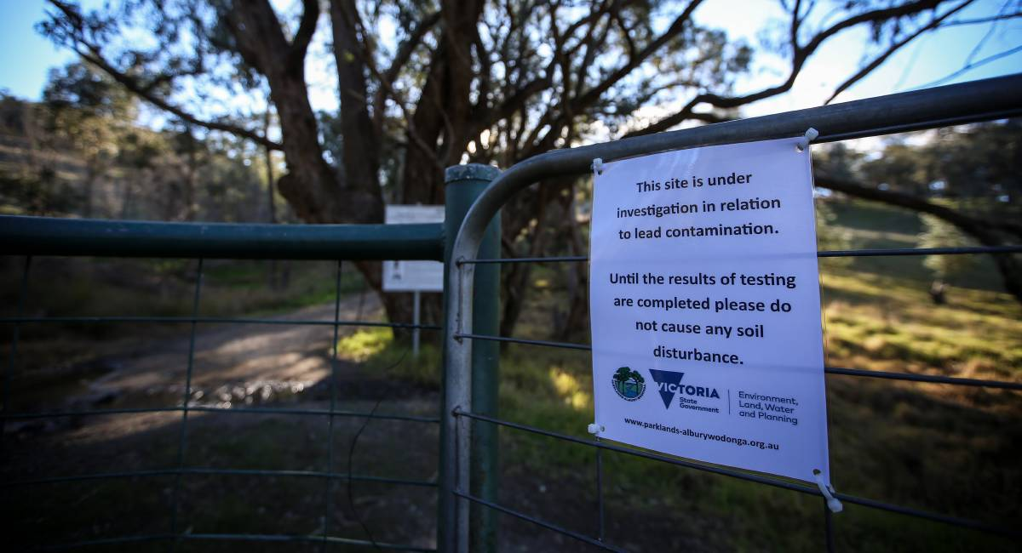

One of the warning signs

A PROBE into lead contamination has resulted in warning signs being posted at Wodonga’s Hunchback Hill.

Parklands Albury Wodonga, which manages the site that is used for mountain biking, erected the notices on Tuesday under instructions from the EPA which had liaised with the Department of Environment, Land Water and Planning. <http://www.bordermail.com.au/story/4888728/soil-contamination-on-hill/>

# **Over the fence: Having fungi in soil ensures healthy crops and pasture**

CAMILLE SMITH, The Weekly Times

7 September 2017 12:00am

A HEALTHY farm ecosystem hinges on diverse plants and animals. But there is a third, often overlooked, kingdom of living things to consider — fungi.

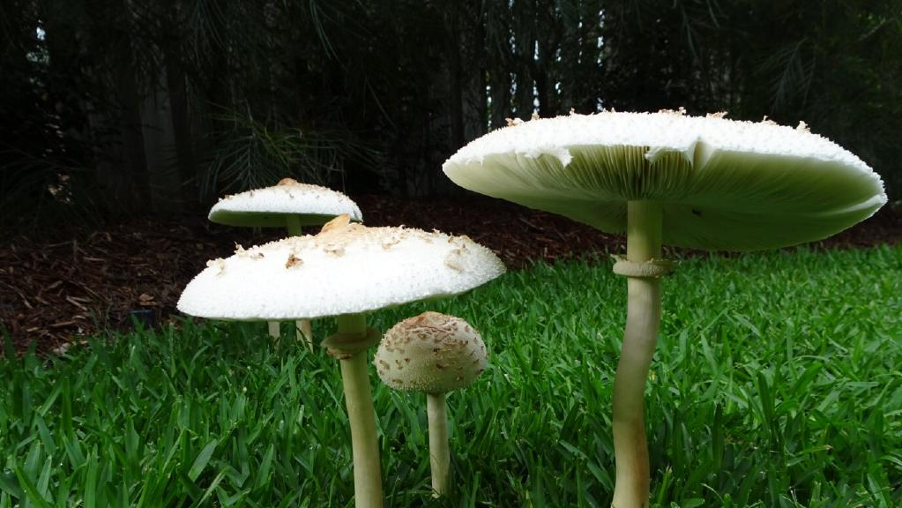

*There are many benefits of diverse, healthy fungi living in the* soil

Two experts say these tiny organisms play a bigger and more beneficial role in agriculture than most imagine.

Sapphire McMullan-Fisher, a mycologist at Royal Botanic Gardens Victoria and not-for-profit group Fungimap, has some surprising knowledge to share.

“Fungi are not a plant and not an animal,” Sapphire says. “They are weird creatures and live very differently.”

To clear up one misconception, a mushroom is the fruiting body of a fungus, but it is not the whole organism. <http://www.weeklytimesnow.com.au/agribusiness/farm-magazine/over-the-fence-having-fungi-in-soil-ensures-healthy-crops-and-pasture/news-story/35e3ec498266b2fe30fc80a313e3e460>

# **Biodiversity just as powerful as climate change for healthy ecosystems**

## In the wild, diversity determines ecosystem production as much as climate and nutrients



Marine ecologist Emmett Duffy of the Smithsonian Environmental Research Center works on a boat in Panama's Bocas Del Toro Research Station. Duffy directs the Smithsonian's Marine Global Earth Observatory (MarineGEO), an international network of sites that track biodiversity in coastal ecosystems around the world.

Credit: Sean Mattson/Smithsonian Tropical Research Institute



Marine ecologist Emmett Duffy of the Smithsonian Environmental Research Center works on a boat in Panama's Bocas Del Toro Research Station. Duffy directs the Smithsonian's Marine Global Earth Observatory (MarineGEO), an international network of sites that track biodiversity in coastal ecosystems around the world.

Credit: Sean Mattson/Smithsonian Tropical Research Institute

Close

Biodiversity is proving to be one of humanity's best defenses against extreme weather and rising temperatures. In past experiments, diversity has fostered healthier, more productive ecosystems, like shoreline vegetation that guards against hurricanes. However, many experts doubted whether these experiments would hold up in the real world. A Smithsonian and University of Michigan study published in this week's issue of Nature offers a decisive answer: Biodiversity's power in the wild does not match that predicted by experiments -- it surpasses it, in some cases topping even the effects of climate.

**Journal Reference**:

1. J. Emmett Duffy, Casey M. Godwin, Bradley J. Cardinale. **Biodiversity effects in the wild are common and as strong as key drivers of productivity**. Nature, 2017; DOI: [10.1038/nature23886](http://dx.doi.org/10.1038/nature23886)

<https://www.sciencedaily.com/releases/2017/09/170911122625.htm>

# 

# <http://www.environment.nsw.gov.au/research-and-publications/publications-search/dustwatch-report-june-2017>

# 

# <http://www.environment.nsw.gov.au/dustwatchapp/Default.aspx>

# **First 'winged' mammals flew over dinosaurs**

By Prof Sarah Gabbott Science writer

* 10 August 2017
* From the section [Science & Environment](http://www.bbc.com/news/science_and_environment)
* [Share this with Facebook](http://www.bbc.com/news/science-environment-40881480)
* [Share this with Twitter](http://www.bbc.com/news/science-environment-40881480)
* [Share this with Messenger](fb-messenger://share/?app_id=58567469885&redirect_uri=http%3A%2F%2Fwww.bbc.com%2Fnews%2Fscience-environment-40881480&link=http%3A%2F%2Fwww.bbc.com%2Fnews%2Fscience-environment-40881480%3FCMP%3Dshare_btn_me)
* [Share this with Messenger](http://www.bbc.com/news/science-environment-40881480)
* [Share this with Email](mailto:?subject=Shared%20from%20BBC%20News&body=http%3A%2F%2Fwww.bbc.com%2Fnews%2Fscience-environment-40881480)

Copy this link

<http://www.bbc.com/news/science-environment-40881480>

[Read more about sharing.](http://www.bbc.co.uk/faqs/questions/bbc_online/sharing)

These are external links and will open in a new window

Close share panel

Image copyright April I. Neander/UChicago Image caption The new species of winged-mammal Maiopatagium in a Jurassic forest

Fossils of the first "winged" mammals, from 160 million years ago, have been discovered in China.

They reveal that mammal ancestors evolved to glide between trees in a similar way to some mammals today.

This adds to evidence that mammals were more diverse during the age of dinosaurs than previously realised.

The work is published by an international team of scientists [**in this week's Nature**](http://nature.com/articles/doi:10.1038/nature23476).

<http://www.bbc.com/news/science-environment-40881480>

# **A New Model for River Meanders**

A river’s twists and turns are shaped by its past flood events.

Source: Water Resources Research

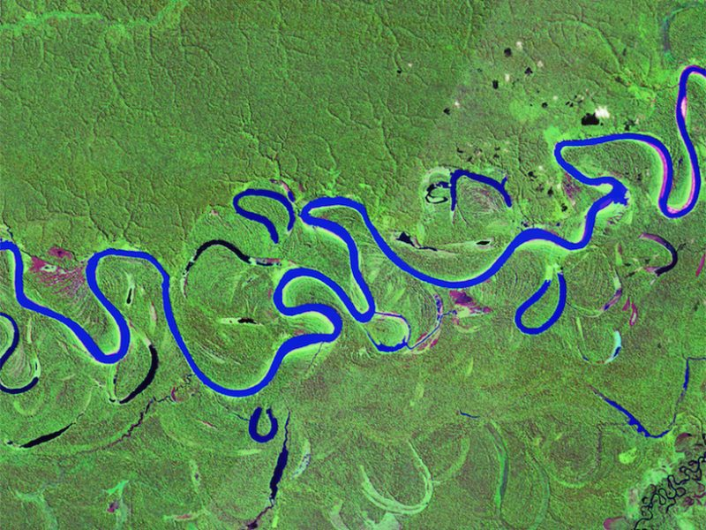Meanders in Brazil’s Juruá River, a tributary of the Amazon. A new model of meanders shows that the scroll bars and oxbow lakes that a river leaves behind after floods can define the future route the river can take. Credit: Landsat, USGS/NASA

By Emily Underwood 2 August 2017

Every time a river floods, it subtly or drastically changes its path. Scientists have long strived to capture this [complex process](https://eos.org/research-spotlights/how-do-tropical-forests-slow-knickpoints-in-rivers) in [mathematical models](https://eos.org/research-spotlights/a-river-runs-through-it-but-why) because it includes many [variables](https://eos.org/research-spotlights/river-gets-width), including the softness or hardness of the soil [the river erodes](https://eos.org/research-spotlights/hillslopes-regulate-sediment-supply-river-channels), [groundwater](https://eos.org/research-spotlights/groundwater-a-hidden-influence-on-river-shape), and the [vegetation](https://eos.org/research-spotlights/aquatic-plants-direct-stalks-grow) within and along its shores.

Now a new computer simulation of how rivers evolve over time comes one step closer to capturing that complexity. The finding could help scientists better predict how floods will remodel a [river’s banks](https://eos.org/research-spotlights/bank-materials-strongly-influence-river-valley-evolution) and affect the people in its path. <https://eos.org/research-spotlights/a-new-model-for-river-meanders>

 "**We need healthy soils to achieve our food security and nutrition goals, to fight climate change and to ensure overall sustainable development."** José Graziano da Silva, FAO Director-General