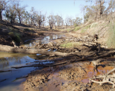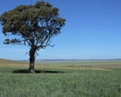

# Warming soils may belch much more carbon

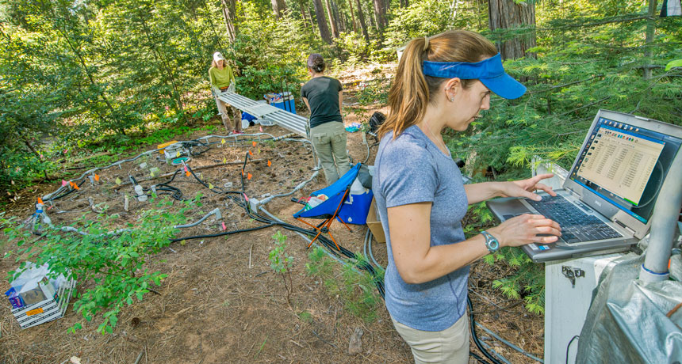

**DEEP DIRT**  Carbon emissions from soils could increase more than previously thought as temperatures go up, a new experiment suggests. Caitlin Hicks Pries (at the computer) and colleagues monitored emissions from a forest plot in the foothills of the Sierra Nevada.

As the planet warms, carbon stashed in Earth’s soils could escape into the atmosphere far faster than previously thought. In the worst-case scenario for climate change, carbon dioxide emissions from soil-dwelling microbes [could increase by 34 to 37 percent by 2100](http://science.sciencemag.org/lookup/doi/10.1126/science.aal1319), researchers report online March 9 in Science. Previous studies predicted a more modest 9 to 12 percent rise if no efforts are taken to curb climate change. Those extra emissions could further intensify global warming. <https://www.sciencenews.org/article/warming-soils-may-belch-much-more-carbon>

# Increased water availability from climate change may release more nutrients into soil in Antarctica

##### 13 March 2017

[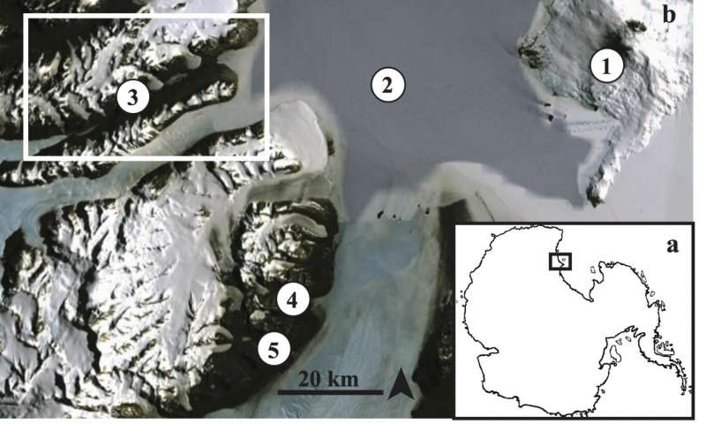](https://3c1703fe8d.site.internapcdn.net/newman/gfx/news/hires/2017/increasedwat.jpg)

Fig. 1. Map of study locations. a. Location of study area on the Antarctic continent. b. Location of places mentioned in the study: Ross Island (1), McMurdo Sound (2), Taylor Valley (3; box shows location of c.), Garwood Valley (4) and …more

As climate change continues to impact the Antarctic, glacier melt and permafrost thaw are likely to make more liquid water available to soil and aquatic ecosystems in the McMurdo Dry Valleys, potentially providing a more nutrient-rich environment for life, according to a Dartmouth study recently published in *Antarctic Science*.

Read more at: <https://phys.org/news/2017-03-availability-climate-nutrients-soil-antarctica.html#jCp>

# Multi-year study finds 'hotspots' of ammonia over world's major agricultural areas

##### 16 March 2017

[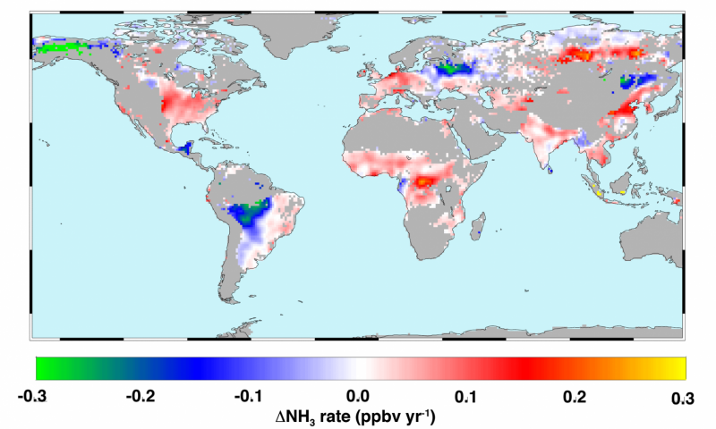](https://3c1703fe8d.site.internapcdn.net/newman/gfx/news/hires/2017/multiyearstu.png)

This map shows global trends in atmospheric ammonia (NH3) as measured from space from 2002 to 2016. Hot colors represent increases due to a combination of increased fertilizer application, reduced scavenging by acid aerosols and climate …more

The first global, long-term satellite study of airborne ammonia gas has revealed "hotspots" of the pollutant over four of the world's most productive agricultural regions. Using data from NASA's Atmospheric Infrared Sounder (AIRS) satellite instrument, the University of Maryland-led research team discovered steadily increasing ammonia concentrations from 2002 to 2016 over agricultural centers in the United States, Europe, China and India. Increased atmospheric ammonia is linked to poor air and water quality.

Read more at: <https://phys.org/news/2017-03-multi-year-hotspots-ammonia-world-major.html#jCp>

**Raindrops make soil bacteria take off and fly through air**

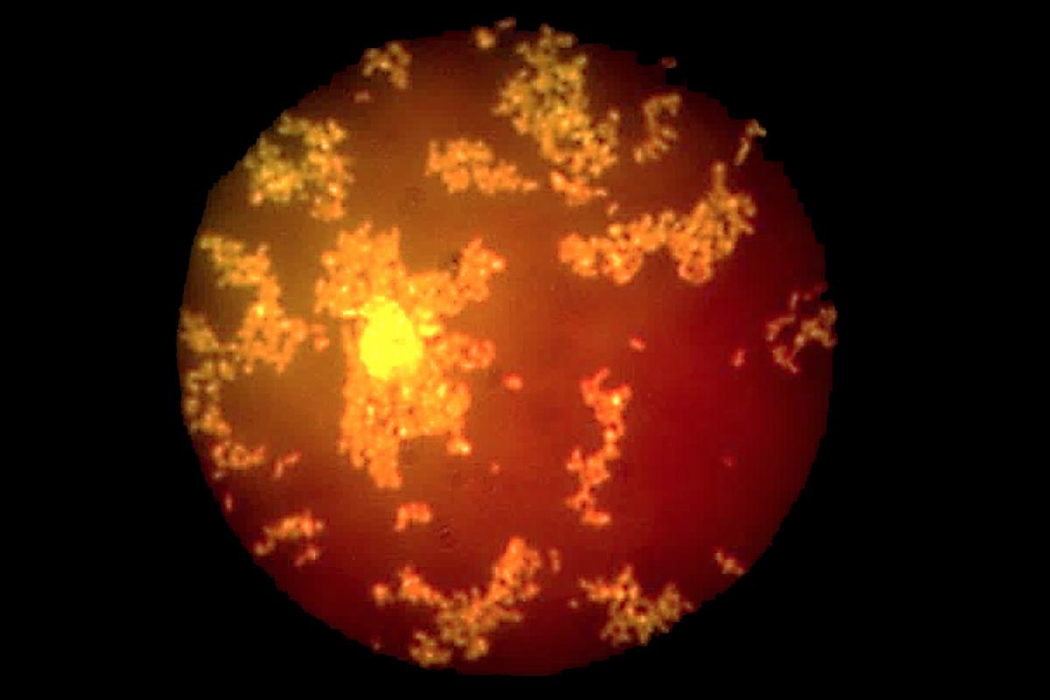

Ready for lift-off

Joung et al. Nature Communications

By Sam Wong

When water falls to the ground, bacteria take to the skies. High-speed camera footage has revealed how raindrops can disperse microbes from the soil into the air in tiny water droplets, possibly allowing them to travel long distances.

Bacteria and other microorganisms are [abundant in the atmosphere](https://www.newscientist.com/article/dn7217-detritus-of-life-abounds-in-the-atmosphere/), affecting the weather and  helping to spread diseases. We knew at least two ways they could get there: wind can lift them into the air from dry soil, and bursting bubbles can expel them from the ocean. <https://www.newscientist.com/article/2123762-raindrops-make-soil-bacteria-take-off-and-fly-through-air/>

# Changing climate could worsen foods’ nutrition

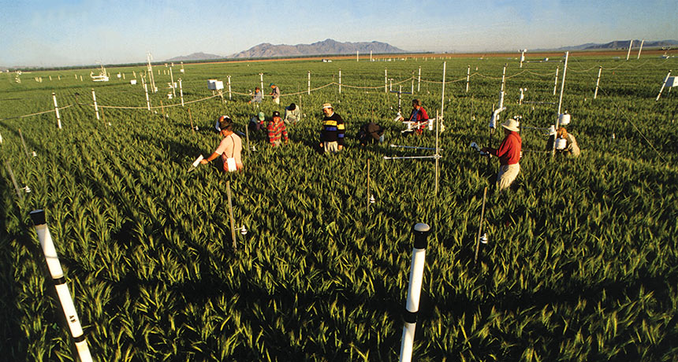

**CROP FUTURES**  Experiments using circles of white pipes blowing extra carbon dioxide over crops suggest that certain nutrients may dwindle in crops grown in a carbon-enhanced future atmosphere. Here, researchers in Arizona measure the growth of wheat.

A dinner plate piled high with food from plants might not deliver the same nutrition toward the end of this century as it does today. Climate change could shrink the mineral and protein content of wheat, rice and other staple crops, mounting evidence suggests. <https://www.sciencenews.org/article/changing-climate-could-worsen-foods-nutrition>

## Soils For Life focuses on capturing more rain through better land management

Lara Webster, Monday March 6, 2017 - 15:25 EDT

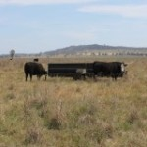

Soils For Life believe the rain drops that are evaporating can be used for things like extra vegetation. - ABC

How do you capture every rain drop from the sky, how is it possible and what difference would that make for our farmers?   
  
The Soils For Life organisation is determined to work out how it can capture more rain for Australian farmers and the landscape.  
  
Their work is based on the 100-drop scenario developed by a scientist called Walter Jehne, as explained by Soils For Life chief of staff Natalie Williams. <http://www.weatherzone.com.au/news/soils-for-life-focuses-on-capturing-more-rain-through-better-land-management/525986>

# Frozen soils overlooked as greenhouse gas emitter and reduction opportunity

UM Today

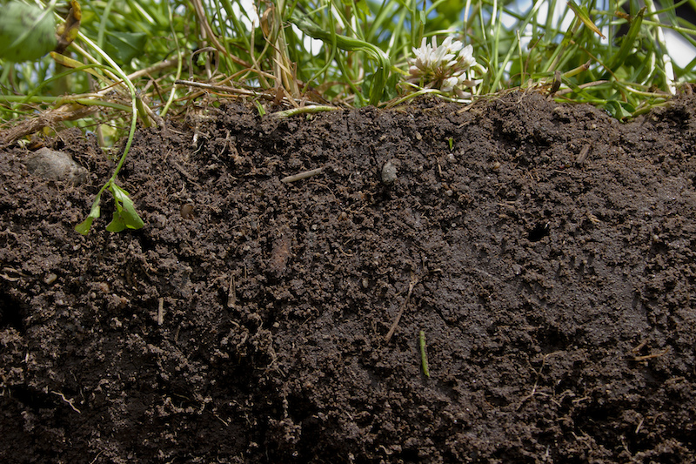

Photo: Natural Resources Conservation Service Soil Health Campaign

## New Canadian study shows we need to recalculate global greenhouse gas emissions

10 March 2017

Global greenhouse emission calculations have overlooked an aspect of the agriculture sector and emissions may in fact be about 17 to 28 per cent greater for cultivated soils frozen in winter than currently thought, a new paper suggests.

Mario Tenuta, Professor in Applied Soil Ecology at the University of Manitoba, and his colleagues from the University of Guelph led by Claudia Wagner-Riddle, published their findings in Nature Geoscience this week.

Their paper, “[Globally important nitrous oxide emissions from croplands induced by freeze–thaw cycles](http://www.nature.com/ngeo/journal/vaop/ncurrent/full/ngeo2907.html)”, argues that current calculation do not account for freeze-thaw emissions. <http://news.umanitoba.ca/an-overlooked-contribution-to-of-greenhouse-gas-emissions-from-soils/>

# Micro-organisms will help African farmers: Soil microbes to the rescue

##### 14 March 2017

[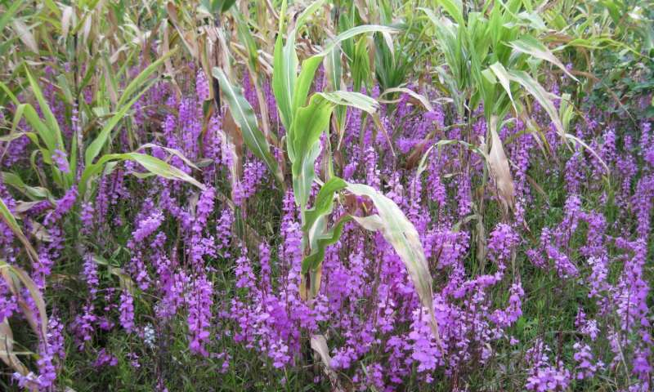](https://3c1703fe8d.site.internapcdn.net/newman/gfx/news/hires/2017/microorganis.jpg)

The parasitic weed Striga severely reduces crop yield in sub-Saharan Africa. Credit: Taye Tessema / Ethiopian Institute of Agricultural Research (EIAR)

Sorghum is the fifth most important cereal in the world. In sub-Saharan Africa, many farmers rely on this grain for food and feed. But Striga, a parasitic weed, can have a devastating impact on crop yield. With an 8-million-dollar grant from the Bill & Melinda Gates Foundation, an international team will now explore the potential of soil microbes to offer crop protection. The Netherlands Institute of Ecology (NIOO-KNAW) is coordinating this 5-year project.

Read more at: <https://phys.org/news/2017-03-micro-organisms-african-farmers-soil-microbes.html#jCp>

# Phosphorus is vital for life on Earth – and we're running low

##### 16 March 2017 by Vera Thoss, The Conversation

[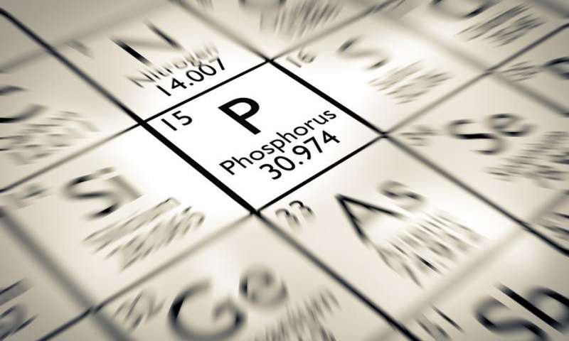](https://3c1703fe8d.site.internapcdn.net/newman/gfx/news/hires/2017/phosphorusis.jpg)

The stuff of life. Credit: Shutterstock

[Phosphorus](http://www.rsc.org/periodic-table/element/15/phosphorus) is an essential element which is contained in many cellular compounds, such as DNA and the [energy carrier ATP](http://hyperphysics.phy-astr.gsu.edu/hbase/Biology/atp.html). All life needs phosphorus and agricultural yields are improved when phosphorus is added to growing plants and the diet of livestock. Consequently, it is used globally as a fertiliser – and plays an important role in meeting the world's food requirements.

Read more at: <https://phys.org/news/2017-03-phosphorus-vital-life-earth-runninglow.html#jCp>

# Enzymes aid rice plants’ arsenic defenses

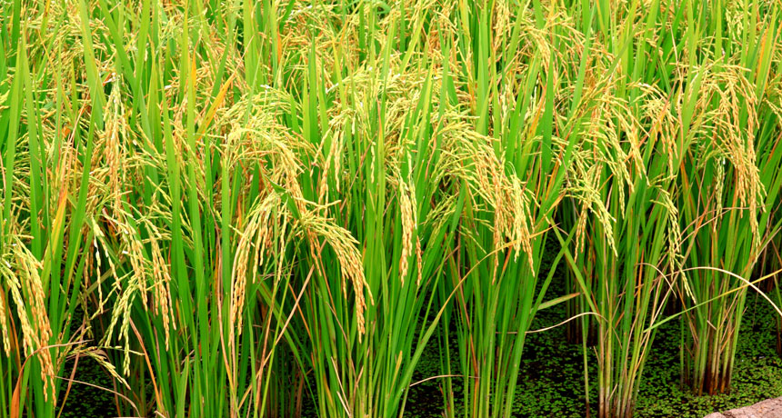

**DETOX**  Rice plants can convert arsenic to a different form in their roots to push the toxic element back into the soil.

**BOSTON** — Rooted in place, plants can’t run away from arsenic-tainted soil — but they’re far from helpless. Scientists have identified enzymes that help rice plant roots tame arsenic, converting it into a form that can be pushed back into the soil. That [leaves less of the toxic element to spread](https://aaas.confex.com/aaas/2017/webprogram/Paper19263.html) into the plants’ grains, where it can pose a health risk to humans, researchers reported February 17 at the annual meeting of the American Association for the Advancement of Science.

<https://www.sciencenews.org/article/enzymes-aid-rice-plants-arsenic-defenses>

# Climate change to worsen drought, diminish corn yields in Africa

##### 16 March 2017 by Jennifer Chu

[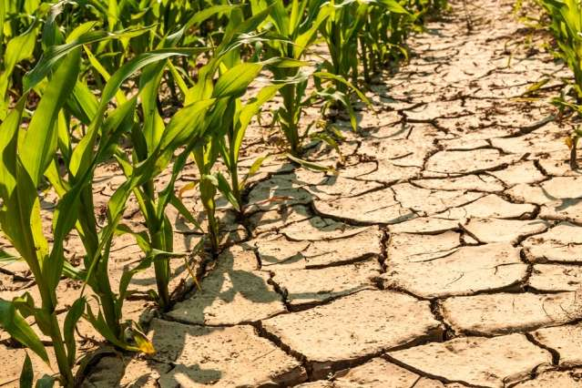](https://3c1703fe8d.site.internapcdn.net/newman/gfx/news/2017/18-climatechang.jpg)

MIT scientists have found that climate change will likely worsen drought conditions in parts of Africa, dramatically reshaping the production of maize throughout sub-Saharan Africa as global temperatures rise over the next century. Credit: Massachusetts Institute of Technology

Nearly 25 percent of the world's malnourished population lives in sub-Saharan Africa, where more than 300 million people depend on corn, or maize, as their main food source. Maize is the most widely harvested agricultural product in Africa and is grown by small farmers who rely heavily on rainwater rather than irrigation. The crop is therefore extremely sensitive to drought, and since 2015 its production has fallen dramatically as a result of record-setting drought conditions across southern and eastern Africa.

Read more at: <https://phys.org/news/2017-03-climate-worsen-drought-diminish-corn.html#jCp>

# Scientists studying how to make poorer soils perform better

## **The work is in response to a growing problem of the loss of prime farmland to urbanization**

AddThis Sharing Buttons

Share to FacebookShare to TwitterShare to EmailShare to PinterestShare to More

By [Alex Binkley](https://www.manitobacooperator.ca/contributor/alex-binkley/) [FOLLOW](https://www.manitobacooperator.ca/news-opinion/news/scientists-studying-how-to-make-poorer-soils-perform-better/)

Published: 7 March 2017

[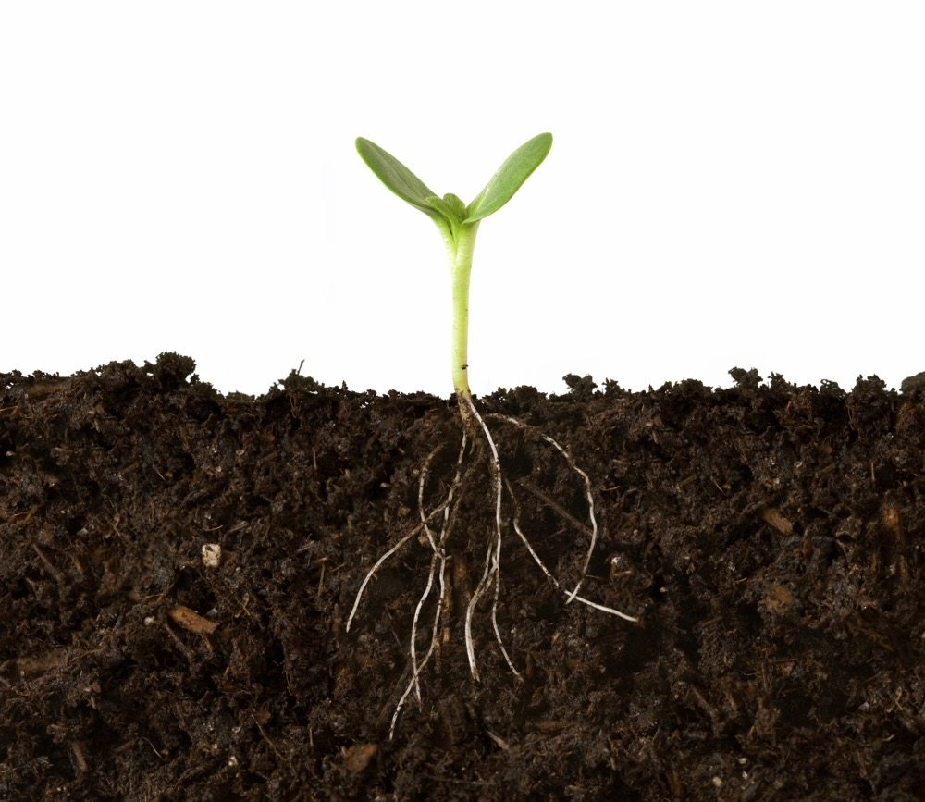](https://static.agcanada.com/wp-content/uploads/sites/5/2016/04/soil-roots-98274521-thinkstock.jpg)

*Photo: Thinkstock*

As Canada steadily loses top-quality farmland to urban sprawl, Agriculture Canada scientists are studying ways to make poorer soils perform better in co-operation with foreign researchers.

Brian Gray, assistant deputy minister for science and technology, told the Senate agriculture committee the work will help feed an expected global population of 9.5 billion in 2050. <https://www.manitobacooperator.ca/news-opinion/news/scientists-studying-how-to-make-poorer-soils-perform-better/>

# Future climate change will affect plants and soil differently

##### 7 March 2017

[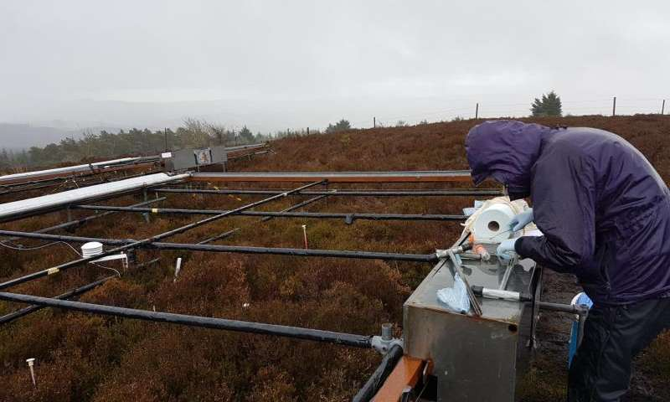](https://3c1703fe8d.site.internapcdn.net/newman/gfx/news/hires/2017/futureclimat.jpg)

Data collection from Cloceanog forest, Wales. Credit: Rachel Harvey

A new European study has found that soil carbon loss is more sensitive to climate change compared to carbon taken up by plants. In drier regions, soil carbon loss decreased but in wetter regions soil carbon loss increased. This could result in a positive feedback to the atmosphere leading to an additional increase of atmospheric CO2 levels.

Read more at: <https://phys.org/news/2017-03-future-climate-affect-soil-differently.html#jCp>

# Microbes survived inside giant cave crystals for up to 50,000 years

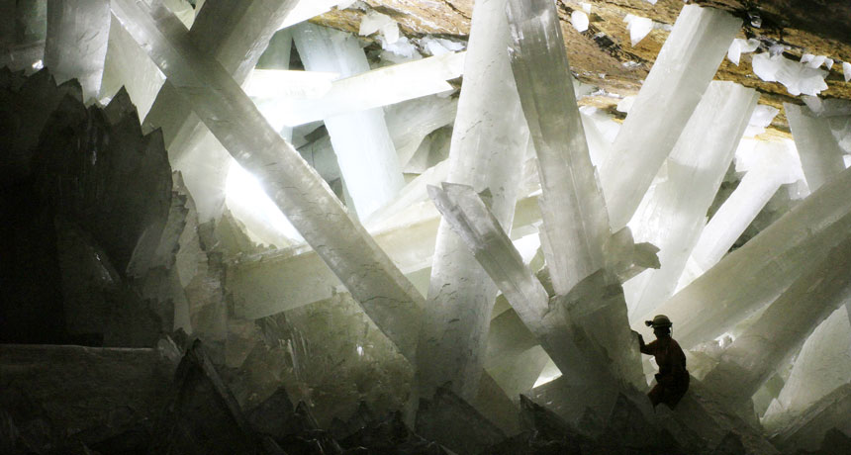

**IN DEEP**Samples from fluid pockets in crystals inside Mexico's Naica mine in Chihuahua revealed life-forms that may have been trapped in the minerals for up to 50,000 years.

**BOSTON**— Microbes found stowed inside giant crystals in caves in Chihuahua, Mexico, may have survived there for tens of thousands of years. The microorganisms, which appear to be vastly different from nearly all life-forms found on Earth, offer a good indication of how resilient life can be in extremely harsh environments, including those found on other planets. <https://www.sciencenews.org/article/microbes-survived-inside-giant-cave-crystals-50000-years>

# Earth's first example of recycling—its own crust

##### 16 March 2017

[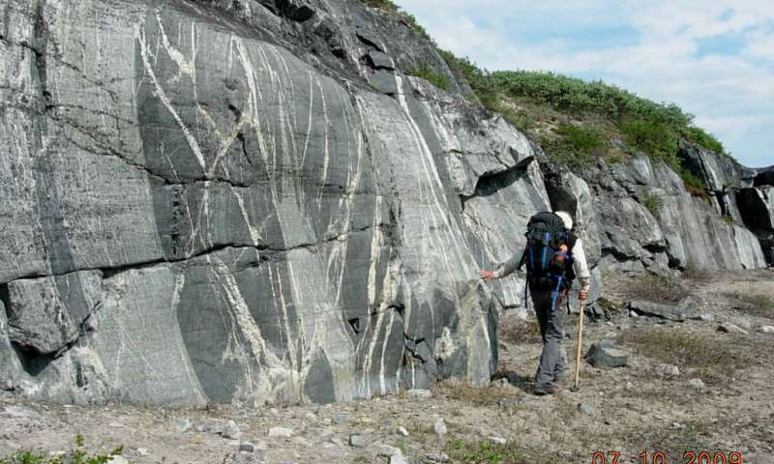](https://3c1703fe8d.site.internapcdn.net/newman/gfx/news/hires/2017/earthsfirste.jpg)

Photograph of the ancient crust such as these found along the eastern shores of the Hudson Bay. Credit: Rick Carlson.

Rock samples from northeastern Canada retain chemical signals that help explain what Earth's crust was like more than 4 billion years ago, reveals new work from Carnegie's Richard Carlson and Jonathan O'Neil of the University of Ottawa. Their work is published by *Science*.

Read more at: <https://phys.org/news/2017-03-earth-recyclingits-crust.html#jCp>

# Copper-bottomed deposits

##### 15 March 2017

[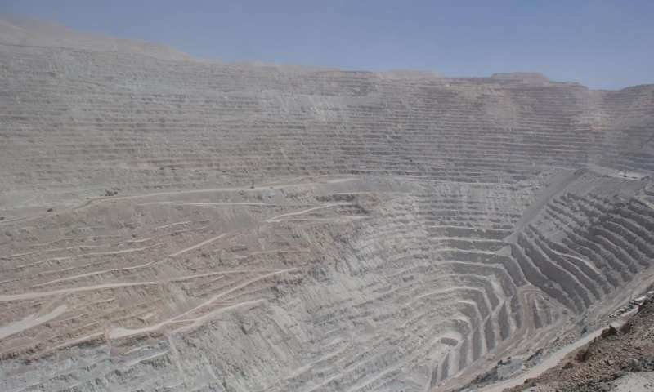](https://3c1703fe8d.site.internapcdn.net/newman/gfx/news/hires/2017/copperbottom.jpg)

Chuquicamata, in Chile, is amongst the largest copper deposits in the world. Credit: © M. Chiaradia, UNIGE

The world's most valuable copper deposits, known as porphyry deposits, originate from cooling magma. But how can we predict the size of these deposits? What factors govern the amount of copper present? Researchers at the University of Geneva (UNIGE), Switzerland, have studied over 100,000 combinations to establish the depth and number of years required for magma to produce a given amount of copper. The same scientists have also devised a model that can detect the quantity of copper held in a deposit by means of a simple factor analysis. The research, which is published in the journal *Scientific Reports*, will make it possible to estimate the potential for mining the metal before beginning any drilling. It is a model that will undoubtedly be of great benefit to mining companies.

Read more at: <https://phys.org/news/2017-03-copper-bottomed-deposits.html#jCp>

Improving defence against earthquakes and tsunamis

10 March 2017

[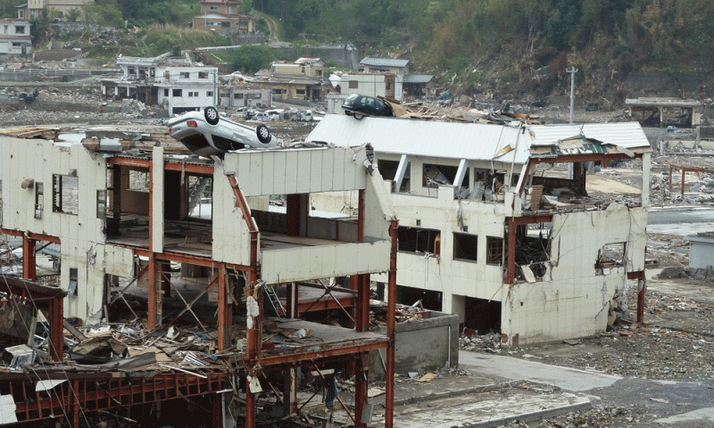](https://3c1703fe8d.site.internapcdn.net/newman/gfx/news/hires/2017/improvingdef.gif)

A pioneering new computer model has been developed to simulate the whole chain of hazard events triggered by offshore mega subduction earthquakes, by a team involving UCL and Bristol engineers.

Read more at: <https://phys.org/news/2017-03-defence-earthquakes-tsunamis.html#jCp>

RHS soil survey will promote effective reuse of in-situ soils

[](https://www.landscapeinstitute.org/wp-content/uploads/2017/02/RHS-Garden-Bridgewater-Tom-Stuart-Smith.jpg)Design for walled garden at RHS Garden Bridgewater, by Tom Stuart-Smith

Soil scientists at Tim O’Hare Associates (TOHA) are carrying out a comprehensive soil resource survey for the proposed RHS Garden Bridgewater, Salford, that could see fertile soils relocated to the areas of the site where they will be most needed. The survey will be used as an exemplar case study for the sustainable reuse and management of soils <https://www.landscapeinstitute.org/news/rhs-soil-survey/>

**"Thirty-six drops go into the landscape itself, of that 30 go to vegetation, keeping grass green and trees growing and only six of those drops go into recharging the aquifers."**

**Soils For Life chief of staff Natalie Williams**