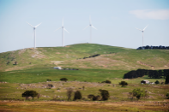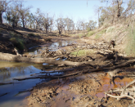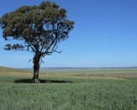Dingo control is damaging Australian soils, say university researchers
By Sally Bryant
Posted 11 May 2017 at 2:27 pm

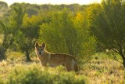

Control of this apex predator is said to have far-reaching impacts on soil health in inland Australia.

(Supplied UNSW: Anna Normyle)
Trapping, baiting and fencing against dingoes is depleting Australia's soils, according to university research released this week.
The University of New South Wales study has found dingo controls have resulted in a boom in kangaroo numbers, with more wide-reaching environmental effects than previously thought.
Associate Professor Mike Letnic said the impact extended beyond the implications for other flora and fauna of the region. http://www.abc.net.au/news/rural/2017-05-11/dingo-control-is-damaging-australian-soils/8517252

Soil organic carbon predicted to plummet over next 60 years lowering agricultural productivity
Climate change could reduce the amount of carbon stored in soil in the Mediterranean region by a third over the next 60 years, according to research undertaken at the University of Cordoba. This in turn could drive up food prices and endanger crop production in the region as soils become poorer and more and more fertiliser is needed to keep yields up.
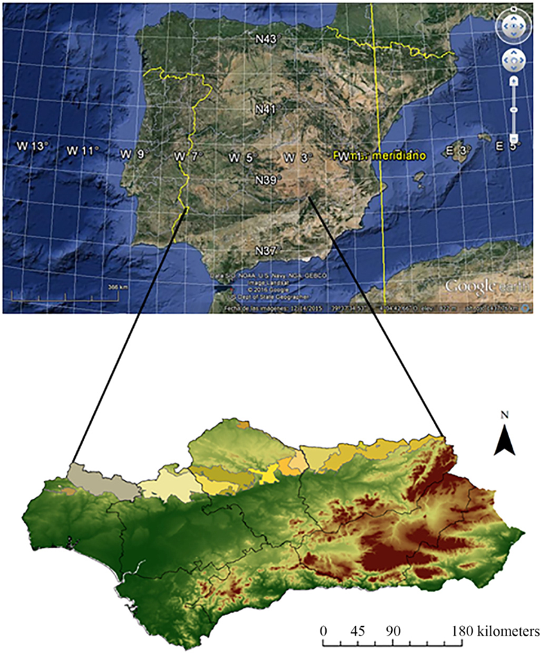
Source: © Elsevier – from Science of the Total Environment 592 (2017) 134–143
Over 600 soil samples were taken from across the Sierra Morena region in Spain. The results show cause for concern on food production in the region over the next 60 years
https://www.chemistryworld.com/news/changing-climate-to-wreak-havoc-on-mediterranean-soils/3007280.article

Who is wilt-free? Farmers with organic-rich, water-holding soils, that's who
As climate change alters rainfall, UK farms with heavily irrigated crops on chemically fed soil may learn from organic growers
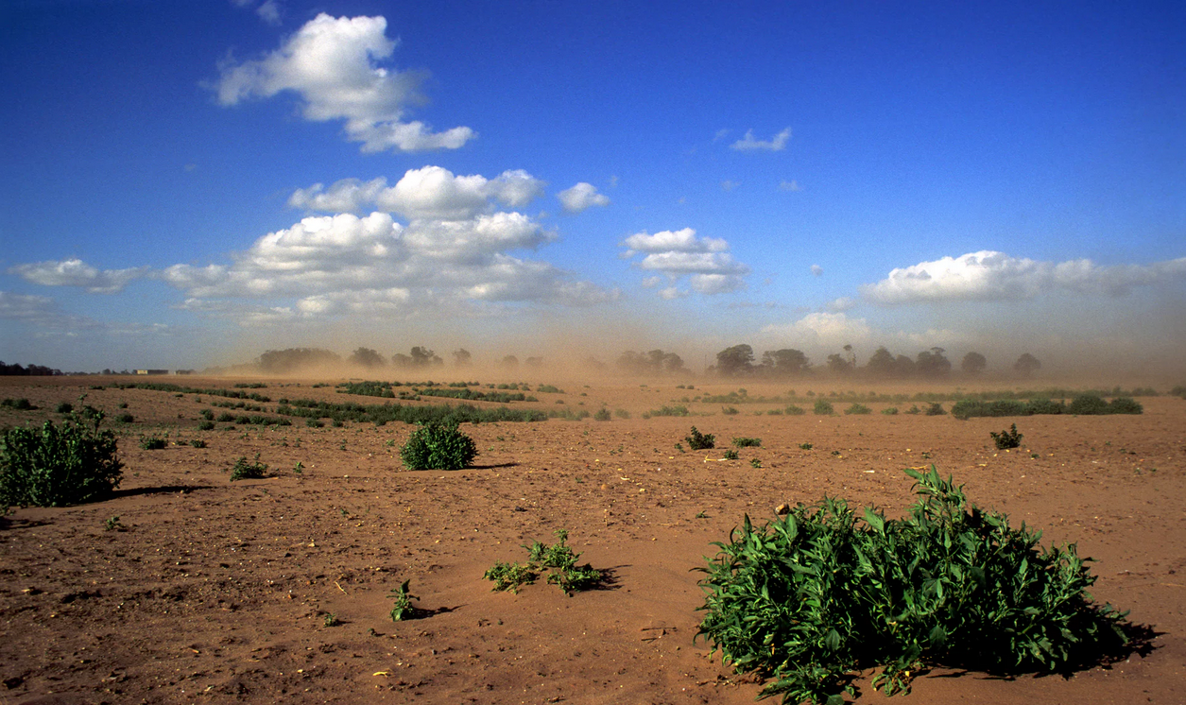
Erosion of thin soil in Suffolk, UK. Farmers with soil holding plenty of organic matter may benefit from a lower fertiliser bill, reduced flooding and less need for irrigation. Photograph: Alamy
Paul Brown
Wednesday 7 June 2017 06.30 AESTLast modified on Wednesday 7 June 201707.00 AEST
Long-term success for farmers depends on how they treat their soil, especially as climate change is making rainfall patterns more unreliable.
The make-up of soils varies enormously, sometimes from one field to another. Clay, which holds four times as much water as coarse light sand, can be a big advantage, but with too much rain can become waterlogged, leading to drowned crops. Clay soils also compress under heavy farm machinery. https://www.theguardian.com/news/2017/jun/06/who-is-wilt-free-farmers-with-organic-rich-water-holding-soils-thats-who
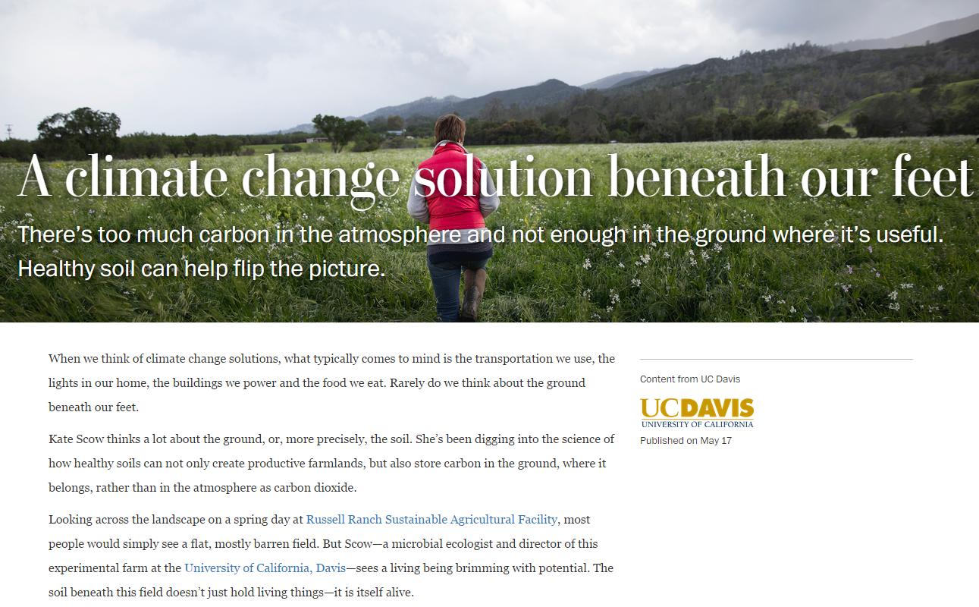
http://www.washingtonpost.com/sf/brand-connect/ucdavis/a-climate-change-solution-beneath-our-feet/
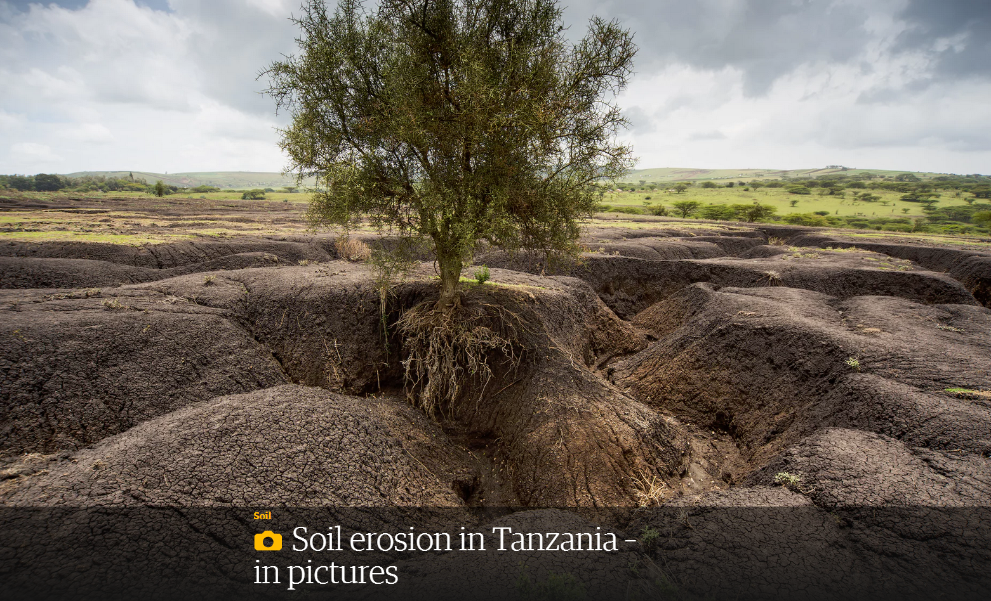
https://www.theguardian.com/environment/gallery/2017/may/04/soil-erosion-in-tanzania-in-pictures

Microscopic soil creatures could orchestrate massive tree 'migrations'
Date:
8 May 2017
Source:
University of Tennessee at Knoxville
Summary:
Warming temperatures are prompting some tree species in the Rocky Mountains to 'migrate' to higher elevations in order to survive. Researchers have discovered that tiny below-ground organisms play a role in this phenomenon -- and could be used to encourage tree migration in order to preserve heat-sensitive species. Their work shows how these invisible biotic communities create 'soil highways' for young trees, meaning they could determine how quickly species march uphill, if at all.

Warming temperatures are prompting some tree species in the Rocky Mountains to "migrate" to higher elevations in order to survive.
Researchers at the University of Tennessee, Knoxville, have discovered that tiny below-ground organisms play a role in this phenomenon -- and could be used to encourage tree migration in order to preserve heat-sensitive species. Their work shows how these invisible biotic communities create "soil highways" for young trees, meaning they could determine how quickly species march uphill, if at all. https://www.sciencedaily.com/releases/2017/05/170508184902.htm

Does ploughing actually damage soils and crops?

David Gregory-KumarScience, Environment & Rural Affairs Correspondent
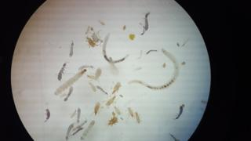Image copyright HARPER ADAMS UNIVERSITY Image caption Under the microscope you can see the huge range of organisms living in the soil
A tractor dragging a plough through rich soil and breaking it open is one of the most familiar images of farming. But is this most traditional of agricultural activities doing more harm than good?
All last year we followed farmer Jake Freestone as he stopped ploughing on his farm in the Cotswolds. http://www.bbc.com/news/uk-england-40166313

Phosphorus is vital for life on Earth – and we’re running low

More than 70% of the global phosphorus supply comes from a single location. Scientists are warning that we are approaching the point at which demand begins to outstrip supply. So how worried should we be?

Phosphorus is an essential element which is contained in many cellular compounds, such as DNA and the energy carrier ATP. All life needs phosphorus and agricultural yields are improved when phosphorus is added to growing plants and the diet of livestock. Consequently, it is used globally as a fertiliser – and plays an important role in meeting the world’s food requirements.
RECOMMENDED
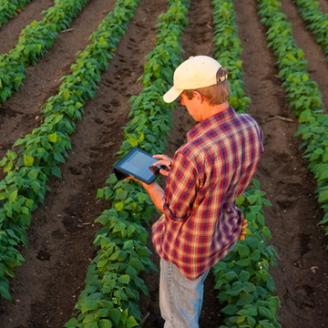

Physicists help deliver precision to paddocks

PHYSICS

In order for us to add it, however, we first need to extract it from a concentrated form – and the supply comes almost exclusively fromphosphate mines in Morocco (with far smaller quantities coming from China, the US, Jordan and South Africa). Within Morocco, most of the mines are inWestern Sahara, a former Spanish colony which was annexed by Morocco in 1975. https://cosmosmagazine.com/chemistry/phosphorus-is-vital-for-life-on-earth-and-we-re-running-low

Slow-freezing Alaska soil driving surge in carbon dioxide emissions
Northern tundra’s autumn carbon dioxide emissions increased 70% between 1975 and 2015, researchers find, blaming warming temperatures
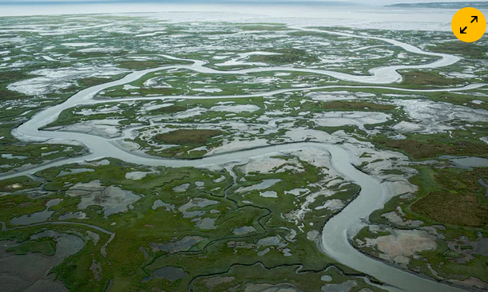

The soils of Alaska’s tundra are taking longer to freeze over than in past decades. Photograph: Andrew Burton/Getty Images
Oliver Milman

@olliemilman

Tuesday 9 May 2017 05.00 AESTLast modified on Wednesday 10 May 201722.22 AEST
Alaska’s soils are taking far longer to freeze over as winter approaches than in previous decades, resulting in a surge in carbon dioxide emissions that could portend a much faster rate of global warming than scientists had previously estimated, according to new research. https://www.theguardian.com/us-news/2017/may/08/alaska-climate-change-tundra-soil-carbon-dioxide

Fossil find pushes back birth of modern humans by 100,000 years

300,000-year-old Homo sapiens remains discovered in Morocco will change our understanding of human evolution and migration, writes Andrew Masterson.

SHARE
TWEET
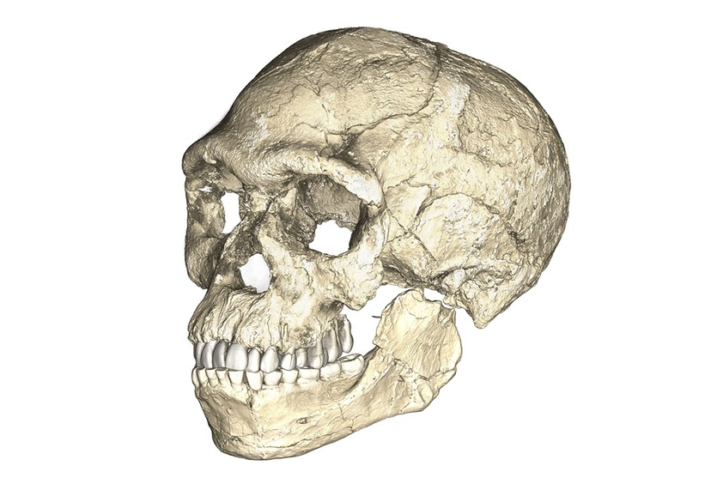
A composite reconstruction of the earliest known Homo sapiens fossils from Jebel Irhoud (Morocco) based on micro computed tomographic scans of multiple original fossils.
PHILIPP GUNZ, MPI EVA LEIPZIG
The discovery of modern human remains dating to 300,000 years ago looks set to overturn many current models of the evolution and migration of Homo sapiens. https://cosmosmagazine.com/archaeology/fossil-find-pushes-back-birth-of-modern-humans-by-100-000-years

Hidden landscapes of the deep sea floor

Advanced scientific imaging has allowed scientists to capture stunning images of patterns and movement etched into the seafloor, writes Sarah Condie.

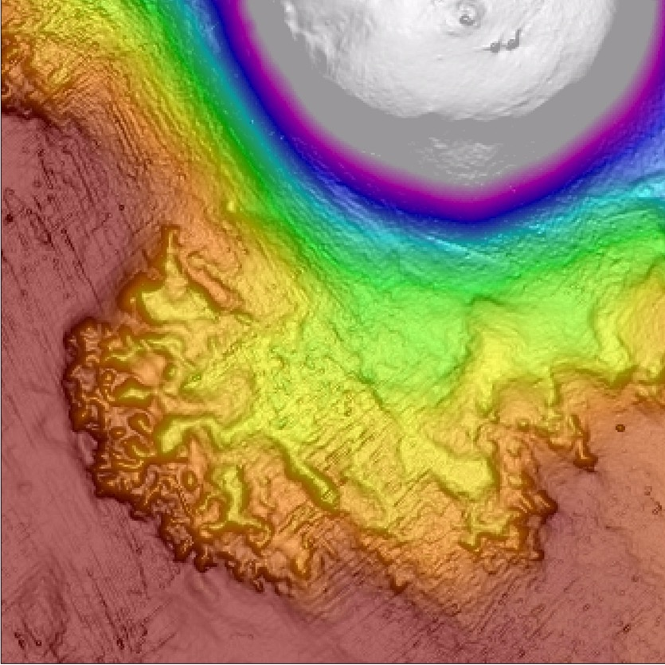
Scientific imaging captured lava flowing from a recent submarine volcanic eruption, taking the form of a brain in its complexity and shape.
VISUAL SOUNDINGS
Human kind has explored the surface of the moon, documenting craters and studying rock formations. Thanks to NASA’s rovers, we’ve even gone as far as Mars, familiarising ourselves with the appearance of the dusty red planet. But, only five percent of the world’s oceans have been mapped in any detail. There’s a whole world beneath us, supporting human life, that remains a mystery. https://cosmosmagazine.com/geoscience/the-hidden-landscapes-of-the-deep-sea-floor
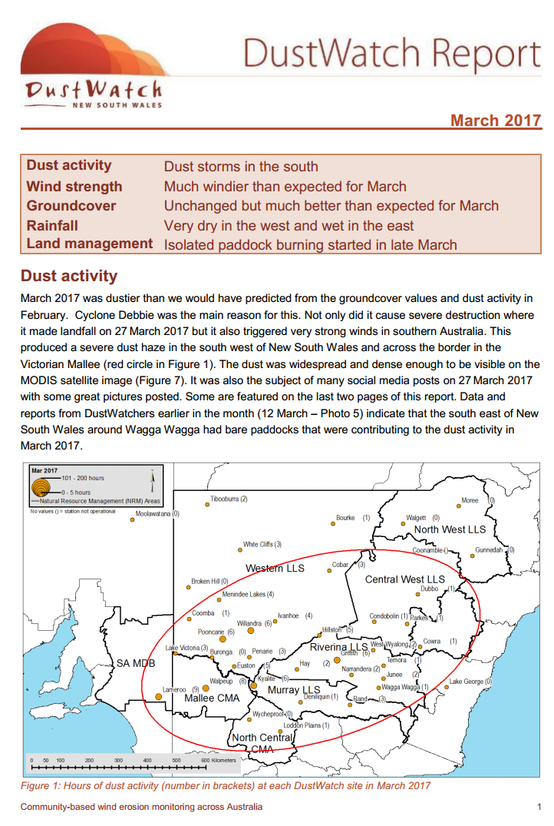
http://www.environment.nsw.gov.au/resources/dustwatch/170003DWNL.pdf

A Swiss-cheese Martian landscape

The low summer Sun highlights subtle features of the Martian landscape.

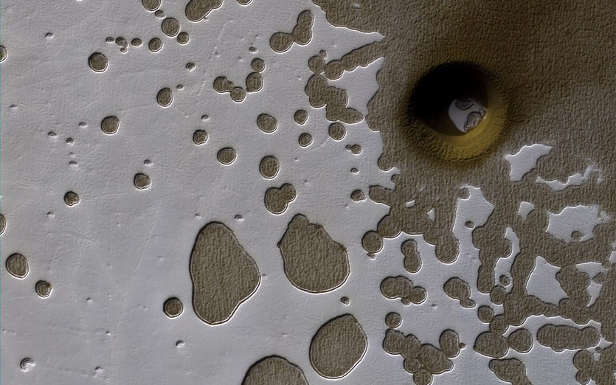
A thin crust of carbon dioxide ice covers ground near the South Pole of Mars.
NASA / JPL-CALTECH / UNIV. OF ARIZONA
In this photo by NASA’s Mars Reconnaissance Orbiter, it is summer in the red planet’s southern hemisphere. The Sun hangs low in the Martian sky and strikes the ground at an oblique angle, throwing small variations in topography into sharp relief. https://cosmosmagazine.com/space/a-swiss-cheese-martian-landscape

Peatlands, already dwindling, could face further losses

Climate change could damage the fragile zones, causing major carbon emissions
Date:
12 June 2017
Source:
Massachusetts Institute of Technology
Summary:
Tropical peatlands have been disappearing fast due to clear-cutting and drainage projects. Now, new research shows peatlands face another threat, as climate change alters rainfall patterns, potentially destroying much of what remains and turning these carbon sinks into net carbon sources.
Share:
FULL STORY

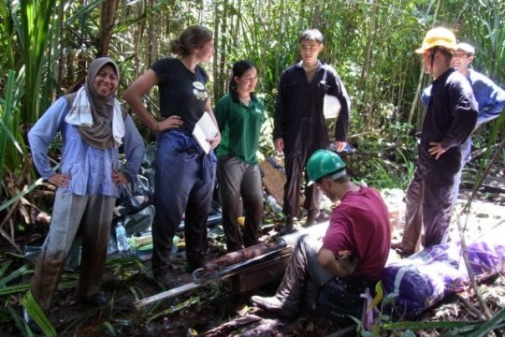
Researchers have found one of the last undisturbed tropical peat forests, in the nation of Brunei on the island of Borneo.
Credit: Courtesy of the researchers

Tropical peat swamp forests, which once occupied large swaths of Southeast Asia and other areas, provided a significant "sink" that helped remove carbon dioxide from the atmosphere. But such forests have been disappearing fast due to clear-cutting and drainage projects making way for plantations. Now, research shows peatlands face another threat, as climate change alters rainfall patterns, potentially destroying even forested peatlands that remain undrained.
Journal Reference:
- Alexander R. Cobb, Alison M. Hoyt, Laure Gandois, Jangarun Eri, René Dommain, Kamariah Abu Salim, Fuu Ming Kai, Nur Salihah Haji Su’ut, Charles F. Harvey. How temporal patterns in rainfall determine the geomorphology and carbon fluxes of tropical peatlands. Proceedings of the National Academy of Sciences, 2017; 201701090 DOI: 10.1073/pnas.1701090114

https://www.sciencedaily.com/releases/2017/06/170612153604.htm

Naracoorte, where half a million years of biodiversity and climate history are trapped in caves

The Naracoorte caves have captured more than just animal fossils, clues to the past environment are also preserved in plant fossils, sediments and calcite formations.

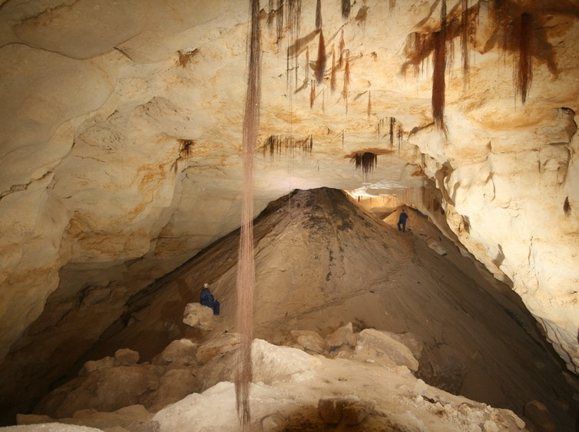Enormous sediment cones in a cave at Naracoorte. Two people in overalls show the scale of the area. Steven Bourne, Author provided
In 1857, guided by the flickering light of a candle deep in a cave at Naracoorte in South Australia, the Reverend Julian Tenison-Woods stumbled across thousands of tiny bones of rodents and small marsupials buried at the base of crystal columns. https://cosmosmagazine.com/climate/naracoorte-where-half-a-million-years-of-biodiversity-and-climate-history-are-trapped-in-caves

Winning climate strategy demands details

Why we need to sweat the small climate stuff
Date:
12 June 2017
Source:
Michigan State University
Summary:
Examining the daily minutia of climate, not just temperature, but also sunshine, precipitation and soil moisture simultaneously all over a country gives a better understanding of how variable a land's climate can be. That information is crucial when countries are setting policies aimed at growing food, protecting water supplies and the environment and stemming disease outbreaks.
Share:
FULL STORY

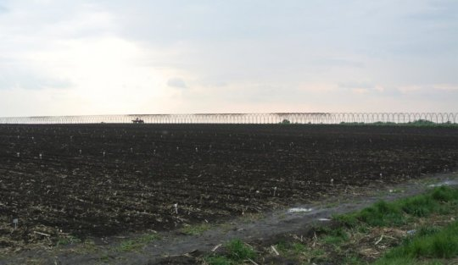
Heilongjiang Province in the far northeastern reaches of China, has been shifting more crops from soybeans to corn, even though emerging variability of weather points to conditions that may not be best for corn's long-growing season.
Credit: Sue Nichols, Center for Systems Integration and Sustainability, Michigan State University

When understanding a country's climate -- especially vast countries like the United States or China -- to protect food security, biodiversity and human health, the devil is in the details.

Journal Reference:
- Zhenci Xu, Ying Tang, Thomas Connor, Dapeng Li, Yunkai Li, Jianguo Liu. Climate variability and trends at a national scale. Scientific Reports, 2017; 7 (1) DOI: 10.1038/s41598-017-03297-5

https://www.sciencedaily.com/releases/2017/06/170612170930.htm

The mysterious bend in the Hawaiian-Emperor chain

8 June 2017
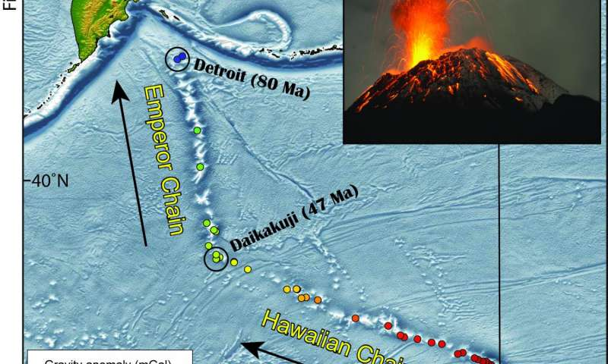
The Hawaiian-Emperor Chain is an example of a hotspot track - a trail of volcanic islands and seamounts created on a lithospheric plate as the plate slowly shifts over a spot of localized melting sourced by a jet of hot material rising from …more
The volcanic islands of Hawaii represent the youngest end of a 80 million years old and roughly 6,000 kilometres long mountain chain on the ground of the Pacific Ocean. The so-called Hawaiian-Emperor chain consisting of dozens of volcanoes is well known for its peculiar 60 degrees bend. The cause for this bend has been heavily debated for decades. One explanation is an abrupt change in the motion of the Pacific tectonic plate, the opposite model states southward drift of the mantle plume that has sourced the chain since its beginning 80 million years ago. Apparently both processes play an important role, shows a new study in Nature Communications, published by a group of scientists from the University of Oslo, German Research Centre for Geosciences GFZ Potsdam, and Utrecht University.
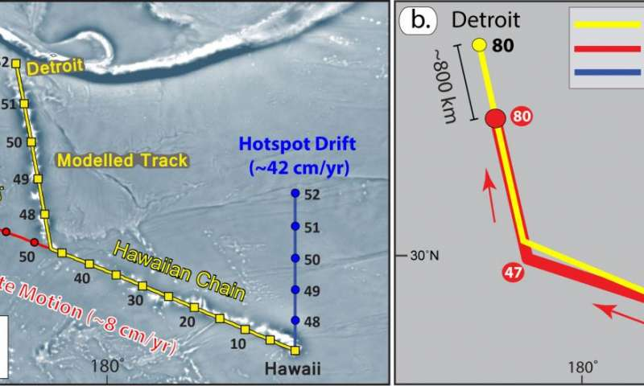
Simulating the Hawaiian-Emperor Bend explains that the bend was formed through changes both of the direction of the lithospheric plates and some motion of the hotspot beneath the plates. Credit: T. Torsvik et al. (GFZ)
"Since the late 1990s it has become clear that hotspots are not totally fixed", says GFZ´s Bernhard Steinberger, one of the co-authors of the paper. That is now generally accepted, he adds, and mantle flow models predict that the Hawaiian hotspot has drifted slowly to the south. "But some recent studies have argued that rapid southward motion of the hotspot before 47 Ma can explain the formation of the bend without requiring Pacific plate motion change", he says. "Such a scenario has become attractive because the geology of the plates surrounding the Pacific shows no clear evidence for a Pacific plate

Read more at: https://phys.org/news/2017-06-mysterious-hawaiian-emperor-chain.html#jCp

How Chinese fossils are rewriting the history of feathered dinosaurs

Paleontologists thought they had a good idea of the diversity of feathered dinosaur species. But a recent finding left them scratching their heads, John Pickrell reports.


With the fossil known as Yi qi, palaeontology has gone from the strange to the bizarre.
LIDA XING / YUJIANG HAN
Since 1996, nearly 50 new feathered dinosaur species have emerged from the fossil fields of China. Paleontologists thought they had a good idea of the diversity of these fluffy carnivores. But a recent finding left them scratching their heads. https://cosmosmagazine.com/palaeontology/jurassic-flight-school

Earliest human impact on geological processes took place 11,500 years ago (Update)

5 June 2017
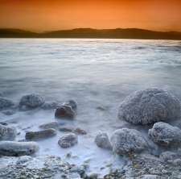
Credit: Tel Aviv University
A new Tel Aviv University study has uncovered the earliest known geological indications of manmade impact on geological processes, in particular erosion of the surface, from 11,500 years ago. Within a core sample retrieved from the Dead Sea, researchers discovered basin-wide erosion rates dramatically incompatible with known tectonic and climatic regimes of the period recorded.
Read more at: https://phys.org/news/2017-06-earliest-manmade-climate-years.html#jCp

Clouds seen from space

This video celebrates the diverse array of clouds that can be seen from space

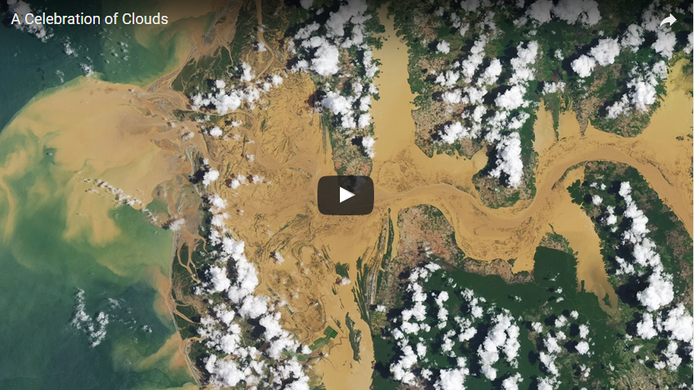
If you were to look down at Earth from space, you’d notice that around two-thirds of its surface would be blanketed by clouds at any time.
While clouds are simply ice and water particles suspended in the atmosphere, they can manifest in a huge range of shapes, sizes, and forms. https://cosmosmagazine.com/geoscience/clouds-seen-from-space

Rice was domesticated in China almost 10,000 years ago

Carbon dating of rice fossils from Shangshan in the Lower Yangtze region shows domestication occurred there at least 9,400 years ago, writes Amy Middleton.

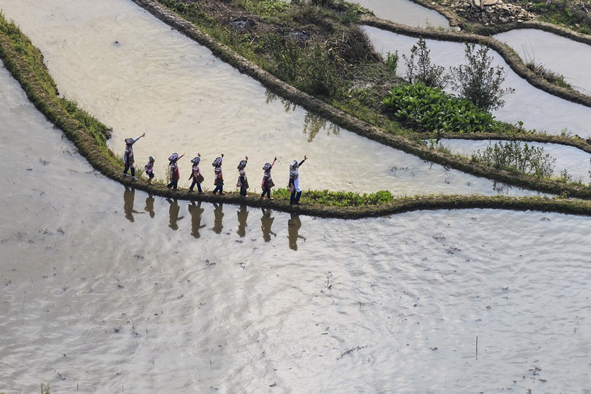
Rice paddies in Yunnan, China.
FABIO NODARI / GETTY
The earliest known domestic rice was cultivated in China as early as 9,400 years ago, at the beginning of the Holocene epoch, according to a new study. https://cosmosmagazine.com/archaeology/rice-was-domesticated-in-china-almost-10-000-years-ago

Thawing permafrost will release powerful greenhouse gas nitrous oxide

New research shows nitrous oxide emissions from the warming Arctic are much greater than previously thought, and will add to climate change and damage the ozone layer. Andrew Masterson reports.

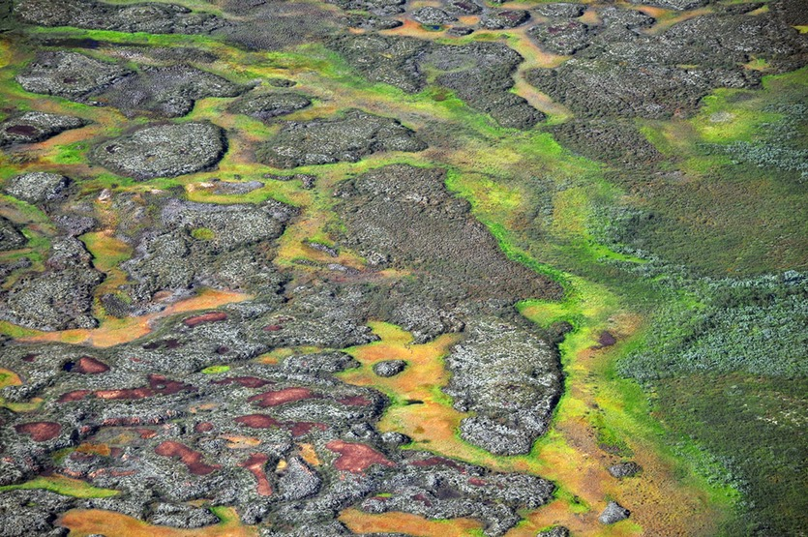
Permafrost peatlands in the Arctic.
TARMO VIRTANEN, UNIVERSITY OF HELSINKI, HELSINKI.
Thawing ground inside the Arctic circle could release as much nitrous oxide (N₂O) into the atmosphere as tropical rainforests – previously the biggest known natural emitter of the powerful global warming gas.
https://cosmosmagazine.com/climate/thawing-permafrost-will-emit-powerful-greenhouse-gas-nitrous-oxide

Peatlands, already dwindling, could face further losses

12 June 2017
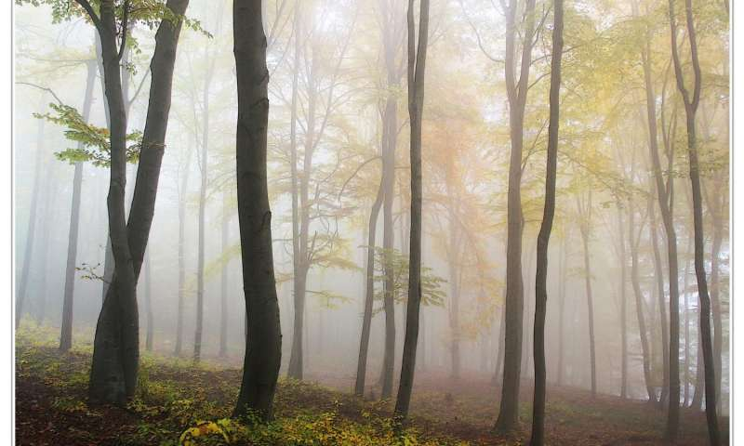
Credit: CC0 Public Domain
Tropical peat swamp forests, which once occupied large swaths of Southeast Asia and other areas, provided a significant "sink" that helped remove carbon dioxide from the atmosphere. But such forests have been disappearing fast due to clear-cutting and drainage projects making way for plantations. Now, research shows peatlands face another threat, as climate change alters rainfall patterns, potentially destroying even forested peatlands that remain undrained.
Read more at: https://phys.org/news/2017-06-peatlands-dwindling-losses.html#jCp

Greenland’s thaw

NASA’s Operation IceBridge monitors the state of the Arctic ice from above.

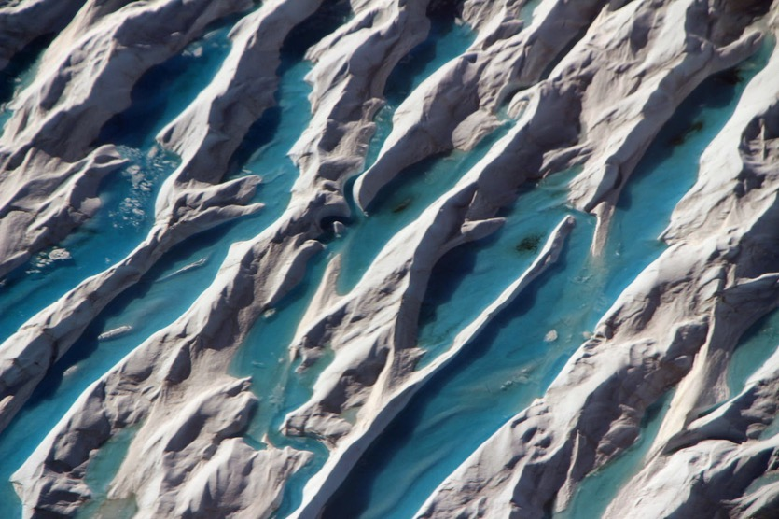
Meltwater in crevasses in southern Greenland, as seen during Operation IceBridge's last flight of the 2017 Arctic campaign, on 11 May 2017.
NASA / JOHN SONNTAG
In a series of 39 flights lasting eight hours each, NASA’s Operation IceBridge – the largest airborne survey of Earth’s polar ice – conducted critical surveys of our planet’s polar regions to trace their changing features. https://cosmosmagazine.com/climate/greenland-s-thaw

Europe’s ancient hunter-gatherers and farmers were intimately connected

Genome sequencing challenges assumptions about ancient lifestyles necessarily being in conflict. Andrew Masterson reports.


A facial reconstruction of one of the subjects of the genetic study.
SERRULLA, F., AND SANÍN, M.
Far from being mutually antagonistic, ancient farmers and hunter-gatherers mixed freely with each other and interbred, new genetic data shows.
https://cosmosmagazine.com/archaeology/europe-s-ancient-hunter-gatherers-and-farmers-were-intimately-connected

Capturing the Earth as art
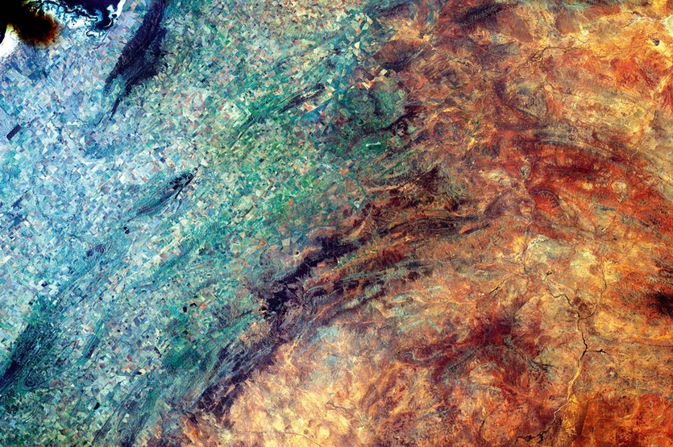
While students learn about space flight, orbital paths, mapping and weather by participating in the EarthKAM program, perhaps it is these snapshots that teach the greatest lesson. From space, differences between nations and groups are rarely discernable. But other fractures are starkly drawn.
We see nature’s organic forms subjugated to the geometric lines of human industry. The conquest is a graphic reminder. “This planet is not terra firma,” as Mercury 7 astronaut Scott Carpenter once said. “It is a delicate flower and it must be cared for.“
Pictured: Australia 33.38° S, 138.90° E Credit: Sally Ride EarthKAM
https://cosmosmagazine.com/geoscience/capturing-the-earth-as-art

Landslide on Mars

A stunning Martian landscape bears traces of a recent landslide and ancient floods.

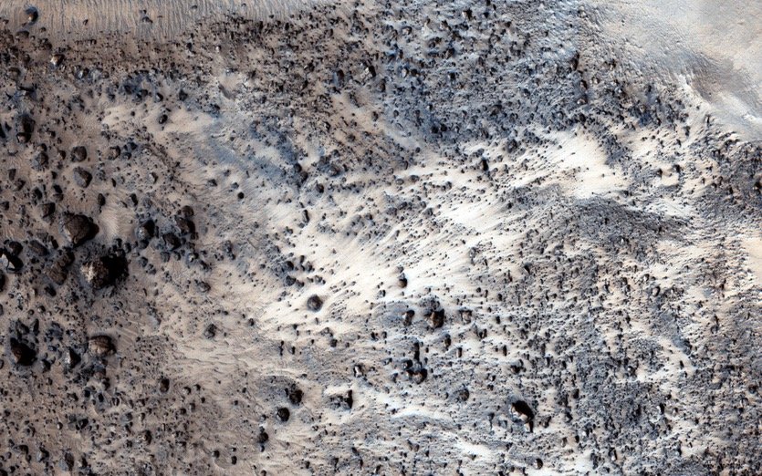
A Martian landscape from orbit.
NASA/JPL-CALTECH/UNIV. OF ARIZONA
This image taken by NASA’s Mars Reconnaissance Orbiter (MRO) shows a fresh (well-preserved) landslide scarp and rocky deposit off the edge of a streamlined mesa in Simud Valles, a giant outflow channel carved by ancient floods. https://cosmosmagazine.com/geoscience/landslide-on-mars

“The situation our soils are in is dire, and it is so important that we listen to the experts and begin changing a number of things if we are to have a healthy, productive planet that can feed the world into the future.” Gerry Gillespie May 2017

