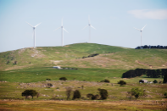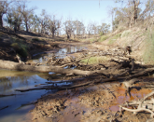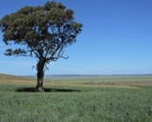

Eight-Year Project to Map and Catalog Soils of L.A. Completed
7 February 2017
This KCET story is viewer-supported.
Share on FacebookShare on TwitterSend EmailMoreComment


City Hall in 1949. | Photo courtesy of the L. Mildred Harris Slide Collection – Los Angeles Public Library

Los Angeles is no longer the largest city in the country without a completed soil survey, the U.S. Department of Agriculture announced today.
The department has concluded an eight-year project creating an inventory of the soil in the southeastern section of Los Angeles County, which includes the city. https://www.kcet.org/news-analysis/eight-year-project-to-map-and-catalog-soils-of-la-completed

https://www.yahoo.com/news/nrcs-california-concludes-eight-mapping-survey-los-angeles-165100276.html

Climate Change Causes Fundamental Shifts in the Chemistry of Mountain Soil
New research says the changes will likely displace some plants altogether and dramatically shift the range of others.
By Bob Berwyn
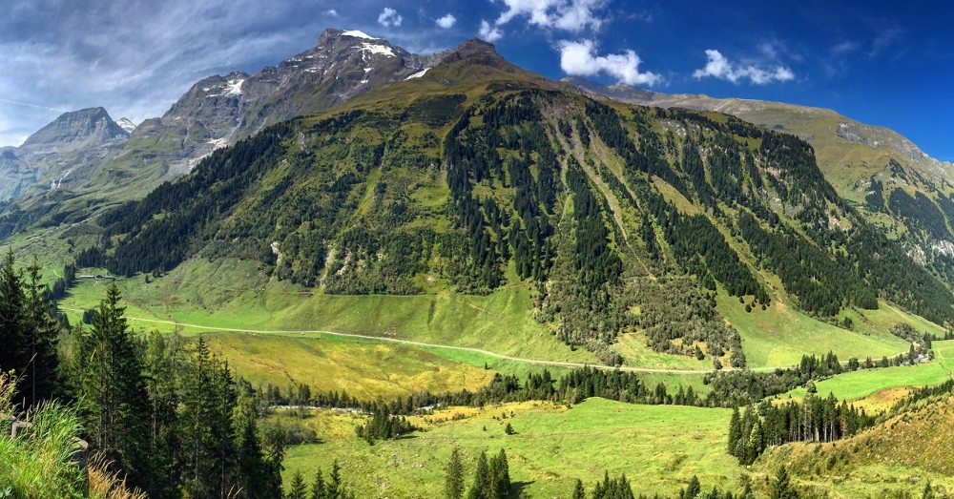
A new study projects that global warming will alter the soil chemistry in mountains around the world, leading to visible shifts in vegetation. (Photo: Bob Berwyn)
A warming climate will fundamentally change the chemistry of mountain soils by shifting the balance of nutrients, visibly disrupting fragile, high-elevation ecosystems of grasses, flowers, and trees within decades. https://psmag.com/global-warming-is-changing-mountain-soils-8b527fe1b7ec#.ij2cn6v7z

Limited sign of soil adaptation to climate warming
While scientists and policy experts debate the impacts of global warming, Earth's soil is releasing roughly nine times more carbon dioxide to the atmosphere than all human activities combined. This huge carbon flux from soil, which is due to the natural respiration of soil microbes and plant roots, begs one of the central questions in climate change science. As the global climate warms, will soil respiration rates increase, adding even more carbon dioxide to the atmosphere and accelerating climate change?
Journal Reference:
- Joanna C. Carey, Jianwu Tang, Pamela H. Templer, Kevin D. Kroeger, Thomas W. Crowther, Andrew J. Burton, Jeffrey S. Dukes, Bridget Emmett, Serita D. Frey, Mary A. Heskel, Lifen Jiang, Megan B. Machmuller, Jacqueline Mohan, Anne Marie Panetta, Peter B. Reich, Sabine Reinsch, Xin Wang, Steven D. Allison, Chris Bamminger, Scott Bridgham, Scott L. Collins, Giovanbattista de Dato, William C. Eddy, Brian J. Enquist, Marc Estiarte, John Harte, Amanda Henderson, Bart R. Johnson, Klaus Steenberg Larsen, Yiqi Luo, Sven Marhan, Jerry M. Melillo, Josep Peñuelas, Laurel Pfeifer-Meister, Christian Poll, Edward Rastetter, Andrew B. Reinmann, Lorien L. Reynolds, Inger K. Schmidt, Gaius R. Shaver, Aaron L. Strong, Vidya Suseela, Albert Tietema. Temperature response of soil respiration largely unaltered with experimental warming. Proceedings of the National Academy of Sciences, 2016; 113 (48): 13797 DOI: 10.1073/pnas.1605365113
https://www.sciencedaily.com/releases/2017/01/170130140004.htm

Arable Horizons: How science and technology could save our soils
Adam Clarke
Friday 3 February 2017 6:10
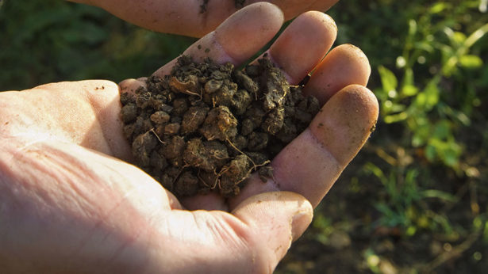© Mint Images/REX/Shutterstock
Our soils are in trouble. That has been the clear and much-publicised message from the scientific community in recent years.
But despite the gloomy headlines, Wilfred Otten of the Cranfield Soil and Agrifood Institute says there is reason for optimism as exciting new technologies help improve our understanding and management of an extremely complex soil environment. http://www.fwi.co.uk/arable/how-science-and-technology-could-save-our-soils.htm

University of Missouri Extension study shows cover crops help soils after flooding
.
COURIER-POST FILE

Thursday
Posted 2 Feb 2017 at 1:30 PM

Share

Stories From Chatter Network
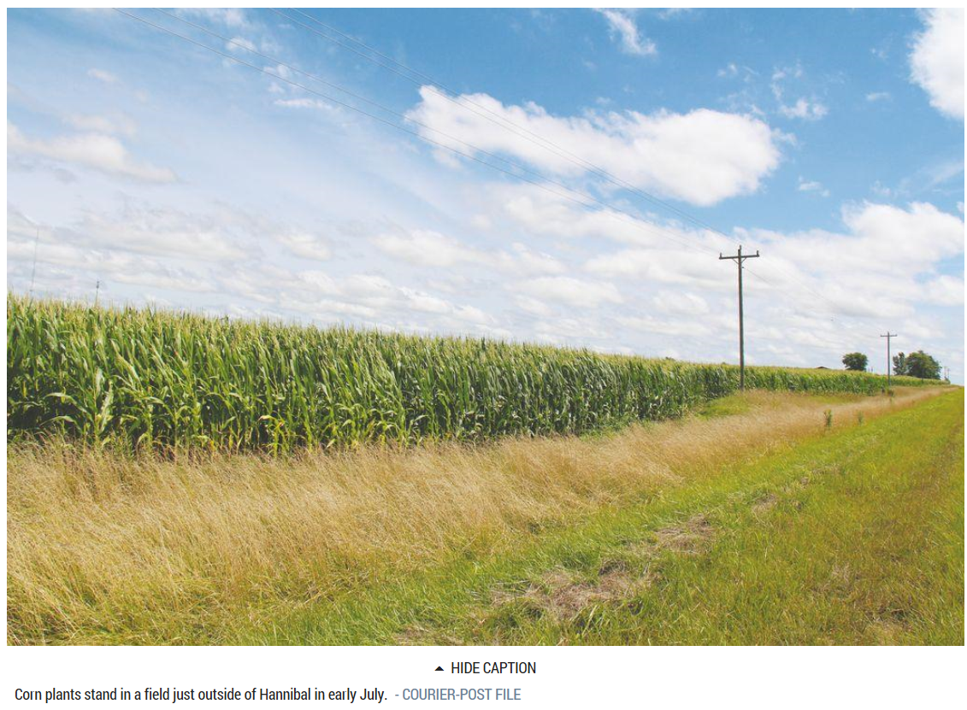

Corn plants stand in a field just outside of Hannibal in early July
A four-year study by University of Missouri Extension seeks to find how cover crops can best benefit soils after flooding and prevented planting.
A four-year study by University of Missouri Extension seeks to find how cover crops can best benefit soils after flooding and prevented planting. http://www.hannibal.net/news/20170202/university-of-missouri-extension-study-shows-cover-crops-help-soils-after-flooding

Underground farm secures its first retail deal
Jez Fredenburgh
Sunday 5 February 2017 6:00
A farm growing salads in a Second World War bomb shelter under London has just signed its first retail deal with online supermarket Ocado.
The Growing Underground company will supply “microherbs” – tiny salad leaves and herbs fashionable with top chefs – from 100ft beneath Clapham High Street in Vauxhall, south London.
The company does not use soil, but grows its seeds on special agricultural matting made from carpet cut-offs and feeds the shoots with water and a standard NPK nutrient mix.
See also: Underground farm set up 100ft below streets of London
Like the London Tube, the space does not need heating and is an ambient 16C, said a spokesman.
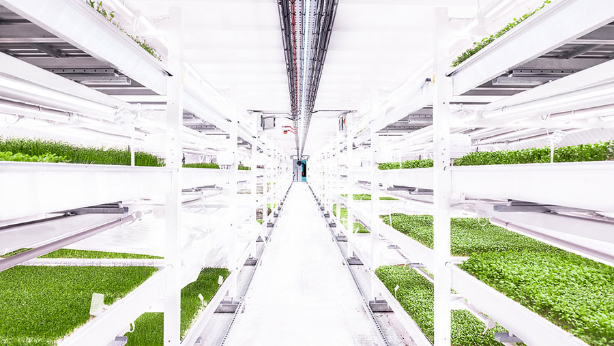
http://www.fwi.co.uk/business/underground-farm-secures-its-first-retail-deal.htm

Watch live: Arable Horizons soil science lecture
James Williams
Thursday 26 January 2017 12:00
© Shutterstock
People from across UK agriculture will gather at Rothamsted Research Centre this evening (Thursday, 26 January) for the second in the Farmers Weekly series of Arable Horizons Interactive lectures.
The project aims to build a conversation around the most important topics in the arable sector, with some of the UK’s top experts speaking on topics from crop genetics to climate change resilience.
Tonight’s talk will focus on UK soil science and how exciting research projects could affect the way we farm in the future.
http://www.fwi.co.uk/arable/watch-live-arable-horizons-soil-science-lecture.htm

New Life for Saline Soil
Here’s how some perennial grasses can lower soil salinity.
By
Raylene Nickel
3/2/2017
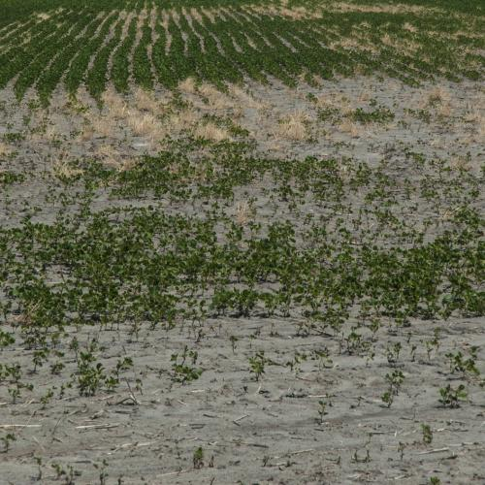
Those dead zones in fields where crops fizzle out and give way to kochia and foxtail barley are places where perennial grasses might lend a hand. Research suggests these may actually reclaim soil from excess salinity.
At North Dakota State University’s Carrington Research Extension Center, research specialist Ezra Aberle has for six years evaluated perennial grasses, legumes, and cover crops for their performance in soils of varying salinity. His research included: http://www.agriculture.com/crops/cover-crops/new-life-for-saline-soil

Top-yielding Iowa counties share deep soils, timely rains
Bill Tiedje, Iowa Farmer Today
25 Jan 2017



Top of Form
Bottom of Form
When it comes to posting the highest average corn yields in the state, several Northwest Iowa counties are often near the top of the list, but the title tends to move around the state depending on growing season weather. http://globegazette.com/top-yielding-iowa-counties-share-deep-soils-timely-rains/article_7418ea57-3e89-5a8e-8bbb-8a0e38f44ee4.html

Study finds limited sign of soil adaptation to climate warming
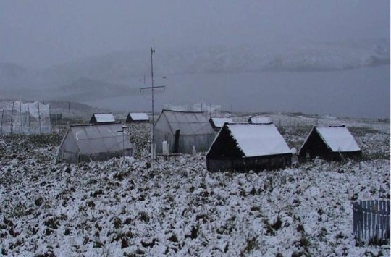
This photo shows measurements of carbon flux from soil at Toolik Field Station in Arctic Alaska.
Credit: Jianwu Tang

While scientists and policy experts debate the impacts of global warming, Earth's soil is releasing roughly nine times more carbon dioxide to the atmosphere than all human activities combined. This huge carbon flux from soil -- due to the natural respiration of soil microbes and plant roots -- raises one of the central questions in climate change science. As the global climate warms, will soil respiration rates increase, adding even more carbon dioxide to the atmosphere and accelerating climate change?
Journal Reference:
- Joanna C. Carey, Jianwu Tang, Pamela H. Templer, Kevin D. Kroeger, Thomas W. Crowther, Andrew J. Burton, Jeffrey S. Dukes, Bridget Emmett, Serita D. Frey, Mary A. Heskel, Lifen Jiang, Megan B. Machmuller, Jacqueline Mohan, Anne Marie Panetta, Peter B. Reich, Sabine Reinsch, Xin Wang, Steven D. Allison, Chris Bamminger, Scott Bridgham, Scott L. Collins, Giovanbattista de Dato, William C. Eddy, Brian J. Enquist, Marc Estiarte, John Harte, Amanda Henderson, Bart R. Johnson, Klaus Steenberg Larsen, Yiqi Luo, Sven Marhan, Jerry M. Melillo, Josep Peñuelas, Laurel Pfeifer-Meister, Christian Poll, Edward Rastetter, Andrew B. Reinmann, Lorien L. Reynolds, Inger K. Schmidt, Gaius R. Shaver, Aaron L. Strong, Vidya Suseela, Albert Tietema. Temperature response of soil respiration largely unaltered with experimental warming. Proceedings of the National Academy of Sciences, 2016; 201605365 DOI: 10.1073/pnas.1605365113
https://www.sciencedaily.com/releases/2016/11/161114162228.htm

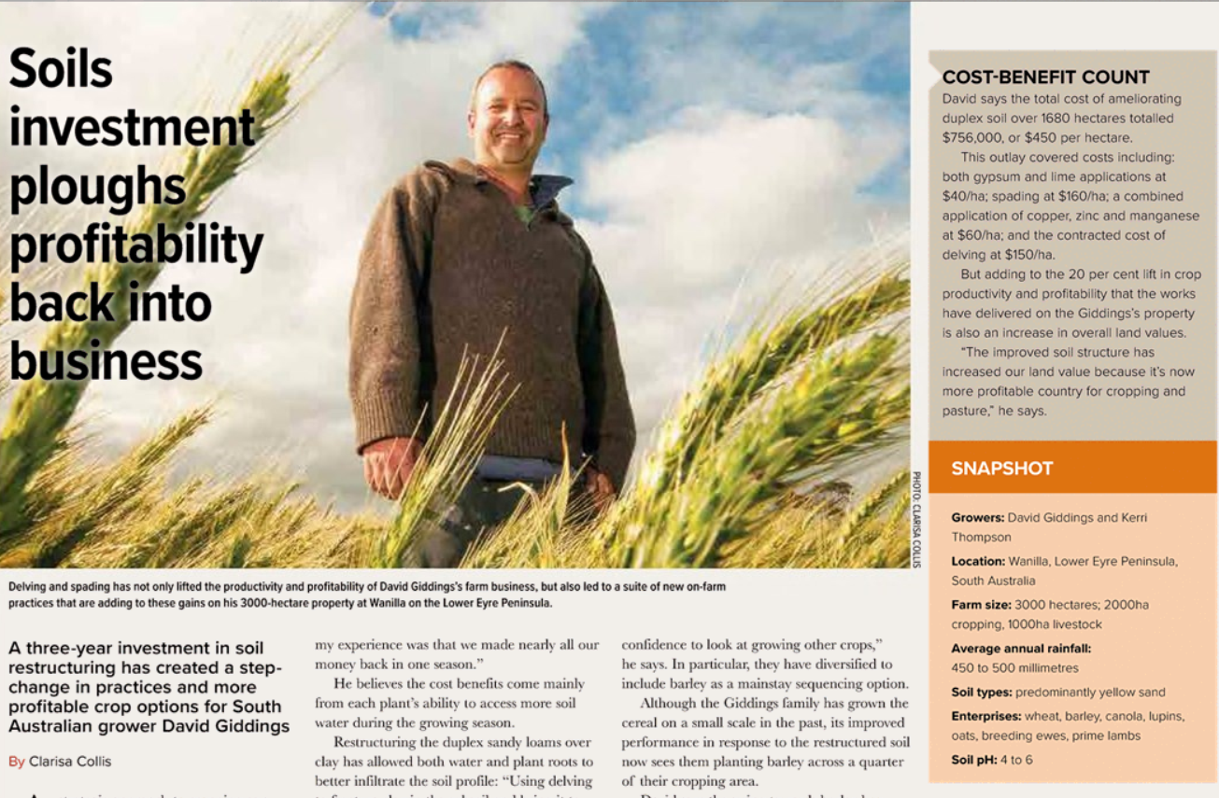
http://groundcover.realviewdigital.com/?xml=GCN&iid=149855#folio=26

Arable Horizons: How science is revolutionising crop growing
Adam Clarke
Thursday 1 December 2016 6:02
Dr Alison Bentley of Niab delivers a lecture at the Arable Horizons event
A genetic toolbox held at the fingertips of plant breeding scientists is set to completely revolutionise the way crops are grown in UK fields over the next 20 years.
This was the topic of the first of five Farmers Weekly Arable Horizons interactive lectures, in association with Syngenta, examining some of the most exciting and innovative scientific research in agriculture.
http://www.fwi.co.uk/arable/arable-horizons-how-science-is-revolutionising-crop-growing.htm

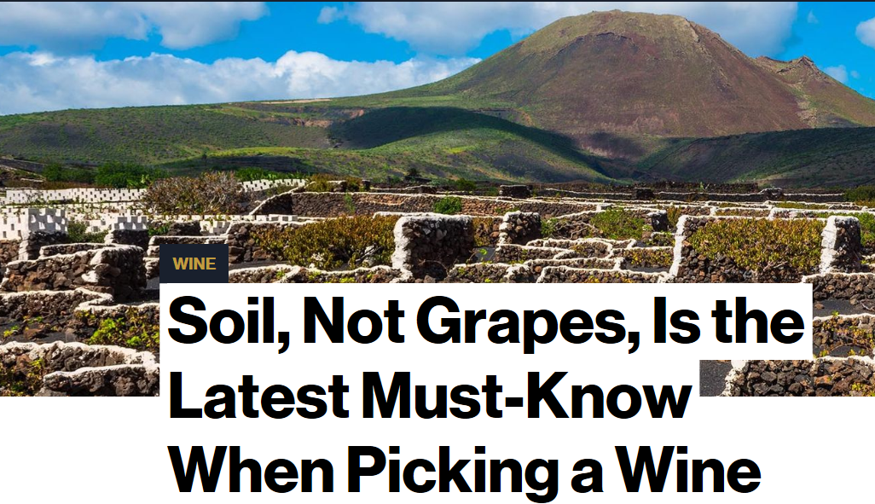 Do you like granite? Or are you a sandy-river person? How to shop the hot, new “dirty” trends in wine.
by
Elin McCoy
More stories by Elin McCoy
‎26‎ ‎January‎ ‎2017‎ ‎5‎:‎03‎ ‎AM
OK, you know the names of dozens of grape varietals and wine regions and all (well, almost all) the Bordeaux crus classes. You can name with ease the best Burgundy chateaux and famous vineyards such as Napa’s To Kalon. https://www.bloomberg.com/news/articles/2017-01-25/soil-not-grapes-is-the-latest-must-know-when-picking-a-wine

Targeting soil pH with precision mapping
Author: Alistair Lawson
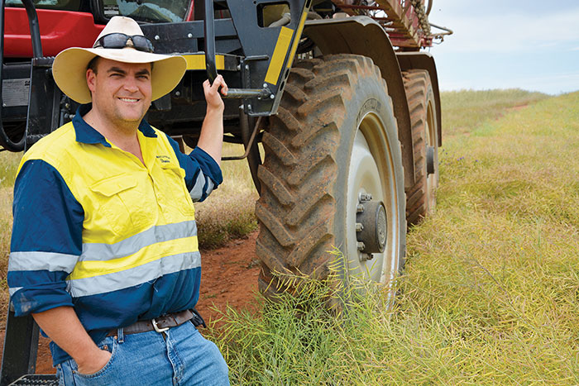
South Australian grower Damien Sommerville uses precision pH mapping to help better manage his lime applications.
PHOTO: Alistair Lawson

Snapshot
Growers: Eric, Judith, Ben, Damien and Ruth Sommerville
Location: Spalding and Burra, SA
Farm size: 1600 hectares
Enterprises: cropping, contracting
Average annual rainfall: 440 millimetres
Soil pH: 4.5 to 8.5
Soil types: predominantly red-brown clay
Crops: wheat, barley, canola, oaten hay
Healthy soils are the ultimate goal for South Australian grower Damien Sommerville, and addressing soil acidity through liming is one way he is looking to improve crop productivity.
He cites acidic clay soils as one of the biggest yield constraints on his family’s grain-growing properties at Spalding and Burra in SA’s Mid North region.
“Where the soil is acidic the crops are uncompetitive,” Damien says. “We get ryegrass weed blowouts and as a result of poor soil structure we also get waterlogging and the associated denitrification.”
https://grdc.com.au/Media-Centre/Ground-Cover/Ground-Cover-Issue-126-January-February-2017/Targeting-soil-pH-with-precision-mapping
Five things you probably don't know about Australia
ABC Science
By Bernie Hobbs
Updated 25 Jan 2017, 7:17amWed 25 Jan 2017, 7:17am
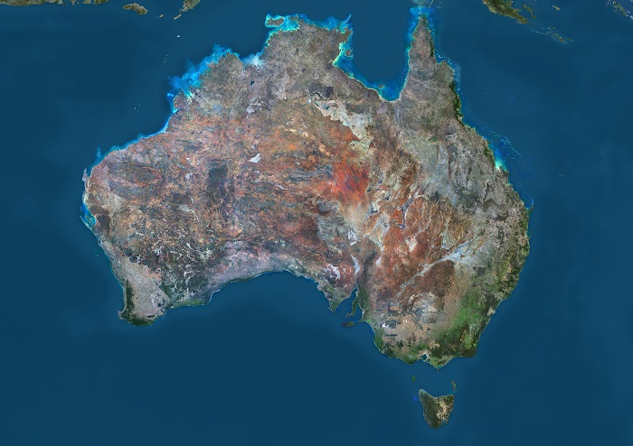Infographic: Australia, as seen by the Landsat 8 satellite in 2014, is on the move. (Getty Images: Planet Observer)
Map: Australia
Every schoolkid knows that Australia is gradually heading north — but we're also turning sideways, rising up and down, and entire cities are moving further apart. How do we know all this? Because of supermassive black holes. http://www.abc.net.au/news/2017-01-25/five-things-you-probably-dont-know-about-australia/8144516

New scientific approach assesses land recovery following oil and gas drilling

7 February 2017

Active oil and gas pad on BLM lands near Canyonlands National Park, Utah. Credit: USGS
A new scientific approach can now provide regional assessments of land recovery following oil and gas drilling activities, according to a new U.S. Geological Survey study published in the journal Science of the Total Environment.
Read more at: https://phys.org/news/2017-02-scientific-approach-recovery-oil-gas.html#jCp

Manganese, 2017 nutrient of the year
‎01-12-2017 07:38 AM
Every year a hot new plant food or soil amendment is plugged, this year it`s Manganese. Brian Hefty was in Rochester talking about their yield plot on their test plot in Baltic. They have top yield growers from around the country and give them their own little plot to manage however they want (sounds very interesting). Well the top plot yielders Brian H and Randy Dowdy applied 10-15lbs of Manganese Sulfate. http://community.agriculture.com/t5/Crop-Talk/Manganese-2017-nutrient-of-the-year/m-p/651226#M714

Persistent tropical foraging in the highlands of terminal Pleistocene/Holocene New Guinea

7 February 2017
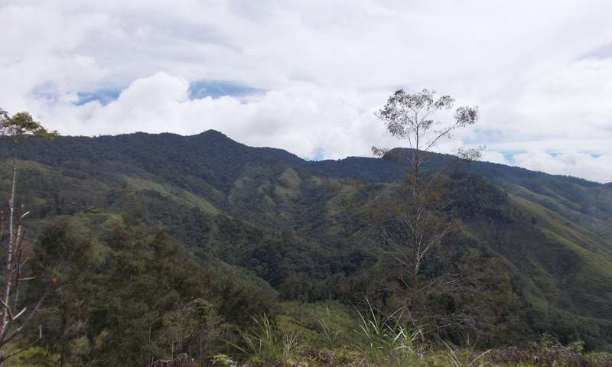
Montane rainforest in the Central Highlands of New Guinea. Credit: Dylan Gaffney and Glenn Summerhayes
The development of agriculture is frequently seen as one of the major economic, social, and demographic thresholds in human history. From the perspective of the modern world it is often seen as an inevitable, desirable subsistence strategy, allowing larger populations, settled life, and the development of cities. Likewise it has even been argued that long-term human survival in tropical forests must have been impossible without some form of agricultural system, with agriculture developing as a result of climatic or environmental instability.
Read more at: https://phys.org/news/2017-02-persistent-tropical-foraging-highlands-terminal.html#jCp

Data builds on WA deep ripping experience
Author: Melissa Williams

Key points
Deep-ripping in WA:
- Primarily addresses soil compaction
- Suits deep and loamy sands, deep sandy duplex and some clay soils
- Involves using tynes to break up hard pans
- Has minimal soil mixing and has a typical working soil depth of 50 to 70 centimetres
- Costs $40 to $90 per hectare, depending on soil type
- Can improve wheat yields by 0.6 tonnes/ha in the first year after ripping
- Can have benefits lasting three or more years
- Ideally should be matched with controlled-traffic farming (CTF)
SOURCE: Department of Agriculture and Food, WA, trial results
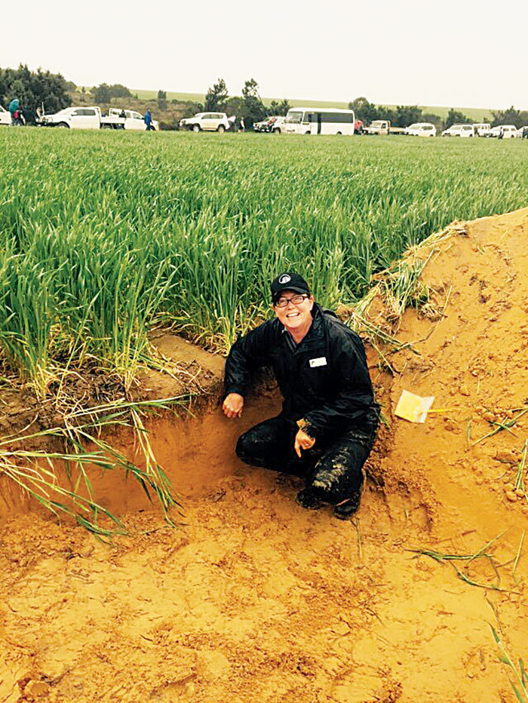
DAFWA development officer Bindi Isbister examines a deep-ripping trial at Binnu.
PHOTO: DAFWA
Ripping soil to a depth of 30 to 50 centimetres is one of the most effective tools for addressing subsoil compaction on vast tracts of WA’s deep sands, sandy loam duplex and some clay soils.
Optimal results typically occur when deep-ripping is carried out just after opening rains in autumn. Soil is then moist enough to allow penetration of the ripping tynes, but not too wet, which can cause ‘smearing’ without shattering the compacted soil layers.
https://grdc.com.au/Media-Centre/Ground-Cover/Ground-Cover-Issue-126-January-February-2017/Data-builds-on-WA-deep-ripping-experience

Grow, mow, mulch: Finding lawn's value

8 February 2017
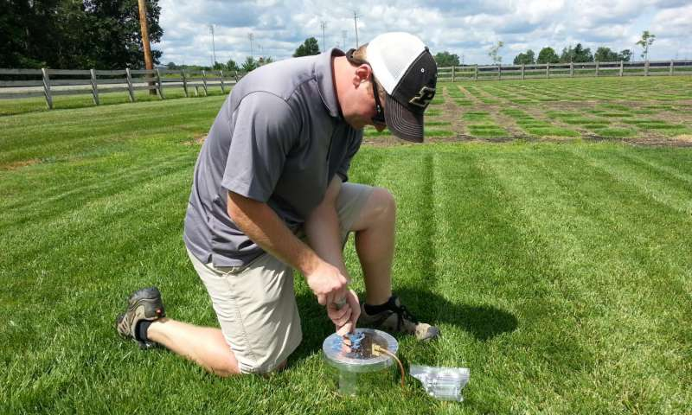
Law collecting greenhouse gas samples from turf plots using a vented flux chamber. Credit: Jon Trappe
Cranking up the lawn mower on a Saturday afternoon may be a child's most dreaded chore. But little does he or she know that it also affects how much carbon and nitrogen are present in the soil below the grass.
Read more at: https://phys.org/news/2017-02-mulch-lawn.html#jCp

Losses of soil carbon under global warming might equal US emissions

Global study finds losses will be greatest in world's coldest places
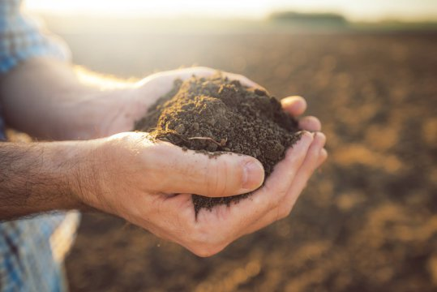
Warming will drive the loss of at least 55 trillion kilograms of carbon from the soil by mid-century, or about 17% more than the projected emissions due to human-related activities during that period. That would be roughly the equivalent of adding to the planet another industrialized country the size of the United States.
Credit: © Bits and Splits / Fotolia

For decades scientists have speculated that rising global temperatures might alter the ability of soils to store carbon, potentially releasing huge amounts of carbon into the atmosphere and triggering runaway climate change. Yet thousands of studies worldwide have produced mixed signals on whether this storage capacity will actually decrease -- or even increase -- as the planet warms.
Journal Reference:
- T. W. Crowther, K. E. O. Todd-Brown, C. W. Rowe, W. R. Wieder, J. C. Carey, M. B. Machmuller, B. L. Snoek, S. Fang, G. Zhou, S. D. Allison, J. M. Blair, S. D. Bridgham, A. J. Burton, Y. Carrillo, P. B. Reich, J. S. Clark, A. T. Classen, F. A. Dijkstra, B. Elberling, B. A. Emmett, M. Estiarte, S. D. Frey, J. Guo, J. Harte, L. Jiang, B. R. Johnson, G. Kröel-Dulay, K. S. Larsen, H. Laudon, J. M. Lavallee, Y. Luo, M. Lupascu, L. N. Ma, S. Marhan, A. Michelsen, J. Mohan, S. Niu, E. Pendall, J. Peñuelas, L. Pfeifer-Meister, C. Poll, S. Reinsch, L. L. Reynolds, I. K. Schmidt, S. Sistla, N. W. Sokol, P. H. Templer, K. K. Treseder, J. M. Welker, M. A. Bradford. Quantifying global soil carbon losses in response to warming. Nature, 2016; 540 (7631): 104 DOI: 10.1038/nature20150
https://www.sciencedaily.com/releases/2016/11/161130134341.htm

Why nature restoration takes time: fungi grow 'relationships'

8 February 2017
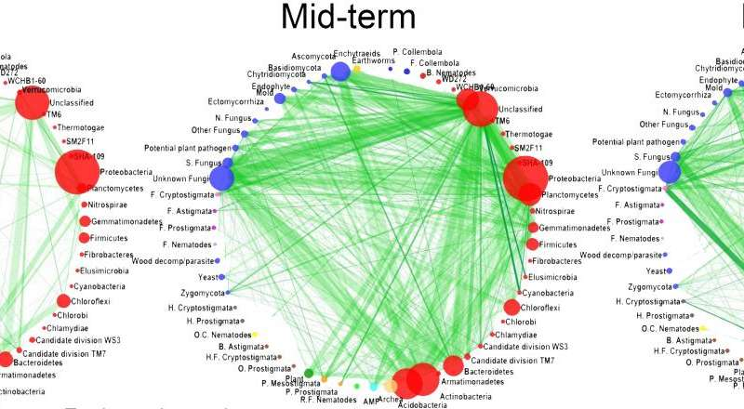
How strong are the 'relationships' in soil communities? From left to right the interaction strength between groups in seminatural grasslands are visualized on recently, mid-term and long-term abandoned agricultural fields. Credit: Elly Morriën et al. / Netherlands Institute of Ecology (NIOO-KNAW)
'Relationships' in the soil become stronger during the process of nature restoration. Although all major groups of soil life are already present in former agricultural soils, they are not really 'connected' at first. These connections need time to (literally) grow, and fungi are the star performers here. A European research team led by the Netherlands Institute of Ecology (NIOO-KNAW) has shown the complete network of soil life for the first time. This Wednesday, the results of the extensive study are published in Nature Communications.
https://phys.org/news/2017-02-nature-fungi-relationships.html

Sensor network builds soil moisture knowledge bank
Author: Rebecca Thyer

Key points
- Thirty-three public-access soil moisture probes exist across the WA wheatbelt
- Data from soil moisture probes is being used with Yield Prophet® modelling to improve soil type characterisations
- The data can better inform on-farm decisions in dry years and help growers better understand water-holding capacity in wet years
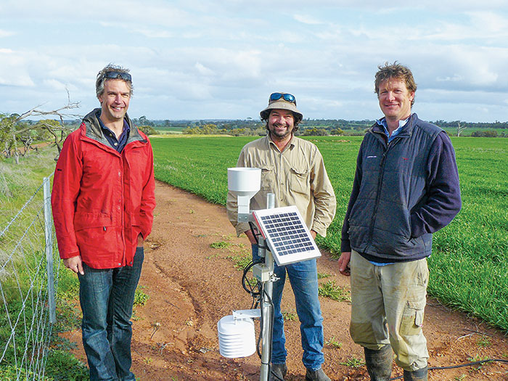
(From left) Frank D’Emden with Brad Tonkin and Kristin Lefroy from the Moora-Miling Pasture Improvement Group at the Bindi Bindi soil moisture probe site. Data from soil moisture probes is being used with Yield Prophet® modelling to improve soil type characterisations.

Theories on the water-holding capacity of soils across Western Australia’s wheatbelt are being tested after the wet winter in 2016, utilising a network of moisture probes
https://grdc.com.au/Media-Centre/Ground-Cover/Ground-Cover-Issue-126-January-February-2017/Sensor-network-builds-soil-moisture-knowledge-bank
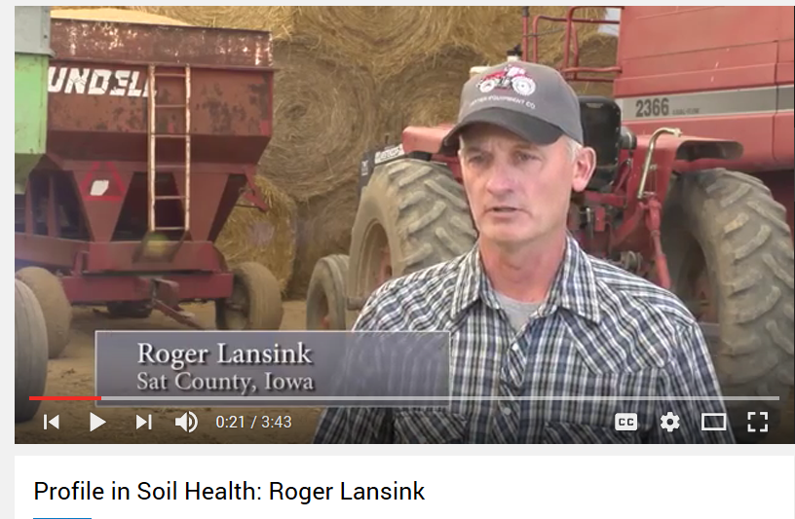
https://www.youtube.com/watch?list=PL4J8PxoprpGbRi3gZ-fWN0dGD8bnnq3wM&v=miOt_V18QDI
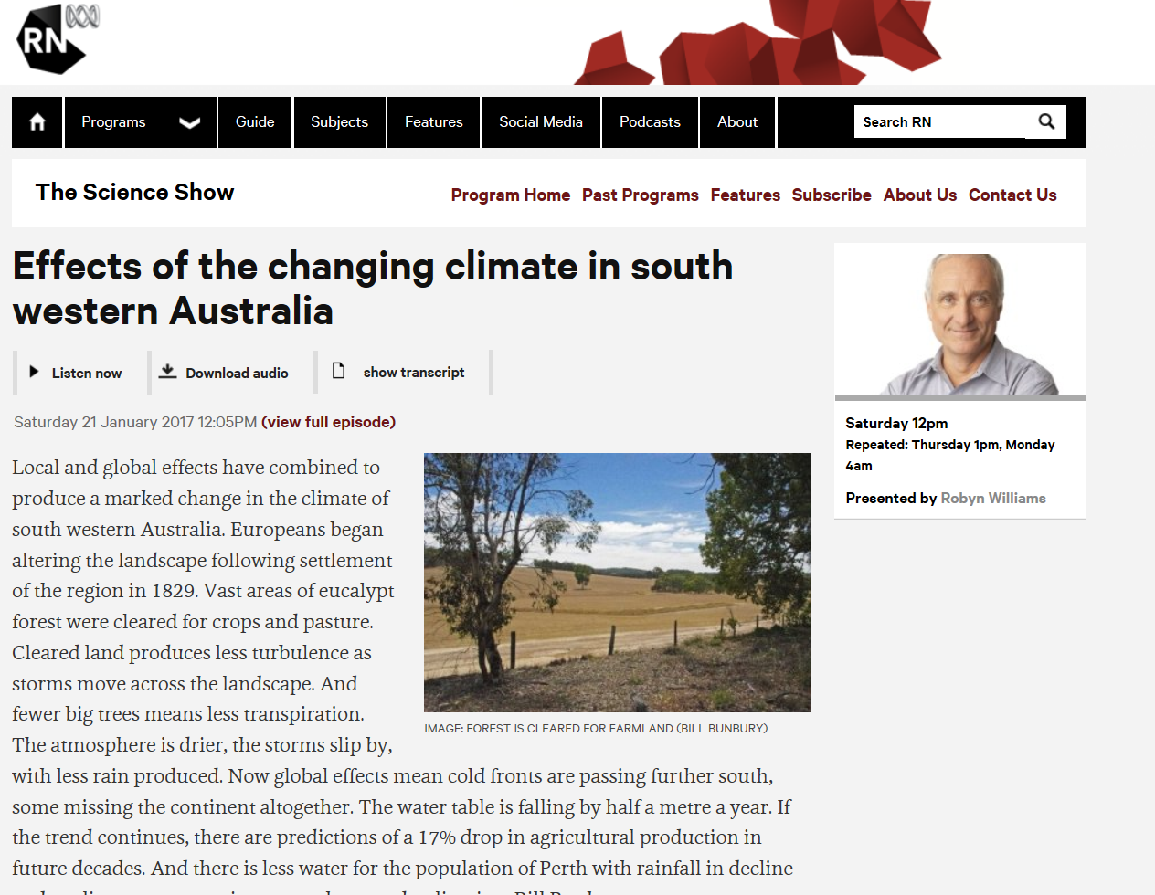
http://www.abc.net.au/radionational/programs/scienceshow/effects-of-the-changing-climate-in-south-western-australia/8175170

Soil microbes flourish with reduced tillage
Microbes improve soil quality by cycling nutrients and breaking plant residues down into soil organic matter. In an effort to detect consistent patterns across a large geographical area, University of Illinois researchers conducted a meta-analysis of 62 studies examining the effect of tillage on soil microbes. No-till systems had greater soil microbial biomass and enzymatic activity. Tilled systems that used a chisel plow were equivalent to no-till systems, in terms of microbial biomass.
Journal Reference:
- Stacy M. Zuber, María B. Villamil. Meta-analysis approach to assess effect of tillage on microbial biomass and enzyme activities. Soil Biology and Biochemistry, 2016; 97: 176 DOI: 10.1016/j.soilbio.2016.03.011
https://www.sciencedaily.com/releases/2016/10/161004125836.htm

Largest undersea landslide revealed on the Great Barrier Reef

7 February 2017
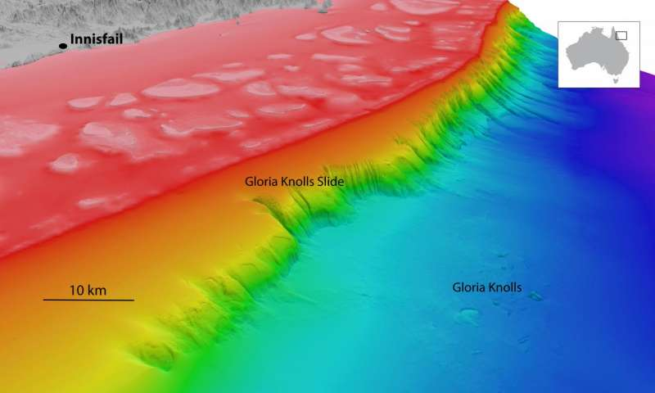
North-westerly view of the Gloria Knolls Slide and Gloria Knolls off Innisfail. Depths are coloured red (shallow) to blue (deep), over a depth range of about 1700 metres. Credit: deepreef.org/Creative Commons Attribution 4.0 International Licence.
James Cook University scientists have helped discover the remnants of a massive undersea landslide on the Great Barrier Reef, approximately 30 times the volume of Uluru.
Read more at: https://phys.org/news/2017-02-largest-undersea-landslide-revealed-great.html#jCp

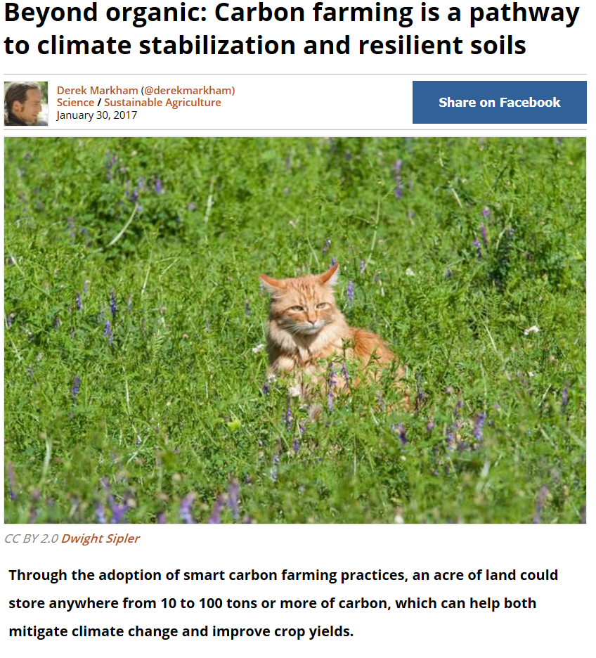
http://www.treehugger.com/sustainable-agriculture/beyond-organic-carbon-farming-pathway-climate-stabilization-and-resilient-soils.html

Things fall apart: why do the ecosystems we depend on collapse?

A look at two natural resource industries – fisheries and forestry – that are highly susceptible to collapse.
People collapse, buildings collapse, economies collapse and even entire human civilizations collapse. Collapse is also common in the natural world – animal populations and ecosystems collapse. These collapses have the greatest impact on us when they affect resources our industries depend on, leaving ecosystems in tatters and sometimes ruining local economies.
In a new paper, I look at two natural resource industries – fisheries and forestry – that are highly susceptible to collapse.
From the infamous 1980s collapse of the Canadian cod industry to the apparent imminent collapse of the Heyfield sawmill in southern Victoria, we can see a recurring pattern. And by getting better at predicting this pattern, we might be able to avoid collapse in the future. https://cosmosmagazine.com/biology/things-fall-apart-why-do-the-ecosystems-we-depend-on-collapse?utm_source=Today+in+Cosmos+Magazine&utm_campaign=47671b56ba-RSS_EMAIL&utm_medium=email&utm_term=0_5f4ec2b124-47671b56ba-179982353

From Utah with love and thanks for all the uranium

7 February 2017 by Allison Mills
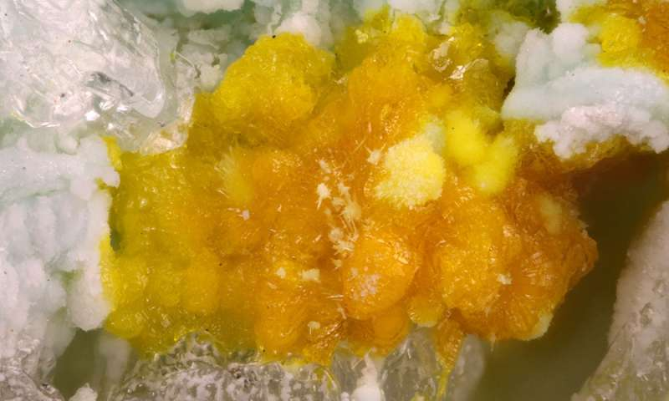
Uranyl minerals have distinct bright colors even after the uranium-rich ore interacts with air and water to form crusts like leesite. Credit: Travis Olds
Three new minerals discovered by a Michigan Tech alumnus are secondary crusts found in old uranium mines. They're bright, yellow and hard to find.
Read more at: https://phys.org/news/2017-02-utah-uranium.html#jCp

Zimbabwe Farms, Still Reeling From Drought, Now Battered by Rain
by
Brian Latham
More stories by Brian Latham
and
Godfrey Marawanyika
@GMarawanyikaMore stories by Godfrey Marawanyika
‎1‎ ‎February‎ ‎2017‎ ‎9‎:‎00‎ ‎AM ‎1‎ ‎February‎ ‎2017‎ ‎5‎:‎08‎ ‎PM
- Crop review under way after unseasonably heavy rains
- Southern Africa emerging from worst drought in two decades
Farmers in Zimbabwe, emerging from the region’s worst drought in at least two decades, are being threatened with a second year of losses as heavy rains damage corn and tobacco crops.
A crop review is under way to assess the damage from the unseasonably heavy rain and farmers will probably need extra fertilizer to help harvests survive, Deputy Agriculture Minister David Marapira said in an interview on Monday. https://www.bloomberg.com/news/articles/2017-01-31/zimbabwe-farms-still-reeling-from-drought-now-battered-by-rain

Team publishes new data about the history of the Pacific Ring of Fire

10 February 10, 2017
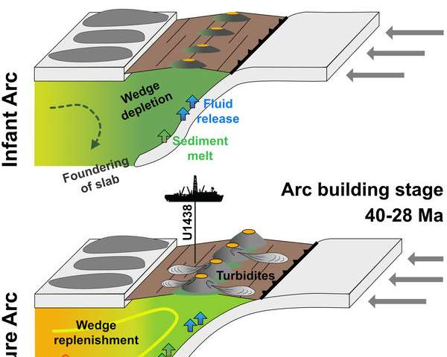
The graphic shows the early stages of the Izu-Bonin subduction zone. The active subduction zone has been moving eastwards throughout its history. The drilling took place where the process has begun. Credit: Philipp Brandl, GEOMAR
The movements of Earth's tectonic plates shape the face of our planet. The sinking of one plate beneath another causes volcanism and earthquakes. As part of the International Ocean Discovery Program, an international science team was able to drill and investigate the origin of a subduction zone for the first time in 2014. The team is now publishing its data in the international scientific journal Earth and Planetary Science Letters.
Read more at: https://phys.org/news/2017-02-team-publishes-history-pacific.html#jCp

Two huge magma plumes fed the Deccan Traps eruption

Two vast hotspots fuelled the eruption that contributed to one of the greatest extinction events on Earth 65 million years ago. Kate Ravilious reports.


Thick lava flows in Hawaii are nothing compared to the mammoth rivers of hot rock that rolled across in India in the late Cretaceous. New research suggests those flows were fed by two magma sources.
Justinreznick / Getty Images
Some 65 million years ago, the skies over India darkened as one of Earth's biggest volcanic eruptions burbled from below. It rumbled on for millions of years, blocking out sunlight and casting a chill globally, to produce what we know today as the Deccan Traps.
https://cosmosmagazine.com/geoscience/two-huge-magma-plumes-fed-the-deccan-traps-eruption?utm_source=Today+in+Cosmos+Magazine&utm_campaign=47671b56ba-RSS_EMAIL&utm_medium=email&utm_term=0_5f4ec2b124-47671b56ba-179982353

Drought ends great green boom and Australia’s carbon budget shifts

Flux and satellite data collected and delivered by TERN infrastructure has been used to monitor the greening and browning of Australia’s vegetation and infer its very significant impact on the nation's carbon budget.
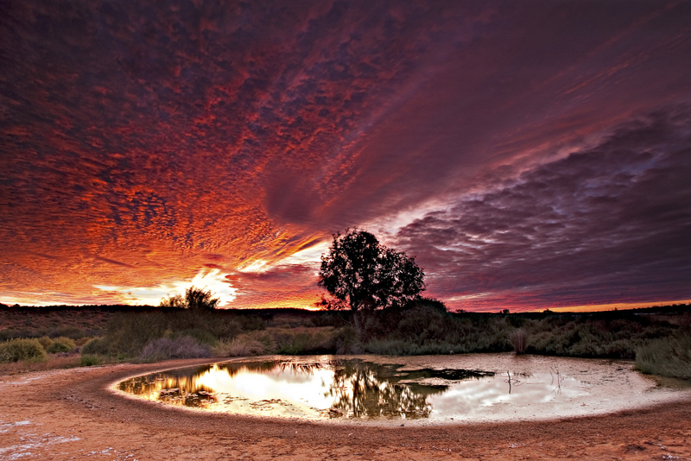
A international team from UTS and NASA has used satellite imagery and ground observations collected and made openly available by TERN AusCover and TERN OzFlux infrastructure (OzFlux tower below) to show that the record-breaking green boom of 2011 of central Australia has finished and drought conditions have returned (images courtesy of Aaron Greenville, above, and Suzanne Long, below)
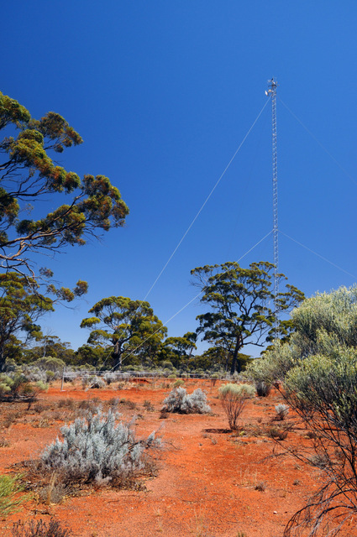
Science can’t prevent extreme events. But good ecosystem science—underpinned by collaborative research infrastructure and critical data such as that being delivered
http://www.tern.org.au/Newsletter-2016-Dec-Green-Boom-Drought-Carbon-pg31775.html

Relief in sight: countrywide pollen monitoring and mapping for early warning
TERN’s collaborative networks and data infrastructure have provided the platforms from which to establish the inaugural national pollen-monitoring network and a new, high-tech approach to pollen mapping and forecasting.
Together, these initiatives are bringing unprecedented and timely public health benefits, including helping to predict future outbreaks of thunderstorm asthma.
Forecasting pollen exposure and movement with satellite data from TERN Australia on Vimeo. By integrating satellite data, field phenology cameras, and multiple pollen traps a new ARC Discovery project will track grass pollen sources, their evolution, and impact areas. Darker green zones show areas of higher pollen levels in Australia over several years.
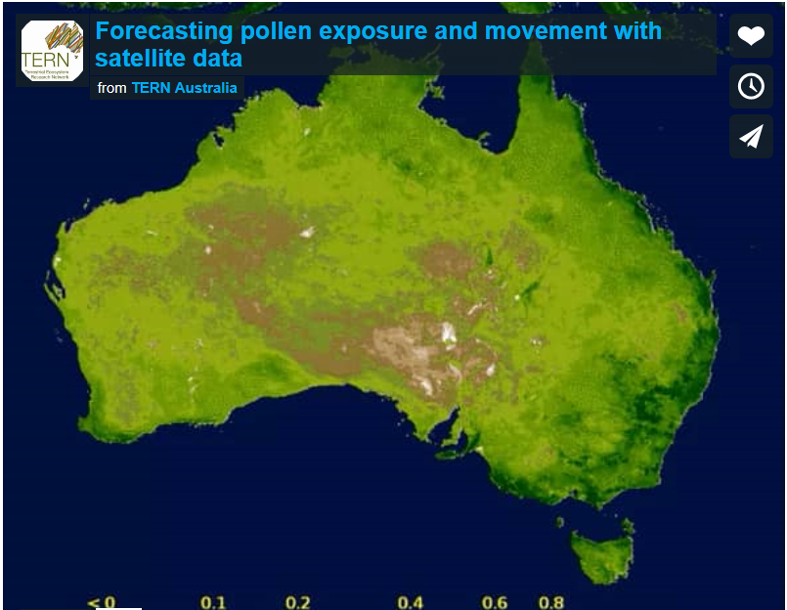

Forecasting pollen exposure and movement with satellite data
40 years of satellite data are being pieced together to better understand climate change and landscape modification drivers that are leading to increasing allergen exposure levels in Australia.
http://www.tern.org.au/Newsletter-2016-Dec-Pollen-Mapping-Monitoring-pg31776.html


http://www.abc.net.au/news/2017-02-08/back-to-school-science-quiz/8236324?section=science

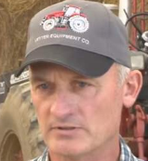 “We need to produce food for the world, but we can also preserve the soil for future generations." Roger Lansink, USDA Profiles in Soil Health

