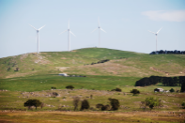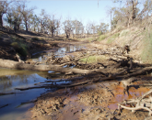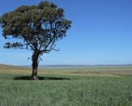

Opinion | Soils ain't soils | Tim Roberts
20 Feb 2017, 1:30 a.m.

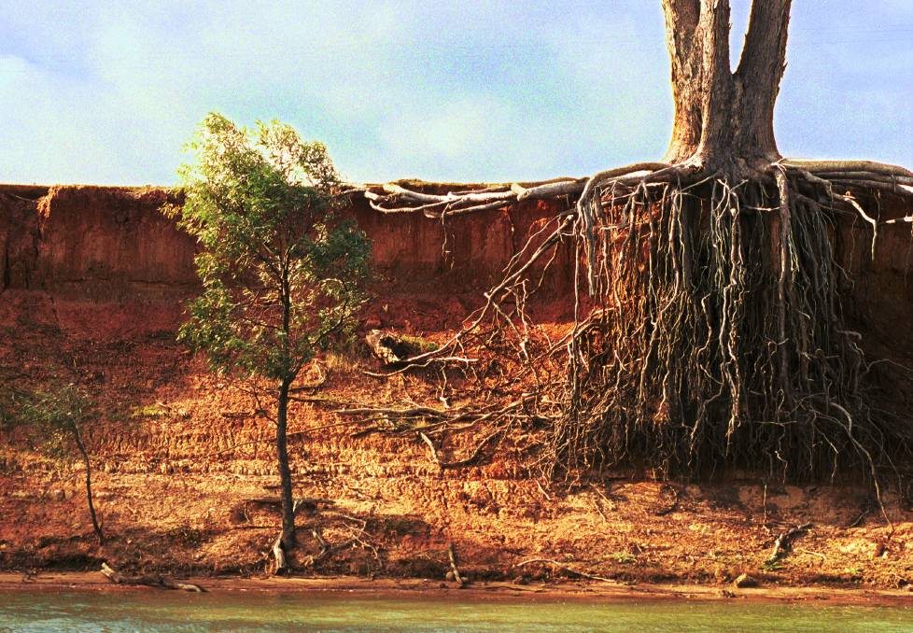
Channelling the brilliant Castrol GTX ads ‘soils ain’t soils, Sol’: pre-1788 Australian soils were carbon rich with levels some five to 10 times higher than current levels, as reported by the explorer Strzelecki in 1845. A return to such stored carbon levels across Australia would be equivalent to a massive capture of atmospheric carbon.
Soil carbon is the key to soil health and productivity. In a few short decades of European settlement the Australian soils moved from being soft and spongy and absorbent to being hard and impervious with water flowing rapidly across the surface.

Professor Tim Roberts is the director of the Tom Farrell Institute for the Environment, University of Newcastle
http://www.theherald.com.au/story/4473422/legacy-of-land-degradation-australian-soils-aint-soils/

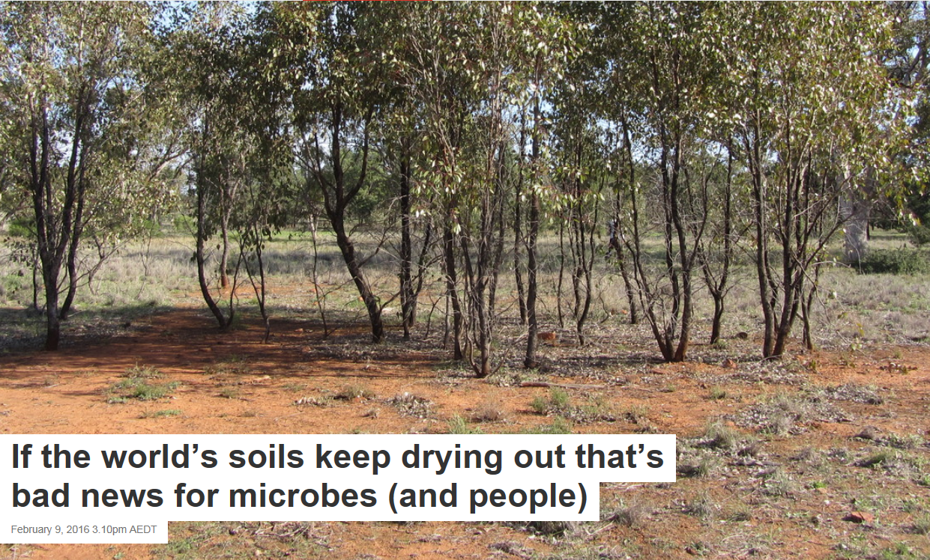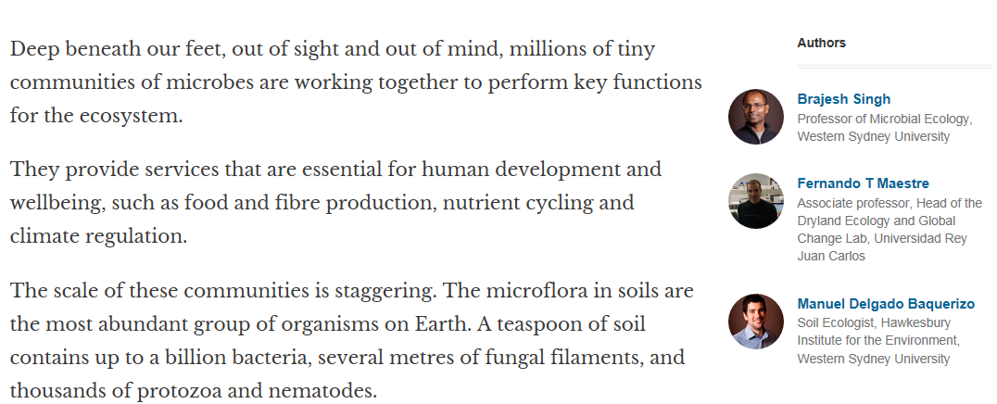
https://theconversation.com/if-the-worlds-soils-keep-drying-out-thats-bad-news-for-microbes-and-people-53937

Opinions on Soil

Here you have a list of opinions about Soil and you can also give us your opinion about it.
You will see other people's opinions about Soil and you will find out what the others say about it.
Also, you will see opinions about other terms. Do not forget to leave your opinion about this topic and others related.
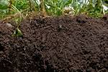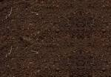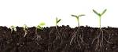

http://www.writeopinions.com/soil

As global food demand rises, climate change is hitting our staple crops
March 1, 2017 6.10am AEDT
Andrew Borrell

Author
- Andrew Borrell
Associate Professor, Queensland Alliance for Agriculture and Food Innovation, The University of Queensland; Centre Leader, Hermitage Research Facility; College of Experts, Global Change Institute, The University of Queensland
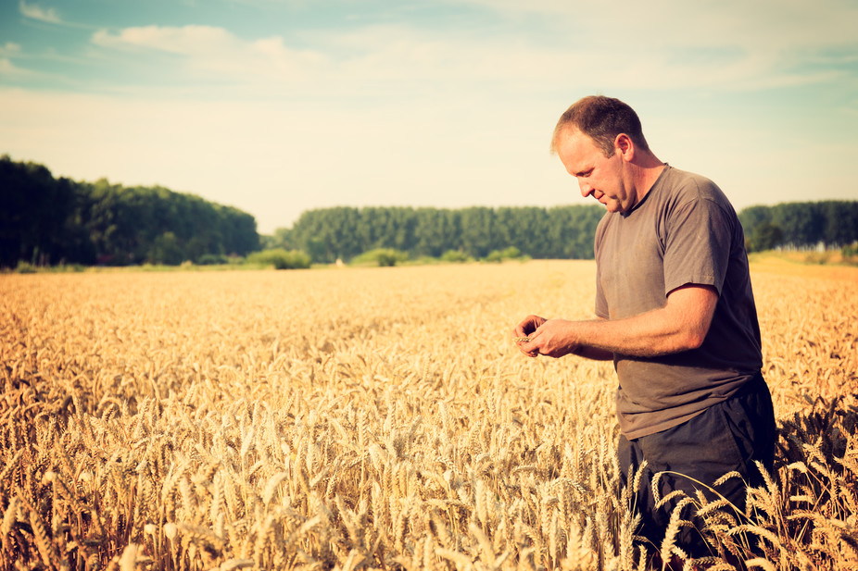Farmers face falling crop yields and growing food demand. Shutterstock
Climate change and extreme weather events are already impacting our food, from meat and vegetables, right through to wine. In our series on the Climate and Food, we’re looking at what this means for the food chain.

While increases in population and wealth will lift global demand for food by up to 70% by 2050, agriculture is already feeling the effects of climate change. This is expected to continue in coming decades.
Scientists and farmers will need to act on multiple fronts to counter falling crop yields and feed more people. As with previous agricultural revolutions, we need a new set of plant characteristics to meet the challenge.
https://theconversation.com/as-global-food-demand-rises-climate-change-is-hitting-our-staple-crops-73360

‘Soil health’ is gaining attention
Tony Nye - OSU Extension

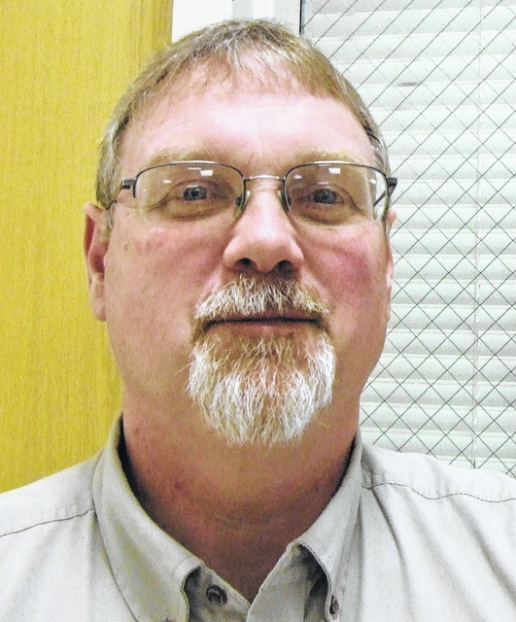
Over the years that I have been here in Clinton County, I have seen our farmers do some outstanding things in terms of crop production. We know getting the crop planted in a timely fashion, good weather, good genetics and little plant pressure from weeds, insects and disease can all have a positive impact on yield and hopefully for a profitable year. https://wnewsj.com/opinion/columns/35049/soil-health-is-gaining-attention

Genetically Modified Food and the Second Green Revolution
9 February 2017 Mervyn Piesse, Research Manager, Global Food and Water Crises Research Progarmme Download PDF
Key Points
- Just as the Green Revolution was made possible by multiple technologies, such as higher-yielding food crops, more efficient irrigation, fertilisers and pesticides, the second Green Revolution will be made possible by numerous innovations.
- While the Green Revolution is arguably still ongoing in parts of the world, most notably sub-Saharan Africa, other regions have reached a barrier and a new wave of research and development is required if agricultural production is to sustainably increase.
- Genetic modification has mainly been applied to crop production where it is mainly used for the control of pests and disease. In livestock it is used to speed up the rate of maturation or make animals more resistant to disease.
- Diligent testing, regulation and oversight of genetically modified food will help reduce any possible associated risk.

http://www.futuredirections.org.au/publication/genetically-modified-food-second-green-revolution/

Grow more microbes per acre

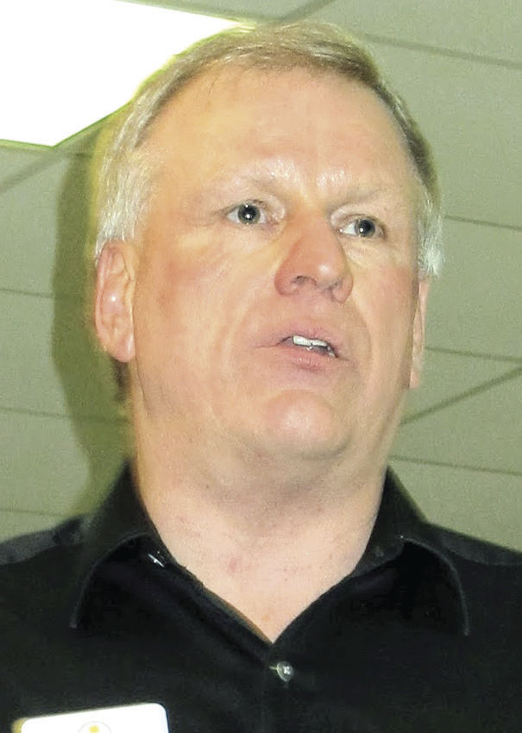
AgriNews photo/Martha Blum Dean Craine talks about factors that impact soil health. The bottom line, he says, is growing more microbes per acre. He encourages farmers to dig in all their fields to determine if a hard pan is affecting the ability for roots to grow and access water from the subsoil.
Bottom of Form
PRINCETON, Ill. — Loose soil tilth is important to allow capillary action to work.
“Water comes from the subsoil to the surface to water the crop,” said Dean Craine of AgriEnergy Resources. “If the soil surface is hard and there’s no loose tilth there, the water will evaporate off and you’ll lose a lot of moisture.”
There are many factors associated with improving soil health.
“You need to manage the air and water in the soil, manage the residue, use the right tillage and spoon-feed the crop,” Craine said during the Solving the Farm Profit Puzzle — Biologicals Are a Key Piece meeting, hosted by AgriEnergy Resources. “The bottom line is you need to grow more microbes per acre.”
http://www.agrinews-pubs.com/news/how-to-improve-soil-health/article_0e854d14-8c01-56a7-98e7-68e30e47d649.html

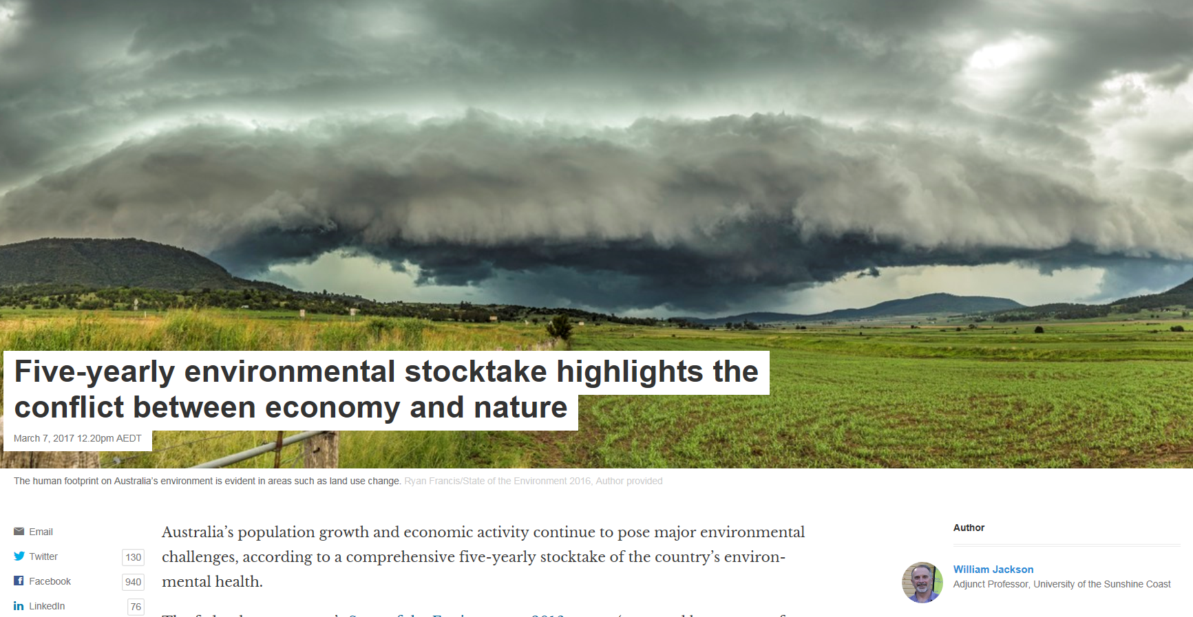
https://theconversation.com/five-yearly-environmental-stocktake-highlights-the-conflict-between-economy-and-nature-73964

Bunck: Help fighting glyphosate-resistant weeds

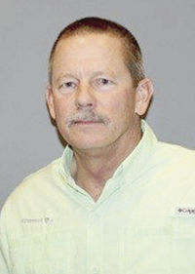
Opinion
Late last year, the U.S. Environmental Protection Agency approved XtendiMax herbicide with VaporGrip Technology for in-crop use with Roundup Ready 2 Xtend soybeans. A wide variety of Roundup Ready 2 Xtend soybean products are available for the 2017 growing season, so growers need advice as to which products best fit their acres http://www.agrinews-pubs.com/opinion/bunck-help-fighting-glyphosate-resistant-weeds/article_2fc2ad87-33f4-5e38-b16e-6ef2272d75d9.html
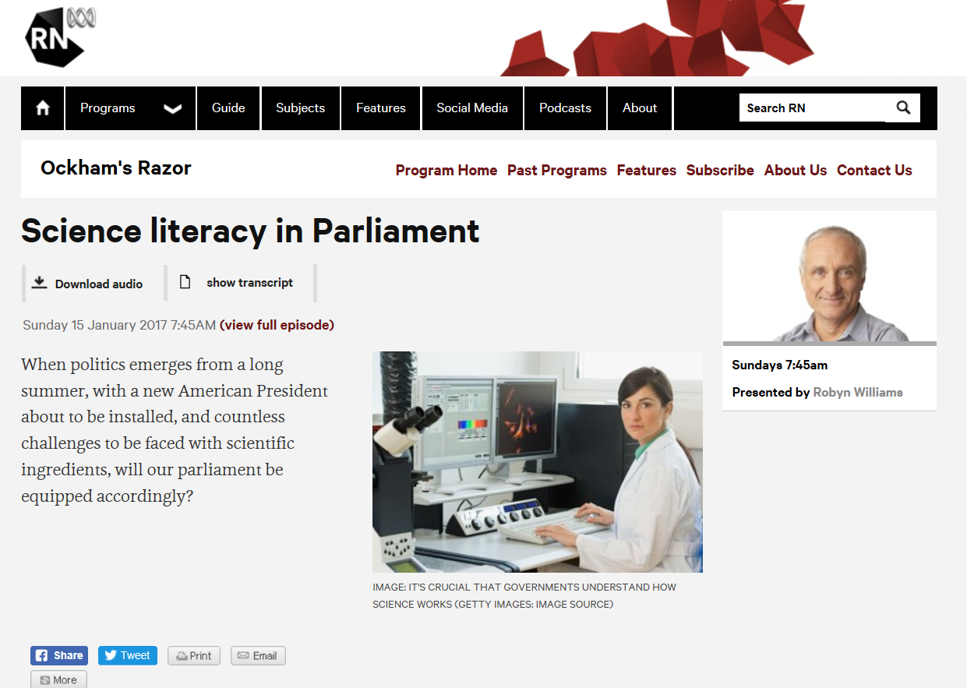
http://www.abc.net.au/radionational/programs/ockhamsrazor/science-literacy-in-parliament/8142506
What do livestock mean for wildlife
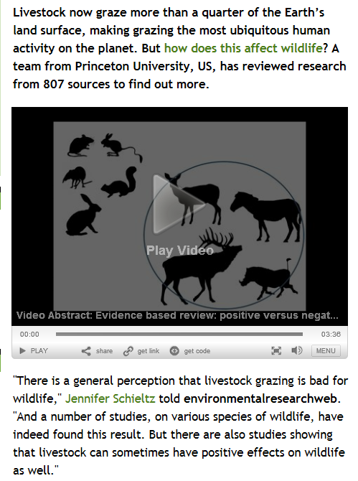
http://environmentalresearchweb.org/cws/article/opinion/67852

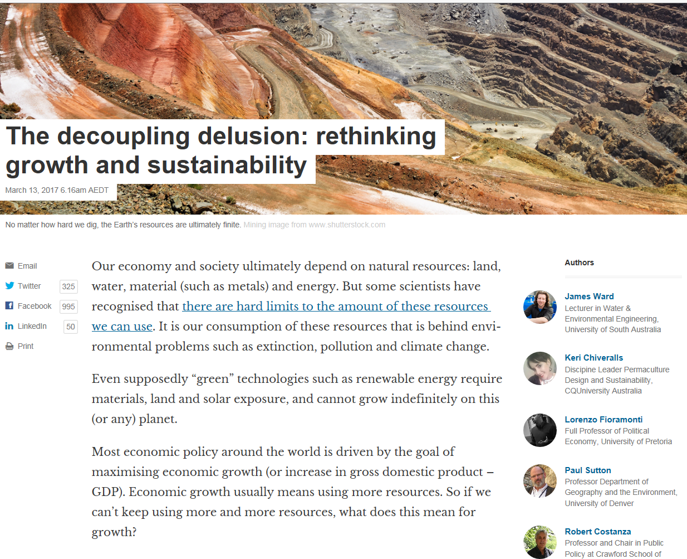
https://theconversation.com/the-decoupling-delusion-rethinking-growth-and-sustainability-71996

The fossil fuel industry's invisible colonization of academia
Corporate capture of academic research by the fossil fuel industry is an elephant in the room and a threat to tackling climate change.

A combination of file photos shows the logos of five of the largest publicly traded oil companies; BP, Chevron, Exxon Mobil, Royal Dutch Shell, and Total. Photograph: REUTERS/Reuters
Benjamin Franta and Geoffrey Supran

Monday 13 March 2017 21.00 AEDT Last modified on Tuesday 14 March 2017 14.46 AEDT
On February 16, the Harvard Kennedy School’s Belfer Center hosted a film screening of the “Rational Middle Energy Series.” The university promoted the event as “Finding Energy’s Rational Middle” and described the film’s motivation as “a need and desire for a balanced discussion about today’s energy issues.”
Who can argue with balance and rationality? And with Harvard’s stamp of approval, surely the information presented to students and the public would be credible and reliable. Right?
Wrong.
https://www.theguardian.com/environment/climate-consensus-97-per-cent/2017/mar/13/the-fossil-fuel-industrys-invisible-colonization-of-academia

Feral cat cull is just the first step in saving our native species
A passenger woke to find her headphones on fire and burning her neck on a flight from Beijing to Melbourne.

Australia to cull 2 million feral cats
The federal government has pledged to reduce the nation's feral cat population by a third between now and 2020.
Even before European settlers colonised parts of Australia, cats were digging their claws into the country. They may have arrived as early at the 17th century on Dutch shipwrecks, but certainly by the early 1850s, there were well-established colonies of feral cats. The Pintupi people of the Gibson Desert in central Australia have been hunting, killing and eating cats for generations.
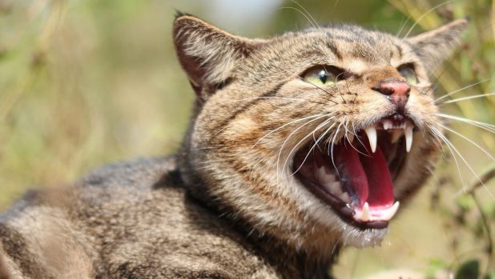Feral cats are the number one threat to native mammals. Photo: Andrew Cooke, Invasive Animals Cooperative Research Centre
http://www.smh.com.au/comment/smh-editorial/feral-cat-cull-is-just-the-first-step-in-saving-our-native-species-20170217-gufisg.html
How can farming in the Pampas and Campos grasslands stay sustainable?
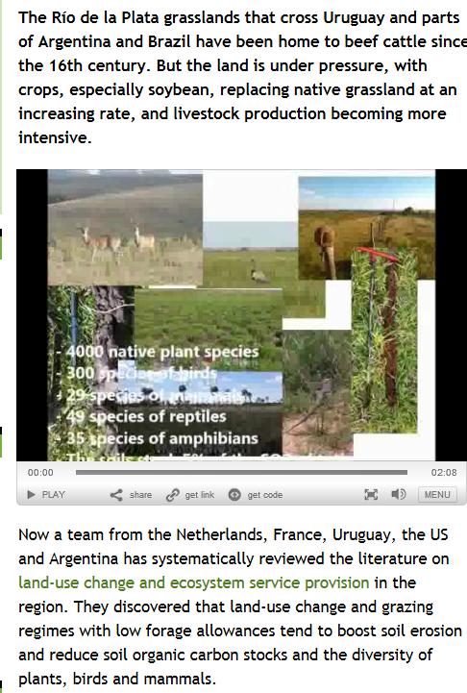
http://environmentalresearchweb.org/cws/article/opinion/67684

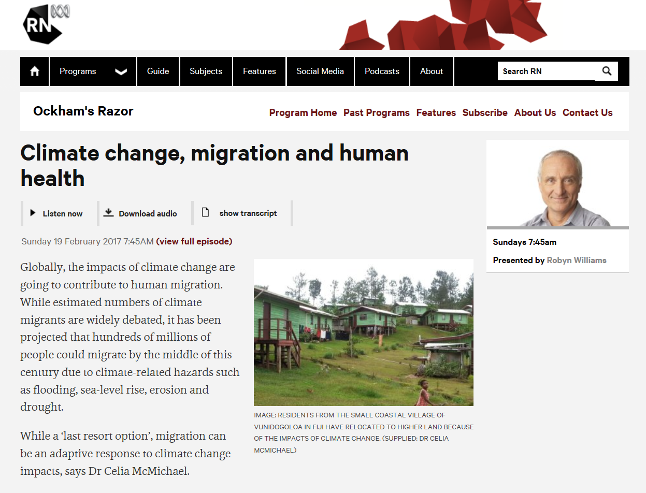
http://www.abc.net.au/radionational/programs/ockhamsrazor/climate-change,-migration-and-human-health/8265846

Opinion: Soil Testing Needs Sensors To Get More Accurate
17 February 2017 Ben D. Johnson

We are entering a very exciting time in agriculture. With so many great software platforms and data collection tools we are on the cusp of unlocking some really deep, profound information and management techniques like we’ve only dreamed of before. Being able to stack several layers of data on top of each other begins to tell an interesting story at angles that we weren’t able to look at until now. This is great stuff and is really interesting until we realize one huge, uncomfortable truth about the very foundation of our data: our soil tests really aren’t all that accurate.
Don’t get me wrong, the test results we get from soil labs generally get us to a place where we can determine a fertilizer application rate that nets us a return on our investment and at this point in time soil sampling is one of the best investments you can make on your farm. However, there are several areas where we could be doing much better. http://www.precisionag.com/systems-management/data/opinion-soil-testing-needs-sensors-to-get-more-accurate/

Losing ground in a warmer world
Paid for by

Transformational change is needed to solve crises in the vital global commons resources of fertile land and water which will be exacerbated by climate change
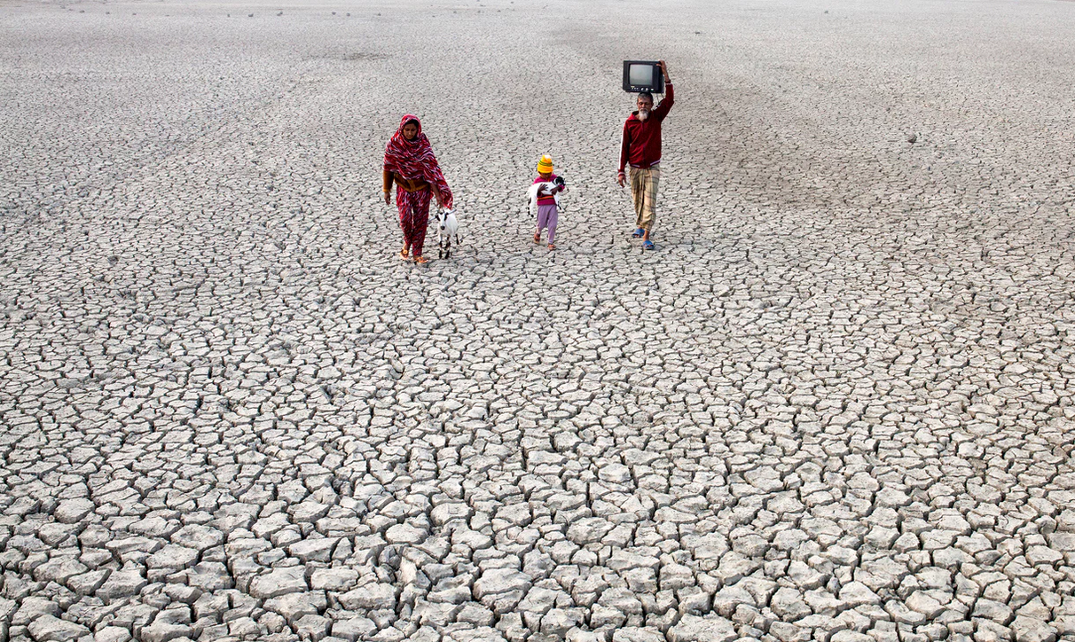 Local villagers on a dried river bed in Satkhira, Bangladesh. Photograph: Zakir Hossain Chowdhury / Barcro
N H Ravindranath, professor, Indian Institute of Science, Bangalore
Two global commons resources, fertile land and water, will be critical as the world’s population increases. Having crossed 7 billion in 2010 – rising from about 3.7 billion 40 years earlier – the number of people is likely to rise to 9-10 billion by 2050. This presents a big challenge: can the world feed so many and provide them fresh water?
Content on this page is paid for and provided by The Global Environment Facility, a sponsor of the Guardian’s Global Development Professionals Network.
https://www.theguardian.com/the-gef-partner-zone/2017/feb/20/losing-ground-in-a-warmer-world

http://www.abc.net.au/radionational/programs/ockhamsrazor/mathematics,-my-father-and-me/8343426
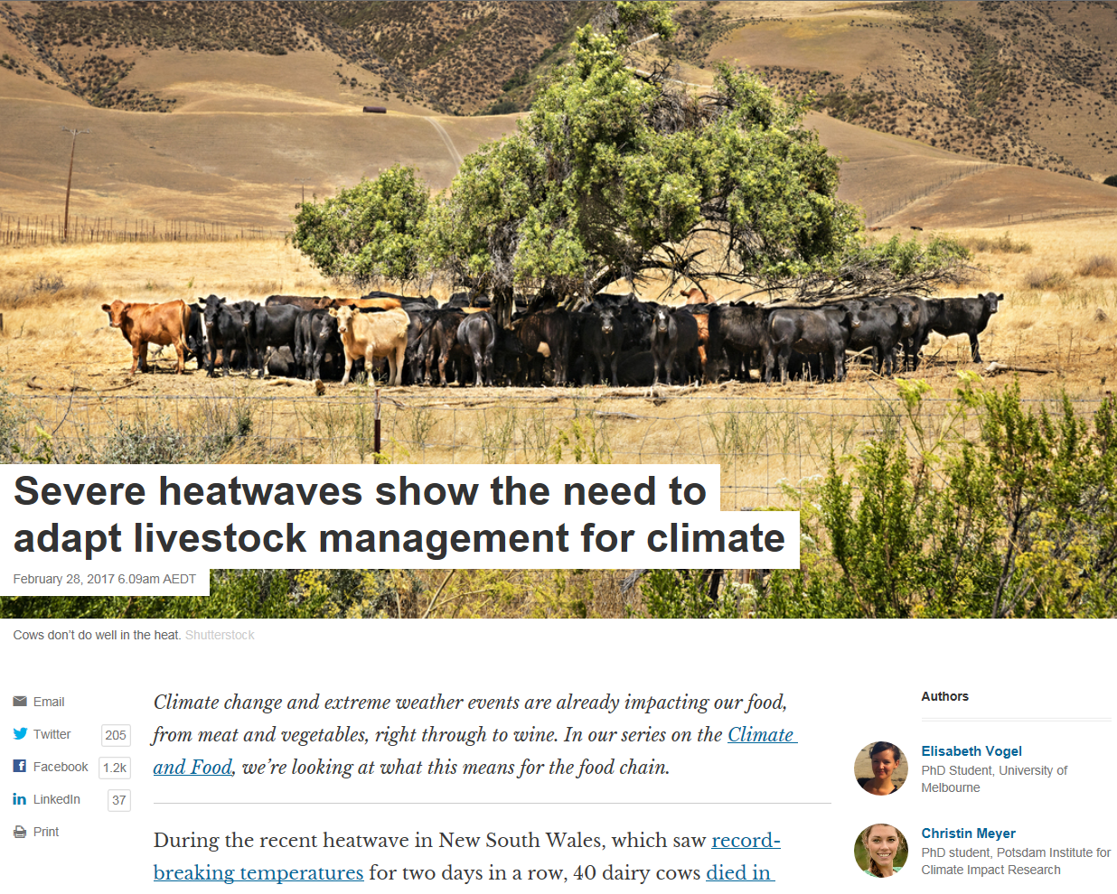
https://theconversation.com/severe-heatwaves-show-the-need-to-adapt-livestock-management-for-climate-73447

Australia is still clearing too much vegetation
Though the extreme rates of land clearing that placed Australia in the top 10 land clearing nations in the world have reduced over the past 5 years, we're still clearing much more native vegetation than is being replanted or that's regenerating naturally.
This ongoing net loss and decline continues to threaten Australia’s environment. Clearing increases erosion and sedimentation of waterways and reduces water quality. Clearing removes habitats leading to the direct loss of millions of native animals and plants every year and creates an extinction debt.
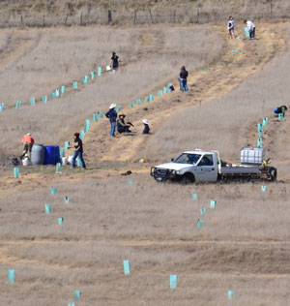
Large-scale revegetation work has taken place on parts of our Scottsdale Reserve (NSW) that had been cleared before purchase. Photo Peter Saunders.
http://www.bushheritage.org.au/about/about-us/our-challenge/land-clearing
How the mining industry parasites helped destroy good energy policy
15 March 2017

We're abandoning good policymaking in Australia and parasites like the mining industry are to blame.

Bernard Keane
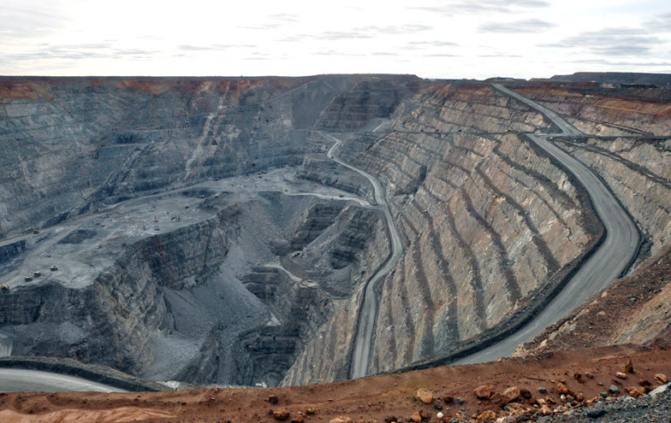
Two quite separate events yesterday illustrated, in painful detail, exactly how badly policy-making in Australia has run off the rails. For a country with a proud record of making tough but eventually worthwhile economic and fiscal decisions over the last 30 years, our process for making decisions has now gone badly awry.
https://www.crikey.com.au/2017/03/15/how-the-mining-industry-parasites-helped-destroy-good-energy-policy/

Explainer: what is ‘precipitable water’, and why does it matter?
February 27, 2017 4.03pm AEDT
Karl Braganza, Acacia Pepler, and David Jones

Authors
- Karl Braganza
Climate Scientist, Australian Bureau of Meteorology
- Acacia Pepler
Climatologist, Australian Bureau of Meteorology
- 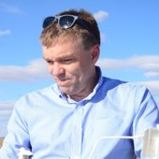David Jones
Climate Scientist, Australian Bureau of Meteorology
Get ready for heavier rain. Shutterstock
As the planet warms, rainfall and weather patterns will change. As temperatures rise, the amount of water in the atmosphere will increase. Some areas will become wetter, while others, like southern Australia, will likely be drier. https://theconversation.com/explainer-what-is-precipitable-water-and-why-does-it-matter-73358

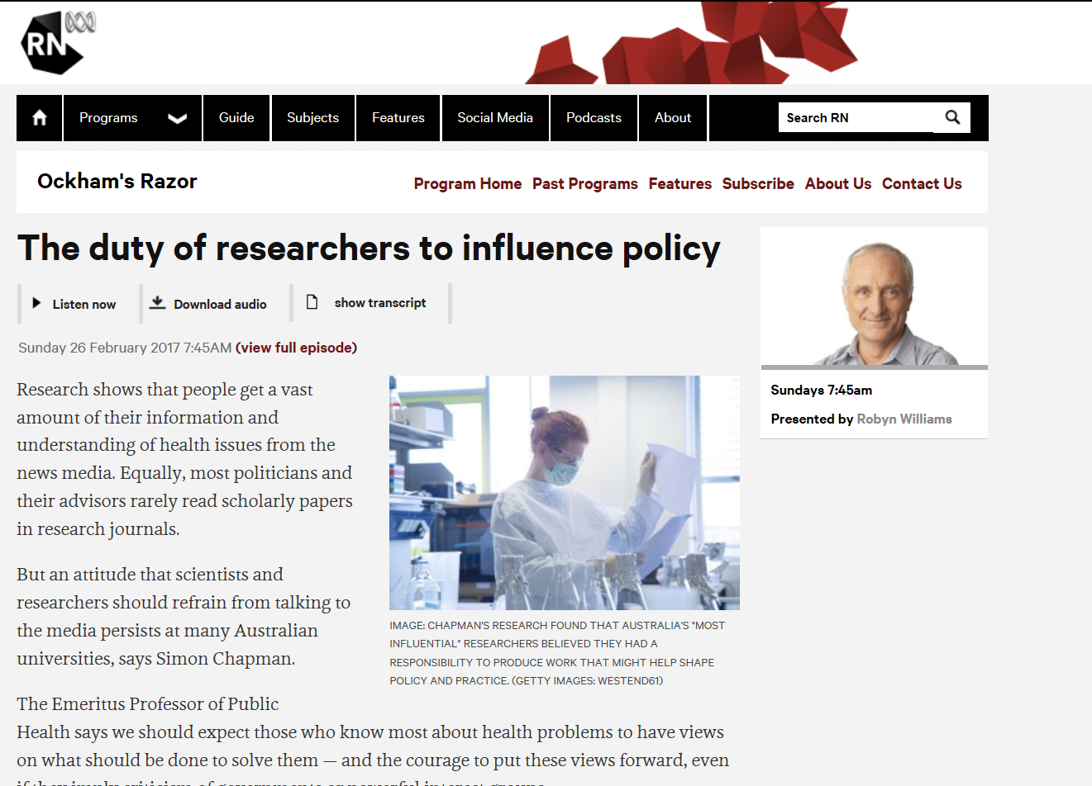
http://www.abc.net.au/radionational/programs/ockhamsrazor/the-duty-of-researchers-to-influence-policy/8265906
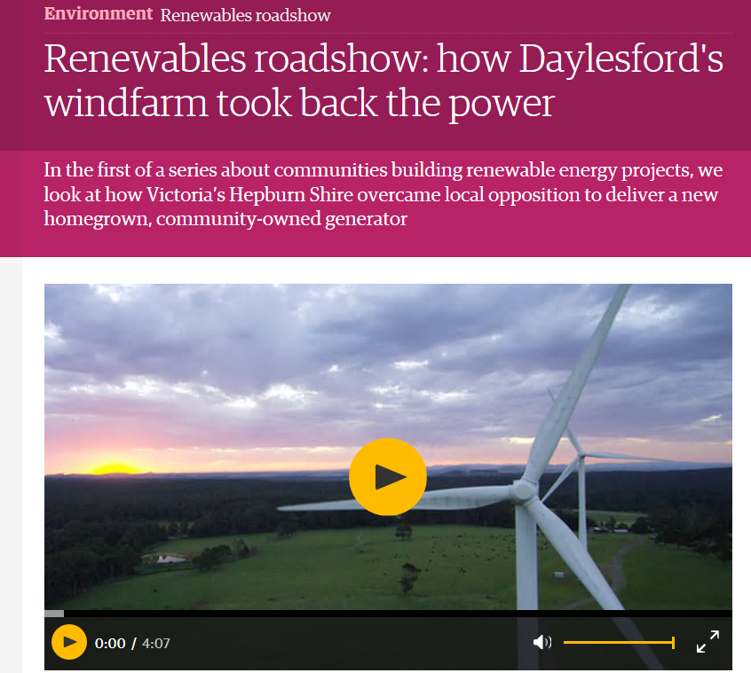

https://www.theguardian.com/environment/2017/mar/15/renewables-roadshow-community-owned-windfarm-daylesford-hepburn-australia

Why a gas generator, South Australia? There are better options to lower power prices
Tristan Edis
Jay Weatherill was backed into a corner to produce an energy plan. But it is a grab bag of overlapping ideas that don’t really make sense
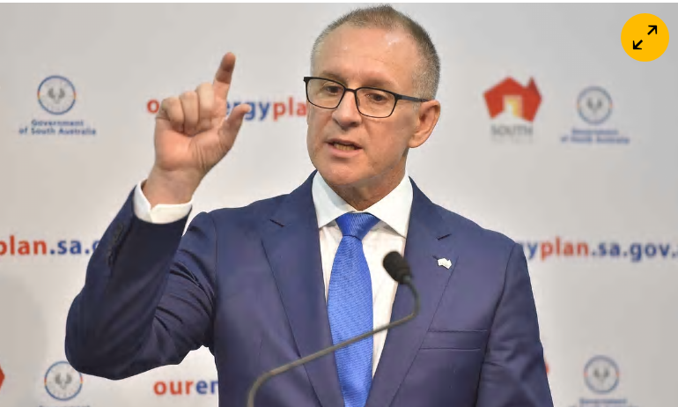

‘Jay Weatherill has to respond fast to keeping the lights on in South Australia – before next summer when demand soars during hot days driven by air conditioning.’ Photograph: David Mariuz/AAP

Wednesday 15 March 2017 08.55 AEDT Last modified on Wednesday 15 March 2017 09.47 AEDT
South Australian Premier Jay Weatherill is a politician panicked by a cynical and misleading campaign by his SA Liberal party opponents and the federal government to blame the state’s high power prices and recent blackouts on his 50% renewable energy target. https://www.theguardian.com/commentisfree/2017/mar/15/why-a-gas-generator-south-australia-there-are-better-options-to-lower-power-prices

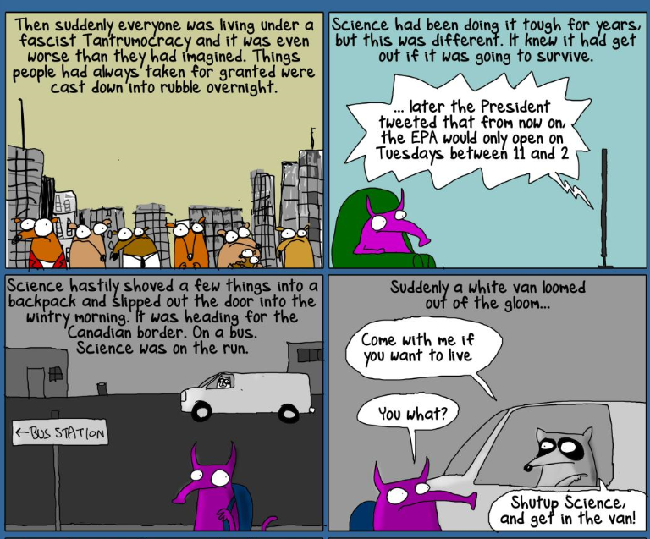
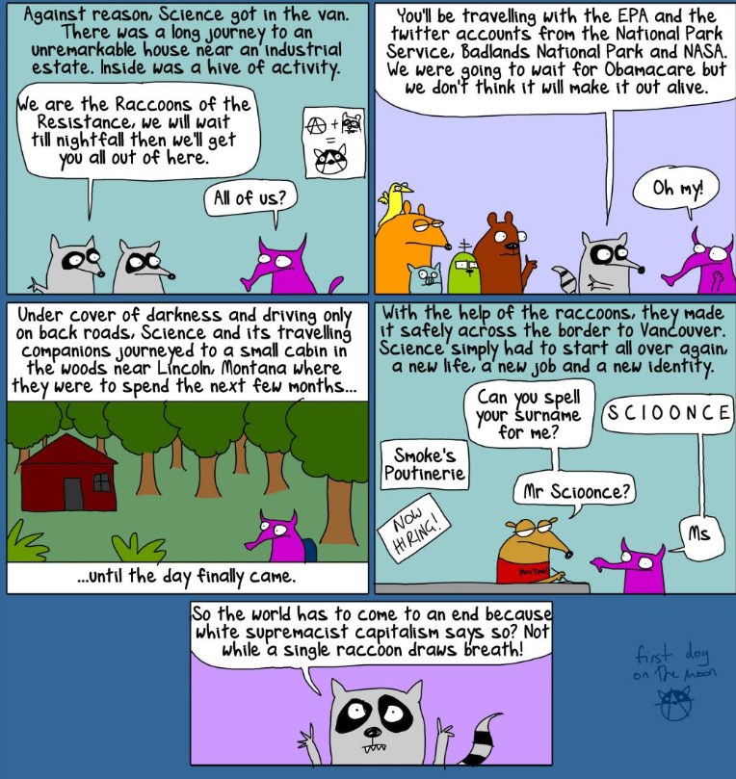
https://www.theguardian.com/commentisfree/2017/jan/27/can-raccoons-of-the-resistance-save-science-from-the-tantrumocracy
