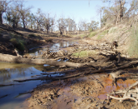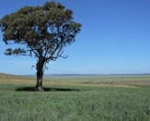

**How Much Carbon Could Soils Release Amid Warming Climate?**

24 MAY 2017 01:34 PM

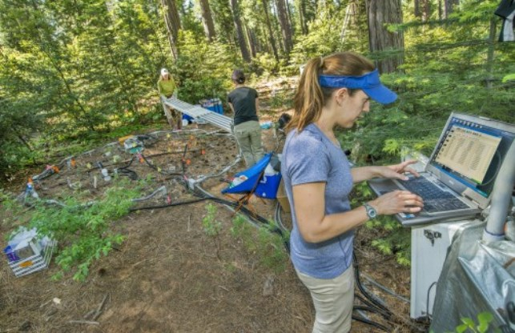

In the foreground, scientist Caitlin Hicks Pries downloads soil temperature data while two colleagues work on an experimental plot in the background.

© Berkeley Lab

At Lawrence Berkeley National Laboratory in California, scientists are fully engaged in what they call a “deep soil warming experiment.” Their initial findings – soils could release much more carbon dioxide into the atmosphere than previously expected if climate change continues its current warming trends.

The scientists conducted a field experiment to look at what happens to organic carbon in soil when all layers are warmed to a depth of 100 centimeters (a little more than 3’). When they did, the plots that were warmed released 34% to 37% more carbon dioxide than the non-warmed plots. <https://www.agweb.com/article/how-much-carbon-could-soils-release-amid-warming-climate-naa-ben-potter/>

# Historical rainfall levels are significant in carbon emissions from soil

##### **29 May 2017**

**[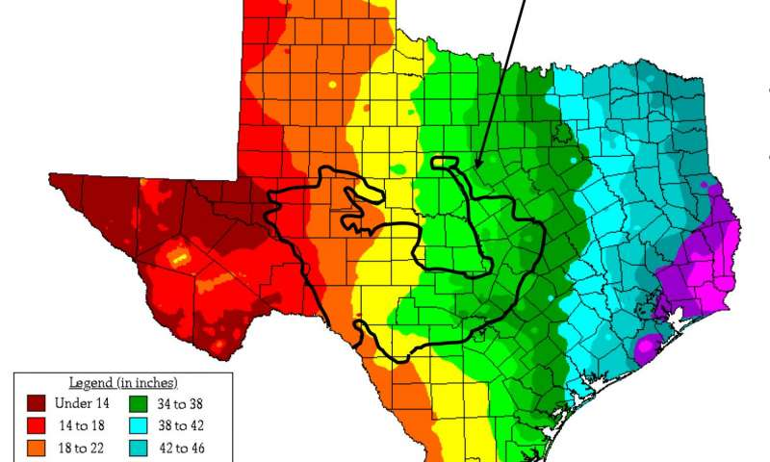](https://3c1703fe8d.site.internapcdn.net/newman/gfx/news/hires/2017/1-historicalra.jpg)**

Researchers sampled soil at various locations along the Edwards Plateau in Texas to determine the effects of historic rainfall on soil respiration from microbes. Microbes living in the dark green region had historic rainfall of 34-38 inches …[more](https://phys.org/news/2017-05-historical-rainfall-significant-carbon-emissions.html)

Scientists have known that microbes living in the ground can play a major role in producing atmospheric carbon that can accelerate climate change, but now researchers from The University of Texas at Austin have discovered that soil microbes from historically wetter sites are more sensitive to moisture and emit significantly more carbon than microbes from historically drier regions. The findings, reported today in the *Proceedings of the National Academy of Sciences*, point the way toward more accurate climate modeling and improve scientists' understanding of distinct regional differences in microbial life.

Read more at: <https://phys.org/news/2017-05-historical-rainfall-significant-carbon-emissions.html#jCp>

## **How Much Nitrogen Is Left in Soggy Soils?**

[Emily Unglesbee](https://www.dtnpf.com/agriculture/web/ag/news/author?authorFullName=Emily%20Unglesbee), DTN Staff Reporter

26/5/2017 | 12:18 PM CDT

**1**

[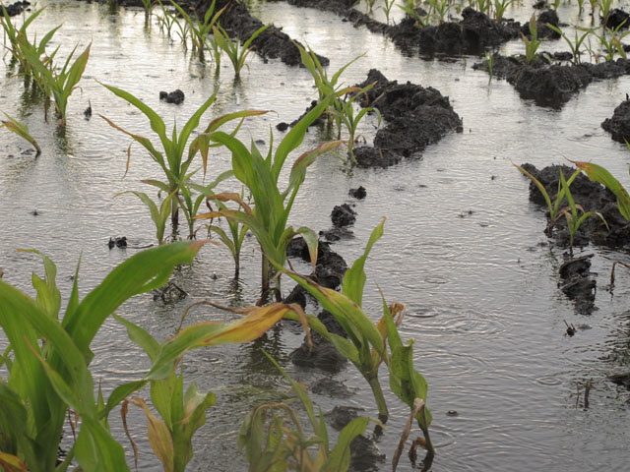](https://www.dtnpf.com/agriculture/web/ag/news/crops/article/2017/05/26/much-nitrogen-left-soggy-soils-3)

Flooded cornfields are at risk for denitrification and leaching, but cold soil temperatures in May might have slowed or prevented those processes recently. (DTN photo by Scott Kemper)

ROCKVILLE, Md. (DTN) -- Central Indiana grower Mike Starkey has watched rainfall soak, saturate and flood soils across his state with great alarm this spring.

"For everyone who applied nitrogen pre-plant, a lot of it has got to be going right down the tile lines and down to the Mississippi," he said.

Nitrogen loss -- and its crop and environmental consequences -- seem more possible than ever during this wet spring. <https://www.dtnpf.com/agriculture/web/ag/news/crops/article/2017/05/26/much-nitrogen-left-soggy-soils-3>

# Avoid Fertilizer Deficiency

## K Levels in Soil Important to Monitor

[Russ Quinn](https://www.dtnpf.com/agriculture/web/ag/news/author?authorFullName=Russ%20Quinn), DTN Staff Reporter

2/13/2017 | 6:47 AM CST

**58**

[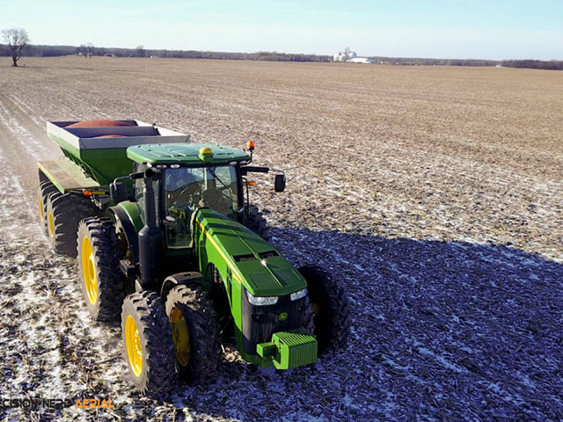](https://www.dtnpf.com/agriculture/web/ag/news/crops/article/2017/02/13/k-levels-soil-important-monitor)

Potassium fertilizer application in corn and soybean production is an important aspect and often overlooked. (Photo courtesy of Michael Cline)

OMAHA (DTN) -- With tight crop margins and increasing yields, it's easy to overlook the importance of potassium (K) applications.

Soils deficient in K will limit yields and quality. Farmers can face several different issues with how much of an investment they make with nutrient applications.

KEEP IN OPTIMUM RANGE

Clarke McGrath, Iowa State University Extension on-farm research coordinator for the Iowa Soybean Research Center and agronomist in southwestern Iowa, said grain producers should keep K in the optimum range, roughly 90 to 120 parts per million (ppm) for his area. <https://www.dtnpf.com/agriculture/web/ag/news/crops/article/2017/02/13/k-levels-soil-important-monitor>

OIL HEALTH INSTITUTE DETAILS NEXT STEPS ON IMPROVING NATION’S SOILS

BY Chris Clayton, DTN/Progressive Farmer | May 19, 2017

[**Home**](http://kticradio.com/)**›**[**News**](http://kticradio.com/news/)**›**[**Agricultural News**](http://kticradio.com/news/?news=agricultural)

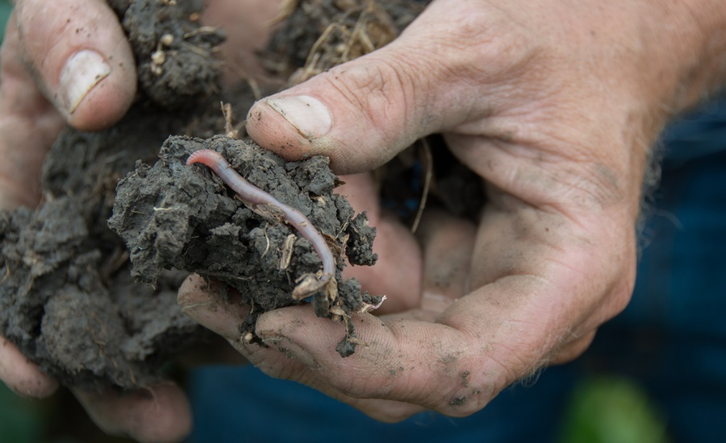

**Soil health represents one of those rare win-win situations where what is good for the farmers is good for the environment.**

*- Wayne Honeycutt, CEO of the Soil Health Institute*

The Soil Health Institute unveiled its action plan on Thursday for advancing soil health in research, policy and on-farm practices.

The institute — created by the Oklahoma-based Samuel Roberts Noble Foundation and the Farm Foundation — held an event at the National Press Club in Washington, D.C., to highlight the action plan and its purpose. <http://kticradio.com/agricultural/soil-health-institute-details-next-steps-on-improving-nations-soils/>

# Don’t rush canola into cooler soils

## **Agronomy tips... from the field**

By [Rob Bishop](https://www.grainews.ca/contributor/rob-bishop/)

Published: 24 May 2017 

[](https://static.agcanada.com/wp-content/uploads/sites/4/2017/05/Phyllotreta_striolata_striped-flea-beetle-WikimediaCommons.jpg)

A striped flea beetle on a canola leaf. *Photo: Wikimedia Commons (Author: Sanja565658*

Your flea beetle management strategy this season is going to depend on what type of weather conditions and soil temperatures experienced in the days leading up to seeding.

Striped flea beetles are going to be a significant threat to your emerging canola, and were responsible for about 90 per cent of the feeding damage we saw in fields last season. <https://www.grainews.ca/2017/05/24/why-you-shouldnt-rush-canola-seeding-into-cooler-soils/>

**Testing for soil stability across UK grasslands**

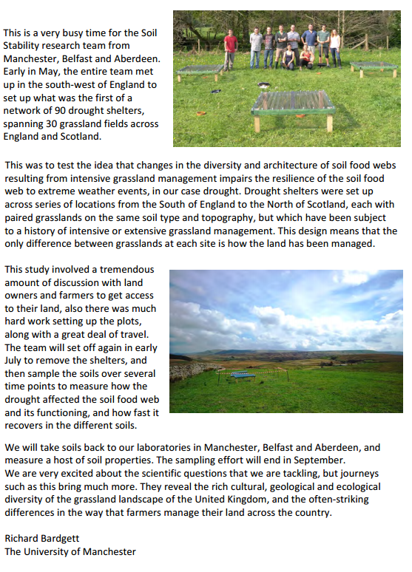

<http://blogs.reading.ac.uk/soil-security/files/2016/08/Soil-Security-News-Volume-1-Issue-2.pdf>

**PA technology makes more of Mallee soils**

[Alisha Fogden](http://www.stockjournal.com.au/profile/215/alisha-fogden)[@alishafogden](https://www.twitter.com/@alishafogden)

23 May 2017, 7:30 a.m.

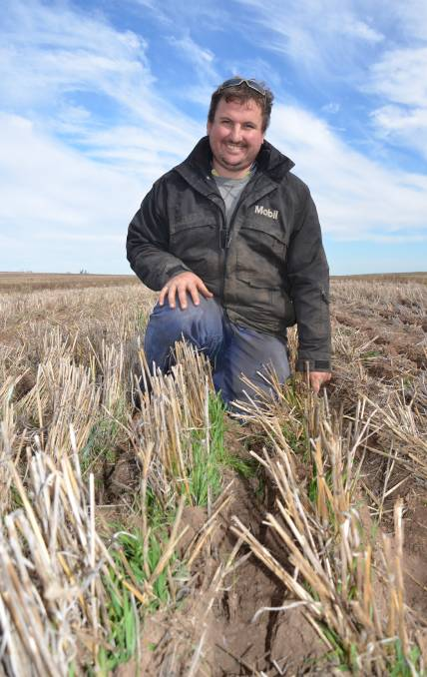

 PRECISION APPROACH: At a recent SPAA Expo in Lameroo, Robert Pocock outlined how his family had incorporated precision ag on-farm since the early 2000s.

SINCE the early 2000s, the Pocock family have slowly integrated precision agriculture into their southern Mallee farming operation, progressing to a controlled traffic farming approach for the first time last year. <http://www.stockjournal.com.au/story/4669862/pa-technology-makes-more-of-mallee-soils/>



<file:///C:/Users/jenkinb.DEC/Downloads/FY17_NRCS-Soils_Report.pdf>

**Mobile isotope and gas laboratory**



<http://blogs.reading.ac.uk/soil-security/files/2016/08/Soil-Security-News-Volume-1-Issue-2.pdf>

## **Why does boron show up on my soil test report?**

### **Based on your soil type and intended crop, the nutrients recommended by the MSU soil test report may include boron.**

Posted on **17 May 2017** by [**Jim Isleib**](http://msue.anr.msu.edu/experts/james_isleib), Michigan State University Extensio

Even though you didn’t request a special soil test for boron when you sent your samples into the [Michigan State University Soil and Plant Nutrient Laboratory](http://www.spnl.msu.edu/), you might have received a recommendation to add 1 or 2 pounds for boron per acre for your selected crop. Like nitrogen, the boron recommendation is not based on chemical analysis of your regular soil sample. Instead, it is based on many years of accumulated research results regarding crop response to boron. Special tests for soil content of nitrogen and boron are available through [MSU Soil and Plant Nutrient Laboratory](http://www.spnl.msu.edu/) and other reputable labs.

There are two main reasons why boron is routinely recommended:

1. Coarse-textured soil low in organic matter.
2. Crops sensitive to boron deficiency.

<http://msue.anr.msu.edu/news/why_does_boron_show_up_on_my_soil_test_report>

Apriori1/Thinkstock

**Vineyard soil productivity hinges on a healthy three-way relationship**

Good soil structure is particularly important when planting a new vineyard, because it encourages development of a strong root system that will help sustain the vines for years to come.

<http://www.westernfarmpress.com/grapes/vineyard-soil-productivity-hinges-healthy-three-way-relationship>

**Soil health represents one of those rare win-win situations where what is good for the farmers is good for the environment.** *- Wayne Honeycutt, CEO of the Soil Health Institute*